Topic – more notes on jdbc part 2🡪

**Jdbc –** Api to connect and query db.

Jdbc also known as **thin driver,** written in **java.**

**If you want to refer-**

**This jar file should be downloaded-**

**Ojdbc11.jar.**

**If connection details wrong, we get below error-**

**If connection successful-**

**Another way to establish connection-**

Added **35-45-**

**Savepoint argument cannot have spaces, else we get error-**

**Working Code-**

Firstname not updated in db-

Added **line 102-**

Table also is updated-

**Uncomment delete-**

Record not deleted as no commit-

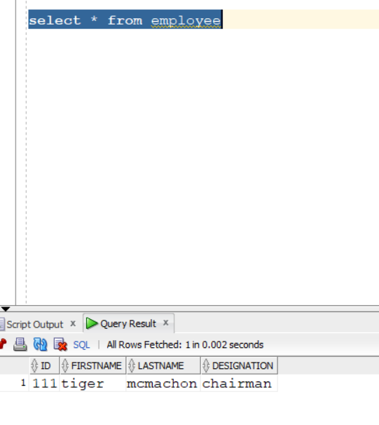

Add **115-**

Deleted-

In **DML** we check **if i!=0** then it means that is a **successful operation.**

In **DDL** we check **if i==0** then it means that is a **successful operation.**

**Statement-**

For simpler queries.

**Preparedstatement –** pass arguments at runtime, get input from user and based on input insert into database. **? is the placeholder.**

**Callablestatement –** to deal with stored procedures.

**Stored procedures –** entire functionality in one table. Code written in SQL language.

**Prepared statement code-**

**Oracle SQL server error-**

**Play with the result set-**

Get third row.

**Commented 35,** added rest-

Our **ODBC jar** supports all these metadata.

