Topic – lambdas part 1 🡪

**We cannot use the sysout and call the interface before defining it:**

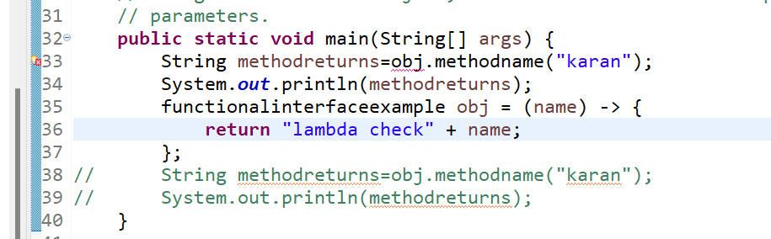

**Using lambda without calling interface method results in blank output:**

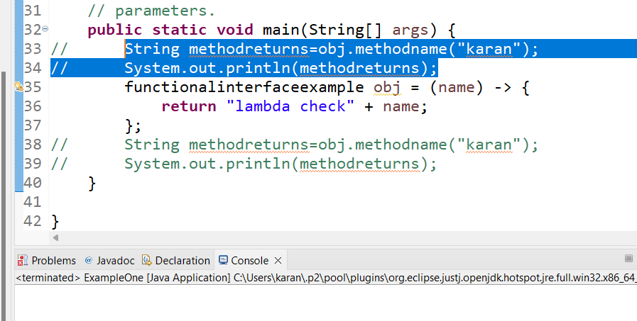

**ExampleOne-**

**See the error when we write public before interface in a class file which has another class in it:**

**Private is also not allowed before interface as we need to use in other class:**

**Abstract works properly in the same class:**

**Example two-**

**ExampleThree-**

**Example four-**

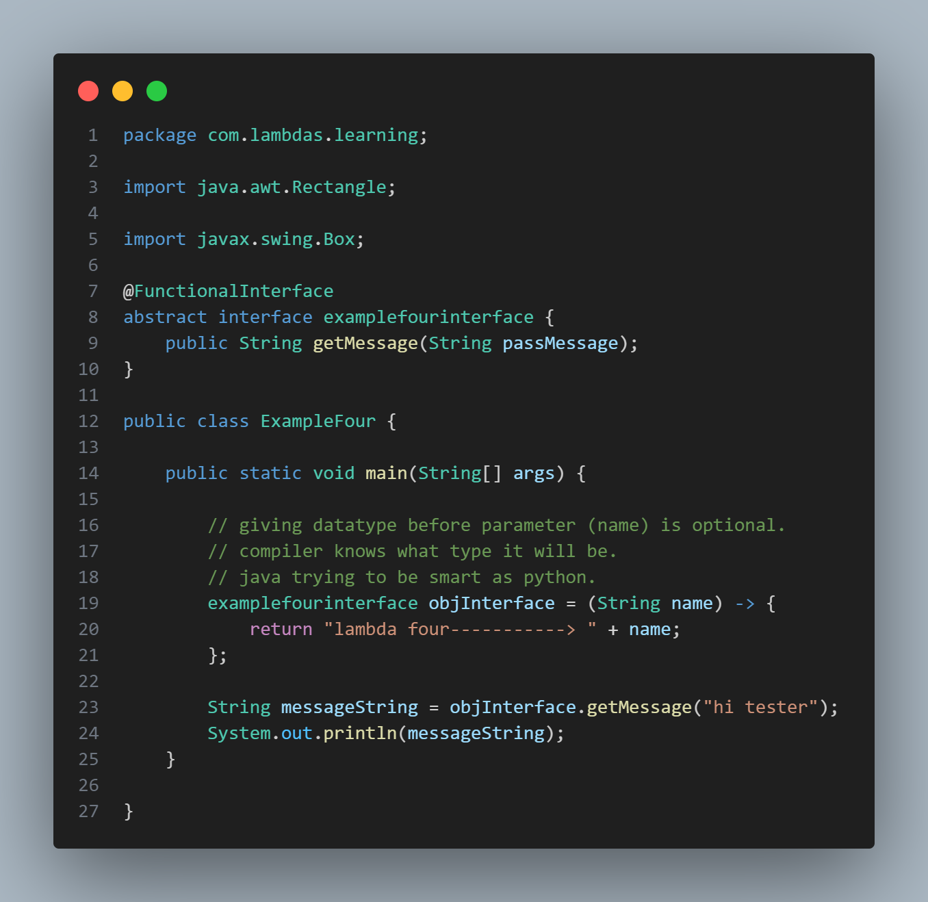

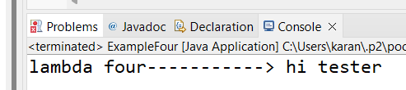

**Example five-**

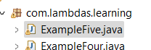

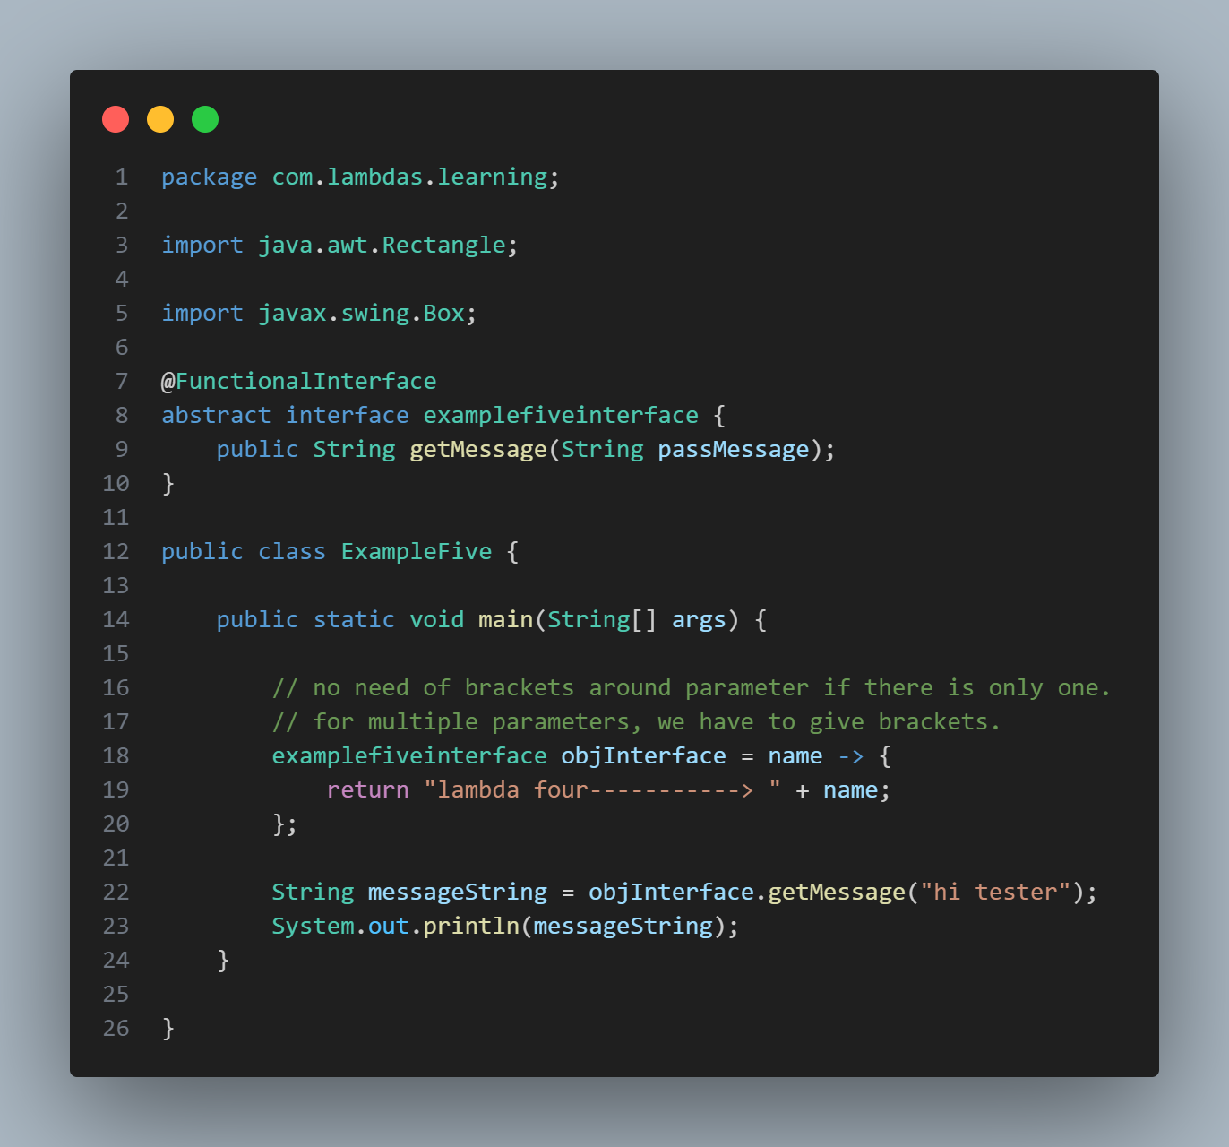

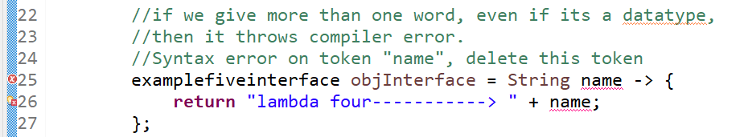

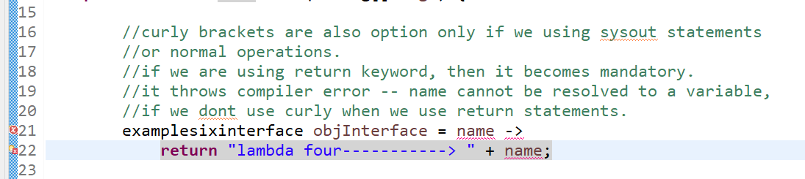

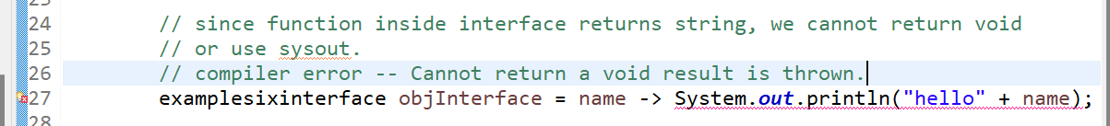

**Example six-**



