Topic 3 – lamda expressions part 3 🡪

**Lambda with comparator-**

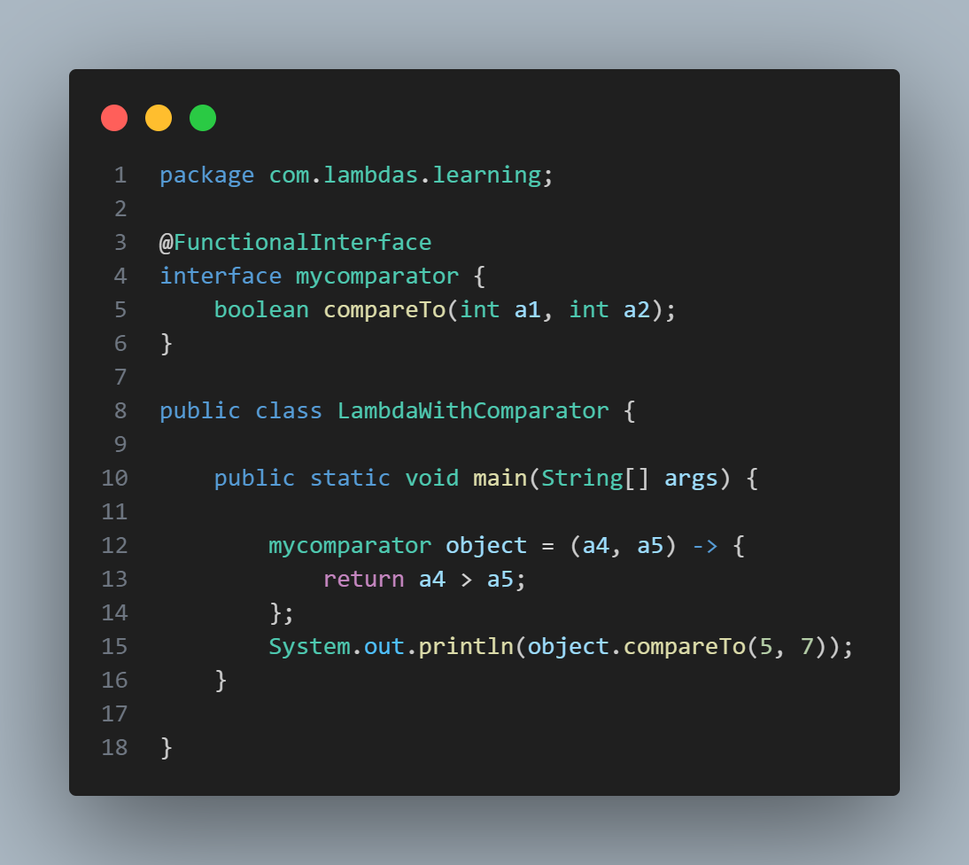

**Lamda with anonymous classes-**

**

**LambdaSolvesAnonymousClassComplexityRemoveCurly-**



**LambdaSolvesAnonymousClassComplexityRemoveBrackets-**

