Topic – list interface part 2 🡪

**Remove method with multiple occurrence of the same element-**

**Remove all method with same values in both interfaces-**

**Retain all method with duplicate elements-**

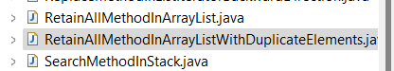

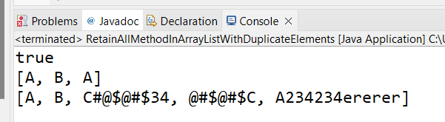

**When a method returns void, we cannot use system.out.println on it-**

**Get method-**

**List iterator-**



