Topic – list interface part 3 🡪

If we don’t use **next() method,** it prints memory address and goes into infinite loop.

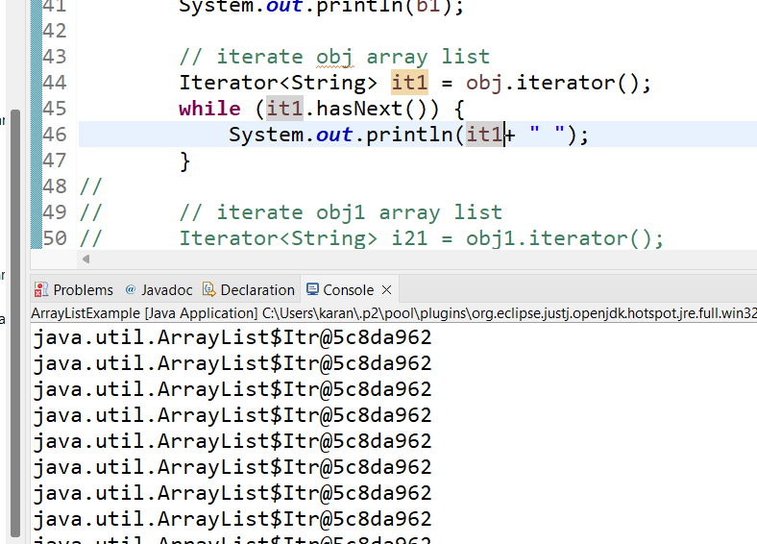

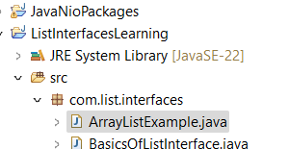

**ArrayListExample-**

**Using enhanced for loop -**

**Add two array list each of different data type—**

Compile time error.

