Topic – list interface part 4 🡪

**Remove method-**

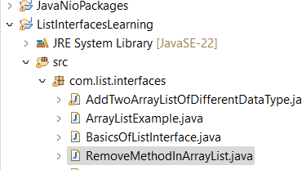

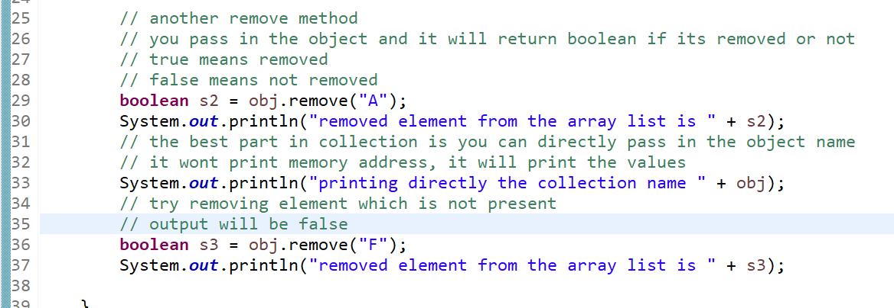

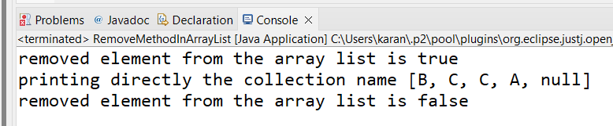

**Remove all method-**

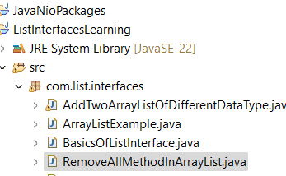

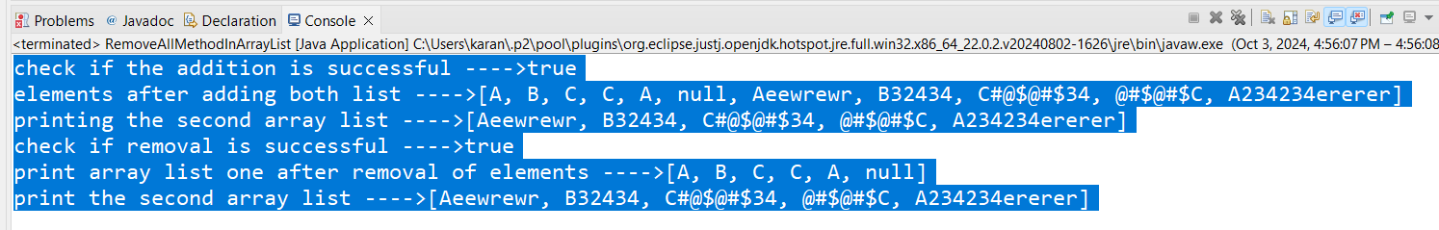

**Set method-**

**Clear method-**

**Retain all method -**

**Custom class as generics-**

Added **line 13—**

Commented **27-33.**

Added **35-39.**

**Convert arrays to array list-**

