Topic – list interface part 6 🡪

**Array list with custom class with null values-**

**Remove all method -**

**Remove element by index number-**

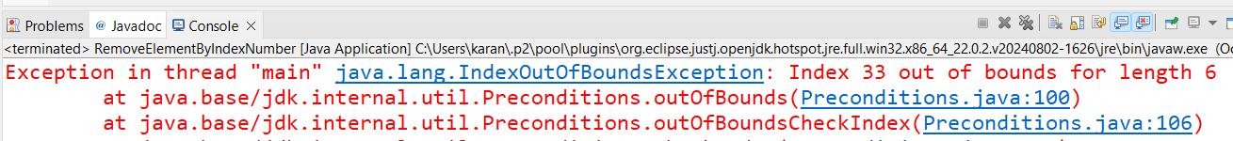

**Replace method-**

Note-

We can traverse **list, set, map** using **for each loop** and **iterator.**

**Poll method -**

**Add array list and link list-**

