Topic – list interface part 9 🡪

**Note regarding how the dynamic size of list interface changes–**

Array list increases size by 50% when threshold limit is reached, i.e., when array size is full then increase by 50% of the size. Example, if size is 10 and its full, then increase by 50% which is equal to 15.

**AddTwoArrayList-**

**Removall() method is not for single elements –**

**Size method-**

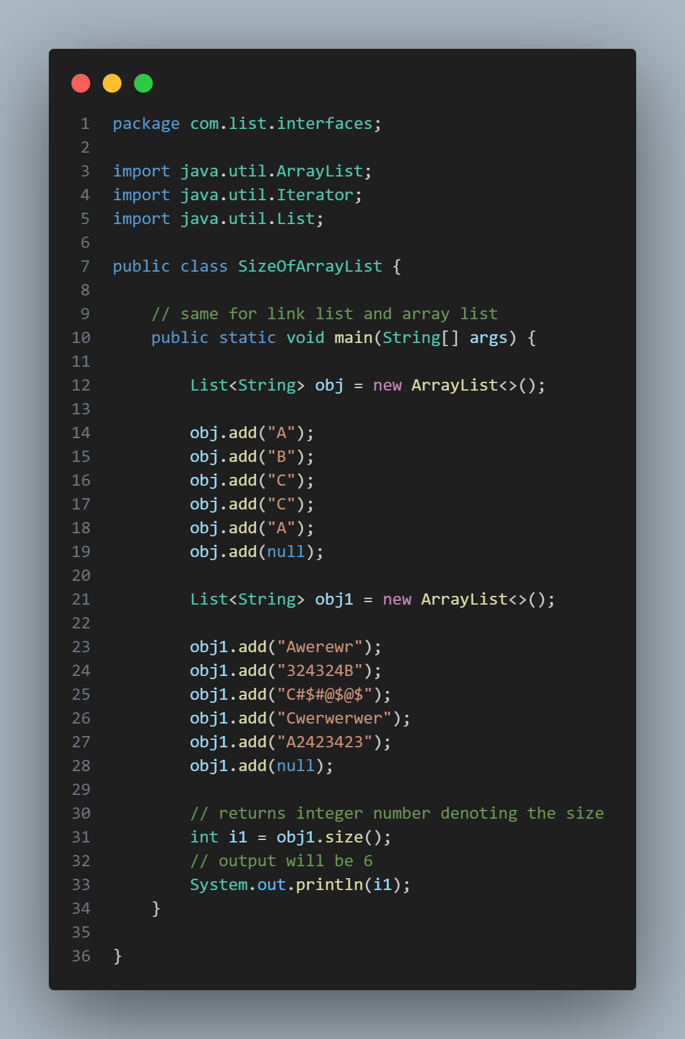

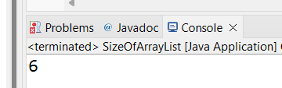

**Clear method-**

Even if you miss any argument in the constructor call, then compile time error –

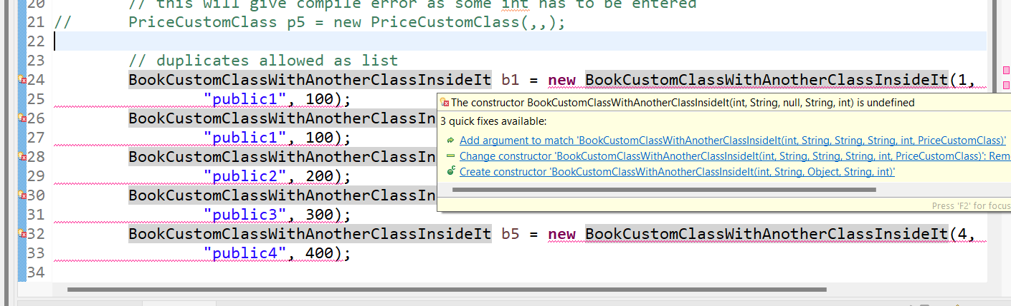

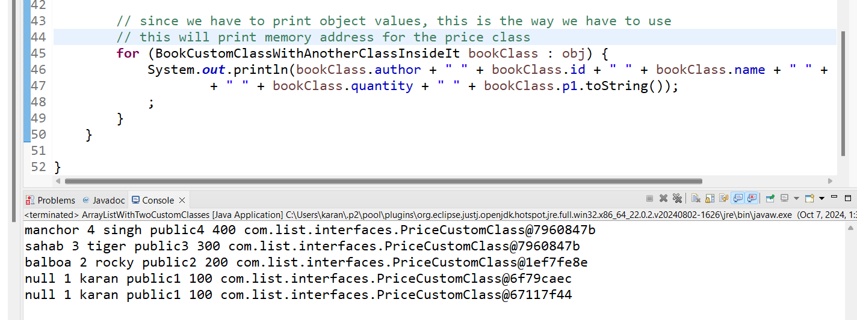

**Price custom class-**

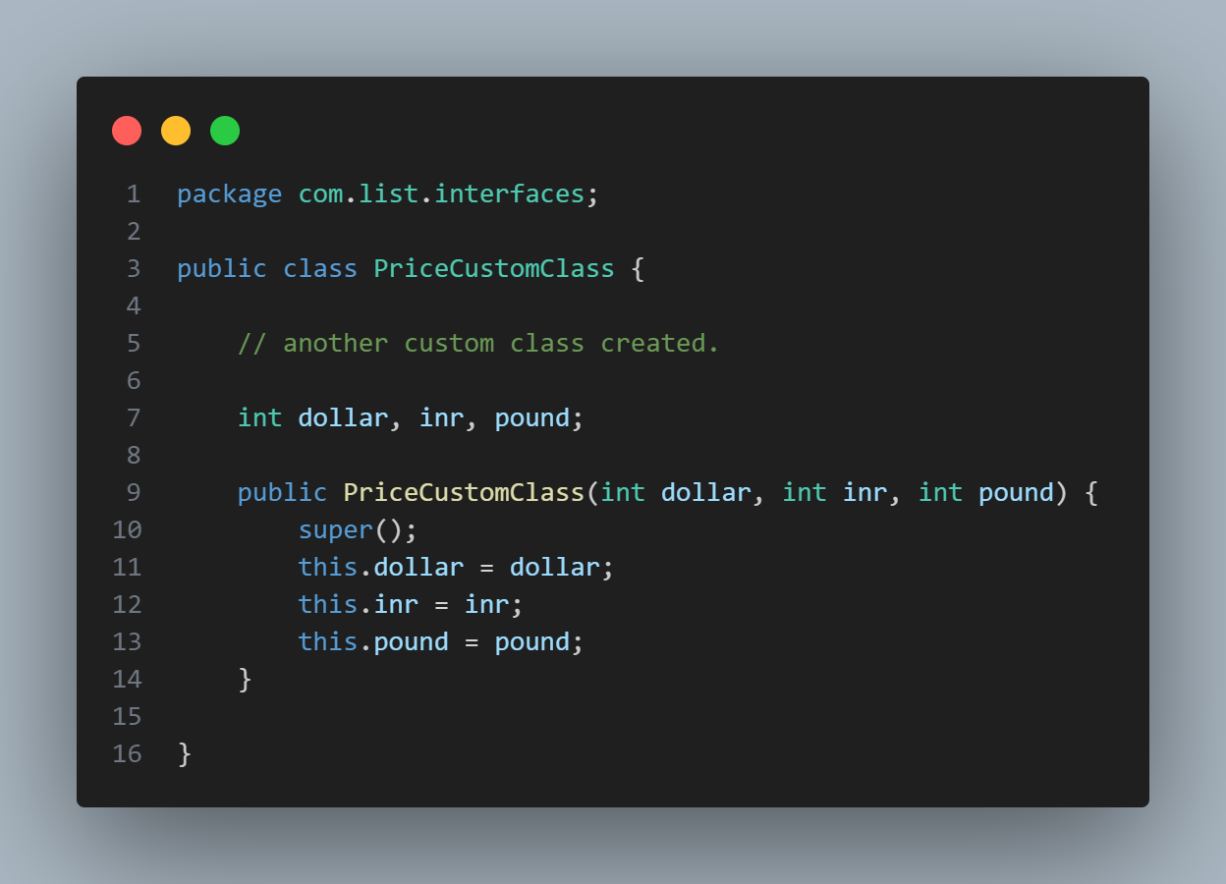

**BookCustomClassWithAnotherClassInsideIt-**

**ArrayListWithTwoCustomClasses-**

