Topic – locale part 1 🡪

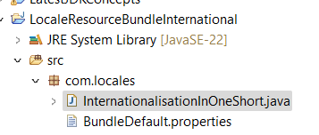

If we pass in the extension of properties file, we get below error:



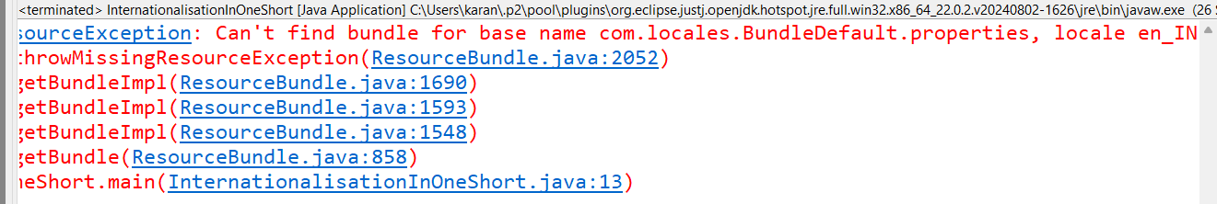

**All about internationalisation -**

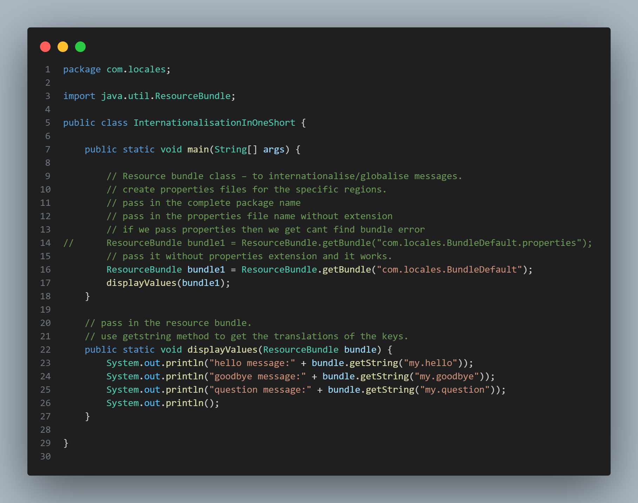

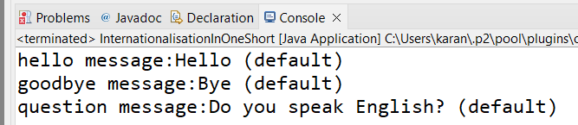

**Added line 16—**



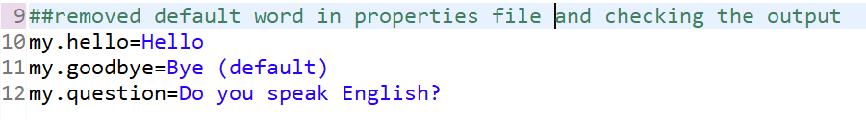

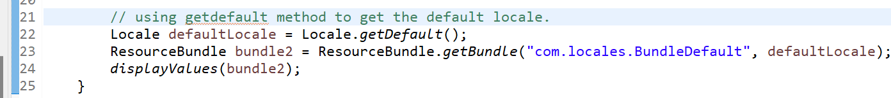

**Sweden bundle properties file –**

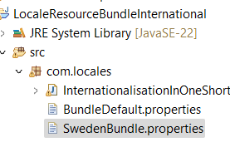

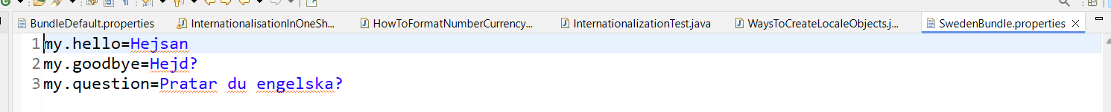

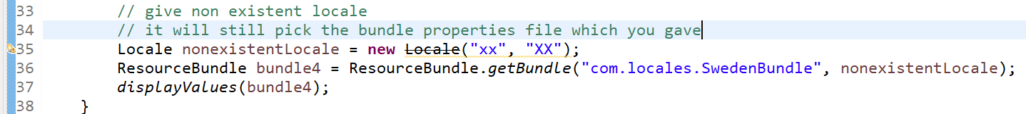

**Us bundle properties file—**

**Advantages of internationalisation–**

Now no need of different build and deployments as per regions.