Topic – locale part 2 🡪

**NumberFormats**

**NumberFormatsIsNull**

|  |
| --- |
| Exception in thread "main" java.lang.NullPointerException: Cannot invoke "java.text.NumberFormat.setCurrency(java.util.Currency)" because "chinaFormatDefault" is null  at com.locales.NumberFormatsIsNull.main(NumberFormatsIsNull.java:16) |

To solve null pointer exception –

Another way to solve null pointer –

Comment **line 25, 26.**

Add **line 28, 29, 30.**

**DateFormatWithoutFormatOption**

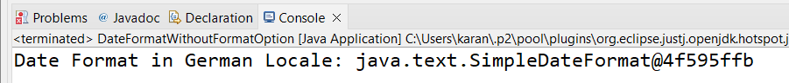

**WaysToCreateLocaleClass**

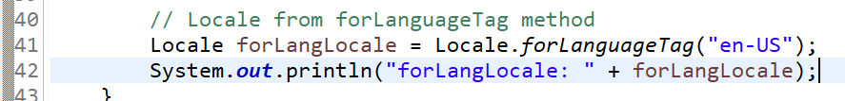

**Tried most of the methods of locale –**

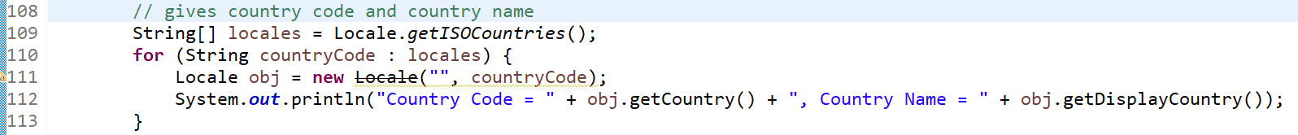

**Check all methods in iso countries—**

