**Hash map notes-**

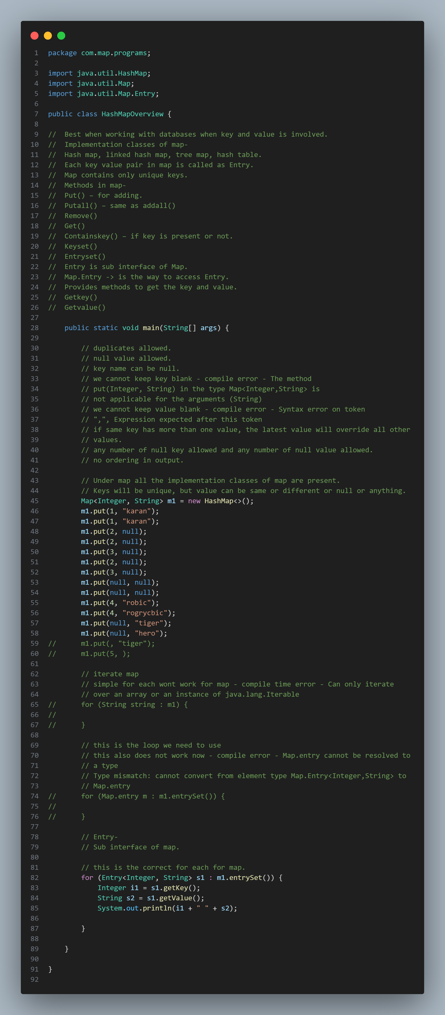

**See the error when we try to use for-each loop in maps-**

**But for tree map the custom class need not implement comparable interface on some value which can be sorted-**

Not mandatory to implement comparable interface-

Tree map:

Custom class used:

Output:

**For-each gives this error:**

**See how to use iterator in map-**



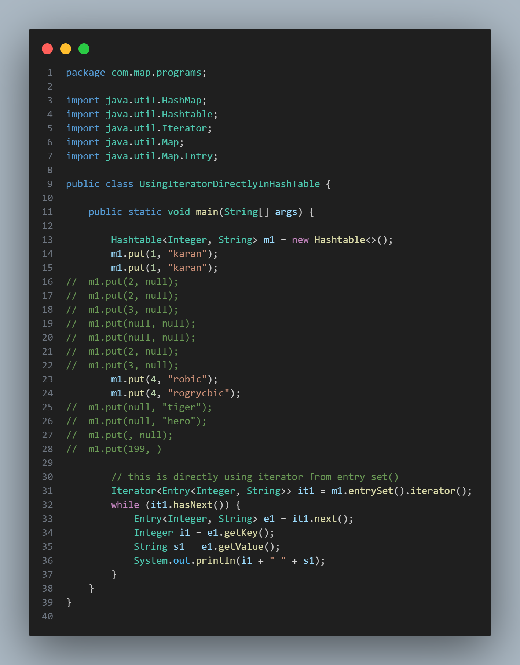

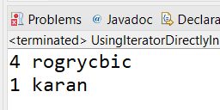



**What happens if we try to write it this way, which is a common mistake, we capture the value of hasnext() and then go inside loop-**

Same change for HashMap, hash table, link hash map, tree map.

