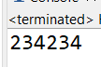



ocd

