Topic – java nio package part 2 🡪

**Create file using nio-**

Blank file created-

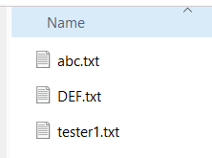

**Line 14 added-**



**Create directory using nio-**

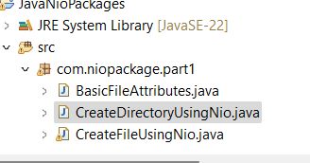

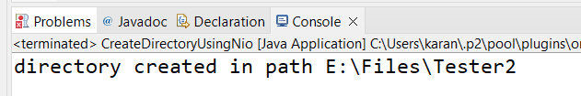

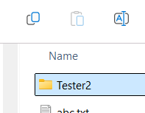

**Create sub directory using nio-**

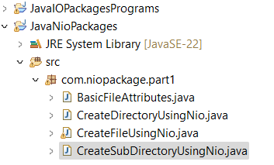

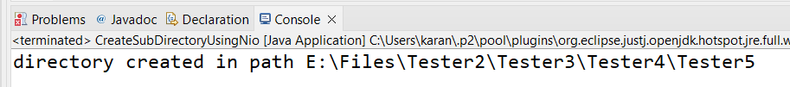

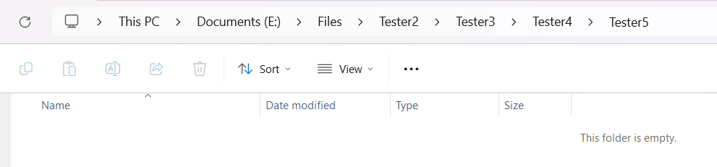

**When file does not exist –**

**Delete file using nio-**

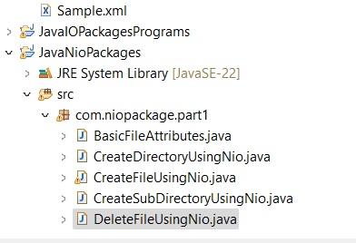

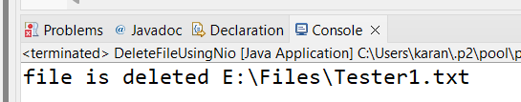

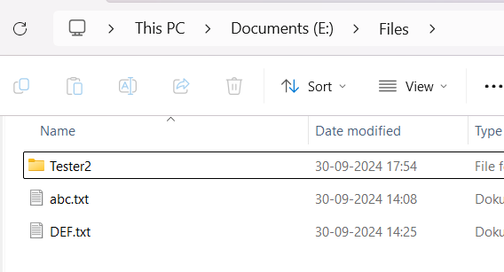

**When directory does not exist—**

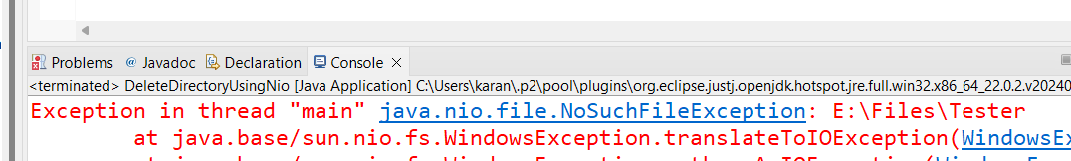

When you try to delete directory which is not empty-

**DeleteDirectoryUsingNio-**

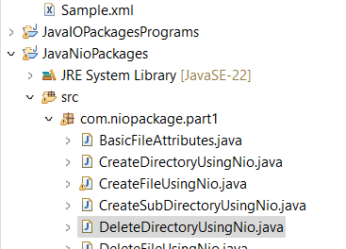

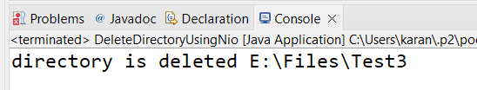

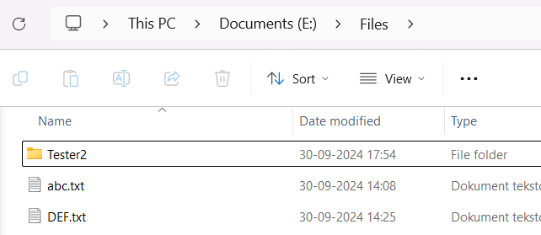

**Delete sub directories using nio-**



