Topic – java nio package part 4 🡪

**CheckAttributesOfFile-**

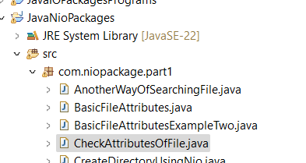

**LegacyFileSystemClubbedWithNio-**

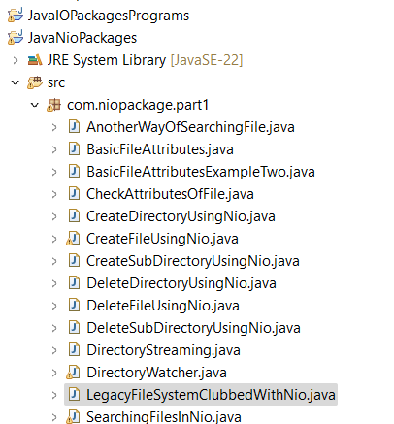

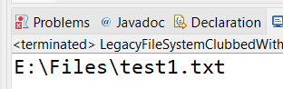

**ReadingFileClubbedLegacyWithNio-**

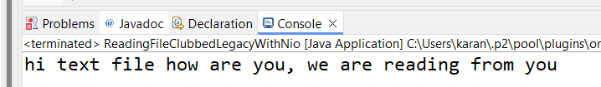

**How to go through documentation of anything new like charset etc –**

Type the word **charset -> hit control+spacebar.**

Read the description.

Press **control+click** and go into that method or class or interface.

We can see that **charset** is **abstract** and implementing **comparable** **interfaces.** We can similarly go through and check for all the other methods and their usages.

Another hint is **typing dot** and check the methods available:

And then manually check each and every method what they do, but it will be time consuming.

Second method is creating object of that class:

**“new charset” and press control+space.**

You read the documentation, and you will get more idea.

Finally, once you have rough idea get help from google, which is the fastest.