Topic – java nio package part 5 🡪

**AboutNioClassesAndUses-**

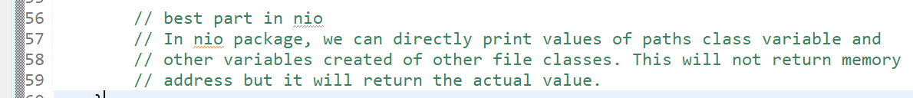

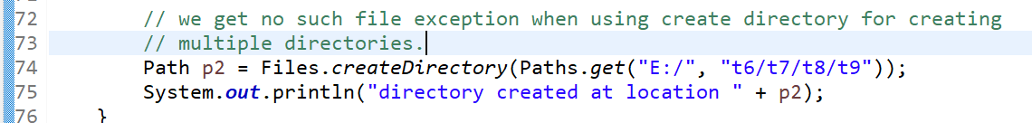

**BasicFileAttributesExampleThree-**

