**Vectors using iterator for traversal-**

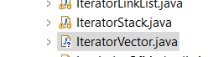

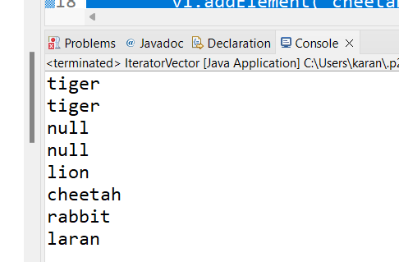

**Capacity method-**



Final code-

**When we try to access variable before declaring it-**

See the error:

**This is another way to declare collections –** **interface** name on left and **class name** on right. **Polymorphism** concept.

