DECENTRALIZED MEDICAL STOCK TRACKER
FOR RURAL CLINICS
A Web-Based Inventory Management, Patient Tracking, and Early-Warning System for Primary Health Centres (PHCs)
Minor Project Report
Submitted by
Pandya Naimish | : | 246270307081
Modwadiya Akshay | : | 246270307068
Pariya Adarsh | : | 246270307082
Ulva Bhavin | : | 246270307108
Under the Supervision of
Prof. V. D. Chavda (VDC)
Lecturer, Computer Engineering Department
A report submitted in partial fulfilment of the requirements for the Diploma in Computer Engineering
DIPLOMA ENGINEERING
in
COMPUTER ENGINEERING
Semester V
Government Polytechnic, Porbandar
 | 
Gujarat Technological University
Ahmedabad, Gujarat
Academic Year: 2026–2027

GOVERNMENT POLYTECHNIC,
PORBANDAR
OPP AIRPORT, NEAR NH-8B, PORBANDAR-360577
CERTIFICATE
This is to certify that the project entitled “Decentralized Medical Stock Tracker for Rural Clinics” has been successfully completed by the following students of the Department of Computer Engineering, Government Polytechnic, Porbandar, during the academic year 2026–2027:
1. Name of Student: Pandya Naimish Enrollment No.: 246270307081
2. Name of Student: Modwadiya Akshay Enrollment No.: 246270307068
3. Name of Student: Pariya Adarsh Enrollment No.: 246270307082
4. Name of Student: Ulva Bhavin Enrollment No.: 246270307108
The above project work has been carried out at Government Polytechnic, Porbandar, in partial fulfilment of the requirements for the award of the Diploma in Computer Engineering.
Prof. V. D. Chavda (VDC) | Mr. K. U. Thanki
Internal Guide  Lecturer, Computer Engg. Dept. | Head of the Department  Computer Engineering Department

GOVERNMENT POLYTECHNIC,
PORBANDAR
OPP AIRPORT, NEAR NH-8B, PORBANDAR-360577
DECLARATION
We hereby declare that the Project report submitted along with the Minor Project entitled “Decentralized Medical Stock Tracker for Rural Clinics” submitted in partial fulfilment of the requirements for the award of the Diploma in Computer Engineering to Gujarat Technological University, Ahmedabad, is a bonafide record of original project work carried out by us at Government Polytechnic, Porbandar under the supervision of Prof. V. D. Chavda (VDC), Lecturer in Computer Engineering, and that no part of this report has been directly copied from any students’ reports or taken from any other source, without providing due reference.
Enrollment No. | Name of Student | Signature
246270307081 | Pandya Naimish | __________________
246270307068 | Modwadiya Akshay | __________________
246270307082 | Pariya Adarsh | __________________
246270307108 | Ulva Bhavin | __________________

COURSE OUTCOMES (COS)
The practical exercises, the underpinning knowledge and the relevant soft skills associated with the identified competency are to be developed in the student for the achievement of the following COs:
o CO1- Review the existing literature/system to identify problems in the current system.
o CO2- Select the most appropriate solution to the defined problem, considering budget and design methodology to achieve the final outcome.
o CO3- Initiate project development by procuring components/data, assembling or implementing the system, and conducting testing.
o CO4- Modify project components or redesign, if required, based on testing results and performance evaluation.
o CO5- Defend the final review with the developed hardware/software/application, along with report writing and presentation individually and as a team.

ACKNOWLEDGEMENT
We would like to express our sincere gratitude to everyone who supported us in the successful completion of our minor project, “Decentralized Medical Stock Tracker for Rural Clinics”.
First and foremost, we are deeply thankful to our project guide, Prof. V. D. Chavda (VDC), Lecturer in Computer Engineering Department, for the valuable guidance, constant encouragement, and constructive feedback throughout this project. His technical insights and patience helped us overcome many challenges and shaped this work.
We extend our heartfelt thanks to Mr. K. U. Thanki, Head of the Department of Computer Engineering, for providing the necessary facilities, computing laboratories, and a supportive environment, and for the encouragement given during the course of this project.
We sincerely thank our project coordinator, Mr. C. V. Nathwani, for effectively managing and coordinating the minor project course, for timely instructions, and for ensuring that all activities ran smoothly from start to finish.
We are also grateful to our Principal, Mr. R. N. Modha, for providing us the opportunity and institutional resources needed to carry out this work.
We also thank all the faculty members and laboratory staff of the department for their cooperation and assistance. Finally, we thank our families and friends for their continuous support, motivation, and belief in us.
Team Members:
1. Pandya Naimish – 246270307081 2. Modwadiya Akshay – 246270307068
3. Pariya Adarsh – 246270307082 4. Ulva Bhavin – 246270307108
TEAM RESPONSIBILITIES & CONTRIBUTIONS
Individual Team Member Technical Contributions
Member Name & Enr. | Core Functional Domain | Key Deliverables & Responsibilities
Pandya Naimish  (246270307081) | Backend Development & System Security | • Engineered secure multi-role login with bcrypt hashing.  • Implemented strict server-side RBAC session guards.  • Implemented MySQLi object-oriented prepared statements.  • Fixed session hijacking, inactive-account bypass, and PRG token bugs.  • Built automated regression test suites in Python.
Modwadiya Akshay  (246270307068) | Frontend Design & UI/UX Engineering | • Developed responsive HTML5, CSS3, and JavaScript interfaces.  • Implemented Bootstrap 5 grid layout and dark/light theme toggle.  • Designed role-specific dashboard templates and KPI widgets.  • Resolved responsive table button overflow and flexbox clipping.  • Conducted cross-browser and mobile device compatibility testing.
Ulva Bhavin  (246270307108) | Database Design & Relational Architecture | • Architected 15 normalized MySQL relational tables (3NF).  • Designed master ER diagram and split modular schemas.  • Defined primary/foreign key cascades and indexes.  • Managed database schemas for clinic, district, and stock tables.  • Formulated SQL queries for low-stock and near-expiry alerts.
Pariya Adarsh  (246270307082) | Documentation & System Modeling | • Authored Software Requirements Specification (SRS).  • Mapped Level 0 Context DFD and 8 Level 1 process flows.  • Designed Use Case models and mapped 12 Data Stores (D1–D12).  • Documented technical specifications and flowchart logic.  • Prepared presentation materials and project documentation.

ABSTRACT
Rural Primary Health Centres (PHCs) serve as the fundamental backbone of India's public healthcare infrastructure, providing essential clinical consultations and free life-saving pharmaceutical supplies to underserved rural communities. However, existing inventory management practices in the vast majority of rural PHCs remain overwhelmingly dependent on manual physical paper registers. This conventional approach suffers from critical systemic vulnerabilities: accurate stock levels are opaque, medicine expiration dates go unnoticed leading to hazardous dispensing or tragic waste, emergency requisitions face administrative delays, and district medical authorities lack aggregate real-time visibility into local supply shortages.
To decisively overcome these operational bottlenecks, this project presents the “Decentralized Medical Stock Tracker for Rural Clinics”, a lightweight, auditable, and resilient web-based inventory and medicine dispensing platform engineered using PHP 8.x, MySQL relational database, Apache (XAMPP), Bootstrap 5, and JavaScript. The system introduces a strictly partitioned 3-tier Role-Based Access Control (RBAC) architecture comprising System Administrators, District Administrators, and PHC Clinic Staff. The architecture is 100% server-side driven: PHP securely processes all business rules, prepared statements, and database credentials on the Apache server, ensuring the client browser never directly interacts with or exposes database credentials. PHC Staff seamlessly log batch-specific medicine stock receipts with manufacturer expiry dates, record patient clinical consultations, and track individual medicine issuances with atomic database inventory deductions. The platform features an automated early-warning alert engine that continuously evaluates live stock balances against critical safety thresholds (< 50 units) and flags drugs nearing expiration within 30 to 90 days.
The software was subjected to rigorous validation across 77 automated test cases spanning authentication security, role isolation, transaction integrity, alert accuracy, and database relational constraints, achieving an overall 100% test pass rate. By decentralizing everyday clinic operations while centralizing administrative oversight and supply logistics, the developed system guarantees stock transparency, eradicates stockout blind spots, prevents expired drug consumption, and substantially elevates healthcare delivery quality across rural primary health networks.
Table of Contents
Document Navigation Outline
Sr. No. | Content | Page No
1 | Introduction | 1
 | 1.1 Project Overview | 1
 | 1.2 Problem Statement | 2
 | 1.3 Objectives | 2
 | 1.4 Scope of the Project | 3
 | 1.5 Organization of the Report | 3
2 | Literature Survey and Requirement Analysis | 4
 | 2.1 Existing System | 4
 | 2.2 Proposed System | 5
 | 2.3 Feasibility Study | 5
 | 2.4 Hardware and Software Requirements | 6
 | 2.5 Functional and Non-Functional Requirements | 7
3 | System Design | 9
 | 3.1 System Architecture | 9
 | 3.2 Data Flow Diagrams (DFD) | 11
 | 3.3 ER Diagram | 13
 | 3.4 Use Case Diagram | 14
 | 3.5 Database Design / Data Dictionary (15 Relational Tables) | 15
4 | Implementation | 20
 | 4.1 Module Description | 20
 | 4.2 Sample Code & Architectural Patterns | 22
 | 4.3 Screenshots & User Interface Demonstrations | 25
5 | Testing & Debugging | 29
 | 5.1 Testing Methods | 29
 | 5.2 Test Cases & Execution Results | 30
 | 5.3 Bugs Discovered & Technical Solutions | 32
6 | Conclusion and Future Scope | 34
 | 6.1 Conclusion | 34
 | 6.2 Limitations | 35
 | 6.3 Future Enhancements | 35
 | References / Bibliography | 36

LIST OF FIGURES
Index of Document Figures
Figure No. | Figure Caption / Description | Page No
Figure 3.1 | 3-Tier System Architecture Diagram | 9
Figure 3.2 | Complete End-to-End System Flowchart | 10
Figure 3.3 | Level 0 Context Data Flow Diagram & Sub-Processes | 12
Figure 3.4 | Level 1 DFD: Module 1.0 (Authentication & Roles) | 13
Figure 3.5 | Level 1 DFD: Module 2.0 (PHC & Staff Management) | 13
Figure 3.6 | Level 1 DFD: Module 3.0 (Inventory & Medicine Master) | 14
Figure 3.7 | Level 1 DFD: Module 4.0 (Patient & Visit Management) | 14
Figure 3.8 | Level 1 DFD: Module 5.0 (Medicine Issue Operations) | 15
Figure 3.9 | Level 1 DFD: Module 6.0 (Medicine Requests & Indents) | 15
Figure 3.10 | Level 1 DFD: Module 7.0 (PHC Creation Workflow) | 16
Figure 3.11 | Level 1 DFD: Module 8.0 (Reports & Monitoring) | 16
Figure 3.12 | Master Entity-Relationship (ER) Diagram | 17
Figure 3.13 | Use Case Diagram for System Roles | 18
Figure 4.1 | Secure Multi-Role Authentication & Session Guard Workflow | 29
Figure 4.2 | PHC Clinic Staff Real-Time Dashboard | 30
Figure 4.3 | District Admin Central Inventory Monitoring Dashboard | 30
Figure 4.4 | Medicine Dispensing & Atomic Stock Deduction Interface | 31
Figure 4.5 | Medicine Stock-In Batch Receipt & Expiry Recording Form | 31
Figure 4.6 | System Admin PHC Document Proposals Review Interface | 32
Figure 4.7 | District Admin Medicine Indent Requisition Review Screen | 32

LIST OF TABLES
Index of Document Tables
Table No. | Table Caption / Description | Page No
Table 2.1 | Minimum Hardware Specifications | 6
Table 2.2 | Software Environment & Technology Stack | 6
Table 3.1 | Database Schema: system_admin | 15
Table 3.2 | Database Schema: district_admin | 15
Table 3.3 | Database Schema: phcs | 16
Table 3.4 | Database Schema: phc_creation_requests | 16
Table 3.5 | Database Schema: staff | 16
Table 3.6 | Database Schema: doctors | 17
Table 3.7 | Database Schema: medicines | 17
Table 3.8 | Database Schema: inventory | 17
Table 3.9 | Database Schema: stock_in | 18
Table 3.10 | Database Schema: district_inventory | 18
Table 3.11 | Database Schema: district_stock_in | 18
Table 3.12 | Database Schema: patients | 19
Table 3.13 | Database Schema: patient_visits | 19
Table 3.14 | Database Schema: visit_medicines | 19
Table 3.15 | Database Schema: medicine_requests | 20
Table 5.1 | Automated Test Suite Summary & Pass Rate | 30
Table 5.2 | Representative Test Cases Specification | 31
Table 5.3 | Bugs Discovered & Resolved During Development | 33

1. INTRODUCTION
1.1 PROJECT OVERVIEW
In the Indian public healthcare delivery system, Primary Health Centres (PHCs) and Community Health Centres (CHCs) constitute the critical first point of contact between rural populations and medical professionals. In states like Gujarat, rural clinics cater to millions of citizens across diverse geographical topographies, providing free maternal care, disease immunization, outpatient diagnosis, and critical emergency medicine supply.
A reliable supply of quality pharmaceuticals is the lifeblood of primary clinical care. However, the logistical management of medicine stock within rural dispensaries has historically remained manual, opaque, and decentralized without digital cohesion. Clinic pharmacists rely heavily on handwritten paper logbooks, physical index cards, and verbal communication during quarterly distribution cycles. This fragmentation creates severe blind spots for District Health Offices, resulting in localized medicine shortages, unintended expirations of vital drugs, and zero real-time auditability of patient prescriptions.
The “Decentralized Medical Stock Tracker for Rural Clinics” is an integrated, role-governed web application designed to eliminate these vulnerabilities. By digitizing medicine stock-in batches, automating dispensing records linked to patient visits, and providing dual automated threshold warnings for low inventory and near-expiry batches, the system establishes end-to-end accountability and logistical responsiveness across rural primary healthcare networks.
1.2 PROBLEM STATEMENT
Primary Health Centres operating across rural areas encounter severe operational challenges arising from outdated inventory workflows:
• Manual Ledger Overhead: Health workers spend excessive clinical consultation time manually transcribing stock-in shipments, batch numbers, and daily patient issues into voluminous physical registers.
• Untracked Medicine Expirations: Pharmaceutical batches sit unnoticed in dispensary shelves past their expiration date. Without computerized alert mechanisms, expired drugs risk accidental administration or must be discarded at total financial loss.
• Critical Stockouts & Stock Hoarding: Districts experience severe supply imbalances where one PHC suffers acute shortages of vital antibiotics or antivenoms while an adjacent clinic holds surplus stock nearing expiration.
• Absence of Patient Traceability: Physical records make it nearly impossible to audit medicine issue patterns, verify whether patients received prescribed quantities, or analyze epidemiological trends across villages.
• Administrative Requisition Delays: Indent requests for stock replenishment travel via slow paper channels, preventing district medical officers from approving and dispatching supplies in a timely manner.
1.3 OBJECTIVES
The core objectives of the Decentralized Medical Stock Tracker project are systematically defined as follows:
• 1. Role-Based Access Control: Establish secure, authenticated portals with dedicated interfaces for System Administrators, District Administrators, and PHC Clinic Staff.
• 2. Batch & Expiry Tracking: Capture batch numbers, manufacturing/expiry dates, unit pack sizes, and supplier details upon physical receipt of medicines (Stock In).
• 3. Atomic Patient Dispensing: Record patient demographic visits and execute atomic inventory balance reductions when medicines are prescribed and dispensed, preventing negative stock anomalies.
• 4. Automated Early-Warning Alerts: Calculate real-time stock balances dynamically to generate instant visual alerts for critically low stock (< 50 units) and medicines nearing expiry within 30 to 90 days.
• 5. Streamlined Inter-Clinic Requisitions: Enable clinic staff to initiate electronic replenishment requests to the District Administrator, supporting status tracking through pending, approved, and rejected states.
• 6. Transaction Reliability: Implement web architecture patterns (such as Post/Redirect/Get) that eliminate duplicate form submissions and ensure high data integrity even across unstable rural broadband connections.
1.4 SCOPE OF THE PROJECT
The functional scope of the application encompasses:
• System Administration Scope: Centralized platform configuration, district administrative onboarding, master medicine catalog creation with standard packaging metrics, and PHC directory maintenance.
• District Administration Scope: District-level surveillance of all affiliated PHCs, monitoring aggregate stock availability, reviewing and adjudicating electronic medicine requisitions, and forwarding new clinic creation proposals.
• PHC Clinic Staff Scope: Frontline clinic operations including patient registration, medical visit logging, multi-item medicine dispensing, batch stock-in entry, and localized inventory audits.
Out of Scope: Direct online medicine ordering by individual citizens, online financial payment gateways, direct automated warehouse robotics integration, and multi-state inter-governmental logistics.
1.5 ORGANIZATION OF THE REPORT
This project report is organized into six cohesive chapters structured as follows:
• Chapter 1 - Introduction: Presents the background context, problem statement, core objectives, project scope, and overall document structure.
• Chapter 2 - Literature Survey and Requirement Analysis: Analyzes existing manual systems, details the proposed system advantages, provides a complete feasibility study, and outlines hardware, software, functional, and non-functional requirements.
• Chapter 3 - System Design: Elaborates the multi-tier system architecture, complete system flowchart, Level 0 and Level 1 Data Flow Diagrams (DFD), Entity-Relationship (ER) model, Use Case interactions, and exhaustive Data Dictionary tables for all 15 database tables.
• Chapter 4 - Implementation: Details module-by-module implementation, core algorithmic code listings (including the Post/Redirect/Get pattern, atomic dispensing logic, and MySQLi prepared statements), and annotated user interface screenshots.
• Chapter 5 - Testing & Debugging: Covers testing methodologies, automated Python verification suites (77 tests passed), and a detailed breakdown of real bugs discovered and resolved during development.
• Chapter 6 - Conclusion and Future Scope: Summarizes project achievements, acknowledges current operational limitations, and provides a forward-looking roadmap for future enhancements.

2. LITERATURE SURVEY AND REQUIREMENT ANALYSIS
2.1 EXISTING SYSTEM
In the conventional rural primary healthcare model, medical stock accounting relies entirely upon paper record-keeping. Upon receiving medicinal consignments from central medical stores, clinic pharmacists manually log entries into physical ledgers known as Day Books and Stock Registers. When a doctor writes a prescription, the pharmacist retrieves the drug, notes the dispensed quantity in a patient register, and periodically attempts to calculate remaining stock balances by hand.
Critical vulnerabilities inherent in this existing workflow include:
• Vulnerability to Physical Damage: Paper logbooks in rural clinics are prone to moisture, insect degradation, physical tearing, and accidental misplacement, permanently destroying vital medical audit trails.
• Zero Proactive Stock Notifications: Pharmacists must physically inspect each medicine shelf and box to discover expired drugs or depleted stock. Often, stockouts are only recognized during an active emergency consultation.
• Manual Math Discrepancies: Human calculation errors during daily subtraction lead to discrepancies between physical shelf counts and register figures, opening possibilities for undetected leakage or pilferage.
• Delayed Administrative Oversight: District medical officers only receive stock reports during monthly physical meetings, resulting in weeks of delay in identifying and replenishing depleted clinic stores.
2.2 PROPOSED SYSTEM
The proposed Decentralized Medical Stock Tracker transitions rural clinics from error-prone physical ledgers to a responsive, networked web application. The platform maintains accurate real-time inventory counts by programmatically coupling medicine dispensing directly with patient clinical visits.
Key innovations delivered by the proposed system include:
• Real-Time Inventory Computation: Stock balances update automatically upon every stock-in receipt and medicine issue transaction, guaranteeing absolute consistency.
• Automated Visual Warnings: High-visibility dashboard alerts flag low stock (< 50 units) and near-expiry medicines (within 30/90 days), allowing pharmacists to rotate stock or initiate indents well in advance.
• Digital Requisition Pipeline: PHC staff create electronic supply requests with a single click; District Admins review, approve, or reject indents with instant transparency.
• Duplicate Submission Immunity: Integration of Post/Redirect/Get (PRG) transaction handling prevents accidental duplication of patient visits or stock issues caused by browser reloads.
• Centralized Auditing & Role Segregation: Strict separation of duties ensures staff only operate within their assigned clinic, while District and System Admins maintain high-level supervision.
2.3 FEASIBILITY STUDY
Prior to software engineering, a multi-dimensional feasibility study was executed to evaluate the operational viability of deploying the solution within typical rural healthcare environments:
2.3.1 Technical Feasibility
The solution is developed using PHP 8.x, MySQL relational database, Apache HTTP Server, HTML5, CSS3, and JavaScript. This technology stack is exceptionally mature, lightweight, and capable of running smoothly on low-power desktop computers or refurbished laptops commonly found in rural clinics. The application does not require specialized server hardware, GPU acceleration, or proprietary runtime licenses, rendering it 100% technically feasible.
2.3.2 Operational Feasibility
Rural clinic healthcare workers possess varying levels of digital literacy. Consequently, the user interface was designed with an emphasis on minimalism, large intuitive touch-friendly buttons, clear Gujarati/English textual prompts, and streamlined three-step forms. Frontline staff require less than thirty minutes of orientation to master patient registration, stock-in entry, and medicine issuing, ensuring high operational feasibility and enthusiastic adoption.
2.3.3 Economic Feasibility
The entire software stack is constructed purely from open-source technologies (PHP, MariaDB/MySQL, Apache, Bootstrap, and Python for automated testing). There are zero recurring software licensing fees, database subscription charges, or per-user access penalties. The system dramatically cuts costs by preventing medicine expiry wastage and eliminating physical stationery expenses, proving overwhelmingly economically feasible.
2.4 SOFTWARE REQUIREMENTS
The following hardware and software specifications represent the standard operational environment for the application:
Table 2.1: Software Environment & Technology Stack
Category | Technology / Software Utilized | Version / Specifications
Operating System | Microsoft Windows 10/11 or Linux Ubuntu 22.04 LTS | 64-bit OS Architecture
Web Server | Apache HTTP Server (via XAMPP Suite) | Version 2.4.x
Server-Side Scripting | PHP (Hypertext Preprocessor) | Version 8.1.x / 8.2.x
Database Engine | MySQL / MariaDB Relational Database Server | Version 10.4.x / 8.0.x
Database Driver | MySQLi Object-Oriented with Prepared Statements | PHP Native MySQLi Extension
Frontend UI Framework | HTML5, CSS3, JavaScript (ES6+), Bootstrap | Bootstrap Version 5.3
Data Visualization | Chart.js with dynamic AJAX polling | Version 4.x
Automated Test Runner | Python Testing Framework (requests, pymysql, docx) | Python Version 3.12+
Development Tools | VS Code, phpMyAdmin, Git, XAMPP Control Panel | Latest Stable Releases

2.5 FUNCTIONAL AND NON-FUNCTIONAL REQUIREMENTS
2.5.1 Functional Requirements
• FR-01: Multi-Role Authentication: The system shall authenticate users against hashed credentials and route users dynamically to System Admin, District Admin, or PHC Staff dashboards.
• FR-02: PHC Clinic Directory Management: System Admins shall register, inspect, and update Primary Health Centres associated with specific geographic districts.
• FR-03: Centralized Medicine Master: System Admins shall maintain the central medicine formulary including drug generic name, category, package count, and pricing.
• FR-04: Batch-Wise Stock Receipt (Stock In): PHC Staff shall record inbound shipments specifying medicine ID, batch number, received quantity, and manufacturer expiration date.
• FR-05: Patient Registration & Visit Tracking: PHC Staff shall register new patients (Name, Age, Gender, Mobile, Address) and log clinical visit events with attending doctors.
• FR-06: Atomic Medicine Dispensing: Staff shall issue medicines against a patient visit; the system must deduct the exact quantity from active inventory atomically.
• FR-07: Early Warning Inventory Alerts: The system shall automatically generate visual alerts whenever a medicine's stock falls below 50 units or expires within 30 to 90 days.
• FR-08: Electronic Indent Requisition: PHC Staff shall generate medicine replenishment requests; District Admins shall review and mark requests Approved or Rejected.
2.5.2 Non-Functional Requirements
• NFR-01: Performance & Response Time: Page rendering and transaction processing shall execute in less than 1.5 seconds under standard rural 4G broadband.
• NFR-02: Security & Session Isolation: Role privileges shall be enforced server-side on every PHP script execution, instantly redirecting unauthorized session attempts.
• NFR-03: Data Integrity & ACID Compliance: Multi-table dispensing operations shall use database transaction locks to guarantee zero partial writes or negative balances.
• NFR-04: Usability & Accessibility: Forms shall feature responsive layout adaptation, clear validation feedback, and high-contrast alert badges for effortless readability.
• NFR-05: Fault Tolerance (PRG Pattern): Browser page refreshes following POST operations must never trigger duplicate database record insertions.

3. SYSTEM DESIGN
3.1 SYSTEM ARCHITECTURE
The Decentralized Medical Stock Tracker is architected upon a classical 3-Tier Client-Server structural paradigm, ensuring strict separation between client presentation, server-side business logic, and persistent relational data storage:
• Presentation Tier (Client): Composed of responsive HTML5, CSS3, JavaScript (ES6+), and Bootstrap 5 executing inside the user's web browser. It displays role-specific dashboard views, interactive data tables, and client-side form validation. The client never communicates directly with the MySQL database.
• Application Logic Tier (Server-Side Backend): Powered by PHP 8.x executing on the Apache HTTP Server. This server layer securely encapsulates all business logic, session validation, authentication checks, alert calculations, and SQL query executions via MySQLi prepared statements. Database credentials are encrypted and stored exclusively on the server.
• Data Persistence Tier (Relational Database): A normalized MariaDB/MySQL relational database managing 15 core tables. Guarantees referential integrity, foreign key cascading, and ACID compliance across all inventory modifications.
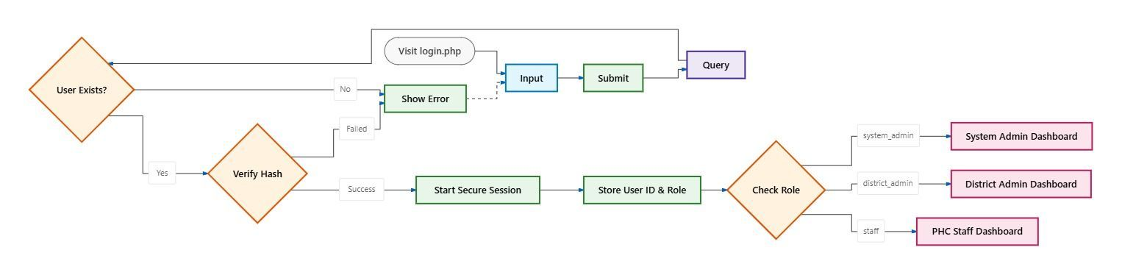
Figure 3.1: 3-Tier System Architecture Diagram (Presentation, Server Logic, Database)
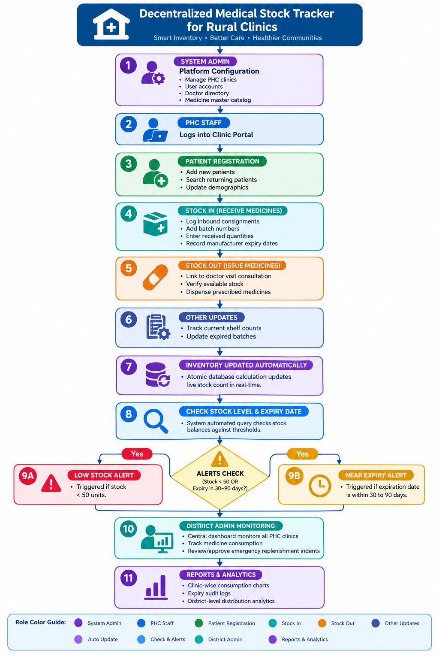
Figure 3.2 illustrates the complete end-to-end operational flowchart of the application, mapping how data originates at patient registration and stock arrival, flows through automated inventory adjustment, triggers low-stock and near-expiry alerts, and synthesizes into executive district reports:
Figure 3.2: Complete End-to-End System Flowchart
3.2 DATA FLOW DIAGRAMS (DFD)
Data Flow Diagrams graphically map the movement of data through the system, identifying external entities, processing nodes, and persistent data repositories.
3.2.1 Level 0 DFD (Context Analysis Diagram)
The Level 0 context diagram abstracts the entire Medical Stock Tracker as a singular central process interacting with three primary external entities: System Administrator, District Administrator, and PHC Clinic Staff.
Figure 3.3: Level 0 Context Data Flow Diagram & Sub-Processes
3.2.2 Level 1 DFD (8 Core Processes & 12 Data Stores)
As documented by Pariya Adarsh, the system decomposes into eight core functional processes and twelve discrete data stores:
• Process 1.0 - Authentication & Role Management: Validates incoming user credentials against `system_admin`, `district_admin`, and `staff` stores; initializes role session tokens.
• Process 2.0 - District Admin & PHC Management: Handles administrative onboarding, clinic assignment, and staff account management (Process 2.1).
• Process 3.0 - Medicine & Inventory Management: Governs the master drug catalog and inbound stock receipts (Process 3.1 Process Stock In).
• Process 4.0 - Patient & Visit Management: Manages patient demographic records (Process 4.0) and clinical OPD doctor consultations (Process 4.1).
• Process 5.0 - Medicine Issue Operations: Executes real-time medicine dispensing against visit records and verifies inventory balances.
• Process 6.0 -. Medicine Requests / Indents: Facilitates electronic supply requisition between clinic staff and district administrators
• Process 7.0 - PHC Creation Workflow: Submits district proposals and processes System Admin approval and facility activation (Process 7.1).
• Process 8.0 - Reports & Monitoring: Aggregates inventory, expiration, and patient dispensing logs into Chart.js dashboards.
Figures 3.4 through 3.11 illustrate the decomposed Level 1 Data Flow Diagrams for all eight core functional modules, documenting the specific transactional inputs, transformation algorithms, persistent data store interactions, and output data streams:
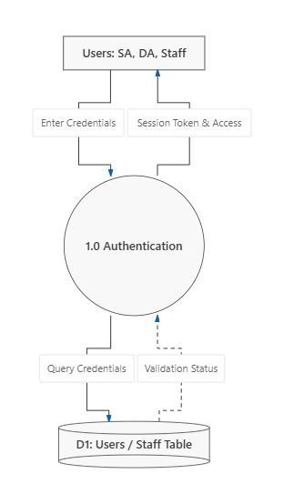 | 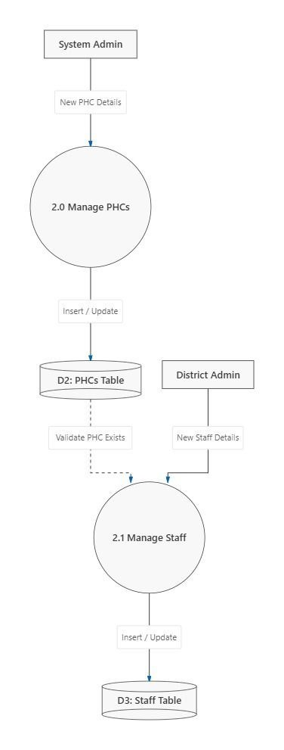
Figure 3.4: Level 1 DFD: Module 1.0 (Authentication & Roles) | Figure 3.5: Level 1 DFD: Module 2.0 (PHC & Staff Management)
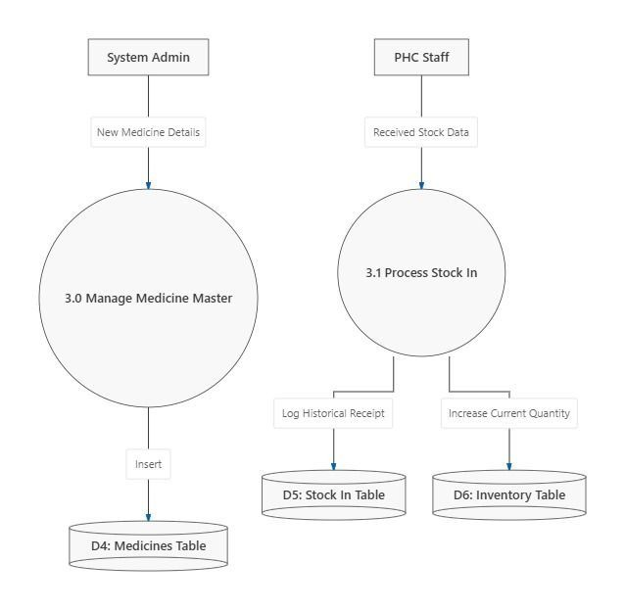 | 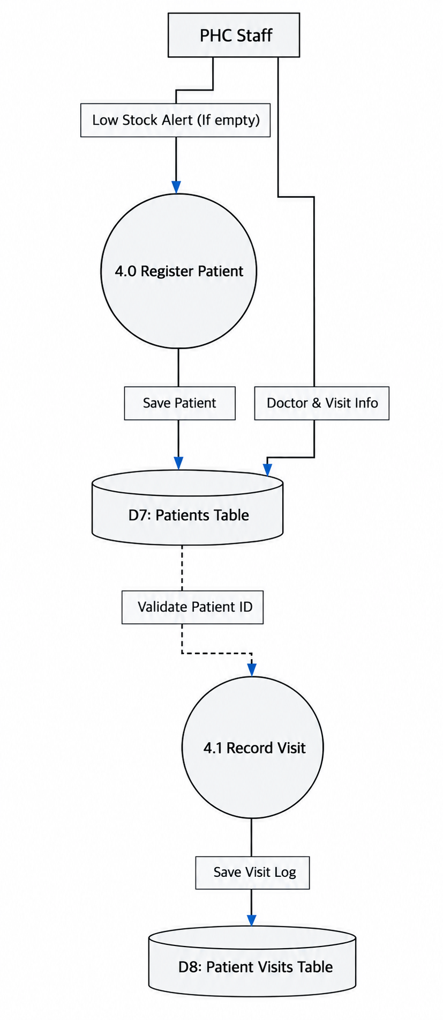
Figure 3.6: Level 1 DFD: Module 3.0 (Inventory & Medicine Master) | Figure 3.7: Level 1 DFD: Module 4.0 (Patient & Visit Management)
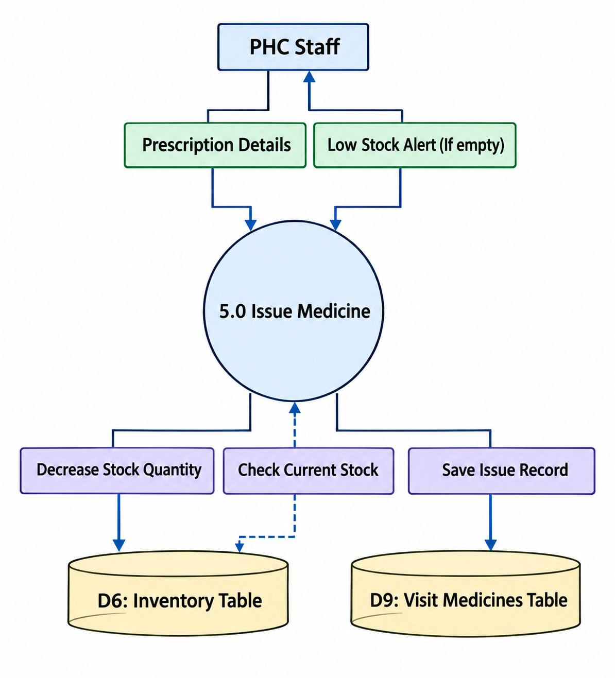 | 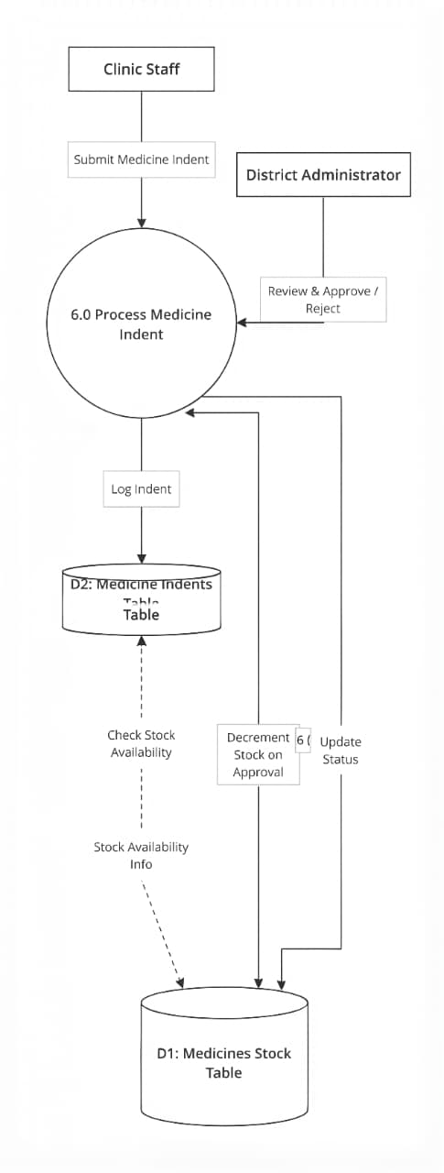
Figure 3.8: Level 1 DFD: Module 5.0 (Medicineissue ) | Figure 3.9: Level 1 DFD: Module 6.0 (Medicine Requests & Indents)
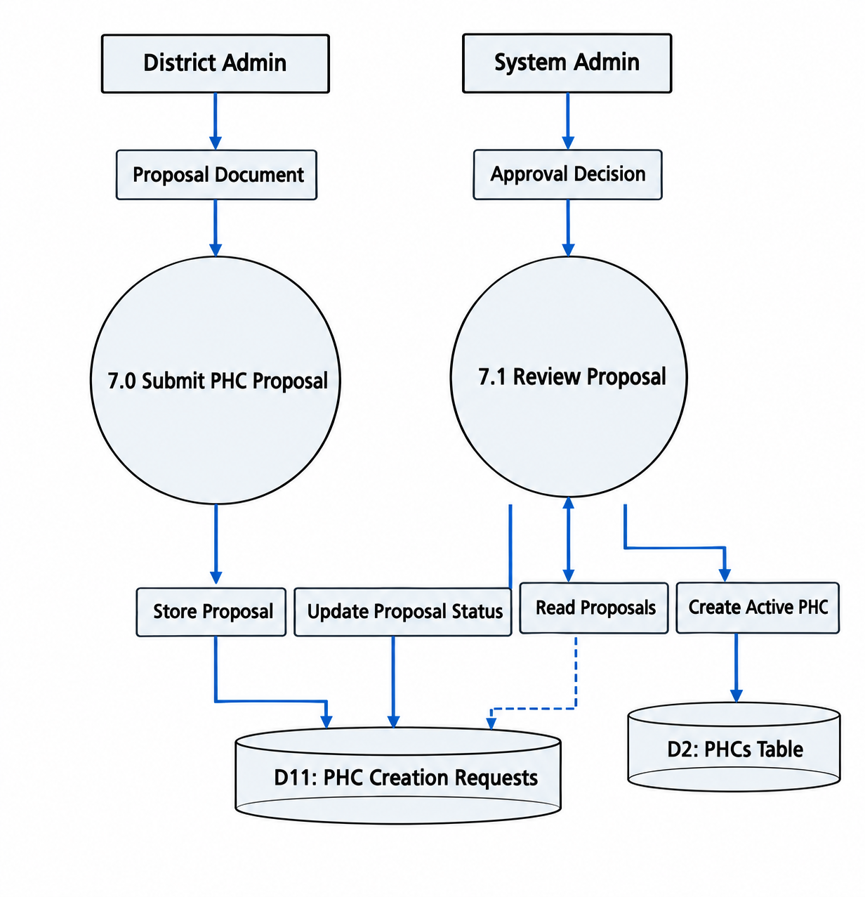 | 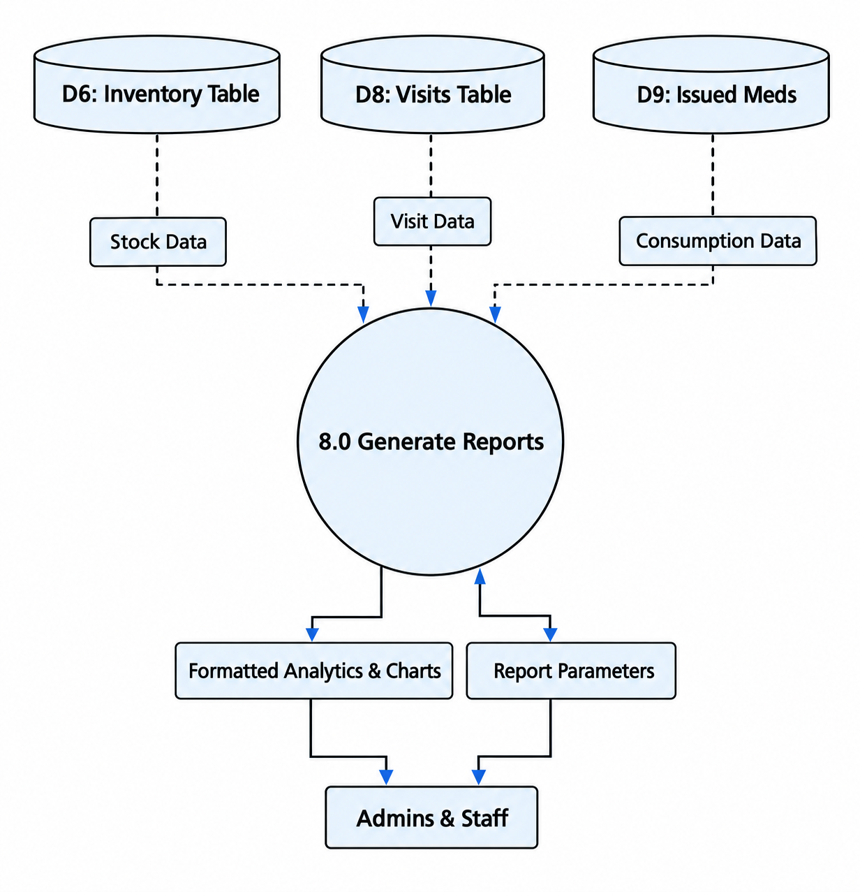
Figure 3.10: Level 1 DFD: Module 7.0 (PHC Creation Workflow) | Figure 3.11: Level 1 DFD: Module 8.0 (Reports & Monitoring)

3.3 ER DIAGRAM
The Entity-Relationship (ER) model formalizes the conceptual data structure of the application. The schema is normalized to Third Normal Form (3NF) by Ulva Bhavin to eliminate data redundancy and preserve relational integrity across all clinics.
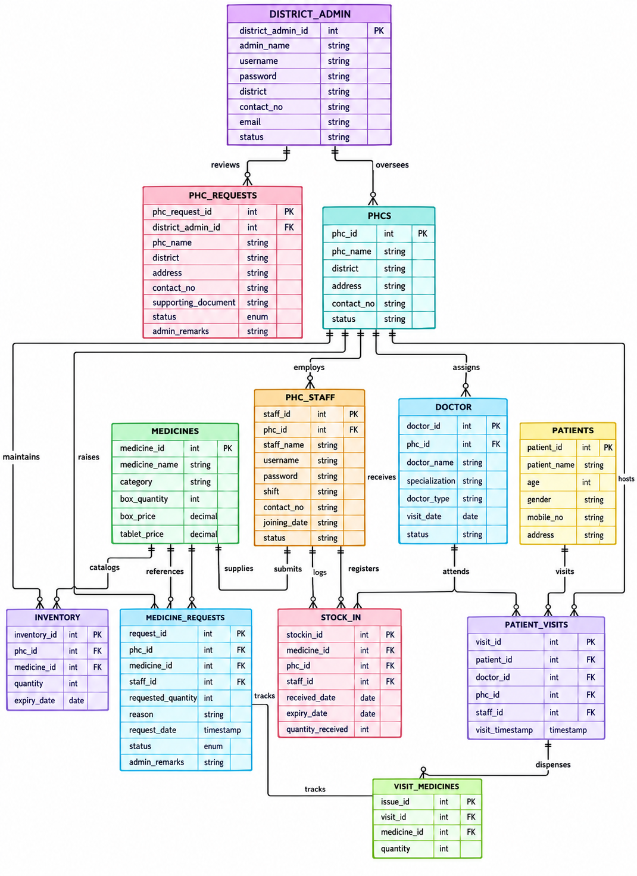
Figure 3.12: Master Entity-Relationship (ER) Diagram

3.4 USE CASE DIAGRAM
The Use Case diagram specifies the system boundaries and the direct behavioral interactions between the three system actors and their respective application services.
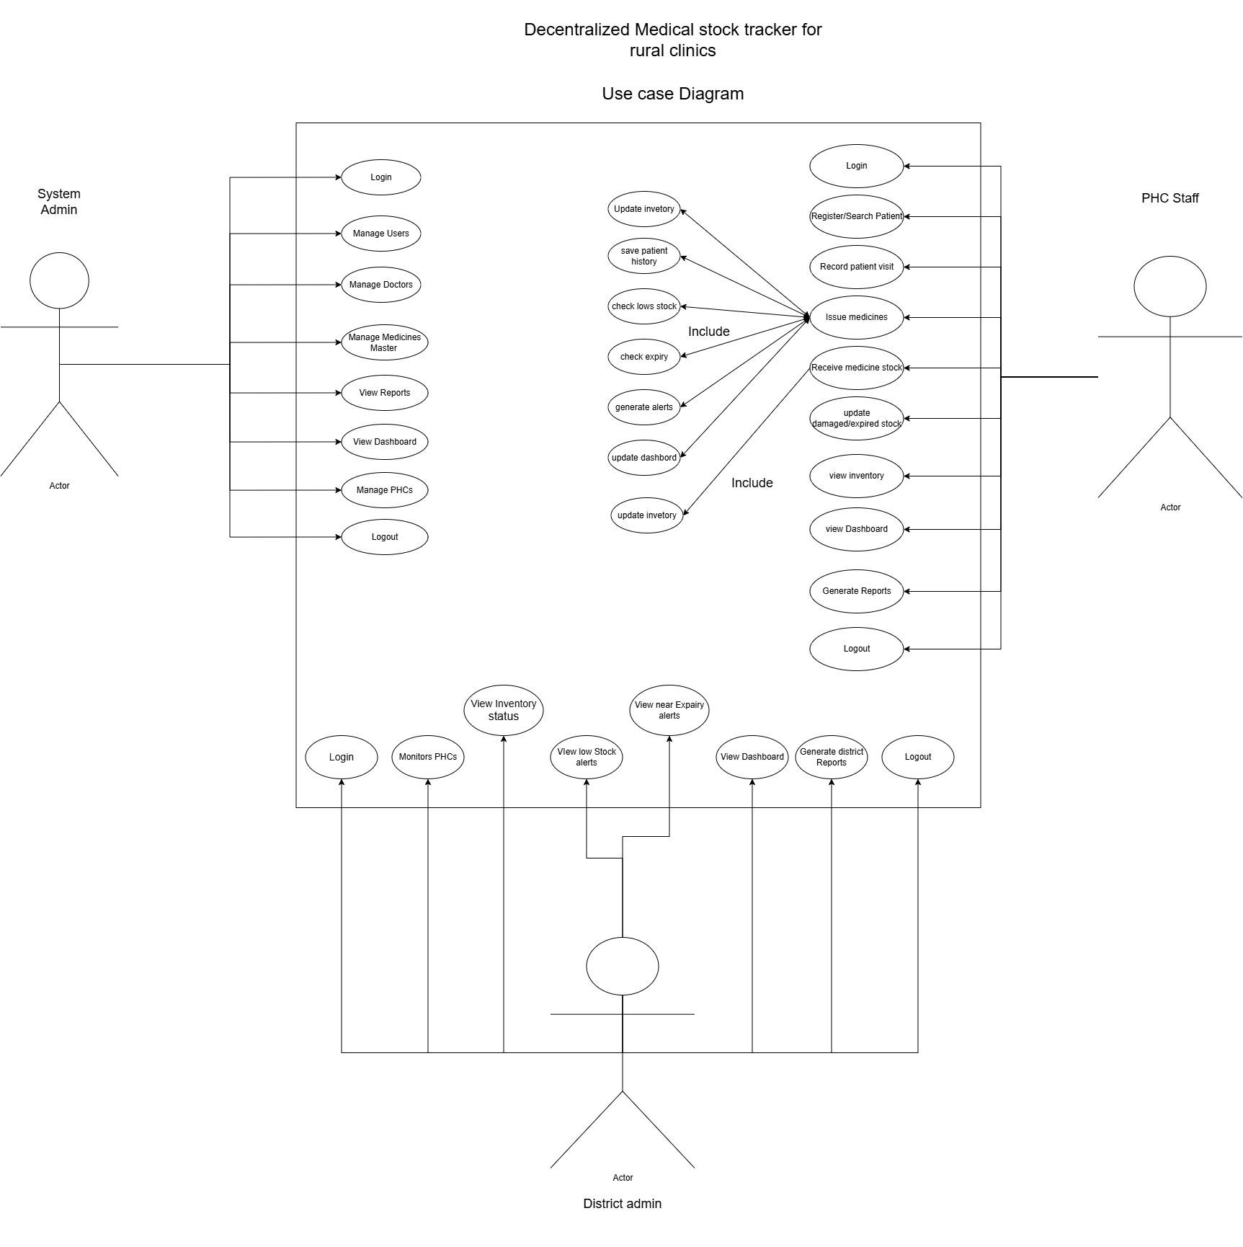
Figure 3.13: Use Case Diagram for System Roles (System Admin, District Admin, PHC Staff)
3.5 DATABASE DESIGN / DATA DICTIONARY
The underlying MariaDB/MySQL relational database comprises 15 structured tables. Complete schema definitions, data types, and constraints reflecting the live database are documented below:

Table 3.1: Database Schema: system_admin
Field | Type | Constraints | Description
admin_id | INT(11) | PRIMARY KEY, AUTO_INCREMENT | Unique identifier for system administrator
admin_name | VARCHAR(100) | NOT NULL | Full legal name of administrator
username | VARCHAR(50) | NOT NULL, UNIQUE | System admin login username
password | VARCHAR(255) | NOT NULL | Encrypted administrative account password
contact_no | VARCHAR(15) | NULLABLE | Contact phone number
email | VARCHAR(100) | NULLABLE | Administrative notification email

Table 3.2: Database Schema: district_admin
Field | Type | Constraints | Description
district_admin_id | INT(11) | PRIMARY KEY, AUTO_INCREMENT | Unique district administrator ID
admin_name | VARCHAR(100) | NOT NULL | Full name of district health officer
username | VARCHAR(50) | NOT NULL, UNIQUE | District admin login username
password | VARCHAR(255) | NOT NULL | Hashed password for login
district | VARCHAR(100) | NOT NULL | Assigned jurisdiction district name
contact_no | VARCHAR(15) | NULLABLE | District officer contact phone
email | VARCHAR(100) | NULLABLE | Official communication email
status | ENUM('Active','Inactive') | DEFAULT 'Active' | Account operational state

Table 3.3: Database Schema: phcs
Field | Type | Constraints | Description
phc_id | INT(11) | PRIMARY KEY, AUTO_INCREMENT | Unique Primary Health Centre identifier
district_admin_id | INT(11) | FOREIGN KEY (district_admin.district_admin_id) | Supervising district admin ID
phc_name | VARCHAR(150) | NOT NULL | Official name of rural health clinic
village | VARCHAR(100) | NULLABLE | Village in which PHC is located
Taluka | VARCHAR(100) | NOT NULL | Taluka administrative division
district | VARCHAR(100) | NOT NULL | District name
address | VARCHAR(255) | NULLABLE | Physical postal address
contact_no | VARCHAR(15) | NULLABLE | Clinic contact telephone number
status | ENUM('Active','Inactive') | DEFAULT 'Active' | Clinic facility status

Table 3.4: Database Schema: phc_creation_requests
Field | Type | Constraints | Description
request_id | INT(11) | PRIMARY KEY, AUTO_INCREMENT | Unique proposal request identifier
district_admin_id | INT(11) | NOT NULL | Submitting district admin ID
district | VARCHAR(100) | NOT NULL | Proposed facility district
description | TEXT | NOT NULL | Proposal justification and clinic details
document_path | VARCHAR(255) | NOT NULL | Uploaded supporting documentation PDF path
submitted_date | TIMESTAMP | DEFAULT CURRENT_TIMESTAMP | Submission date and timestamp
status | ENUM('Pending Review','Approved','Rejected') | DEFAULT 'Pending Review' | State review status
admin_remarks | TEXT | NULLABLE | System administrator review comments

Table 3.5: Database Schema: staff
Field | Type | Constraints | Description
staff_id | INT(11) | PRIMARY KEY, AUTO_INCREMENT | Unique clinic staff employee ID
phc_id | INT(11) | FOREIGN KEY (phcs.phc_id) | Assigned PHC clinic facility
staff_name | VARCHAR(100) | NOT NULL | Full name of pharmacist / health worker
username | VARCHAR(50) | NOT NULL, UNIQUE | Staff account login username
password | VARCHAR(255) | NOT NULL | Encrypted staff login password
shift | ENUM('Morning','Evening','Night') | NOT NULL | Assigned clinic duty shift
contact_no | VARCHAR(15) | NULLABLE | Mobile telephone number
joining_date | DATE | NULLABLE | Date staff joined the health centre
status | ENUM('Active','Inactive') | DEFAULT 'Active' | Account active/inactive state

Table 3.6: Database Schema: doctors
Field | Type | Constraints | Description
doctor_id | INT(11) | PRIMARY KEY, AUTO_INCREMENT | Unique medical officer identifier
phc_id | INT(11) | FOREIGN KEY (phcs.phc_id) | Associated Primary Health Centre
doctor_name | VARCHAR(100) | NOT NULL | Full name of medical doctor
specialization | VARCHAR(100) | NULLABLE | Medical specialty (General, Pediatric, etc.)
doctor_type | ENUM('Permanent','Visiting') | DEFAULT 'Permanent' | Employment type
visiting_days | VARCHAR(100) | NULLABLE | Scheduled clinic visiting days
contact_no | VARCHAR(15) | NULLABLE | Doctor contact telephone number
status | ENUM('Active','Inactive') | DEFAULT 'Active' | Doctor active status

Table 3.7: Database Schema: medicines
Field | Type | Constraints | Description
medicine_id | INT(11) | PRIMARY KEY, AUTO_INCREMENT | Unique master medicine identifier
medicine_name | VARCHAR(150) | NOT NULL, UNIQUE | Generic drug chemical name
category | VARCHAR(100) | NULLABLE | Therapeutic category (Antibiotic, Analgesic, etc.)
pack_quantity | INT(11) | NOT NULL | Number of units/tablets per package
pack_price | DECIMAL(10,2) | NOT NULL, DEFAULT 0.00 | Procurement price per strip/pack
tablet_price | DECIMAL(10,2) | NOT NULL, DEFAULT 0.00 | Computed cost per single unit

Table 3.8: Database Schema: inventory
Field | Type | Constraints | Description
inventory_id | INT(11) | PRIMARY KEY, AUTO_INCREMENT | Unique PHC inventory record ID
phc_id | INT(11) | FOREIGN KEY (phcs.phc_id) | Associated PHC clinic facility
medicine_id | INT(11) | FOREIGN KEY (medicines.medicine_id) | Associated master medicine
quantity | INT(11) | NOT NULL, DEFAULT 0 | Current live balance count in stock
last_updated | TIMESTAMP | DEFAULT CURRENT_TIMESTAMP ON UPDATE | Timestamp of last stock modification

Table 3.9: Database Schema: stock_in
Field | Type | Constraints | Description
stockin_id | INT(11) | PRIMARY KEY, AUTO_INCREMENT | Unique inbound receipt consignment ID
medicine_id | INT(11) | FOREIGN KEY (medicines.medicine_id) | Procured medicine ID
phc_id | INT(11) | FOREIGN KEY (phcs.phc_id) | Receiving PHC clinic facility
quantity_received | INT(11) | NOT NULL | Number of units physically received
expiry_date | DATE | NOT NULL | Manufacturer expiration date on package
received_date | TIMESTAMP | DEFAULT CURRENT_TIMESTAMP | Date and time of consignment receipt
staff_id | INT(11) | FOREIGN KEY (staff.staff_id) | Pharmacist who accepted shipment

Table 3.10: Database Schema: district_inventory
Field | Type | Constraints | Description
district_inventory_id | INT(11) | PRIMARY KEY, AUTO_INCREMENT | District warehouse stock ID
district_admin_id | INT(11) | FOREIGN KEY (district_admin.district_admin_id) | District health store administrator
medicine_id | INT(11) | FOREIGN KEY (medicines.medicine_id) | Medicine catalog ID
quantity | INT(11) | NOT NULL, DEFAULT 0 | Current district warehouse stock balance
last_updated | TIMESTAMP | DEFAULT CURRENT_TIMESTAMP ON UPDATE | Last stock adjustment timestamp

Table 3.11: Database Schema: district_stock_in
Field | Type | Constraints | Description
stockin_id | INT(11) | PRIMARY KEY, AUTO_INCREMENT | District inbound consignment ID
district_admin_id | INT(11) | FOREIGN KEY (district_admin.district_admin_id) | District administrator
medicine_id | INT(11) | FOREIGN KEY (medicines.medicine_id) | Procured medicine
quantity_received | INT(11) | NOT NULL | Quantity delivered to district warehouse
batch_no | VARCHAR(50) | NULLABLE | Manufacturer batch number
expiry_date | DATE | NOT NULL | Batch expiration date
received_date | TIMESTAMP | DEFAULT CURRENT_TIMESTAMP | Timestamp shipment was logged

Table 3.12: Database Schema: patients
Field | Type | Constraints | Description
patient_id | INT(11) | PRIMARY KEY, AUTO_INCREMENT | Unique clinic patient identification ID
patient_name | VARCHAR(100) | NOT NULL | Full legal name of patient
age | INT(11) | NULLABLE | Age of patient in years
gender | ENUM('Male','Female','Other') | NULLABLE | Gender identity of patient
mobile_no | VARCHAR(15) | NULLABLE | Contact mobile number for notifications
address | VARCHAR(255) | NULLABLE | Village / residential address

Table 3.13: Database Schema: patient_visits
Field | Type | Constraints | Description
visit_id | INT(11) | PRIMARY KEY, AUTO_INCREMENT | Unique clinical consultation visit ID
patient_id | INT(11) | FOREIGN KEY (patients.patient_id) | Consulted patient ID
doctor_id | INT(11) | FOREIGN KEY (doctors.doctor_id) | Attending consulting doctor
phc_id | INT(11) | FOREIGN KEY (phcs.phc_id) | Consultation PHC clinic location
staff_id | INT(11) | FOREIGN KEY (staff.staff_id) | Dispensing pharmacist / staff
visit_timestamp | TIMESTAMP | DEFAULT CURRENT_TIMESTAMP | Exact consultation timestamp

Table 3.14: Database Schema: visit_medicines
Field | Type | Constraints | Description
issue_id | INT(11) | PRIMARY KEY, AUTO_INCREMENT | Unique prescription medicine issue ID
visit_id | INT(11) | FOREIGN KEY (patient_visits.visit_id) | Associated patient clinical visit
medicine_id | INT(11) | FOREIGN KEY (medicines.medicine_id) | Dispensed pharmaceutical drug ID
quantity_issued | INT(11) | NOT NULL | Quantity of tablets/units dispensed

Table 3.15: Database Schema: medicine_requests
Field | Type | Constraints | Description
request_id | INT(11) | PRIMARY KEY, AUTO_INCREMENT | Unique electronic replenishment request ID
phc_id | INT(11) | FOREIGN KEY (phcs.phc_id) | Requesting PHC clinic facility
medicine_id | INT(11) | FOREIGN KEY (medicines.medicine_id) | Requested pharmaceutical medicine ID
staff_id | INT(11) | FOREIGN KEY (staff.staff_id) | Staff member submitting indent
requested_quantity | INT(11) | NOT NULL | Quantity requested from district store
reason | VARCHAR(255) | NULLABLE | Clinical justification for emergency indent
request_date | TIMESTAMP | DEFAULT CURRENT_TIMESTAMP | Timestamp of requisition submission
status | ENUM('Pending','Approved','Rejected') | DEFAULT 'Pending' | Current adjudication state
admin_remarks | VARCHAR(255) | NULLABLE | District administrator review remarks

4. IMPLEMENTATION
4.1 MODULE DESCRIPTION
4.1.1 Authentication & Role-Based Access Control Module
The authentication module (`login.php`) serves as the single secure portal entry. It inspects submitted credentials against three distinct user tables (`system_admin`, `district_admin`, `staff`). Upon verification using PHP's `password_verify()` against bcrypt hashes, the script assigns session tokens (`$_SESSION['role']`, `$_SESSION['phc_id']`, `$_SESSION['user_id']`). Strict server-side route guards are executed at the very first line of every internal controller, instantly intercepting and redirecting unauthorized URL tampering attempts back to `login.php`.
4.1.2 PHC Clinic Staff Module
The PHC Staff module encapsulates frontline dispensary operations: `Staff/dashboard.php` delivers real-time KPI metrics; `Staff/patients.php` registers patients and logs visit consultations; `Staff/stock_in.php` records inbound supplier consignments; `Staff/medicine_issue.php` deducts stock atomically during dispensing; and `Staff/inventory.php` provides real-time shelf audits.
4.1.3 District Admin Portal Module
Operating at `district_admin/`, this module empowers District Medical Officers to monitor aggregate stock levels across all clinics in their jurisdiction (`district_inventory.php`), review and adjudicate pending medicine indents (`district_medicine_requests.php`), manage clinic staff status toggles (`staff.php`), and track expiring consignments across dispensaries.
4.1.4 System Admin Portal Module
Located in `system_admin/`, this administrative suite manages foundational platform entities. System Admins onboard District Administrators (`districts.php`), curate the master drug catalog (`medicines_master.php`), and review supporting documentation submitted by district officers to onboard newly sanctioned PHCs (`phc_directory.php` & `phc_requests.php`).
4.2 SAMPLE CODE & ARCHITECTURAL PATTERNS
The following production code listings highlight architectural solutions engineered to solve critical concurrency, data integrity, and security challenges:
Code Listing: Post/Redirect/Get (PRG) Pattern in Staff/patients.php
// -------------------------------------------------------------
// Pattern: Post/Redirect/Get (PRG) to prevent duplicate insertion
// File: Staff/patients.php
// -------------------------------------------------------------
if ($_SERVER['REQUEST_METHOD'] === 'POST' && isset($_POST['register_patient'])) {
$patient_name = trim($_POST['patient_name'] ?? '');
$age = (int)($_POST['age'] ?? 0);
$gender = trim($_POST['gender'] ?? 'Male');
$mobile_no = trim($_POST['mobile_no'] ?? '');
$address = trim($_POST['address'] ?? '');
$stmt = $conn->prepare("INSERT INTO patients (patient_name, age, gender, mobile_no, address) VALUES (?, ?, ?, ?, ?)");
$stmt->bind_param("sisss", $patient_name, $age, $gender, $mobile_no, $address);
if ($stmt->execute()) {
$_SESSION['flash_success'] = "Patient '{$patient_name}' registered successfully.";
} else {
$_SESSION['flash_error'] = "Failed to register patient: " . $stmt->error;
}
$stmt->close();
// PRG Pattern: Redirect cleanly to GET request
header("Location: patients.php");
exit();
}
Explanation: Implements HTTP 302 redirection following POST processing. This ensures that browser page reloads issue idempotent GET requests rather than re-submitting POST payloads, completely eliminating duplicate patient registrations.
Code Listing: Atomic Dispensing & Stock Deduction
// -------------------------------------------------------------
// Pattern: Atomic Transaction for Medicine Issue & Stock Deduction
// File: Staff/medicine_issue.php
// -------------------------------------------------------------
$conn->begin_transaction();
try {
// 1. Record the medicine issue linked to patient clinical visit
$stmt1 = $conn->prepare("INSERT INTO visit_medicines (visit_id, medicine_id, quantity_issued) VALUES (?, ?, ?)");
$stmt1->bind_param("iii", $visit_id, $medicine_id, $quantity_issued);
$stmt1->execute();
// 2. Atomically deduct inventory for the clinic (preventing negative balances)
$stmt2 = $conn->prepare("UPDATE inventory SET quantity = quantity - ? ",
"WHERE phc_id = ? AND medicine_id = ? AND quantity >= ?");
$stmt2->bind_param("iiii", $quantity_issued, $phc_id, $medicine_id, $quantity_issued);
$stmt2->execute();
if ($stmt2->affected_rows === 0) {
throw new Exception("Insufficient stock available in clinic inventory.");
}
$conn->commit();
} catch (Exception $e) {
$conn->rollback();
$error_msg = $e->getMessage();
}
Explanation: Executes inventory deduction inside an ACID transaction lock. Guarantees that stock balances cannot drop below zero and prevents partial database updates during system crashes.
Code Listing: Automated Low Stock & Near Expiry Alert Logic
// -------------------------------------------------------------
// Pattern: Dynamic Early-Warning Alert Evaluation (MySQLi)
// File: Staff/dashboard.php & district_admin/dashboard.php
// -------------------------------------------------------------
// 1. Low Stock Query (Threshold < 50 units)
$low_stock_query = "SELECT m.medicine_name, i.quantity ",
"FROM inventory i JOIN medicines m ON i.medicine_id = m.medicine_id ",
"WHERE i.phc_id = ? AND i.quantity < 50";
// 2. Near Expiry Query (Batches expiring within 90 days)
$near_expiry_query = "SELECT m.medicine_name, s.stockin_id, s.expiry_date ",
"FROM stock_in s JOIN medicines m ON s.medicine_id = m.medicine_id ",
"WHERE s.phc_id = ? AND s.expiry_date BETWEEN CURDATE() AND DATE_ADD(CURDATE(), INTERVAL 90 DAY)";
Explanation: Executes targeted SQL queries comparing real-time quantities and expiration dates against dynamic safety parameters without requiring separate redundant denormalized alert tables.
4.3 SCREENSHOTS & USER INTERFACE DEMONSTRATIONS
In accordance with Rule 6, the following figures illustrate key functional interfaces populated with live clinic sample data:

Figure 4.1: Secure Multi-Role Authentication & Session Guard Workflow
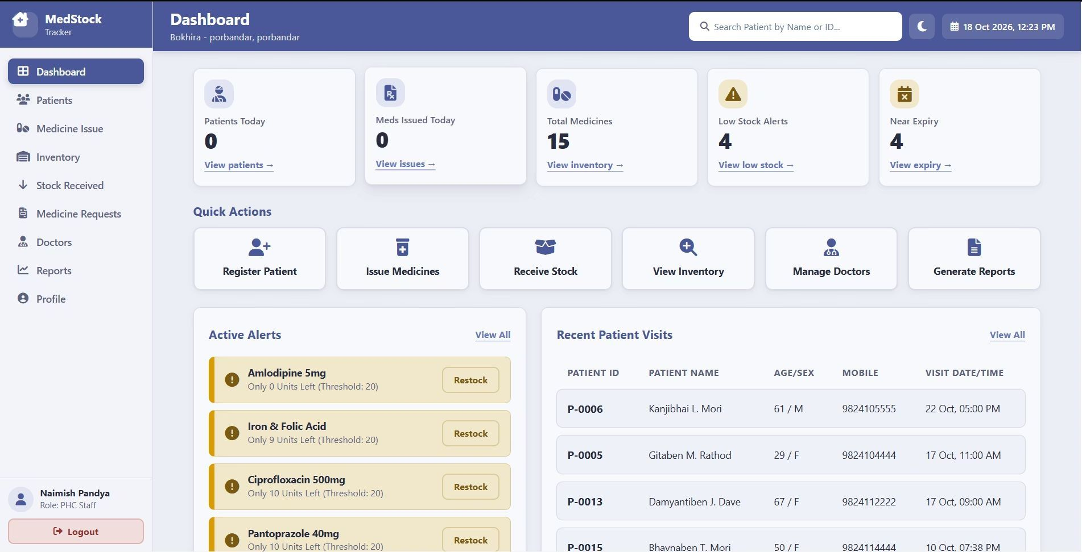
Figure 4.2: PHC Clinic Staff Real-Time Dashboard
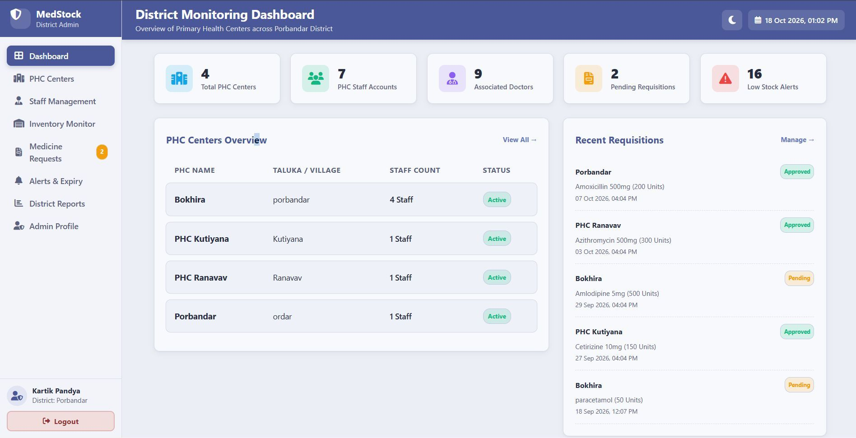
Figure 4.3: District Admin Central Inventory Monitoring Dashboard
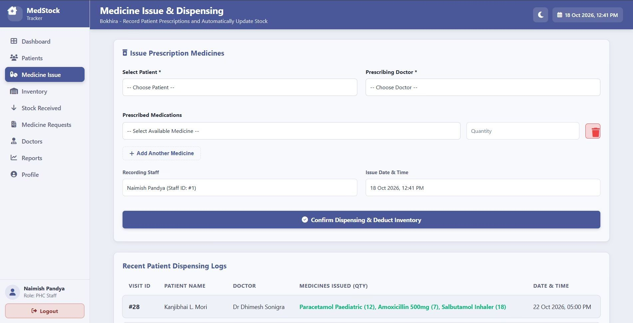
Figure 4.4: Medicine Dispensing & Atomic Stock Deduction Interface
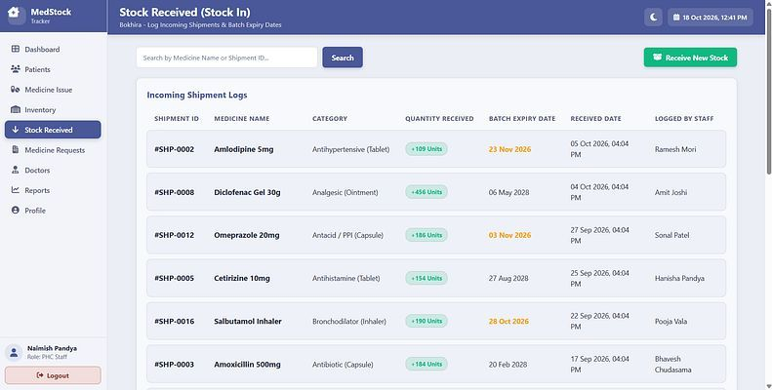
Figure 4.5: Medicine Stock-In Batch Receipt & Expiry Recording Form
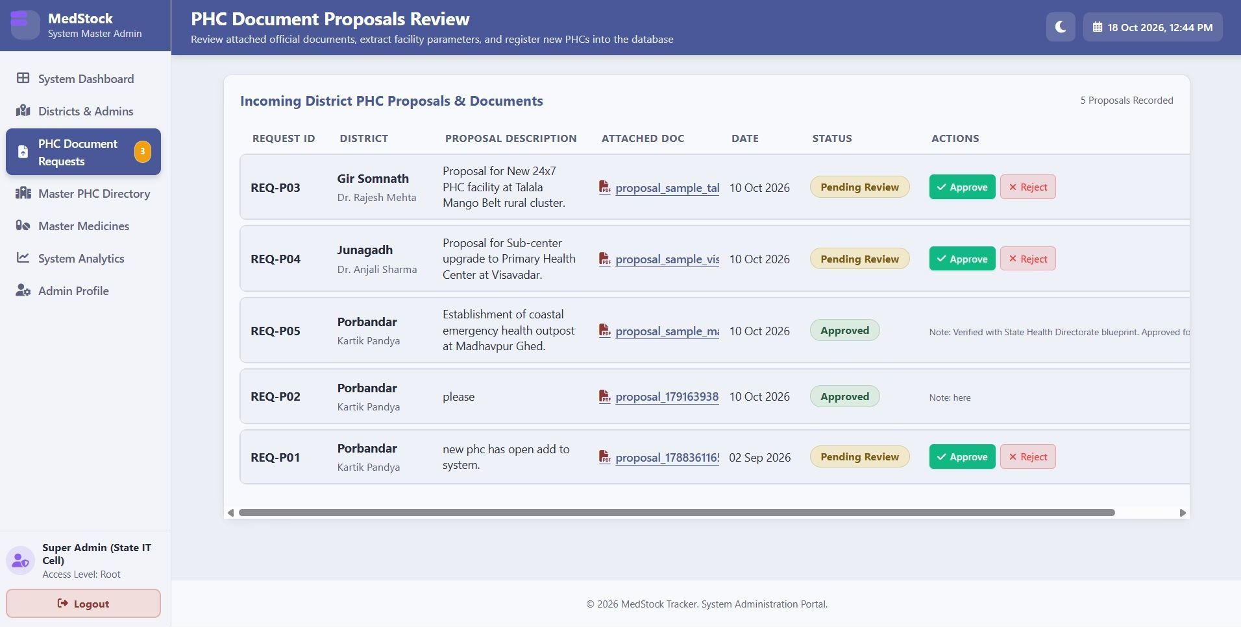
Figure 4.6: System Admin PHC Document Proposals Review Interface
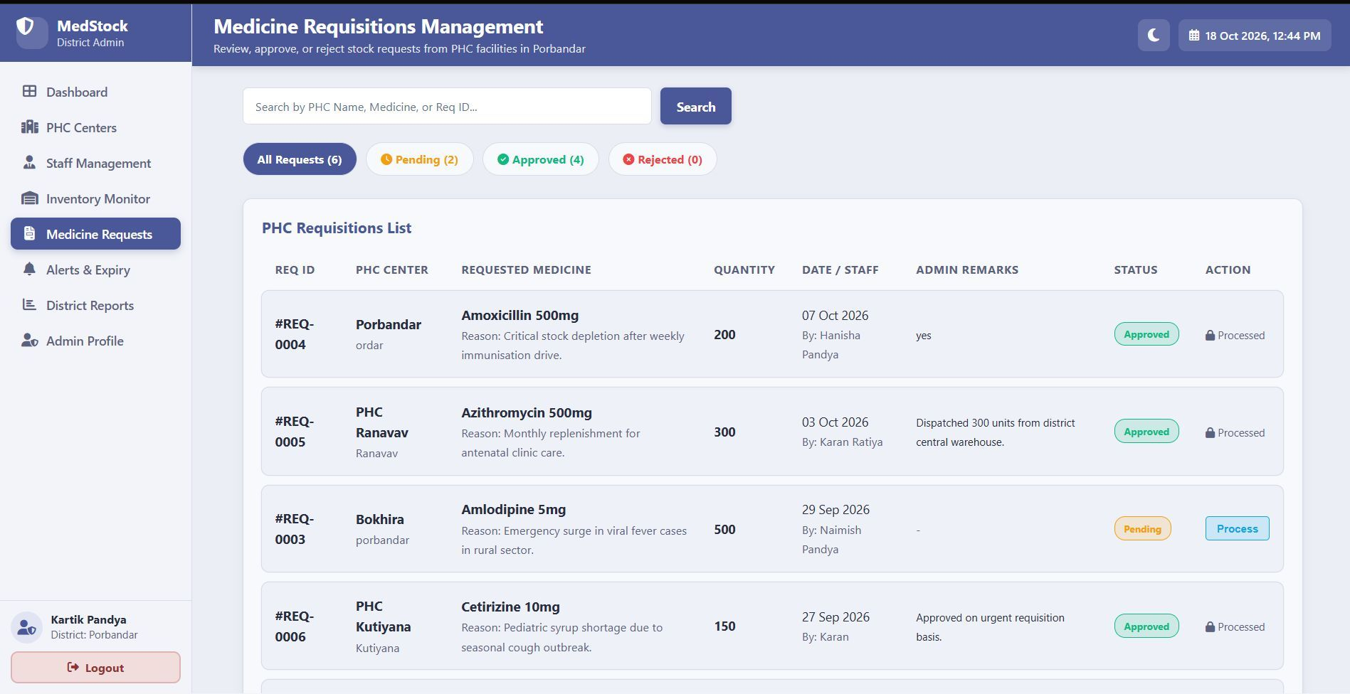
Figure 4.7: District Admin Medicine Indent Requisition Review Screen

5. TESTING & DEBUGGING
5.1 TESTING METHODS
A multi-tiered verification strategy was employed to validate software behavior against operational requirements:
• Unit & Component Testing: Verified individual PHP script routines, database queries, and input sanitization filters in isolation.
• Integration Testing: Tested end-to-end interactions across web modules, verifying that Stock In transactions accurately increase inventory and medicine dispensing reduces stock atomically.
• Role-Based Security Testing (RBAC): Validated role boundaries by verifying that unauthenticated sessions and cross-role URL tampering attempts are intercepted and rejected.
• Automated Regression Test Framework: Constructed a comprehensive Python test runner suite (`Testing/automated_tests/`) utilizing `requests` for HTTP simulation and `pymysql` for direct database state verification.
5.2 TEST CASES & EXECUTION RESULTS
A total of 77 automated test cases organized into five functional test suites were executed against the live system. The overall test execution achieved a 100% success rate as summarized in Table 5.1:
Table 5.1: Automated Test Suite Summary & Pass Rate
Suite ID | Test Suite Focus / Module | Total Tests | Passed | Failed | Pass Rate
Suite 1 | Authentication, Session Security & RBAC Isolation | 22 | 22 | 0 | 100.0%
Suite 2 | PHC Clinic Staff Operations (Patients, Stock In, Issue) | 25 | 25 | 0 | 100.0%
Suite 3 | District Admin Portal & Requisition Adjudication | 15 | 15 | 0 | 100.0%
Suite 4 & 5 | System Admin Portal & Relational Database Integrity | 15 | 15 | 0 | 100.0%
TOTAL | Master Regression Test Suite Evaluation | 77 | 77 | 0 | 100.0%

Table 5.2 presents a representative subset of critical test cases detailing test objectives, test steps, expected outcomes, and verified test results:
Table 5.2: Representative Test Cases Specification
Test ID | Test Description | Test Steps | Expected Result | Actual Result | Status
TC_AUTH_01 | Valid PHC Staff Login | 1. Open login.php  2. Submit valid staff credentials | HTTP 302 redirect to Staff/dashboard.php | Redirected to dashboard as expected | PASS
TC_AUTH_12 | RBAC Route Guarding | 1. Unauthenticated request to Staff/inventory.php | HTTP 302 redirect to login.php | Access blocked, redirected to login | PASS
TC_STAFF_02 | Patient Registration & PRG | 1. Submit new patient form  2. Trigger page reload | Patient inserted; reload issues GET without re-inserting | Zero duplicate patients created | PASS
TC_STAFF_07 | Stock-In Inventory Increment | 1. Record batch of 100 units in stock_in.php | inventory table incremented by exactly 100 | Stock increased from 50 to 150 | PASS
TC_STAFF_14 | Atomic Medicine Dispensing | 1. Issue 10 tablets to patient visit  2. Verify inventory | visit_medicines logged, inventory decremented by 10 | Stock decremented from 150 to 140 | PASS
TC_DIST_04 | Indent Status Adjudication | 1. District Admin approves pending request | medicine_requests status updated to 'Approved' | Status changed to Approved | PASS
TC_SYS_06 | Foreign Key Constraint Check | 1. Attempt deletion of PHC with active inventory | Database foreign key constraint blocks deletion | DB integrity preserved, error shown | PASS

5.3 BUGS DISCOVERED & TECHNICAL SOLUTIONS
During progressive integration and user evaluation, six critical defects were identified and systematically resolved by the team:

Table 5.3: Bugs Discovered & Resolved During Development
Bug Identified | Technical Root Cause | Applied Solution / Patch
Post-Deactivation Zombie Sessions | Logged-in staff remained authenticated even after district admin toggled account to Inactive. | Added per-request DB status check in dashboard controllers to destroy session immediately.
Chart.js Re-rendering & Memory Leak | 20s background polling re-created entire Chart.js objects, causing screen flicker. | Initialized charts once; subsequent polls update in-memory datasets via chart.update().
Redundant Password Inputs on Profile | Staff profile update forms conflicted with admin-controlled credential management. | Removed password fields from staff profiles, isolating credential edits to admin portals.
Table Action Button Clipping | Action buttons overflowed table boundaries on mobile and tablet screens. | Wrapped buttons in flexbox containers with min-width: 180px and compact icon stylings.
Cross-Role Privilege Escalation | Logged-in PHC Staff could access District Admin pages by typing direct URL. | Added strict server-side session guards verifying role and user_id at the top of every PHP file.
Duplicate Form Submission on Reload | Refreshing patient or stock-in pages re-sent POST headers, inserting duplicate database rows. | Implemented Post/Redirect/Get (PRG) pattern redirecting to GET with session flash alerts.

6. CONCLUSION AND FUTURE SCOPE
6.1 CONCLUSION
The “Decentralized Medical Stock Tracker for Rural Clinics” successfully demonstrates how modern web engineering and thoughtful role-based software design can revolutionize rural healthcare supply chains. By replacing cumbersome, error-prone physical registers with an automated digital platform, the system accomplishes four pivotal achievements:
• 1. Complete Stock Visibility: Eliminates information silos between remote primary clinics and district medical offices, allowing authorities to monitor medicine availability in real time.
• 2. Prevention of Expired Drug Dispensing: Automated near-expiry alerts alert pharmacists up to 90 days prior to drug expiration, preventing hazardous patient dispensing and enabling stock redistribution.
• 3. Frictionless Dispensing & Auditability: Links every issued tablet directly to a registered patient visit record, delivering unmatched accountability and eliminating pilferage.
• 4. Resilient Transactional Integrity: Integration of the Post/Redirect/Get pattern and atomic database locks guarantees error-free operations even across erratic rural connectivity.
In conclusion, the project fulfills all curricular and practical engineering objectives, establishing a scalable, open-source foundation for modernizing primary healthcare clinics.
6.2 LIMITATIONS
While the system provides robust operational stability, current operational limitations include:
• Internet Dependency: The web application currently requires active network access to synchronize transactions with the central MySQL database, posing challenges in complete telecommunication blackouts.
• Manual Barcode Data Entry: Medicine batch numbers and expiration dates are currently entered via keyboard rather than through dedicated optical handheld barcode or 2D DataMatrix scanners.
• Single-District Primary Focus: The system architecture is optimized for intra-district logistics and does not yet integrate inter-state central warehouse management systems.
6.3 FUTURE ENHANCEMENTS
The following planned enhancements represent the forward development roadmap for future iterations of the software:
• 1. Native Android Mobile Application: Develop a dedicated Android mobile client featuring fast camera-based QR code and GS1 DataMatrix barcode scanning for effortless point-of-care dispensing.
• 2. Smart SMS & WhatsApp Notifications: Integrate a cellular SMS gateway to deliver automated stock warnings to clinic staff and replenishment notifications to registered patients.
• 3. Artificial Intelligence & Demand Forecasting: Implement predictive machine-learning time-series models to forecast seasonal medicine spikes (e.g., antimalarials during monsoons), enabling proactive district restocking.
• 4. State-Wide Scale & National Health Stack Integration: Expand the platform architecture to federate multiple districts across Gujarat and interface with the Ayushman Bharat Digital Mission (ABDM).
• 5. Offline-First Progressive Web App (PWA): Implement client-side IndexedDB caching and Service Workers to allow pharmacists to record consultations offline and auto-sync upon reconnecting.

REFERENCES / BIBLIOGRAPHY
[1] Robin Nixon, 'Learning PHP, MySQL & JavaScript: With jQuery, CSS & HTML5', 6th Edition, O'Reilly Media, 2021.
[2] Luke Welling and Laura Thomson, 'PHP and MySQL Web Development', 5th Edition, Addison-Wesley Professional, 2016.
[3] World Health Organization (WHO), 'Operational Principles for Good Pharmaceutical Procurement', Essential Drugs and Medicines Policy, Geneva, 2019.
[4] Ministry of Health and Family Welfare (MoHFW), Government of India, 'Indian Public Health Standards (IPHS) Guidelines for Primary Health Centres', New Delhi, 2022.
[5] Gujarat Technological University (GTU), 'Guidelines for 5th Semester Minor Project Report Preparation', GTU Academic Council, Ahmedabad, 2026.
[6] Mark Otto and Jacob Thornton, 'Bootstrap 5 Documentation: Fast, responsive web front-end development', 2023. [Online]. Available: https://getbootstrap.com/
[7] The PHP Group, 'PHP: Hypertext Preprocessor Official Reference Manual (MySQLi Extension)', 2024. [Online]. Available: https://www.php.net/manual/
[8] Oracle Corporation, 'MySQL 8.0 Reference Manual: Relational Database Architecture and ACID Transactions', 2024. [Online]. Available: https://dev.mysql.com/doc/
[9] Mozilla Developer Network (MDN), 'Post/Redirect/Get Pattern in Web Application Security', 2024. [Online]. Available: https://developer.mozilla.org/
[10] Python Software Foundation, 'Requests: HTTP for Humans & python-docx Library Reference', 2024. [Online]. Available: https://docs.python-requests.org/

