Process

A program in execution is called a process. In order to accomplish its task, process needs the computer resources.

There may exist more than one process in the system which may require the same resource at the same time. Therefore, the operating system has to manage all the processes and the resources in a convenient and efficient way.

The operating system is responsible for the following activities in connection with Process Management:

1. Scheduling processes and threads on the CPUs.
2. Creating and deleting both user and system processes.
3. Suspending and resuming processes.
4. Providing mechanisms for process synchronization.
5. Providing mechanisms for process communication.

# Attributes of a process

The Attributes of the process are used by the Operating System to create the process control block (PCB) for each of them. This is also called context of the process. Attributes which are stored in the PCB are described below.

### 1. Process ID

When a process is created, a unique id is assigned to the process which is used for unique identification of the process in the system.

### 2. Program counter

A program counter stores the address of the last instruction of the process on which the process was suspended. The CPU uses this address when the execution of this process is resumed.

### 3. Process State

The Process, from its creation to the completion, goes through various states which are new, ready, running and waiting. We will discuss about them later in detail.

**00:00/11:48**

### 4. Priority

Every process has its own priority. The process with the highest priority among the processes gets the CPU first. This is also stored on the process control block.

### 5. General Purpose Registers

Every process has its own set of registers which are used to hold the data which is generated during the execution of the process.

### 6. List of open files

During the Execution, Every process uses some files which need to be present in the main memory. OS also maintains a list of open files in the PCB.

### 7. List of open devices

OS also maintain the list of all open devices which are used during the execution of the process.

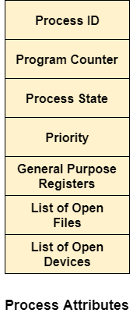

# Process States

**State Diagram**

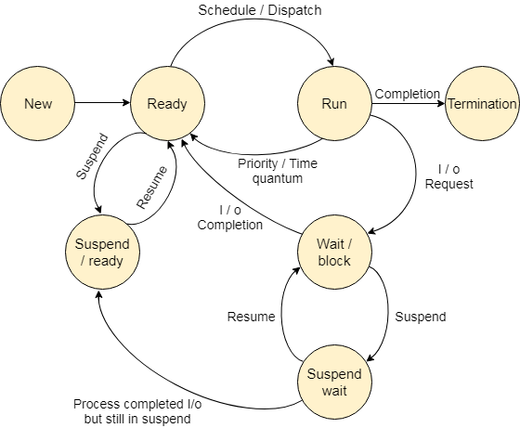

The process, from its creation to completion, passes through various states. The minimum number of states is five.

The names of the states are not standardized although the process may be in one of the following states during execution.

### 1. New

A program which is going to be picked up by the OS into the main memory is called a new process.

### 2. Ready

Whenever a process is created, it directly enters in the ready state, in which, it waits for the CPU to be assigned. The OS picks the new processes from the secondary memory and put all of them in the main memory.

The processes which are ready for the execution and reside in the main memory are called ready state processes. There can be many processes present in the ready state.

### 3. Running

One of the processes from the ready state will be chosen by the OS depending upon the scheduling algorithm. Hence, if we have only one CPU in our system, the number of running processes for a particular time will always be one. If we have n processors in the system then we can have n processes running simultaneously.

### 4. Block or wait

From the Running state, a process can make the transition to the block or wait state depending upon the scheduling algorithm or the intrinsic behavior of the process.

When a process waits for a certain resource to be assigned or for the input from the user then the OS move this process to the block or wait state and assigns the CPU to the other processes.

### 5. Completion or termination

When a process finishes its execution, it comes in the termination state. All the context of the process (Process Control Block) will also be deleted the process will be terminated by the Operating system.

### 6. Suspend ready

A process in the ready state, which is moved to secondary memory from the main memory due to lack of the resources (mainly primary memory) is called in the suspend ready state.

If the main memory is full and a higher priority process comes for the execution then the OS have to make the room for the process in the main memory by throwing the lower priority process out into the secondary memory. The suspend ready processes remain in the secondary memory until the main memory gets available.

### 7. Suspend wait

Instead of removing the process from the ready queue, it's better to remove the blocked process which is waiting for some resources in the main memory. Since it is already waiting for some resource to get available hence it is better if it waits in the secondary memory and make room for the higher priority process. These processes complete their execution once the main memory gets available and their wait is finished.

## **Operations on the Process**

### 1. Creation

Once the process is created, it will be ready and come into the ready queue (main memory) and will be ready for the execution.

### 2. Scheduling

Out of the many processes present in the ready queue, the Operating system chooses one process and start executing it. Selecting the process which is to be executed next, is known as scheduling.

### 3. Execution

Once the process is scheduled for the execution, the processor starts executing it. Process may come to the blocked or wait state during the execution then in that case the processor starts executing the other processes.

### 4. Deletion/killing

Once the purpose of the process gets over then the OS will kill the process. The Context of the process (PCB) will be deleted and the process gets terminated by the Operating system.

Process Schedulers

Operating system uses various schedulers for the process scheduling described below.

1. Long term scheduler

Long term scheduler is also known as job scheduler. It chooses the processes from the pool (secondary memory) and keeps them in the ready queue maintained in the primary memory.

Long Term scheduler mainly controls the degree of Multiprogramming. The purpose of long term scheduler is to choose a perfect mix of IO bound and CPU bound processes among the jobs present in the pool.

If the job scheduler chooses more IO bound processes then all of the jobs may reside in the blocked state all the time and the CPU will remain idle most of the time. This will reduce the degree of Multiprogramming. Therefore, the Job of long term scheduler is very critical and may affect the system for a very long time.

Skip Ad

2. Short term scheduler

Short term scheduler is also known as CPU scheduler. It selects one of the Jobs from the ready queue and dispatch to the CPU for the execution.

A scheduling algorithm is used to select which job is going to be dispatched for the execution. The Job of the short term scheduler can be very critical in the sense that if it selects job whose CPU burst time is very high then all the jobs after that, will have to wait in the ready queue for a very long time.

This problem is called starvation which may arise if the short term scheduler makes some mistakes while selecting the job.

3. Medium term scheduler

Medium term scheduler takes care of the swapped out processes. If the running state processes needs some IO time for the completion then there is a need to change its state from running to waiting.

Medium term scheduler is used for this purpose. It removes the process from the running state to make room for the other processes. Such processes are the swapped out processes and this procedure is called swapping. The medium term scheduler is responsible for suspending and resuming the processes.

It reduces the degree of multiprogramming. The swapping is necessary to have a perfect mix of processes in the ready queue.

# Process Queues

The Operating system manages various types of queues for each of the process states. The PCB related to the process is also stored in the queue of the same state. If the Process is moved from one state to another state then its PCB is also unlinked from the corresponding queue and added to the other state queue in which the transition is made.

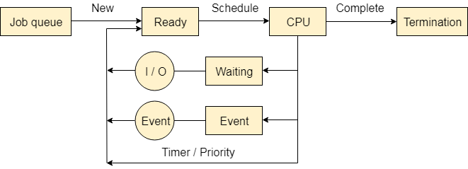

There are the following queues maintained by the Operating system.

### 1. Job Queue

In starting, all the processes get stored in the job queue. It is maintained in the secondary memory. The long term scheduler (Job scheduler) picks some of the jobs and put them in the primary memory.

### 2. Ready Queue

Ready queue is maintained in primary memory. The short term scheduler picks the job from the ready queue and dispatch to the CPU for the execution.nt

### 3. Waiting Queue

When the process needs some IO operation in order to complete its execution, OS changes the state of the process from running to waiting. The context (PCB) associated with the process gets stored on the waiting queue which will be used by the Processor when the process finishes the IO.

# Various Times related to the Process

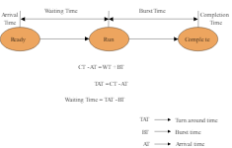

### 1. Arrival Time

The time at which the process enters into the ready queue is called the arrival time.

### 2. Burst Time

The total amount of time required by the CPU to execute the whole process is called the Burst Time. This does not include the waiting time. It is confusing to calculate the execution time for a process even before executing it hence the scheduling problems based on the burst time cannot be implemented in reality.

### 3. Completion Time

The Time at which the process enters into the completion state or the time at which the process completes its execution, is called completion time.

### 4. Turnaround time

The total amount of time spent by the process from its arrival to its completion, is called Turnaround time.

### 5. Waiting Time

The Total amount of time for which the process waits for the CPU to be assigned is called waiting time.

### 6. Response Time

The difference between the arrival time and the time at which the process first gets the CPU is called Response Time.