**Threads**

A thread is a single sequential flow of execution of tasks of a process so it is also known as thread of execution or thread of control. There is a way of thread execution inside the process of any operating system. Apart from this, there can be more than one thread inside a process. Each thread of the same process makes use of a separate program counter and a stack of activation records and control blocks. Thread is often referred to as a lightweight process.

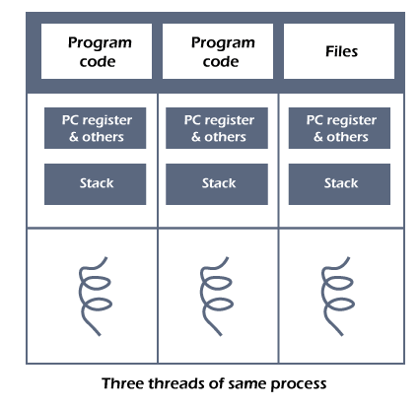

The process can be split down into so many threads. **For example**, in a browser, many tabs can be viewed as threads. MS Word uses many threads - formatting text from one thread, processing input from another thread, etc.

Need of Thread:

* It takes far less time to create a new thread in an existing process than to create a new process.
* Threads can share the common data, they do not need to use Inter- Process communication.
* Context switching is faster when working with threads.
* It takes less time to terminate a thread than a process.

Types of Threads

In the operating system, there are two types of threads.

1. Kernel level thread.
2. User-level thread.

## User Level Threads

In this case, the thread management kernel is not aware of the existence of threads. The thread library contains code for creating and destroying threads, for passing message and data between threads, for scheduling thread execution and for saving and restoring thread contexts. The application starts with a single thread.

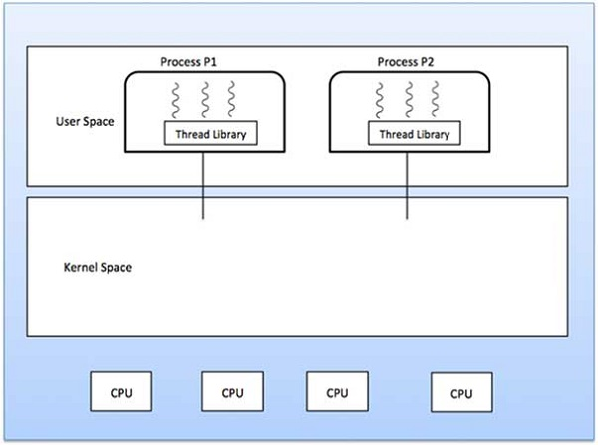

### **Advantages**

* Thread switching does not require Kernel mode privileges.
* User level thread can run on any operating system.
* Scheduling can be application specific in the user level thread.
* User level threads are fast to create and manage.

### **Disadvantages**

* In a typical operating system, most system calls are blocking.
* Multithreaded application cannot take advantage of multiprocessing.

## Kernel Level Threads

In this case, thread management is done by the Kernel. There is no thread management code in the application area. Kernel threads are supported directly by the operating system. Any application can be programmed to be multithreaded. All of the threads within an application are supported within a single process.

The Kernel maintains context information for the process as a whole and for individuals threads within the process. Scheduling by the Kernel is done on a thread basis. The Kernel performs thread creation, scheduling and management in Kernel space. Kernel threads are generally slower to create and manage than the user threads.

### **Advantages**

* Kernel can simultaneously schedule multiple threads from the same process on multiple processes.
* If one thread in a process is blocked, the Kernel can schedule another thread of the same process.
* Kernel routines themselves can be multithreaded.

### **Disadvantages**

* Kernel threads are generally slower to create and manage than the user threads.
* Transfer of control from one thread to another within the same process requires a mode switch to the Kernel.

**The important differences between Process and Thread:**

| **Parameter** | **Process** | **Thread** |
| --- | --- | --- |
| Definition | Process means a program is in execution. | Thread means a segment of a process. |
| Lightweight | The process is not Lightweight. | Threads are Lightweight. |
| Termination time | The process takes more time to terminate. | The thread takes less time to terminate. |
| Creation time | It takes more time for creation. | It takes less time for creation. |
| Communication | Communication between processes needs more time compared to thread. | Communication between threads requires less time compared to processes. |
| Context switching time | It takes more time for context switching. | It takes less time for context switching. |
| Resource | Process consume more resources. | Thread consume fewer resources. |
| Treatment by OS | Different process are tread separately by OS. | All the level peer threads are treated as a single task by OS. |
| Memory | The process is mostly isolated. | Threads share memory. |
| Sharing | It does not share data | Threads share data with each other. |