AI-ENABLED BUSINESS PLANNING FOR CLUSTER LEVEL FEDERATIONS
A route for CLF office bearers to build a business plan from records already held, on terms the federation controls
Note for the Ministry of Rural Development · October 2026
At a glance
The goal. Help the office bearers of a Cluster Level Federation (CLF) prepare a credible business plan, for a bank loan, a fund request or a federation-run enterprise, without re-collecting what is already on record. LokOS records 34,397 Cluster Level Federations (CLFs), federating 5.60 lakh Village Organisations and 93.56 lakh Self-Help Groups with 10.20 crore members.¹
The constraint. A federation's plan is usually put together by hand from files, registers and the memory of a few office bearers. Its quality depends on who is in the room, and the bank or the State Rural Livelihoods Mission (SRLM) must then verify each figure by hand.
The proposal. Through GramStack, office bearers authenticate once and draw the CLF's own documents from its Entity Locker² and the Mission's records from LokOS. A draft plan is built against the Mission's plan format and read back in their language. They add what only they know, correct it, and sign it. The signed plan is kept in the CLF's locker and shared with the bank and SRLM by consent.
What it does not require. No new registry, no separate consent rail, no third party interposed between a department and the federation, no bulk transfer of data, and no change to who owns which record. AI drafts and checks; the office bearers decide, and the bank and SRLM keep the credit decision.
What a prototype has shown. A working prototype, built on invented LokOS, VB–G RAM G and AgriStack records, tests the member-level version of this route by voice, in Hindi.⁶ It asks consent once per request, reads only the fields an answer needs, takes outcomes such as Lakhpati status from published decision tables rather than from the model, builds business plans as spreadsheets with live formulas, and deletes what it read once it has answered. Its lessons are folded into Sections 2 to 4.

1. Context
1.1 The federation and its plan. The CLF is the third tier of the DAY-NRLM community architecture and the main counterpart of the community to banks, SRLMs and line departments.¹⁴ A federation-level business plan typically supports one of three asks: a loan from a bank, a request for community or Mission funds, or an enterprise the federation will run itself, such as a collection, processing or marketing centre.
1.2 What the plan depends on. Two conditions decide whether a plan is accepted. It must fit what the federation and its members actually do, and its numbers must be checkable by whoever reads it. The evidence sits in two places. The federation's own documents (registration, bye-laws, audited accounts, bank mandates, SRLM sanctions, grading reports) would sit in its Entity Locker. The record of what its Village Organisations and SHGs save, borrow, repay and demand sits in LokOS, which the Mission owns.
1.3 Building on the companion notes. The companion note on Entity Locker for CLFs set out how a federation's institutional record could be held and shared.⁵ The note on AI skilling set out the shared rails and the principle that benefit is read from the Ministry's own records.⁵ This note applies both to a task office bearers already perform and that matters to the federation's credit and growth: preparing the plan.
2. GramStack: one shared layer, and one consent layer
2.1 What it is. GramStack is not a new registry, application or database. It is a shared reference stack of AI and digital public infrastructure (DPI) components, with a thin connective layer binding them, that allows a federation's office bearers to combine records already held about it across systems, on terms they control. It composes what the country has already built: Aadhaar for identity and authentication, DigiLocker and Entity Locker for credentials and evidence, the national language rails for access in Indian languages, and departmental systems such as LokOS as authoritative sources. Exchanges run on published, versioned interfaces built to open standards, with mutually authenticated transport for departmental APIs.
2.2 What it adds, and nothing beyond. Identity and relationship resolution, consent mediation, orchestration across systems that were not built to work together, and a minimal record of events, claims, provenance and audit. An inference gateway within the stack governs routing, permissions, budgets and metering across approved models, so that AI use is accountable rather than ambient. It does not itself establish truth: deterministic rules reconcile arithmetic, dates and missing values, and a role-authenticated signature establishes approval. The prototype bears this out. When a language model was left to compute savings projections asked in Hindi, its best prompt scored 0.94 out of 1 on questions it had not seen; when the model only read the question and code computed the figures and the chart, it scored 1.0. Testing also caught a summing error in which a member’s two loans were reported as one loan’s balance. Behind the gateway, models are interchangeable: the prototype writes with an open model hosted on Bhashini and checks its answers with a different, larger model acting as an independent judge.
2.3 Consent belongs to the stack, not to a separate rail. Consent is taken at the point of authentication, against the records and the purpose stated to the office bearers in their own language, and it is mediated, logged and made revocable by GramStack itself. One authentication by an authorised office bearer therefore governs every system reached in that request: the CLF's locker and LokOS alike. Notice, purpose limitation, access control, audit and withdrawal follow the Digital Personal Data Protection Act, 2023.³ Federation-level data is shared by default. Individual member data is reached only on separate and explicit consent. In the prototype, consent is asked aloud, once for every record a request needs. The reply is matched first against local words for yes and no, which a department can extend, and then by a model; an unclear reply is read back for confirmation, and anything still unclear counts as no.
2.4 Two sources, each staying where it is. The pattern is the one DigiLocker and the Unified Payments Interface already follow. The CLF's documents remain in its locker and the Mission's records remain in LokOS. GramStack holds only the linkage, the consent status and the audit of access, so no new copy of the federation's data is created beyond the plan the office bearers choose to keep.
2.5 The Mission gains oversight rather than losing control. Access to LokOS through the shared layer is bound to a stated purpose, time-bound, revocable, and logged where the Mission can see it. The Mission remains the data fiduciary, decides which fields a CLF's office bearers may see (aggregates for their own VOs and SHGs, not other federations' data), and may withdraw access at any time.
3. Architecture & User journey
Architecture: The architecture builds on existing public digital infrastructure rather than creating parallel systems. Authoritative records stay with their custodians, GramStack connects them for one purpose and one request at a time, and the plan that results belongs to the federation.
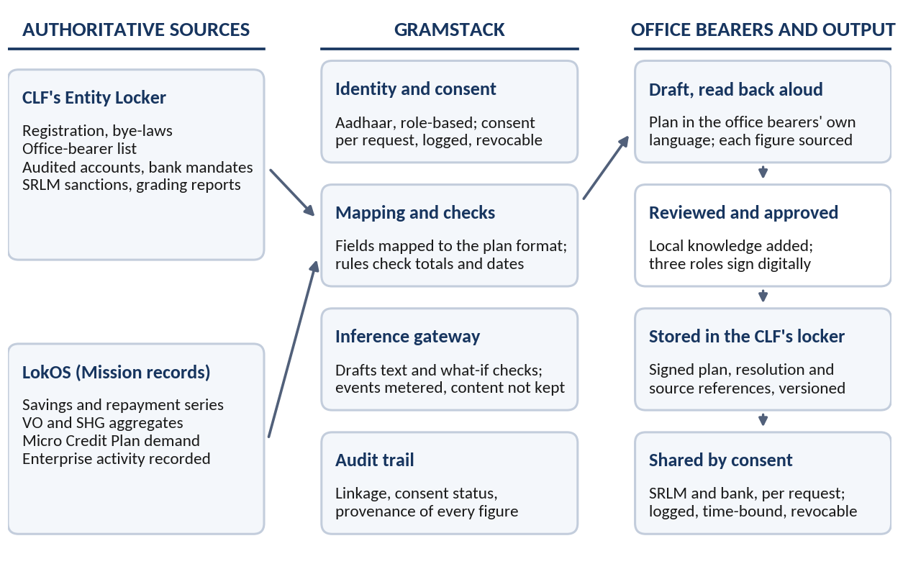
Figure 1: From the CLF's documents and LokOS records to a signed, shared business plan
The table shows where each section of the plan draws its content. The Mission's own plan format, once prescribed, would decide the final sections.
Plan section | From the CLF's Entity Locker | From LokOS | Added by office bearers
Standing of the federation | Registration, bye-laws, office-bearer list, authorising resolution | Number of VOs, SHGs and members affiliated | Purpose and scope of the plan
Demand and market | Earlier project papers, if any | Aggregated credit demand and enterprise activity recorded by member groups | Buyers, prices, seasons and local knowledge
Financial track record | Audited accounts, bank mandates, utilisation certificates | Savings, loan and repayment series for VOs and SHGs | Explanation of exceptions and gaps
Capacity and compliance | SRLM sanctions, grading reports, licences (Udyam, GST, FSSAI) | Grading and compliance trends, training and cadre records | Staffing, management and risk plan
The ask and repayment | Existing liabilities, sanction history | Repayment capacity read from the aggregated series | Amount, tenure, use of funds, targets

User Journey: Lakshmi is the Secretary of a CLF in a DAY-NRLM district. Many of the SHGs under it, Sunita's among them, grow and process spices, and the federation wants a common grading and packing centre. The journey follows its business plan from Lakshmi's first request to the plan's use after funding. The account is illustrative. It assumes the CLF is on Entity Locker, and the steps that read LokOS assume the Mission has opened aggregate records to authorised office bearers.
Phase 1: The office bearers ask, and the request is itself the consent
1 | Asks the Advisory Service, in Her Own Language  Lakshmi tells the Ministry's conversational advisory service, by voice, that the federation wants to set up a spice grading and packing centre and needs a business plan to take to the bank.
2 | Authentication Doubles as Itemised Consent  Before she proceeds, the service states which documents it will read from the CLF's locker, which LokOS records it will read, and why. Lakshmi authenticates in the role the CLF's resolution authorises for this purpose. That authentication against a stated purpose is the consent: itemised to this request, logged, and withdrawable at any time. GramStack mediates and records it. It asks once, for everything the request needs, rather than document by document. In the prototype, asking once cut a five-step spoken exchange to three.
Phase 2: One draft, built from two sources
1 | Documents Come from the CLF's Own Locker  The registration certificate, bye-laws, office-bearer list, audited accounts, bank mandates and earlier SRLM sanctions and grading reports are drawn from the locker. Documents issued by an authority are shown as issued, and those the CLF uploaded itself are shown as self-stored.
2 | Records Come from LokOS, at Federation Level  The savings, loan and repayment series for the VOs and SHGs under the CLF, their aggregated credit demand, and their recorded enterprise activity are read from LokOS. These are group-level figures. Member-level data is not shown unless the members separately and explicitly consent.
3 | The Draft Follows a Format Already Prescribed  GramStack maps these fields onto the Mission's plan format: standing, demand, financial track record, capacity, and the ask. Deterministic rules check totals, dates and missing values. Each figure stays linked to its source and date, so it can be traced rather than argued about.
Phase 3: The office bearers shape and challenge the draft
1 | The Draft Is Read Back, Section by Section  The draft is read to Lakshmi and the President in their own language, so that review does not depend on reading ability. They notice that the recorded demand covers only what groups have entered, and add what buyers and local traders have told them about prices, seasons and likely orders. Each such figure is marked as entered by the office bearers.
2 | What-If Checks Test the Plan, Without Deciding It  The inference gateway runs simple scenarios on the draft: a lower selling price, a late season, a delayed first sale. It shows the repayment burden against the surplus visible in the aggregated LokOS series, and raises weak points as questions for the office bearers. It proposes. They decide. The office bearers ask in their own words, such as what happens if the price falls by ten rupees. The model only turns the question into the scenario’s inputs; code computes the result and draws the chart, so every figure can be traced. In a prototype test on 208 savings what-if questions in Hindi, including numbers spoken in words, this design returned the expected figures and chart for every question held back for testing.
Phase 4: Approved by the federation, kept in its own locker
1 | Three Office Bearers Affirm the Plan  The President, Secretary and Treasurer affirm the plan through role-based approval and a legally valid digital signature, together with the executive committee's resolution. Only after this does it become the federation's plan. A figure that is corrected or rejected requires fresh approval.
2 | The Plan Rests with the Federation First  The signed plan, the resolution and the references to its sources are stored in the CLF's Entity Locker as a versioned document, held under the same role-based controls as its other records.
Phase 5: Shared by consent, checked without re-collection
1 | The SRLM and the Bank Receive the Same Record  The CLF shares the plan with its supporting documents, first with the SRLM for recommendation and then with the bank for appraisal. Each request names the documents and the purpose, is time-bound and logged, and can be withdrawn by the CLF.
2 | Verification Replaces Re-Collection  The bank checks issued documents against the issuer, and traces the repayment history in the plan to the dated LokOS series, instead of asking for photocopies and fresh statements. Queries from the bank are answered from the same record. The credit decision remains the bank's.
Phase 6: Ongoing impact, and why the capabilities reinforce one another
1 | The Plan Becomes the Baseline  Once funded, the fund flows, repayments and enterprise turnover recorded in LokOS and in the CLF's locker can be read against the plan. Variance shows early where the plan needs correction. Observed improvement is reported separately from improvement attributable to the plan or its support.
2 | Better Records, Better Plans, Better Records  As VO and SHG meeting records improve, and as office bearers and cadre grow comfortable with AI tools, the evidence behind each plan gets stronger, and each plan in turn sharpens the record. Record-keeping, skilling and planning are one programme on one set of rails, not three initiatives measured separately.

4. Dependencies and safeguards
4.1 What this note assumes. First, that CLFs are onboarded to Entity Locker and that SRLMs issue their sanctions and grading reports into it, as proposed in the companion note. No public source confirms that this has happened. Second, that the Mission decides which LokOS aggregates an authorised CLF office bearer may read, and exposes them through an interface. Third, that a standard plan format is prescribed by the Mission or the SRLM. Fourth, that the GramStack layer is assembled from existing components as set out in Section 2.
4.2 Safeguards. AI drafts and checks, and the office bearers approve. Every figure is either traced to a dated record or marked as entered by them. Individual member data stays out unless members separately and explicitly consent. Only the event of AI use and its provenance are retained, never the content. The plan is not a credit decision, and the bank and the SRLM keep theirs. The prototype shows what this rule asks of the design: records read for an answer are deleted as soon as it is given, but the question and answer text were kept so that a follow-up could be understood. The service would need to decide whether that text counts as content.
4.3 Support and a first test. Community Resource Persons, Bank Sakhis and block teams would handhold the first plans, and the nodal-person and role arrangements in the companion note cover turnover of office bearers. A pilot in two or three SRLMs, with CLFs that already keep good records, could measure the time taken to prepare a plan, the number of documents requested a second time, the time to bank appraisal, and the gap between plan and actual.
4.4 Testing the AI, before and during the pilot. Every change to a prompt, model or rule would pass a fixed set of test questions before use, scored three ways: by code checks against the records, by an independent model acting as judge, and by standard measures of whether an answer is supported by what was read and matches the expected answer. Hindi-speaking reviewers would check every answer the checks flag and a random 5% of the rest, and their corrections would become new test questions. The prototype runs this loop on invented records; with real records, the traces it keeps would need redaction under the same consent terms.
References
1. LokOS coverage under DAY-NRLM, Ministry of Rural Development, as reported on Oct 27, 2026, on the LokOS portal (https://nrlm.lokos.in/home)
2. Entity Locker, National eGovernance Division, Ministry of Electronics and Information Technology, launched January 2025. Portal: entity.digilocker.gov.in
3. Digital Personal Data Protection Act, 2023 (Act 22 of 2023), in particular the requirements of notice, specified purpose and withdrawal of consent.
4. DAY-NRLM Community Operational Manual and Standard Operating Procedures, Ministry of Rural Development. aajeevika.gov.in
5. Companion notes to the Ministry: Entity Locker for Cluster Level Federations (October 2026); Enabling AI Skilling for Rural Households at Scale (September 2026).
6. Didi ka Playground: a working prototype of the GramStack shared layer for voice-first, consent-based answers in Hindi, built on invented records (October 2026).

