**Lab:7**

Q1) Simple Calculator

Java Code:

Button add=(Button)findViewById(R.id.***main_button_plus***);  
Button sub=(Button)findViewById(R.id.***main_button_minus***);  
Button mul=(Button)findViewById(R.id.***main_button_mul***);  
Button div=(Button)findViewById(R.id.***main_button_div***);  
Button sq=(Button)findViewById(R.id.***main_button_sq***);  
Button pow=(Button)findViewById(R.id.***main_button_pow***);  
Button eql=(Button)findViewById(R.id.***main_button_eq***);  
Button clr=(Button)findViewById(R.id.***main_button_clr***);  
**tvnum**=(EditText)findViewById(R.id.***main_editText_num***);  
  
clr.setOnClickListener(**new** View.OnClickListener() {  
 @Override  
 **public void** onClick(View view) {  
 **tvnum**.setText(**""**);  
 **num**=0.0;  
 }  
});  
  
*//Equal*eql.setOnClickListener(**new** View.OnClickListener() {  
 @Override  
 **public void** onClick(View view) {  
  
 **switch** (**stat**){  
 **case 'a'**:**num**+=Double.*parseDouble*(**tvnum**.getText().toString());**break**;  
 **case 's'**:**num** -= Double.*parseDouble*(**tvnum**.getText().toString());**break**;  
 **case 'm'**:**num** *= Double.*parseDouble*(**tvnum**.getText().toString());**break**;  
 **case 'd'**:**num** /= Double.*parseDouble*(**tvnum**.getText().toString());**break**;  
 }  
  
 **tvnum**.setText(**""**+**num**);  
 }  
});  
*//Add*add.setOnClickListener(**new** View.OnClickListener() {  
 @Override  
 **public void** onClick(View view) {  
 **stat**=**'a'**;  
 **num**+=Integer.*parseInt*(**tvnum**.getText().toString());  
 **tvnum**.setText(**""**);  
 }  
});  
*//Sub*sub.setOnClickListener(**new** View.OnClickListener() {  
 @Override  
 **public void** onClick(View view) {  
 **stat** = **'s'**;  
 **num** += Integer.*parseInt*(**tvnum**.getText().toString());  
 **tvnum**.setText(**""**);  
 }  
});  
*//Mul*mul.setOnClickListener(**new** View.OnClickListener() {  
 @Override  
 **public void** onClick(View view) {  
 **stat** = **'m'**;  
 **num**+=Integer.*parseInt*(**tvnum**.getText().toString());  
 **tvnum**.setText(**""**);  
 }  
});  
  
*//Div*div.setOnClickListener(**new** View.OnClickListener() {  
 @Override  
 **public void** onClick(View view) {  
 **stat** = **'d'**;  
 **num**+=Integer.*parseInt*(**tvnum**.getText().toString());  
 **tvnum**.setText(**""**);  
 }  
});  
*//Sq*sq.setOnClickListener(**new** View.OnClickListener() {  
 @Override  
 **public void** onClick(View view) {  
 **tvnum**.setText(**""** + Math.*sqrt*(Double.*parseDouble*(**tvnum**.getText().toString())));  
 }  
});  
*//Pow*pow.setOnClickListener(**new** View.OnClickListener() {  
 @Override  
 **public void** onClick(View view) {  
 **tvnum**.setText(**""** +Math.*pow*(Double.*parseDouble*(**tvnum**.getText().toString()), 2));  
 }  
});

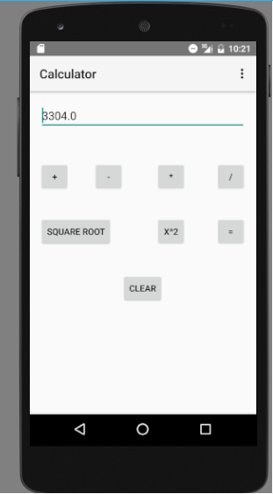

Figure 1: Screen Shot