**A Project Report on**

**“IOT Based Smart Lighting System for Hostels”**

**Report submitted to**

**The LNM Institute of Information Technology**

**for the award of the degree**

**of**

**Bachelor of Technology**

**In Computer Engineering**

**By**

**Rahul Dugar (15UCS105)**

**Karan Agarwal (15UCS058)**

**Nakul Agarwal (15UCS078)**



**DEPARTMENT OF COMPUTER ENGINEERING**

**LNM INSTITUTE OF INFORMATION TECHNOLOGY, JAIPUR**

**May 2018**

**DECLARATION**

I hereby certify that,

a) The work contained in this report is original and has been done by me under the

guidance of my supervisor(s).

b) The work has not been submitted to any other Institute for any degree or

diploma.

c) I have followed the guidelines provided by the Institute in preparing the report.

d) I have conformed to the norms and guidelines given in the Ethical Code of

Conduct of the Institute.

e) Whenever I have used materials (data, theoretical analysis, figures, and text)

from other sources, I have given due credit to them by citing them in the text

of the report and giving their details in the references. Further, I have taken

permission from the copyright owners of the sources, whenever necessary.

Rahul Dugar – 15UCS105

Karan Agarwal – 15UCS058

Nakul Agarwal – 15UCS078

Date: 10 May, 2018

**CERTIFICATE**

This is to certify that the Dissertation Report entitled, “**IOT Based Smart Lighting System**

**for Hostels**” submitted by Rahul Dugar (15UCS105), Karan Agarwal (15UCS058), Nakul

Agarwal(15UCS078) to The LNM Institute of Information Technology, Jaipur, India is a

record of bonafide Project work carried out by him/her under my/our supervision and

guidance and is worthy of consideration for the award of the degree of Bachelor of

Technology in Computer Engineering of the Institute.

Mr. Abhishek Sharma Dr. Kumar Padmanabh

(Signature) (Signature)

**ACKNOWLEDGMENT**

This document is prepared by the inspiration received from Professor Abhishek Sharma, Assistant Professor, Department of Electronics & Communication Engineering, LNMIIT. Many colleagues at LNMIIT have carefully read and improved the document; their contributions are gratefully acknowledged.

We thank non-teaching staff members of Department of Electronics and Communication for their support during this project work.

Above all, we would like to thank our parents for their support all along.

Rahul Dugar 15UCS105

Karan Agarwal 15UCS058

Nakul Agarwal 15UCS078

**ABSTRACT**

IoT lighting solutions are in demand, as commercial building owners, managers and tenants seek increased energy and operational cost savings, as well as access to data to analyse and drive occupant health and well-being. Useless consumption of electricity is one of the main causes of rising electricity bills among various households and institutions.

The project titled ‘**IOT Based Smart Lighting System for Hostels**’ proposes an automatic method of controlling lights via sensing presence of any visitors during night time. All data from various sensors nodes (PIR sensor for detecting motion data, LDR for detecting illumination level and sound sensor for detector sound from environment) are stored and visualised in cloud. The system uses Arduino Uno as controller and is implemented using Arduino IDE and Processing software.

**LIST OF FIGURES**

Fig1 : Hardware components diagram

Fig2 : Algorithm Flowchart

Fig3 : Our Project

Fig4 : Data from Light Sensor

Fig5 : Data from Sound Sensor

Fig6 : Data from PIR sensor

Fig7 : Data when Bulb was switched on

**TABLE OF CONTENTS**

Page

DECLARATION ................................................................................................... 2

CERTIFICATE ..................................................................................................... 3

ACKNOWLEDGEMENTS .................................................................................. 4

ABSTRACT........................................................................................................... 5

LIST OF FIGURES................................................................................................ 6

CHAPTER 1 INTRODUCTION............................................................................ 8

CHAPTER 2 LITERATURE SURVEY ............................................................... 9

CHAPTER 3 PROBLEM STATEMENT ........................................................... 11

CHAPTER 4 OUR SOLUTION ......................................................................... 11

CHAPTER 5 SYSTEM OVERVIEW .............................................................. 12

5.1 Hardware Tools.......................................................................................... 12

5.2 Software Tools.......................................................................................... 14

CHAPTER 6 IMPLEMENTATION ……….......................................................... 15

CHAPTER 7 RESULTS AND DISCUSSIONS…............................................... 16

CHAPTER 8 CONCLUSIONS AND FUTURE SCOPE ..................................... 19

BIBLIOGRAPHY... .................................................................................................... 20

**INTRODUCTION**

Electricity has become a basic need for every human being since the advent of Industrial Revolution. But many are concerned with the sustainability of electricity as Institutions are wasting a lot of electricity each day without paying much attention to the long term effects of such actions.

It is the height of paradox for a country where blackouts are more a norm than exception. Over 3 billion units of electricity, or a day's national consumption, were wasted in 2014-15 as congestion in the transmission highways blocked trading between surplus and deficit regions as evident from [10].

Much of these can be attributed to the carelessness of the authority. Many of the residential, institutional and commercial places tend to waste electricity during night time in the form of useless lighting of the lobbies even when there is no one to attend to. This can lead to some extra weight on their bill which can be reduced.

**LITERATURE SURVEY**

Our proposed solution is based on an IOT system which makes use of sensors installed on it to get sense of environment and with help of actuators can perform required action. Here the required action is turning lights ON or OFF. This decision is based on some algorithm which gives light status decision based on data from sensors. Data from this system can be shared to other such systems thus enabling better decisions based on inter-communication among devices. Data collected from our system can also help in obtaining valuable outcomes using analysis techniques.

[1] proposes a solution based on IOT system for city-wide level. A smart lighting system has been introduced with brief overview of communication protocols used. Their analysis revealed that using IOT solutions can reduce power consumption by over 30%. [2], [3] discuss IOT solutions to build smart lighting solutions in buildings. Sensors have been used to make decisions for lighting and air-conditioning. These solutions have been shown to be more effective in power management.

Most intuitive solution to save electricity is to turn OFF lights when no person is near them and then turn them ON when reaches a specified area. [4] use PIR sensors to decide if someone is inside a room and then switch light state. An algorithm for counting number of people has been implemented. [5] performs human tracking and activity recognition to change light state including illumination. A microwave sensor has been used in [6] For this task, thermal and depth cameras have been used. NFC tags have been used in [7], which work on weak radio signal for communication. Unique user tags have been used containing user information and lights’ illumination are changed based on preference of users. [8] proposes a unique solution for a smart lighting system for a museum. Data from sensors collected include relative position of viewers relative to an exhibit. Different lights near the exhibit are then modified to provide best viewing experience to users. Evolutionary algorithms have been used to give the best outcome. Not only does this give an enhanced user experience but also significant savings have been predicted by use of such a system.

Fruitful conclusions can be derived from analysis of data from sensors. [11] shows data analysis from smart lighting system in hostels and based on consumed voltage they were able to predict that maximum power consumption is from electrical cooking appliances.

It is important for these smart solutions to be cost effective along with being primarily energy efficient. Savings from saved energy should cover up cost of installation of these systems. [9] discusses a system of smart lighting solution at a smart city level. They have simulated deployment of their proposed solution and have successfully shown cost effectiveness of such solutions.

**PROBLEM STATEMENT**

The problem statement which we are focussing on is to reduce the consumption of Electricity in our hostel Lobbies using our IOT device which will operate the lights in the lobbies by sensing presence of the visitors and limit the consumption in day if the strength of light is above a certain limit.

**OUR SOLUTION**

We have made an IOT device which will detect the presence of the visitors using sensor nodes by sensing their motion and audio output which will in turn switch on the lights and switch off them when detecting no presence. We are also checking whether daylight is optimum for switching the lights on or not.

**SYSTEM OVERVIEW**

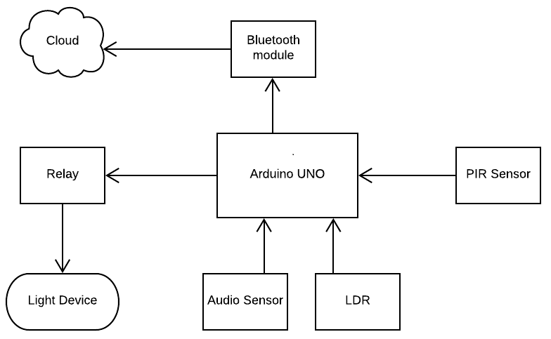

Fig1 : Hardware components diagram

**Hardware Tools:**

* **Arduino Uno:**  It will process all the inputs sent by all the sensor nodes and generate the proper output based on it. Like if we have a value “1” from PIR sensor Node, a value above a certain limit from audio sensor and a value above a optimum light from Light sensor it will make the connection making the lights glow. It will also send the data to the Server/Cloud too.
* **PIR Sensor:** It will sense the motion of any visitor by measuring infrared (IR) light radiating from objects in its field of view. It will then send a digital value based on the readings to the Arduino.
* **Audio Sensor:** It will sense the sound in the lobby whether the visitors are still there or not. It will send analog signals to the Arduino which will decide whether it is above a certain sound value threshold.
* **Light detecting Sensor:** It will sense the illumination in the certain area by changing its resistance. It will send analog signals to the Arduino which will decide for lights to be allowed to turn on or not based on a certain optimum illumination value.
* **Relay:** It will open and close the circuits based on the inputs provided by the various sensors.
* **Bluetooth Module:** It will be used to send all the data from sensors to the cloud (Thing Speak) which will visualize the data in various formats for user to understand the consumption at various times.

**Software Tools:**

* **Arduino IDE:** It contains a text editor for writing code, a message area, a text console, a toolbar with buttons for common functions and a series of menus. It connects to the Arduino and Genuino hardware to upload programs and communicate with them. We can use text editor to write and compile code C code for Arduino. Serial Monitor can be used to view all the inputs received from various nodes.
* **Processing (3.3.7): Processing 64-bit** is a flexible software sketchbook and a language for learning how to code within the context of the visual arts. Since 2001, **Processing** has promoted software literacy within the visual arts and visual literacy within technology. There are tens of thousands of students, artists, designers, researchers, and hobbyists who use **Processing** 64-bit for learning and prototyping. We used it to upload our data from a port using Bluetooth to our Thing Speak Cloud.
* **Thing Speak:** It is an open IOT platform with MATLAB analytics which helped us to visualize data from our various sensors and when the bulb was switched on and for what time period.

**IMPLEMENTATION**

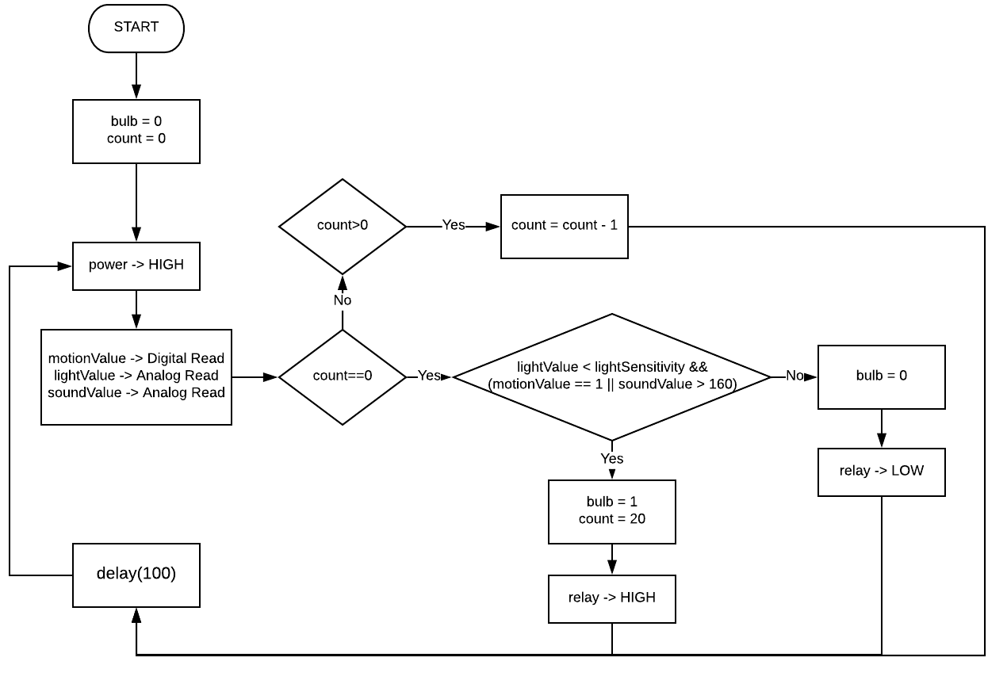Fig2 : Algorithm Flowchart

Our algorithm works on the values given us by the PIR sensor, ldr sensor and audio sensor. It sets the bulb and count value to 0. After gaining values from the sensor nodes, we check the condition whether light value > light sensitivity and motion is there with sound greater than sound sensitivity. All these sensitivity are decided depending on the place. It then proceeds to set count to 20 and relay high which will glow the bulb. If our count is already high then we reduce it by one and add a delay of 100 milliseconds to it. As long as our count is greater than 0, bulb glows. As it comes to 0 it goes back to loop. Our Arduino will keep sensing all the time with a delay of 100 milliseconds.

**RESULTS**

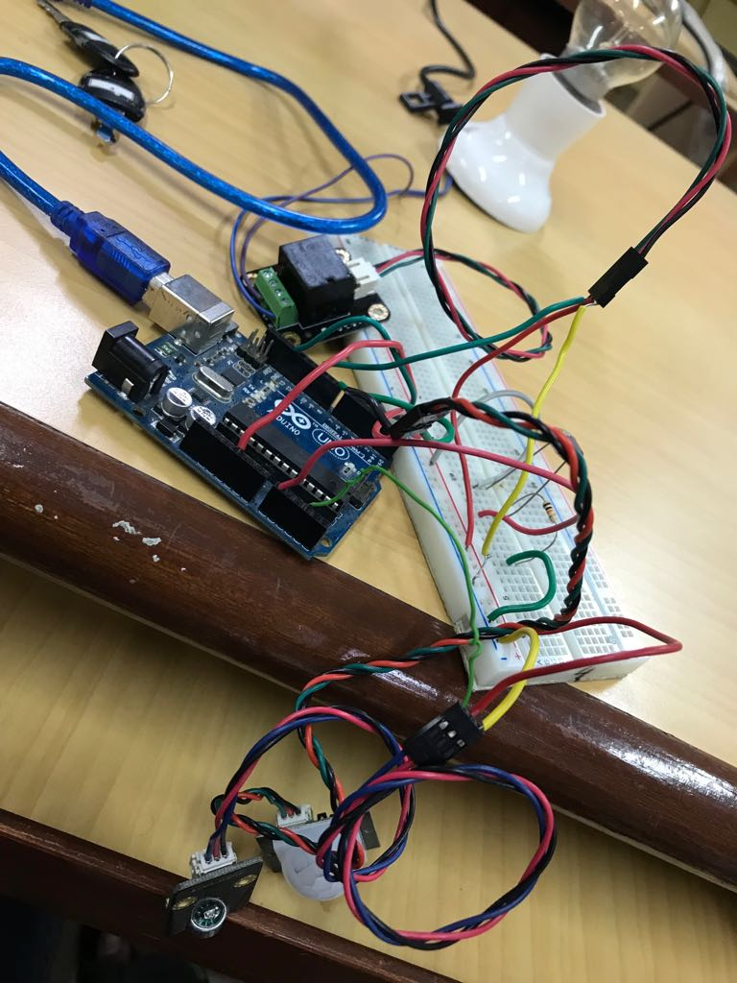

Fig3 : Our Project

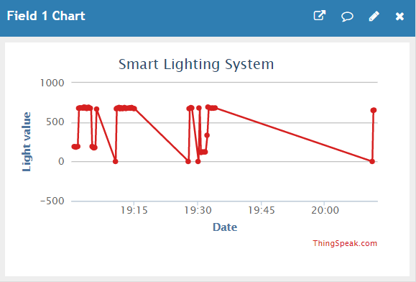

Fig4 : Data from Light Sensor

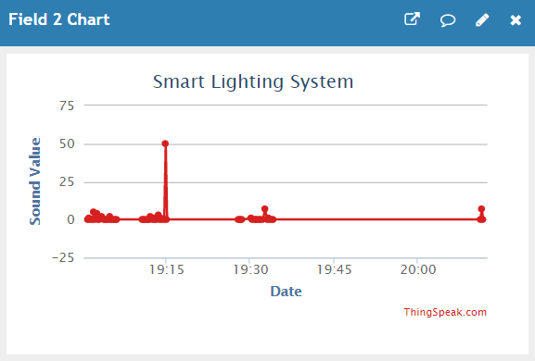

Fig5 : Data from Sound Sensor

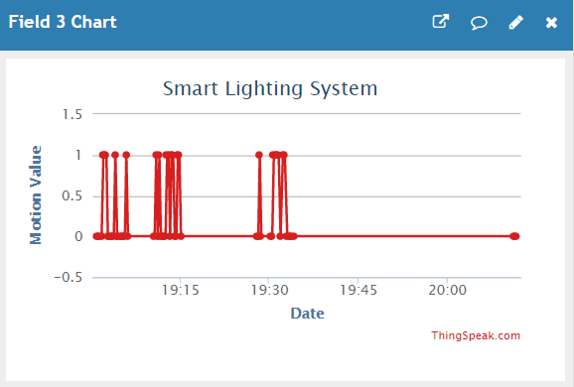

Fig6 : Data from PIR sensor

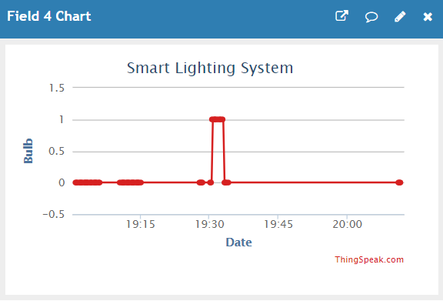

Fig7 : Data when Bulb was switched on

**CONCLUSIONS AND FUTURE WORK**

IOT Based Smart Lighting System for Hostels is an automation system and it is a recompense over the present fair price shops. To increase accuracy, we have added sound sensor so that if in case of no motion we can still keep the lights on. Using the IR, sound and illumination we tried to minimise the consumption where the illumination is below a certain level and no visitors are there in that lobby. Our system can sense the presence of visitors with accuracy.

Project can further be extended by making it more intelligent as to adapt to any environment and setting the light as well as audio threshold for different place by itself. Thus, it will make system more automatic. We can try to increase its accuracy by adding more sensors.

**BIBLIOGRAPHY**

[1]. Sikder, A., Acar, A., Aksu, H., Uluagac, A., Akkaya, K. and Conti, M. (2018). IoT-enabled smart lighting systems for smart cities. 2018 IEEE 8th Annual Computing and Communication Workshop and Conference (CCWC).

[2]. Jeyasheeli, P. and Selva, J. (2017). An IOT design for smart lighting in green buildings based on environmental factors. 2017 4th International Conference on Advanced Computing and Communication Systems (ICACCS).

[3]. Higuera, J., Carreras, J., Perálvarez, M. and Hertog, W. (2014). Hybrid smart lighting and climate control system for buildings. IET Conference on Future Intelligent Cities.

[4]. Botler, L. and Sadok, D. (2016). A presence sensor for smart lighting systems. IECON 2016 - 42nd Annual Conference of the IEEE Industrial Electronics Society.

[5]. Chun, S. and Lee, C. (2013). Applications of Human Motion Tracking: Smart Lighting Control. 2013 IEEE Conference on Computer Vision and Pattern Recognition Workshops.

[6]. Tetervenoks, O., Suskis, P. and Stegura, J. (2017). Integration of microwave sensor into low cost indoor LED lamp — Element of smart lighting system. 2017 5th IEEE Workshop on Advances in Information, Electronic and Electrical Engineering (AIEEE).

[7]. Chandrakar, N., Kaul, S., Mohan, M., Sai Vamsi, C. and Prabhu, K. (2015). NFC based profiling of smart home lighting system. 2015 International Conference on Industrial Instrumentation and Control (ICIC).

[8]. Viani, F., Polo, A., Garofalo, P., Anselmi, N., Salucci, M. and Giarola, E. (2017). Evolutionary Optimization Applied to Wireless Smart Lighting in Energy-Efficient Museums. IEEE Sensors Journal, 17(5), pp.1213-1214.

[9]. Cacciatore, G., Fiandrino, C., Kliazovich, D., Granelli, F. and Bouvry, P. (2017). Cost analysis of smart lighting solutions for smart cities. 2017 IEEE International Conference on Communications (ICC).

[10]. Dutta, Sanjay. “Three Billion Units of Power Wasted in One Year.” The Times of India, India, 4 July 2015, timesofindia.indiatimes.com/india/Three-billion-units-of-power-wasted-in-one-year/articleshow/47942237.cms.

[11]. Olatomiwa, L.J., Uligwe, J.J., Sadiq, A.A. and Ambafi, J.G., Investigation of Electrical Energy Use Efficiency of Students’ Hostel in Gidan Kwano Campus of Federal University of Technology, Minna.