METALS AND NON METALS IMPORTANT QUESTION AND ANSWERS

23:42:00

**One Word Answers**

1.Which metal is liquid at room temperature other than mercury?  
Ans.Gallium  
2.Which non metal is lustrous and shiny?  
Ans.Iodine  
  
3.Which non metal is good conductor of Electricity?  
Ans.Graphite  
4.Which Metals can be cut with Knife?  
Ans.Sodium,Potassium,Lithium  
5.Which Metals have very low melting and boiling point?  
Ans.Gallium and Ceasium  
6.A reaction in which more reactive metal displaces less reactive metal from its salt solution  
Ans.Displacement reaction  
7.Which non metal is liquid at room temeprature  
Ans.Bromine  
8.Which is the hardest element known to mankind  
Ans.Diamond  
9.Metal Oxides which show both basic and acidic nature  
Ans.Amphoteric oxides  (Aluminium oxide, Zinc Oxide)  
10.Sulphur is stored in....  
Ans.Water  
11.Sodium, and Potassium are usually kept in...  
Ans.Keroscene  
12.Some elements show property of both metals and non metals  
Ans.Metalloids  
13.Compound formed by transform of electrons from Metals to Non Metals  
Ans.Ionic Compound  
14.the damage caused to metals due to the reaction of metals with oxygen, moisture, carbon dioxide etc.   
Ans.Corrosion  
15.A mixture of concentrated nitric acid and concentrated hydrochloric acid in the ratio 1:3.  
  
 16.A pencil lead is made up of Non Metal called  
Ans.Graphite  
17:Hard and brittle form of iron with a high carbon content is :-  
Ans:Pig Iron  
18. Tough and Malleable form of iron is  
Ans.Wrought Iron  
  
  
Question and Answers  
  
Q1.Cooking utensils are made of metals but their handles are made of wood or plastic,Why ?  
Ans. Cooking utensils are made of metals because metals are good conductors of heat so that heat gets conducted in a proper way from the fire( cooktop or induction cookerheat) into the food which is being cooked.On the other hand, the handles of cooking utensils must be held time to time during cooking. Since metallic handles will be very hot to hold thus handles are made fromany plastic or wood which are bad conductors of heat.  
Q2.Why is it advised not to store pickles and curd in metallic utensils ?   
Ans.Kitchen  utensils  are  generally  made  up  of  metals  like  iron  These   
metals  are  quite  reactive  and  due  to  the  reaction  between  acid  present  in  pickle  or   
curd and the utensil metal, a toxic substance may be formed. This can harm our health.   
Q3.Other than iron do any metal get rusted?If yes explain how  
Ans.Yes copper gets rusted in moist air and acuires a dull green coating.Copper gets corroded or rusted in the presence of carbon dioxide and water to form a green coating,which is mixture of copper hydroxide and copper carbonate.  
Q4.How will you prove the nature of metal oxides?  
Ans.If we burn a magnesium ribbon, white ash of magnesium oxide is formed. Now by   
adding little water to white ash we can prepare solution of magnesium oxide. When   
we dip red litmus paper into this solution it turns blue while when we dip blue litmus  paper into this solution colour remains unchanged. It proves that metal oxides are basic in nature.  
Q5.Write down any five important uses of metals ?  
Ans. Lead is used in X-ray machines.

(ii) Iron is used in construction.

(iii) Mercury is used in thermometers.

(iv) Gold and silver are used in making jewellery.

(v) Aluminium foil is used for packing food.  
Q6.What are noble metals?  
Ans.Some of the metals are more reactive while other are less reactive. But there are   
certain  metals  that  are  very  unreactive  as  they  do not  react  with  oxygen,  water,   
moisture, or even any of the dilute acids for example gold and platinum. Therefore   
such metals are called as noble metals.  
Q7. List any five important uses of non metals ?  
Ans. i) Sulphur is used in vulcanization of rubber,which makes rubber sufficiently hard

to produce tyres.

(ii) Phosphorus is used in making phosphatic fertilizers.

(iii) Graphite is used in making lead of pencils.

(iv) Hydrogen can be used as a fuel that will be a non polluting option of fuel.

(v) Chlorine is added to water for purification purpose.  
Q8.What would happen if sodium and potassium are kept in open air?  
Ans. Both  sodium  and  potassium  are  highly  reactive  metals.  They  react  violently  (may catch fire) with oxygen and moisture present in air  
 even at the room temperature. A lot of heat is evolved when such reaction occurs and as such the metal is lost because it makes oxides. Hence these extremely reactive metals are not kept in open but are kept immersed in the kerosene.  
  
CBSE class 8 NCERT Question Answers from Metals and Non Metals

[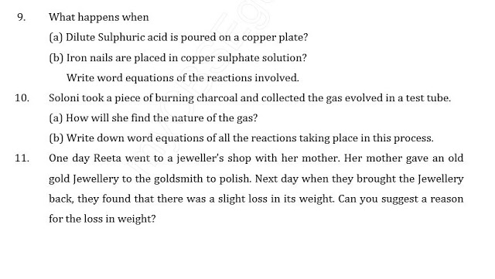](http://1.bp.blogspot.com/-mMDuhHvtxW8/VZjRPs9cATI/AAAAAAAAA2U/cZAdT86YyTg/s1600/ncert.JPG)

[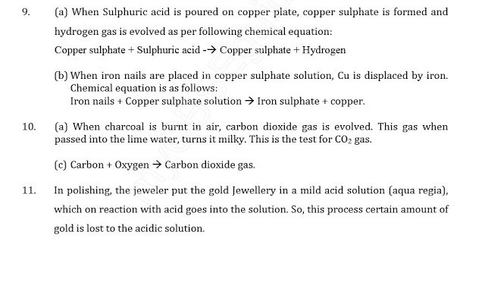](http://4.bp.blogspot.com/-2y-f0wDKZks/VZjRRPcRl8I/AAAAAAAAA2c/Tp16sJRUERY/s1600/ncert+solution.JPG)

**Class VIII Science  
HOTS for Metals and Non-Metals**

**1.**   Explain displacement reaction with the help of an activity.

**2.**   Explain the reaction of non-metals with oxygen with the help of an acitivity.

**3.**   Write the uses of metals and non-metals.

**4.**   Write the difference between metals and non-metals on the basis of their physical properties.

**5.**   Name two most ductile metals.

**6.**   Sodium is stored in kerosene. Why?

**7.**   What are oxides? Write the nature of metallic and non-metallic oxides.

**8.**   Explain displacement reaction with the help of an example.

**9.**   Explain the reactions of metals and non-metals with (i) Acids (ii) Air (iii) Water.

**10.**   Write the uses of metals and non-metals in our daily life.

**FRICTION  
HIGH ORDER THINKING QUESTIONS**

**1.**   Write some harms of friction.

**2.**   What is sliding friction?

**3.**   Why we fall down when we stop on banana peel?

**4.**   In which direction frictional force acts on a moving object.

**5.**   What is easier- rolling or sliding?

**6.**   What is drag?

**7.**   Hoes does the friction get affected by the nature of surface?

**8.**   What happens, if the floor we walk on is friction less?

**9.**   The sole of shoes get worn after some time. Explain why?

**10.**   What happens when there is no friction between the chalk and the blackboard.

**11.**   Write on harm of friction.

**12.**   Why do kabaddi players rub their hands with soil?

**Class VIII Science  
Test for Metals and Non-Metals**

**Total Marks : 20**

**Total Time : 35 min**

**1.**   What happens when a solution of metals oxide is tested with (i) blue litmus and (ii) red litmus?

**(1 mark)**

**2.**   What happens when sodium reacts with water?

**(1 mark)**

**3.**   Why is sodium stored in kerosene?

**(1 mark)**

**4.**   What happens when a metal reacts with acids?

**(1 mark)**

**5.**   Have you ever seen a blacksmith beating an iron piece? Do you find a change in the shape of these pieces on beating? Would you expect a similar change in wood log on beating?

**(2 marks)**

**6.**   What is malleability? Name two most malleable metals.

**(2 marks)**

**7.**   What happens when samples of metals and non-metals are mixed with acids?

**(2 marks)**

**8.**   Write the uses of metals and non-metals.

**(4 marks)**

**9.**   Write the difference between metals and non-metals on the basis of their physical properties.

**(3 marks)**

**10.**   Compare the metals and non-metals on the basis of their chemical properties.

**(3 marks)**

**[CHEMISTRY]**

**METALS AND NON METALS**

**Name the following questions:-**

1. Name some common non-metals used in our daily life.

2. Hardest naturally occurring substance.

3. Property of metals which make them useful as electric wires.

4. Non – metal which has metallic luster.

5. Two non metals which are soft solids.

6. Non metals do not conduct electricity or heat except for one . Name it.

7. An allotrope of carbon which is as tensile as steel.

8. Metals that are not attacked by cold water, boiling water or stream.

9. The property of metals by virtue of which these can beaten into sheets.

10.Non metals used in disinfection of drinking water.

**II. Answer the following( in one or two words)**

1. What are the elements called which can neither fit with metals nor non metals?

2. Which of the following metals is the best conductor of heat and electricity? Gold, Silver, Copper, Aluminum

3. Which property of metals makes them useful as ringing bells?

4. Arrange the following elements in order of increasing reactivity. Sodium, Magnesium, Copper, Zinc, Aluminum

5. An oxide solution of which of the following elements will turn blue litmus red.

6. Which non-metal is used in making pencil lead?

7. Identify the most reactive and least reactive metal amongst the following Aluminum, Potassium, Copper, zinc, Gold

8. State the nature of oxides of non-metals.

9. Give an example of neutral oxide .

10.Which non metal is kept under water and why?

CLASS-8 Term I (2013-2014)

Metals & Non-metals

Chemistry Assignment

Q1. How are elements classified ?

Q2. What are metalloids ? Give 2 examples.

Q3 a. Define the terms: Malleability and Ductility

b. Name the two most malleable metals.

Q4. State the difference between metals and non metals on the basis of the following

criteria –

a. Lustre b. Thermal & electrical conductivity

c. Physical state d. Ductility

Q5. Answer in one word:

a. A liquid metal

b. A liquid non metal

c. A soft metal

d. A lustrous non metal

e. A hardest naturally occurring non metal

f. A non-metal which conducts electrically

g. A metal having low melting point

Q6. State the differences between:-

Metals and non –metals in their reaction with Oxygen. Give 2 examples of the kind

of oxides formed by them.

Q7. Explain the phenomena of rusting with the help of a word equation ?

Q8. Give reasons:-

a. When Iron is mixed with Copper Sulphate Solution, the colour of the solution

changes.

b. Metals like Sodium & Potassium are stored in Kerosene oil while non-metals like

Phosphorous is stored in water.

c. Copper is used for making electrical wires.

d. Copper loses its Lustre and develops a green coating over it when exposed to

atmosphere.

Q9. An unknown element X reacts in air to form its oxide Y. This Y dissolves in water

which turns blue litmus into red. Predict whether X is a metal or a non-metal ?

learncbse.in

learncbse.in

Q10. a. Name the products formed when a piece of Sodium metal is added to water.

b. When the solution so formed, is tested with litmus, what kind of colour change is

expected ? Reason out your answer.

Q11. How do you test the presence of Hydrogen gas ?

Q12. Complete the following reactions:-

a. Magnesium + Oxygen →

b. Magnesium Oxide + Water →

c. Iron + Oxygen + Water →

d. Sulphur dioxide + Water →

Sulphur Dioxide is an acidic oxide which reacts with water to give sulphurous acid.

**SO2 + H2O ==> H2SO3**

Sulphur dioxide is a good reducing and oxidising agent.

e. Aluminium + Hydrochloric acid →

[home](http://www.chegg.com/) / [study](http://www.chegg.com/study) / [science](http://www.chegg.com/homework-help/science) / [chemistry](http://www.chegg.com/homework-help/science-chemistry-s6) / [chemistry questions and answers](http://www.chegg.com/homework-help/questions-and-answers/chemistry-archive) / 1.) aluminum reacts with hydrochloric acid to produce ...

*Question*: 1.) Aluminum reacts with hydrochloric acid to prod...

1.) Aluminum reacts with hydrochloric acid to produce aluminum chloride and hydrogen gas.  
2Al(s) + 6HCl(aq) -> 2AlCl3(aq) + 3H2(g)

f. Iron + Sulphuric Acid →

Iron reacts with dilute sulphuric acid to form ferrous sulphate

Fe +H2SO4 -> FeSO4 + H2

g. Copper + Hydrochloric acid → no reaction

h. Copper + Sulphuric acid (dil.) →

Copper does not react with dilute sulphuric acid

1. Copper Sulphate + Zinc →
2. Zinc is more reactive than copper. So, here , on adding zinc to CuSO4 solution,  zinc **displaces** copper from copper sulphate & forms zinc sulphate solution. This is indicated by colour change from **blue** to **colourless.**CuSO4 solution has a blue colour while ZnSO4 solution is colourless.   
     
   **Chemical equation -**  
   Zn(s) + CuSO4(aq) -> Cu(s) + ZnSO4 (aq).

j. Copper Sulphate + Iron →

* The brown coating on the iron nail shows that copper is deposited on the iron nail by displacing iron.
* The greenish colour of the solution in the test tube shows that Fe2+ ions are present in the solution.
* This shows that iron is more reactive than copper, as Fe2+ ions have displaced Cu2+ ions from copper sulphate solution.
* This is a single displacement reaction in which copper has been displaced from iron from copper sulphate solution.

http://amrita.olabs.edu.in/userfiles/1/image/displacementReactionProcEqn1.gif

Q13. A Copper statue was found to lose its lustre after some time. A layer of dull green

coating was deposited over it. Explain the cause along with a relevant word

equation.

Q14. Consider the following reactions –

a. A + BX → AX + B

b. B + CY → BY + C

Arrange A, B, C in the increasing order of their reactivity.

Q15. What would happen when a Copper wire is dipped in Silver Nitrate solution ?

Q16. Can you guess?

a. Non-metal essential for our life

b. Non-metal used in fertilizers for growth of plants

c. Non-metal which is used in purification of water

d. Non-metal used as an antiseptic over wounds

e. Non-metal used in crackers