FOOD DETECTION AND CALORIE ESTIMATION
Using Python, Tkinter, and YOLO Object Detection

PROJECT DOCUMENTATION

Technologies: Python • Tkinter • YOLO (Ultralytics) • Pillow • OpenCV

1. Abstract
Food Detection and Calorie Estimation is a desktop application that lets a user select a food image, run YOLO object detection, view the detections, and estimate calories using a configurable nutrition lookup table. The graphical user interface is built with Python Tkinter. For each detected label that matches the calorie database, the program estimates calories from a default portion size. This is an educational prototype: recognition and portion estimates are approximate, and the default general-purpose YOLO model recognizes only ten food classes.

2. Introduction
Tracking food intake manually is inconvenient. Image-based food analysis shows how computer vision can be combined with a desktop interface and nutrition data. The application accepts an image, detects supported objects, and displays an estimated calorie total.

2.1 Problem Statement
Create a desktop application that accepts a food image, identifies supported objects, presents detection results, and calculates approximate calories without requiring every food item to be entered manually.

2.2 Objectives
- Build a desktop GUI using Tkinter.
- Browse for JPG, JPEG, PNG, BMP, or WEBP images.
- Run YOLO detection and display annotated results.
- Match detected labels to a calories-per-100-gram lookup table.
- Estimate calories using configurable default portion sizes.
- Display per-item estimates and the total.

3. Scope and Limitations
This version is intended for learning and project demonstration. It can calculate calories only for labels that the model returns and that are also present in the calorie database.
- The default yolo11n.pt model is trained on the COCO dataset. Of its 80 classes, only 10 are foods: apple, banana, orange, broccoli, carrot, sandwich, hot dog, pizza, donut, and cake.
- Portion sizes are assumptions; the application does not measure food mass from the image.
- Mixed dishes such as biryani, curry, dosa, idli, dal, and chapati need a food-specific model. Their nutrition values are already in the database, ready for such a model.
- Calories vary with ingredients, recipes, and cooking methods.
- Results are estimates, not medical or dietary advice.

4. Requirements

4.1 Hardware
- Windows 10 or 11 computer (macOS and Linux also work)
- At least 4 GB RAM; 8 GB recommended
- Internet connection for the initial package and model-weight downloads
- About 2 GB of free storage for Python packages (mostly PyTorch) and model weights

4.2 Software
Package | Purpose
Python 3.11 (3.9 to 3.12 supported) | Runtime
Tkinter | Graphical user interface (bundled with python.org installers)
Ultralytics | YOLO model loading and prediction
PyTorch and TorchVision | Neural-network backend used by Ultralytics
Pillow | Opening, converting, and resizing images
OpenCV | Image utilities used by Ultralytics for drawing boxes
NumPy | Array handling between the model and Pillow

5. System Architecture
1. User Interface: Tkinter buttons, image preview, result table, total, and status bar.
2. Image Input: Pillow opens the chosen image and converts it to RGB.
3. Object Detection: Ultralytics loads YOLO (models/best.pt if present, otherwise yolo11n.pt) and runs prediction on a background thread so the window stays responsive.
4. Label Mapping: class names are normalized (lowercase, underscores and hyphens to spaces, aliases such as "doughnut" to "donut") and matched to the calorie database.
5. Calorie Estimation: calories = kcal per 100 g × assumed portion in grams ÷ 100.
6. Result Display: the worker thread passes results back through a queue, and the main thread shows the annotated image, labels, confidence, portion assumptions, item calories, and the total.

6. Project Folder Structure
Food_Calorie_Detection_Tkinter/
├── app.py # Tkinter GUI and detection workflow
├── calorie_data.py # Calorie table, portion sizes, estimation helpers
├── requirements.txt # Dependencies
├── run_windows.bat # One-click Windows setup and run script
├── README.md # Setup notes
├── LICENSE # AGPL-3.0 (matches Ultralytics)
├── tests/ # Automated tests for the calorie logic
├── docs/ # This document and a screenshot
├── models/ # Optional food-trained model (best.pt)
└── sample_images/ # Test images

7. Main Modules

7.1 app.py
Creates the Tkinter window with three buttons: Load Food Image, Detect Food, and Choose Model. It loads images, loads the YOLO model on first use, runs prediction on a worker thread, and shows the annotated image and result table. Tkinter widgets may only be updated from the main thread, so the worker puts its result on a queue.Queue that the main thread checks every 100 ms. The module handles invalid images, a missing package, model-loading errors, and detection errors with message boxes.

7.2 calorie_data.py
Contains the CALORIES dictionary (approximate kcal per 100 g), the DEFAULT_PORTION_GRAMS dictionary, and an ALIASES dictionary for alternative class names. It also provides three helper functions: normalize_label(), estimate_calories(), and summarize(), which builds the result rows and the total. Edit the dictionaries to add foods or change serving sizes.

7.3 requirements.txt
Lists the external Python packages. Tkinter is included with the standard python.org Windows installer.

7.4 run_windows.bat
On first run it creates the virtual environment with Python 3.11 and installs the requirements. It then checks that PyTorch imports correctly and starts the app.

8. Calorie Calculation
The application uses this formula:
Estimated calories (kcal) = kcal per 100 g × portion size (g) ÷ 100
Example: rice is configured as 130 kcal per 100 g with an assumed portion of 180 g.
130 × 180 ÷ 100 = 234 kcal
The total is the sum of the estimates for detected items that match the calorie dictionary. Unmatched labels appear in the table with calories marked N/A and are not added to the total. Values for the default model's food classes:
Food | kcal / 100 g | Portion (g) | Estimated kcal
apple | 52 | 180 | 93.6
banana | 89 | 120 | 106.8
orange | 47 | 130 | 61.1
broccoli | 34 | 90 | 30.6
carrot | 41 | 60 | 24.6
sandwich | 250 | 150 | 375
hot dog | 290 | 100 | 290
pizza | 266 | 107 | 284.6
donut | 452 | 60 | 271.2
cake | 350 | 80 | 280

9. Installation and Execution on Windows
Use a clean virtual environment to avoid conflicts with Anaconda or other Python installations. The quickest option is to double-click run_windows.bat. To install manually:
1. Extract Food_Calorie_Detection_Tkinter_Project.zip (or clone the GitHub repository).
2. Open Command Prompt in the extracted Food_Calorie_Detection_Tkinter folder.
3. Check Python: py -3.11 --version
4. Create an environment: py -3.11 -m venv venv
5. Activate it: venv\Scripts\activate
6. Upgrade pip: python -m pip install --upgrade pip
7. Install dependencies: python -m pip install -r requirements.txt
8. Test PyTorch: python -c "import torch; print(torch.__version__)"
9. Test YOLO: python -c "from ultralytics import YOLO; print('YOLO OK')"
10. Start the app: python app.py
On the first detection, the YOLO weights (about 5 MB) download automatically. Wait for the download to finish; the status bar shows progress.

10. How to Use the Application
1. Start the app with python app.py (or run_windows.bat).
2. Click Load Food Image and select an image file.
3. Click Detect Food and wait for processing.
4. Review the annotated image and the results table.
5. Read the Total Calories value as an estimate, not a precise nutrition measurement.
6. Optional: click Choose Model to use a food-trained .pt file instead of the default model.

11. Troubleshooting

11.1 ModuleNotFoundError: No module named 'ultralytics'
Activate the project environment and install packages through that environment's Python:
venv\Scripts\activate
python -m pip install -r requirements.txt

11.2 WinError 1114 loading torch\lib\c10.dll
This usually means PyTorch or one of its native dependencies cannot initialize. Check which Python is running:
where python
python -c "import sys; print(sys.executable)"
The executable should point to the project's venv\Scripts\python.exe. If it points to an Anaconda installation (for example C:\Users\<you>\anaconda3\python.exe), activate the project environment or call its Python directly. If the error remains in a clean environment, install the current Microsoft Visual C++ Redistributable for Visual Studio 2015–2022 (x64), restart the terminal, and reinstall PyTorch:
python -m pip uninstall -y torch torchvision torchaudio
python -m pip install torch torchvision
python -c "import torch; print(torch.__version__)"
Do not continue to YOLO testing until importing torch succeeds. Avoid mixing packages between Anaconda base and the project virtual environment.

11.3 No food items are matched
The general YOLO model may return labels that are not in the calorie dictionary (for example "dining table" or "bowl"). Use a food-trained YOLO model, make sure its class names match the lookup table (or add them to ALIASES), and add nutrition values for any new classes.

11.4 No module named '_tkinter' (macOS / Linux)
Some Python builds ship without Tk. On macOS with Homebrew run brew install python-tk@3.12 (matching your Python version); on Debian or Ubuntu run sudo apt install python3-tk.

12. Testing

12.1 Automated tests
tests/test_calorie_data.py checks the calorie logic with pytest (python -m pytest). All 7 tests pass:
- The documented rice example returns exactly 234 kcal.
- Label normalization and aliases ("Hot_Dog", "hotdog", "Doughnut", "French-Fries").
- Unknown labels return no estimate.
- The total includes only matched items.
- An empty detection list gives a total of 0.
- Every portion size has a matching calorie value.
- All 10 COCO food classes are covered by the database.

12.2 Manual test cases
Test | Expected result | Result
Load a valid JPG image | Preview appears | Pass
Load a PNG image | Preview appears | Pass
Click Detect Food with no image loaded | Warning message appears | Pass
Detect on a photo of two pizza slices | Annotated preview and rows appear | Pass
Check calorie arithmetic | 266 × 107 ÷ 100 = 284.6 kcal per slice; total 569.2 kcal | Pass
Unsupported label (dining table) | Row shows N/A, not added to total | Pass

12.3 Sample result
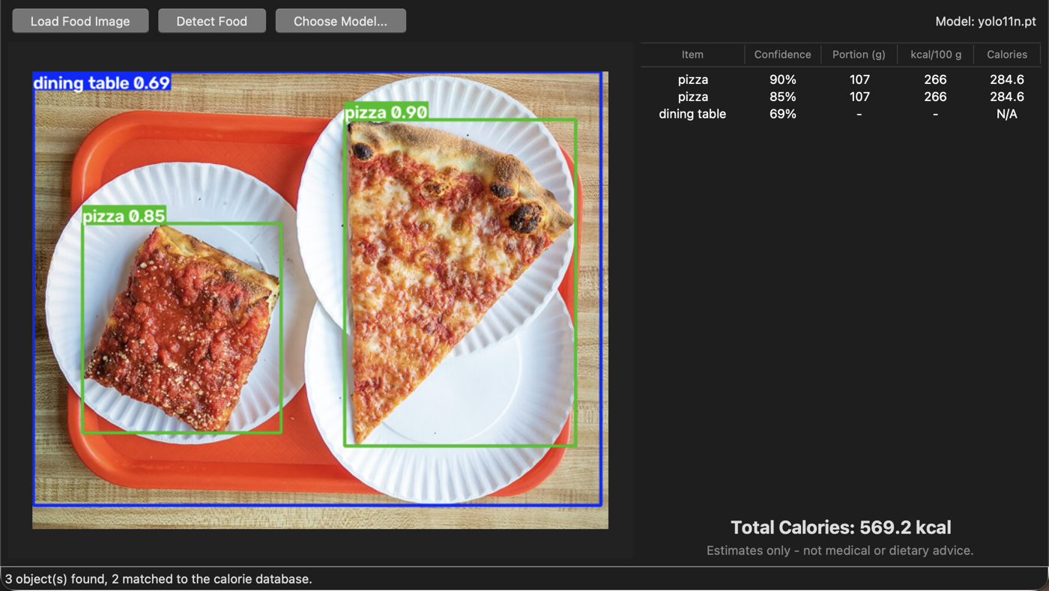
Figure 1. Two pizza slices detected at 90% and 85% confidence. The tray was detected as a dining table and excluded from the total. Photo: Rhododendrites, CC BY-SA 4.0, via Wikimedia Commons.
The same run on a fruit bowl labelled pieces of fruit as "carrot", which shows why a food-trained model is needed for dependable results.

13. Future Enhancements
- Train or integrate a food-specific YOLO model for rice, idli, dosa, chapati, biryani, dal, and curry.
- Allow users to edit portion sizes in the results table.
- Add SQLite storage for users, meals, and daily history.
- Add login/registration and a dashboard.
- Estimate protein, carbohydrates, and fats.
- Add daily goals, charts, and CSV/PDF reports.
- Evaluate the model against a labelled test dataset (precision, recall, mAP).

14. Conclusion
This project combines Python Tkinter, YOLO object detection, and a nutrition lookup table in an image-based calorie-estimation prototype. It provides a foundation for a final-year project. Dependable food recognition requires a food-trained model, and more accurate calorie estimation requires better portion-size estimation and nutrition data.

15. References
- Python documentation: https://docs.python.org/3/
- Tkinter documentation: https://docs.python.org/3/library/tkinter.html
- Ultralytics documentation: https://docs.ultralytics.com/
- COCO dataset classes: https://cocodataset.org/
- PyTorch installation guide: https://pytorch.org/get-started/locally/
- Pillow documentation: https://pillow.readthedocs.io/

