The given graph is the final graph of K-means clustering model . Here we can see that differnet points are clustered according their properties.

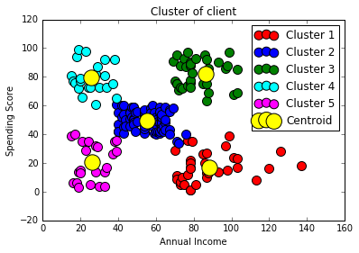

Given graph shows the elbow method to define the number of clusters

