1.Configuring Initial Switch Settings

Enable

Config t

Hostname S1

Line console 0

Password letmein

Enable password cisco

Enable secret itsasecret

Banner motd “txt”

service password-encryption

Line console 0

Login

2.Configure Initial Router Settings

enable

Show running-config

Show startup-config

Config t

Hostname R1

Line console 0

Password letmein

Login

Exit

Enable password cisco

enable secret itsasecret

Service password-encryption

Banner motd “”

Exit

Exit

2.4.1.2 Packet Tracer - Skills Integration Challenge

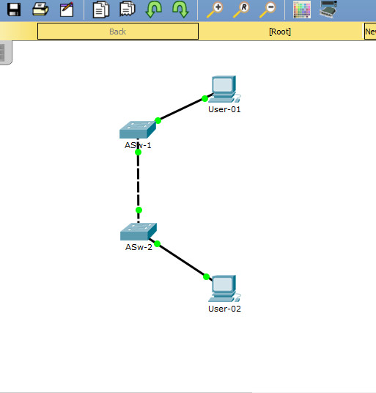

ANS:

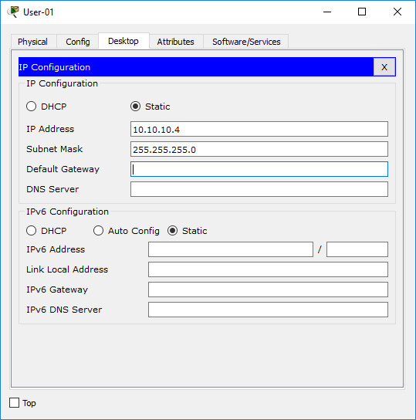

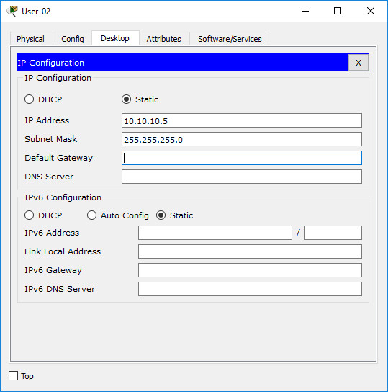

Switch>enable

Switch#configure terminal

Switch(config)#hostname ASw-1

ASw-1(config)#line console 0

ASw-1(config-line)#password xAw6k

ASw-1(config-line)#login

ASw-1(config-line)#exit

ASw-1(config)#line vty 0 4

ASw-1(config-line)#password xAw6k

ASw-1(config-line)#login

ASw-1(config-line)#exit

ASw-1(config)#enable secret 6EBUp

ASw-1(config)#service password-encryption

ASw-1(config)#banner motd #warning#

ASw-1(config)#interface vlan 1

ASw-1(config-if)#ip address 10.10.10.100 255.255.255.0

ASw-1(config-if)#no shutdown

ASw-1(config-if)#exit

ASw-1(config)#exit

ASw-1#copy running-config startup-config

Switch>enable

Switch#configure terminal

Switch(config)#hostname ASw-2

ASw-2(config)#line console 0

ASw-2(config-line)#password xAw6k

ASw-2(config-line)#login

ASw-2(config-line)#exit

ASw-2(config)#line vty 0 4

ASw-2(config-line)#password xAw6k

ASw-2(config-line)#login

ASw-2(config-line)#exit

ASw-2(config)#enable secret 6EBUp

ASw-2(config)#service password-encryption

ASw-2(config)#banner motd #warning#

ASw-2(config)#interface vlan 1

ASw-2(config-if)#ip address 10.10.10.150 255.255.255.0

ASw-2(config-if)#no shutdown

ASw-2(config-if)#exit

ASw-2(config)#exit

ASw-2#copy running-config startup-config

6.5.1.3 Packet Tracer Skills Integration Challenge

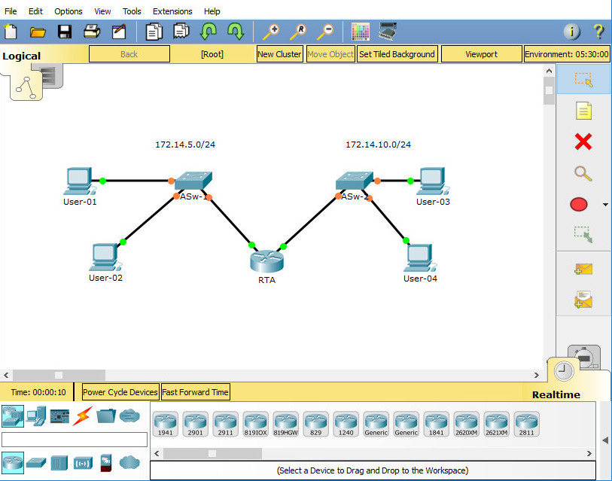

ANS:

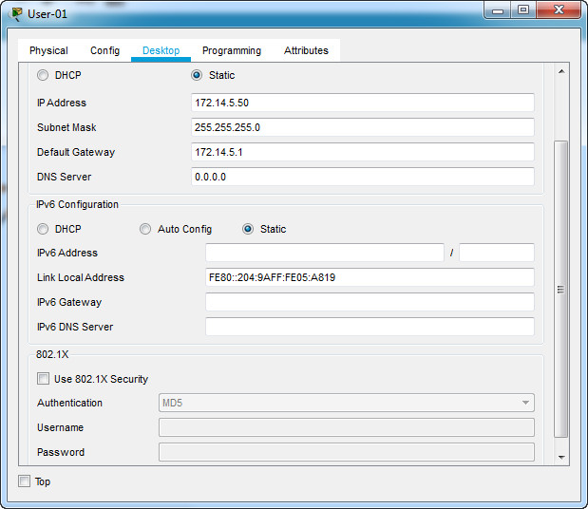

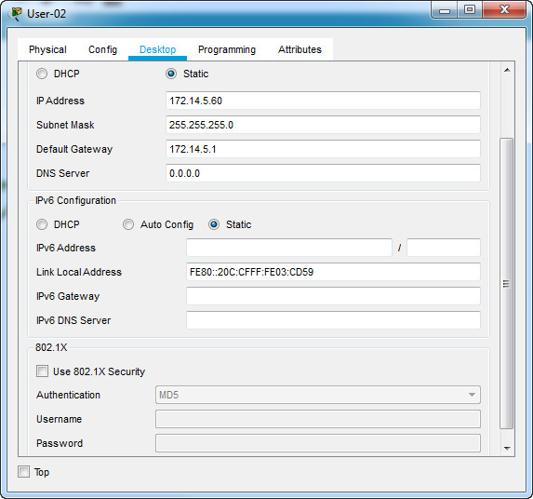

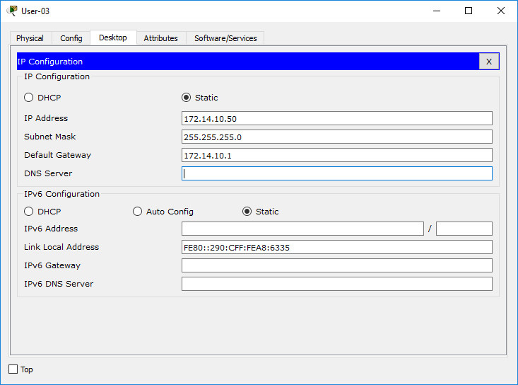

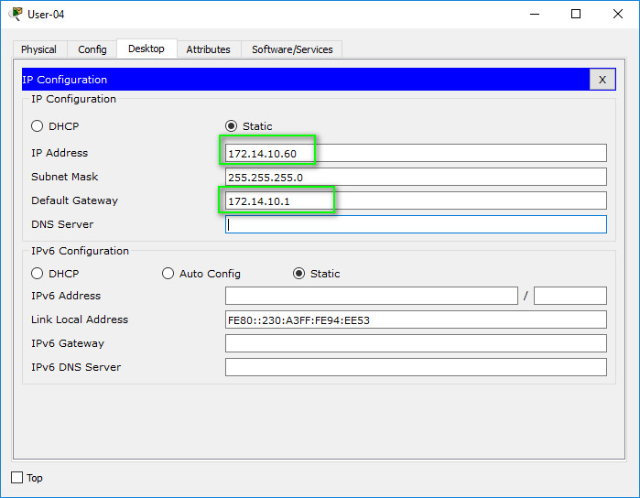

RTA

Router>enable

Router#configure terminal

Router(config)#hostname RTA

RTA(config)#line console 0

RTA(config-line)#password cisco

RTA(config-line)#login

RTA(config-line)#exit

RTA(config)#line vty 0 4

RTA(config-line)#password cisco

RTA(config-line)#login

RTA(config-line)#exit

RTA(config)#enable password cisco

RTA(config)#enable secret class

RTA(config)#service password-encryption

RTA(config)#banner motd #Router RTA#

RTA(config)#interface gigabitEthernet 0/0

RTA(config-if)#ip address 172.14.5.1 255.255.255.0

RTA(config-if)#no shutdown

RTA(config-if)#exit

RTA(config)#interface gigabitEthernet 0/1

RTA(config-if)#ip address 172.14.10.1 255.255.255.0

RTA(config-if)#no shutdown

RTA(config-if)#exit

RTA(config)#exit

RTA#copy running-config startup-config

ASW-2

ASw-2#configure terminal

ASw-2(config)#line console 0

ASw-2(config-line)#password cisco

ASw-2(config-line)#login

ASw-2(config-line)#exit

ASw-2(config)#line vty 0 4

ASw-2(config-line)#password cisco

ASw-2(config-line)#login

ASw-2(config-line)#exit

ASw-2(config)#enable password cisco

ASw-2(config)#enable secret class

ASw-2(config)#service password-encryption

ASw-2(config)#banner motd #Switch 2#

ASw-2(config)#interface vlan 1

ASw-2(config-if)#ip address 172.14.10.35 255.255.255.0

ASw-2(config-if)#no shutdown

ASw-2(config-if)#description #This is interface VLAN 1 in ASw-2#

ASw-2(config-if)#exit

ASw-2(config)#ip default-gateway 172.14.10.1

ASw-2(config)#exit

ASw-2#copy running-config startup-config

11.2.4.5 Packet Tracer - Configuring Secure Passwords and SSH

ANS:

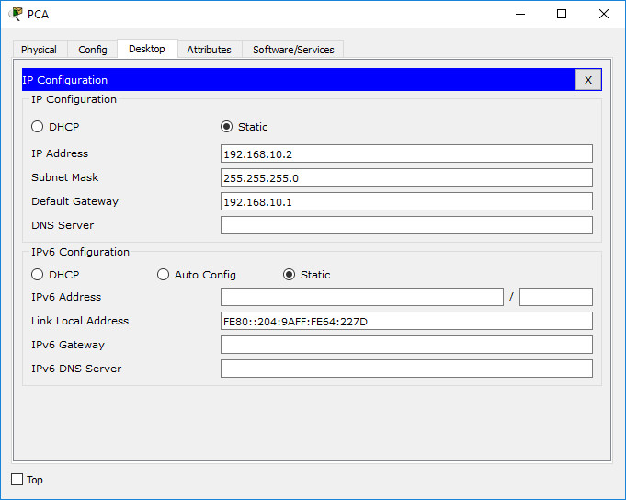

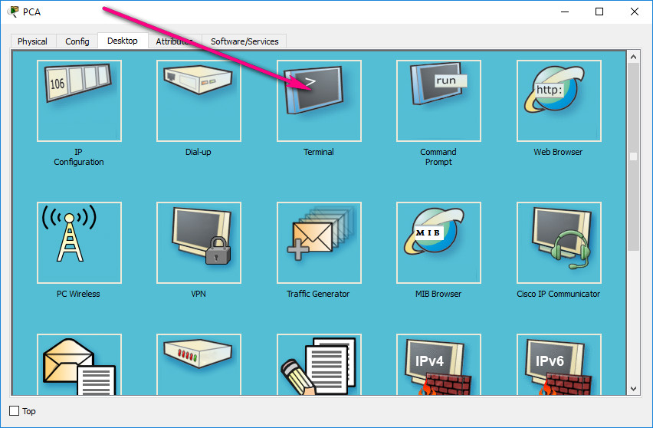

Router>enable

Router#configure terminal

Router(config)#interface gigabitEthernet0/0

Router(config-if)#ip add 192.168.10.1 255.255.255.0

Router(config-if)#no shutdown

Router(config-if)#exit

Router(config)#hostname RTA

RTA(config)#service password-encryption

RTA(config)#enable secret cl@ss

RTA(config)#ip domain-name RTA.com

RTA(config)#username any_user password cisco

RTA(config)#crypto key generate rsa

How many bits in the modulus [512]: 1024

RTA(config)#login block-for 180 attempts 4 within 120

RTA(config)#line vty 0 4

RTA(config-line)#transport input ssh

RTA(config-line)#login local

RTA(config-line)#exit

RTA(config)#exit

RTA#copy running-config startup-config

8.4.1.2 Packet Tracer - Skills Integration Challenge

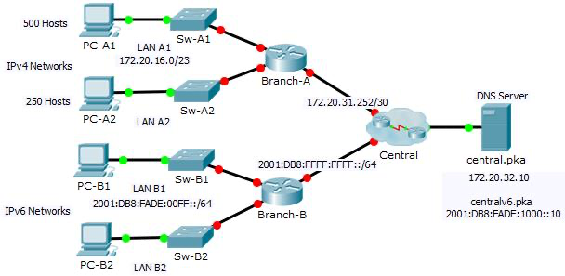

ANS:

BRANCH A

enable

configure terminal

hostname Branch-A

banner motd $This is Branch-A$

line console 0

password cisco

login

line vty 0 4

password cisco

login

enable secret class

service password-encryption

interface gigabitEthernet 0/0

ip address 172.20.16.1 255.255.254.0

no shutdown

interface gigabitEthernet 0/1

ip address 172.20.18.1 255.255.255.0

no shutdown

interface gigabitEthernet 0/2

ip address 172.20.31.254 255.255.255.252

no shutdown

BRANCH B

enable

configure terminal

hostname Branch-B

banner motd $This is Branch-B$

line console 0

password cisco

login

line vty 0 4

password cisco

login

enable secret class

service password-encryption

ipv6 unicast-routing

interface gigabitEthernet 0/0

ipv6 address 2001:DB8:FADE:00FF::1/64

ipv6 address FE80::B link-local

no shutdown

interface gigabitEthernet 0/1

ipv6 address 2001:DB8:FADE:0100::1/64

ipv6 address FE80::B link-local

no shutdown

interface gigabitEthernet 0/2

ipv6 address 2001:DB8:FFFF:FFFF::2/64

ipv6 address FE80::B link-local

no shutdown

PC-A1

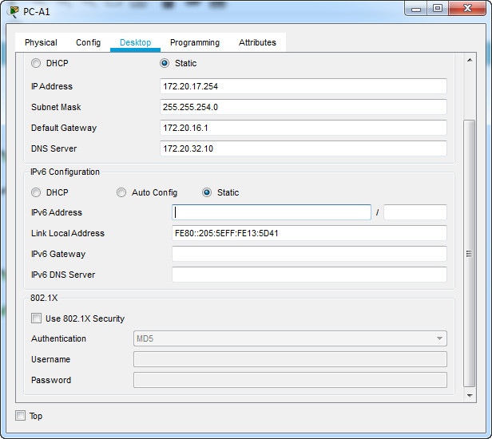

PC-A2

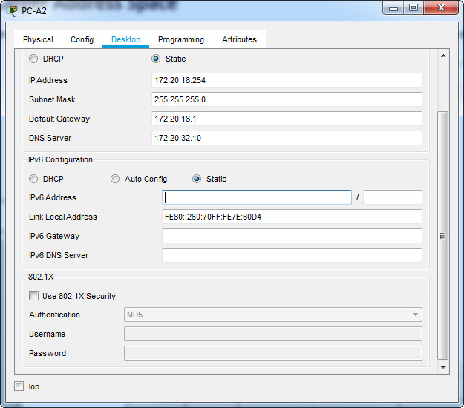

PC-B1

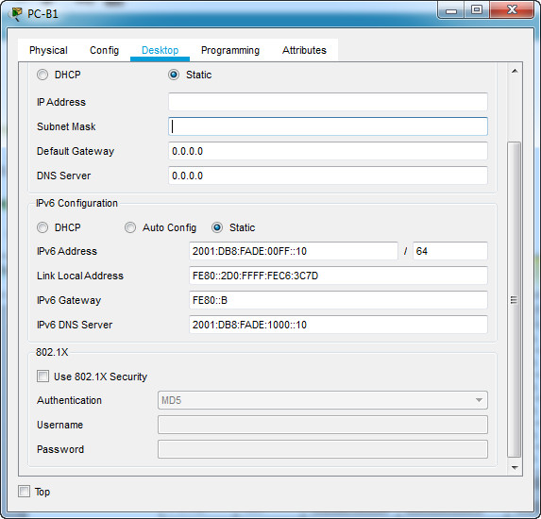

PC-B2

