

**Ooyala Video Plugin**

A Technical and User Guide

September 25, 2012

# 

# Table of Content

Overview 3

Install 3

Re-Installing/Updating the package: 8

Using the Component 9

Using the content finder 10

Uploading a Video 11

Technical Overview 14

Ooyala CQ5 Integration 14

Maven/Eclipse Project Structure 16

Log files 16

# Overview

This documents describes the technical implementation of the Ooyala video component and content finder tab on Adobe’s CQ 5.5. This functionality is packaged following the “Package Manager” tool embedded in Adobe’s CQ 5.5. The package contains the following items:

1. Content Finder Tab
2. Ooyala Video Component
3. Ooyala Configuration Page
4. OSGI Java Classes

The Ooyala plugin enables content authors to find videos from Backlot and place those on pages. Users can configure the video component with players and player sizes. The V2 API’s are used to create the Ooyala plugin and are detailed at the following location:

http://api.ooyala.com/docs/v2/

## Install

The Ooyala CQ5 plugin (the plugin) has been developed using CQ5's standard component model. The plugin consists of an OSGi bundle/module to handle Ooyala Backlot/REST API integration, the Ooyala Video Component (jsp's, Dialogs, and supporting files), and the Tools Configuration Page. The plugin is distributed as a CQ5 Package for easy installation. The source code is also available for download from https://github.com/ooyala/Ooyala-AdobeCQ/

The Ooyala plugin, once downloaded is named “Ooyala-AdobeCQv01.zip”. Do not unzip the file; Adobe CQ5.5 package manager expects it as a zip file.

Click on “package” on the right hand of the cq5.5 start up screen. To navigate directly to the CQ5 Package Manager Page the url is http://[replace with the author instance domain]:4502/crx/packmgr/index.jsp



Figure

On the package manager screen click “Upload Package” on the top menu bar; this will bring up a wizard to upload the package. Navigate to the folder where the zip file is located. Ensure the zip file is not unzipped. When selected the name of the zip file will be displayed in the Package field. If this is the first time the package is being uploaded the “Force Upload” can be left blank. In general it is recommended to click this button to install new versions of the package. Uninstalling the package will delete all the data as well.

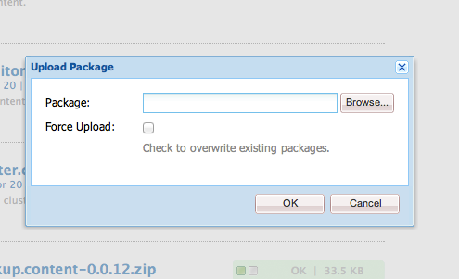

Figure

Once the zip file has been uploaded, it needs to be installed. Click on the “install” button on the top right.

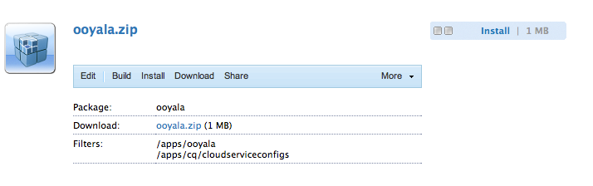

Figure

The wizard below will can be left to defaults. Click on the “Install” button.

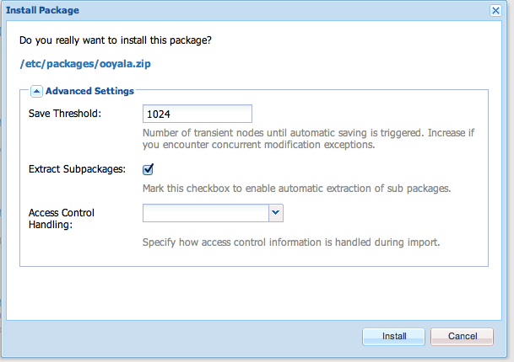

Figure

If the install was successful the following message will be displayed at the bottom of the console.

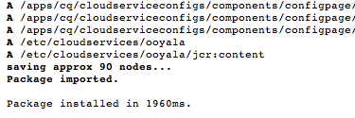

Figure

Once the package installs successfully, proceed back to the main screen and click on “Tools”. On the tools screen navigate to the “Cloud Services Configurations” folder. There should be a page titled “Ooyala Configuration”.

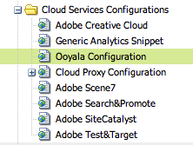

Figure

Double click on this page will open up the Ooyala configuration dialog. The dialog should load automatically, or the user can click the “Edit” button.

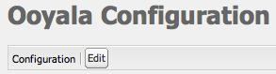

Figure

The following fields are displayed when the dialog loads:

* API Key: the global account key from backlot
* API Secret : the global account key from backlot
* Metadata Keys: The Ooyala api matches metadata keys exactly, so a list of the actual key needs to be configured. This list of keys will be displayed on the content finder tab, so users can select which metadata field they would like to search on.

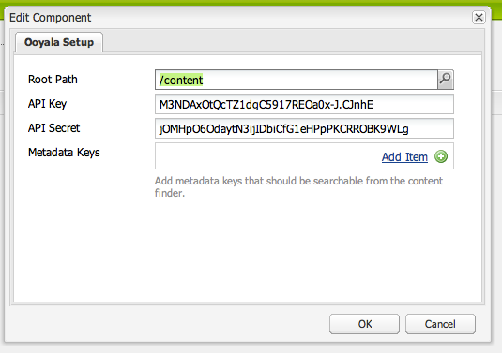

Figure

## Re-Installing/Updating the package:

Re-installation of the Ooyala package requires Uninstalling the Ooyala OSGi bundle first. Once the OSGi bundle has been uninstalled, the package can be re-installed using the same instructions as the previous (Installation) section.

WARNING: Re-installing the Ooyala CQ5 Package will erase the Ooyala Backlot API Credentials on the CQ5 Tools Page. Make sure to backup your API Key/s, API Secret, and Metadata fields before re-installing the package.

This procedure requires CQ5 administrator privileges.

Uninstall the Ooyala OSGi bundle:

* Navigate to the CQ5 OSGi Web Console: http://localhost:4502/system/console/bundles
* Using your browser's search function, find the Ooyala OSGi bundle. Search for “ooyala”.
* The bundle should be named ooyala-osgi com.siteworx.cq5.ooyala.osgi
* Making sure you have selected the Ooyala OSGi bundle.
* Click on the trash can icon/uninstall.

WARNING: Deleting an incorrect bundle could cause the system to fail.

Re-install the Ooyala CQ5 Package using the instruction from the previous section.

## Using the Component

To use the Ooyala video component on any page, the page container component needs to allow the “Ooyala Video Component”. This is done by clicking on the Design button located at the bottom of the Sidekick.

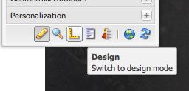

Figure

Check the “Ooyala Video Component” under the Allowed Components “General” Category

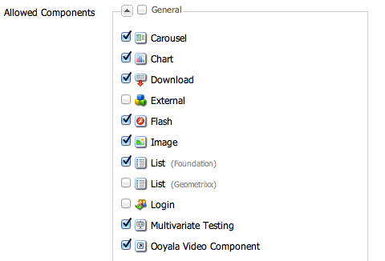

Figure

If everything was successful, back in edit mode, the sidekick should now display the “Ooyala Video Component” for drag and drop on pages.

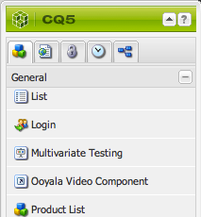

Figure

When the Ooyala video component is dropped on a page, the component renders the following message. The next step is to find a video using the content finder and drag and drop that video on top of this component. When the video is dropped the Video ID will be automatically populated. The next step is to double click on the component to bring up the player configuration. There will be a dropdown where users can choose the player and sizes of the video player.

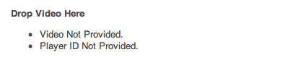

Figure

## Using the content finder

The content finder tab can be used for searching and filtering through Ooyala videos for easy placement on CQ pages. The content finder tab is available from any page in the authoring environment. In order to use the Ooyala content finder functionality, click on the tab at the top of the content finder. The Ooyala tab will be displayed as shown.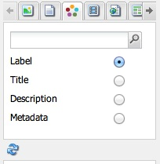

Figure

The content finder offers four different search functionalities; search by label, by title, by description, and by metadata. Search by title and by label accept plain text queries and return the results that best match. Search by label allows the user to enter a label used on their Ooyala account and returns all those videos tagged with that label. The search by label requires an exact spelling match in order to function; for this reason, it provides the user with suggestions in an auto-complete box as shown.

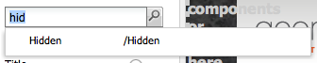

Figure

Searching by metadata shows suggestions in the same manner, based on metadata keys entered by an administrator on the Ooyala configuration screen. Searching by metadata requires both a key and a value. Choosing a key from the autocomplete prefills the search field with the key and a colon(:). Users should enter the value they wish to search for within that key after the colon, before submitting their query. Remember, it is important to make use of the autocomplete functionality to ensure your search is using the correct spelling and returning the proper results.

## Uploading a Video

Videos can be uploaded directly from CQ. Under the Tools section there is a folder labeled “Ooyala”. Double click on the “Ooyala Uploader” page will launch the uploader widget.



Figure

On the page there are three call to actions, the name and description are not required:

1. Name (text field)
2. Description (text field)
3. Select Asset (button)

The select asset button will launch a native file uploader, where the user could navigate their file system and find the video to upload.

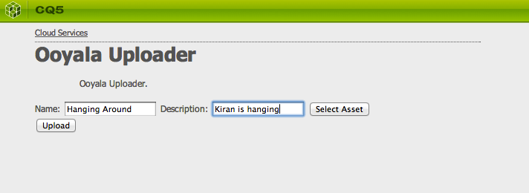

Figure

Once the video has been selected and the proper name and description have been added, click the Upload button. The upload button will take the video, and create chunks that will then be uploaded into Ooyala’s and in a few minutes users could find the video in Backlot. A numeric value starting with 0, 0.5, 1 will be displayed.

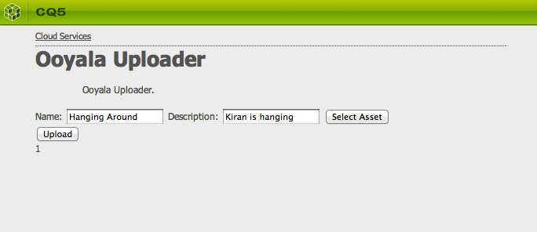

Figure

When the number 1 is displayed the video has been uploaded and Backlot is processing the file.

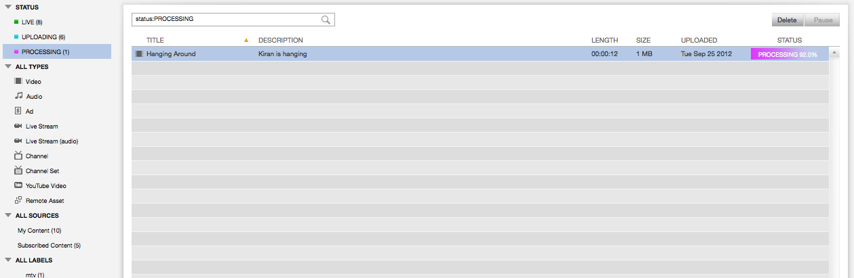

Figure

## Technical Overview

The following is a class diagram for the Ooyala video component and content finder functionality. These classes

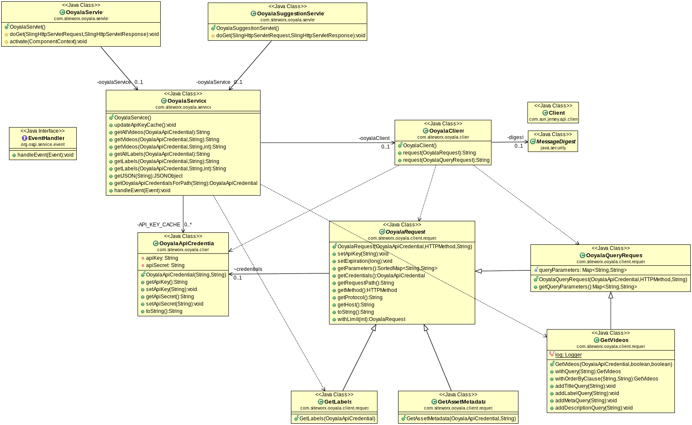

Figure

### Ooyala CQ5 Integration

The following classes were developed as part of the solution

| **Class** | **Description** |
| --- | --- |
| OoyalaApiCredential.java | Contains one API key/secret pair. |
| OoyalaService.java | OSGi Service. Provides methods to call Ooyala API (REST). Has methods such as getVideos, getLabels, etc.  Methods take a OoyalaApiCredential, this allows for multiple credentials (per site/path) |
| OoyalaClient.java | Handles low level implementation of REST calls. Uses Jersey client internally. |
| OoyalaRequest.java  OoyalaQueryRequest.java | These (abstract) classes encapsulate base parameters for a Ooyala REST API request.  Subclasses add more specific parameters/behavior like limit, order by, etc. |
| OoyalaServlet.java | Handles search/browse requests from the CQ Content Finder. The Delegates to OoyalaService.   * responds to: GET /bin/wcm/ooyala?query=[query]&limit=[limit] * returns a CQ-ContentFinder-formatted JSON response. |
| OoyalaSuggestionServlet.java | Handles autocomplete/suggestion requests from the CQ Content Finder. Delegates to OoyalaService.   * reponds to: GET /bin/wcm/ooyala/suggestions?query=[query] * returns a CQ-ContentFinder-formatted JSON response. |

The following components are included in the plugin package:

| **Component** | **Description** |
| --- | --- |
| ooyalaVideo (apps/ooyala/components/content/ooyalaVideo) | A Standard methodology to creating CQ5 components. When used on a page, It is placed on a cq:Page wherever a Video should be displayed. |
| ooyalaTab.js  (apps/ooyala/wcm/extensions/contentFinder/ooyalatab.js) | This is the custom Tab for the Content Finder. It contains JavaScript configuration for the Tab.  This is an instance of the class in cq “CQ.wcm.ContentFinderTab, information about this class can be found in at “http://dev.day.com/docs/en/cq/current/widgets-api/index.html” |
| etc/cloudservices/ooyala | This is a configuration page/node exposed through the Tools section in CQ. It is used to configure the API key(s)/secret(s) in OoyalaService.java. |

### Maven/Eclipse Project Structure

| **Structure** | **Description** |
| --- | --- |
| CQPACKAGE | The CQ Package available for installation |
| DOCUMENTATION | Documentation |
| OSGI | The back end services |
| UI | The code for the component and front end. |

To compile the code, a mvn clean install in the parent directory of where the code is checked out. Then navigate to the CQPackage and run the build CQ package. This will create a zip file read to upload into Adobe CQ 5.5.

### Log files

CQ reports its current state into its log files, and it is often the best way to debug errors in the system:

| **File Name** | **File Location** | **Description** |
| --- | --- | --- |
| access.log | $CQ_HOME/logs | Contains reports of all incoming HTTP requests |
| error.log | $CQ_HOME/logs | Contains standard log information along with any error messages that had occurred. |
| request.log | $CQ_HOME/logs | Contains all incoming requests/responses. |
| stdout.log | $CQ_HOME/logs | Contains messages created with System.out.println(…). |
| stderr.log | $CQ_HOME/logs | Contains messages created with System.err.println(…). |
| server.log | $CQ_HOME/logs | Contains messages from other parts of CQ, like the OSGi bundles and starting up the instance. |
| error.log | $CQ_HOME/logs/crx | Contains errors in $CQ_HOME/logs/crx/error.log |
| access.log | $CQ_HOME/server/logs | Similar to access.log in $CQ_HOME/logs |
| cq.pid | $CQ_HOME/server/logs | Contains the PID of the running CQ instance. |
| startup.log | $CQ_HOME/server/logs | Contains messages that CQ logged during startup. |