**Second-year Mini Project Report**

Submitted in partial fulfillment of the requirements of the degree

## BACHELOR OF ENGINEERING IN COMPUTER ENGINEERING

By

## Karan Bhatia D7B/08

## Nickhil Shivakumar D7B/35

## Piyush Nagrani D7A /45

## Harsh Ahuja D7A/02

Supervisor

**Prof. Prerna Solanke**



**Department of Computer Engineering**

## Vivekanand Education Society’s Institute of Technology HAMC, Collector’s Colony, Chembur,

**Mumbai-400074 University of Mumbai (AY 2023-24)**

# CERTIFICATE

This is to certify that the Mini Project entitled **“ BRAIN PEACE”** is a bonafide work of

1. Karan Bhatia(08)
2. Nickhil Shivakumar (35)
3. Piyush Nagrani (45)
4. Harsh Ahuja (02)

submitted to the University of Mumbai in partial fulfilment of the requirement for the award of the degree of **“Bachelor of Engineering”** in **“Computer Engineering”.**

### (Prof. Prerna Solanke)

**Supervisor**

**(Dr. Nupur Giri) (Dr. J.M.Nair) Head of Department Principal**

# Mini Project Approval

This Mini Project entitled “ BRAIN PEACE **”** by

1. Karan Bhatia(08)
2. Nickhil Shivakumar (35)
3. Piyush Nagrani (45)
4. Harsh Ahuja (02)

are approved for the degree of **Bachelor of Engineering** in **Computer Engineering.**

**Examiners**

**1………………………………………**

(Internal Examiner Name & Sign)

**2…………………………………………**

(External Examiner name & Sign)

Date: Place:

# Contents

**i.Abstract iii.Acknowledgments iii.List of Abbreviations iv.List of Figures**

**List of Tables vi.ListofSymbols**

## Introduction

### Introduction:

In an era of digitalization and rapidly evolving societal norms, addressing mental health concerns has become an essential focus. The "Brain Peace" project sets out to be an innovative, all-encompassing platform dedicated to the promotion of mental health awareness. As we navigate through this introduction, we'll delve into the core principles that guide this project and explain why it is so imperative in today's context. The "Brain Peace" project envisions a world where individuals can explore and understand the intricacies of mental health. Our digital realm acts as a sanctuary for those in need, where they can access a multitude of resources, engage in open discussions, and receive guidance without any reservations. We stand committed to fostering a more empathetic, understanding, and inclusive society.

### Motivation:

Our motivation stems from the profound need to dismantle these barriers. We are driven by the aspiration to create a global community that welcomes, supports, and empowers individuals to seek mental health care without fear or discrimination. By tackling the challenges of accessibility, stigma, and awareness, we aim to improve the overall well-being of individuals worldwide. Through our project, we aspire to make a lasting impact on the mental health landscape by offering a unique blend of education, support, and understanding. The project's purpose is to bring mental health awareness to the forefront, ensuring that it is a universal concern we all engage with. Our mission is to be the change we wish to see in the world. We want to guide those navigating the labyrinth of mental

health, providing them with resources, support, and a sense of belonging. At "Brain Peace," we believe that everyone deserves peace of mind.

### Problem Statement & Objectives:

The "Brain Peace" project aims to address the following challenges:

* Lack of easily accessible mental health information and resources.
* The social stigma that discourages individuals from seeking help.
* Insufficient awareness about the importance of mental well-being.

Our objectives include:

* Creating an informative website with comprehensive mental health resources.
* Building a supportive online community.
* Promoting mental health awareness and destigmatization.

### Organization of the Report:

* Section 2: Literature Survey: This section delves into a comprehensive survey of existing mental health awareness platforms, critically assessing their strengths, weaknesses, and gaps. It lays the foundation for understanding the necessity of the "Brain Peace" project.
* Section 3: Proposed System (New Approach to Mental Health Awareness): In this section, we introduce the innovative approach taken by the "Brain Peace" project to address the identified research gap. We discuss

the project's architecture, framework, algorithm, hardware and software details, experiments, and results, and outline future work.

### Project Updates:

* User Interface (UI) Revamp: We have completely reformatted the UI of the project using React as our framework. The new UI features enhanced user-friendliness, with added sections and improved navigation.
* Login and Sign-up Pages: We've implemented login and sign-up pages to provide personalized experiences and access to user-specific features.
* Additional Sections: Fun quizzes and relaxation sections have been added to provide users with interactive and stress-relieving activities.
* Visual Enhancements: We've incorporated various effects and studied color combinations to make the platform visually appealing and conducive to positive mental health experiences.

## Literature Survey

### Survey of Existing Systems:

The survey revealed a diverse range of resources available to the public, including mobile applications, websites, online forums, and offline support groups, all contributing positively to the mental health awareness landscape. However, there remains room for improvement. Many existing systems are fragmented, focusing on specific aspects of mental health, requiring users to navigate between multiple platforms for comprehensive support. This incongruity can be confusing and inconvenient. Additionally, while some platforms offer valuable information, they may lack engaging and user-friendly interfaces crucial for maintaining user engagement. The survey highlighted the need for more personalized and interactive resources, particularly in offering tailored guidance and real-time interactions during crises.

### Limitations of Existing Systems and Research Gaps:

The research gap centers on several key aspects:

* Holistic Approach: Existing systems often focus solely on information sharing or peer support, lacking a comprehensive approach that integrates information, peer support, professional assistance, and crisis intervention. "Brain Peace" addresses this gap by offering a one-stop solution for various mental health needs.

**-** User Engagement: User experience significantly impacts the effectiveness of mental health resources. Interactive platforms are more likely to retain users and have a positive impact.

-Community and Inclusivity: Stigma surrounding mental health often hinders individuals from seeking support, which many existing platforms fail to address adequately. "Brain Peace" seeks to create an inclusive community, destigmatizing mental health and providing a safe space for individuals to connect and share experiences.

### Mini Project Contribution:

The "Brain Peace" project serves as a bridge to overcome the limitations of existing systems and research gaps. By combining elements of information sharing, peer support, professional guidance, and crisis intervention, our platform offers a holistic approach to mental health. Emphasizing user engagement through interactive content and a welcoming interface, "Brain Peace" aims to break down barriers of stigma and contribute significantly to the field of mental health awareness. It offers a fresh perspective on tailoring mental health resources to meet the diverse and evolving needs of its audience.

## Proposed System

### Introduction:

We present a comprehensive introduction to the proposed system, underscoring the critical need for a dedicated platform that addresses mental health comprehensively. In today's world, characterized by escalating mental health challenges, our mission becomes increasingly vital. We express our vision, emphasizing the profound impact we aspire to make on individuals' mental well-being.

### Architecture/Framework:

In this section, we unveil the intricate technical infrastructure powering the "Brain Peace" ecosystem. It stands as a marvel of modern engineering, meticulously designed for security, scalability, and user-friendliness. We have adopted the Django Framework written in Python for the backend, leveraging its robustness and flexibility. For the frontend architecture, we have utilized React, a powerful and widely-used JavaScript library, to create an intuitive and visually appealing user interface. This choice allows for seamless navigation and accessibility for our users.

Additionally, our development process involves using npm run dev command, which initiates the development server and compiles the code, facilitating live reloading for efficient development and testing.

### Details of Hardware & Software:

This section provides insights into the core components of our technical setup. We detail the robust hardware hosting our system, ensuring seamless operation 24/7. Additionally, we delve into the software applications

powering our website and mobile interfaces, crafted to deliver a seamless user experience.

For software development, we rely on Visual Studio Code (VS Code) with the 'Live Server' extension, facilitating real-time changes and output viewing with a single click. Our hardware setup includes an Intel i7 12th generation laptop from Dell and an Intel i5 8GB RAM 8th generation laptop, ensuring optimal performance during development and deployments

### Algorithm and Process Design :

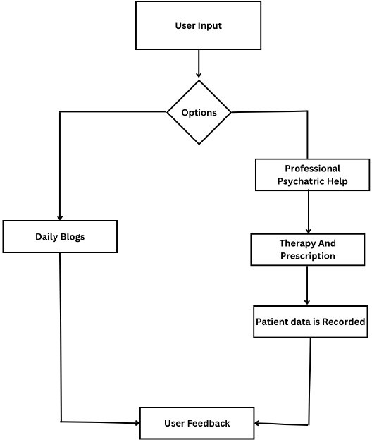

* 1. **Experiment and Results :**

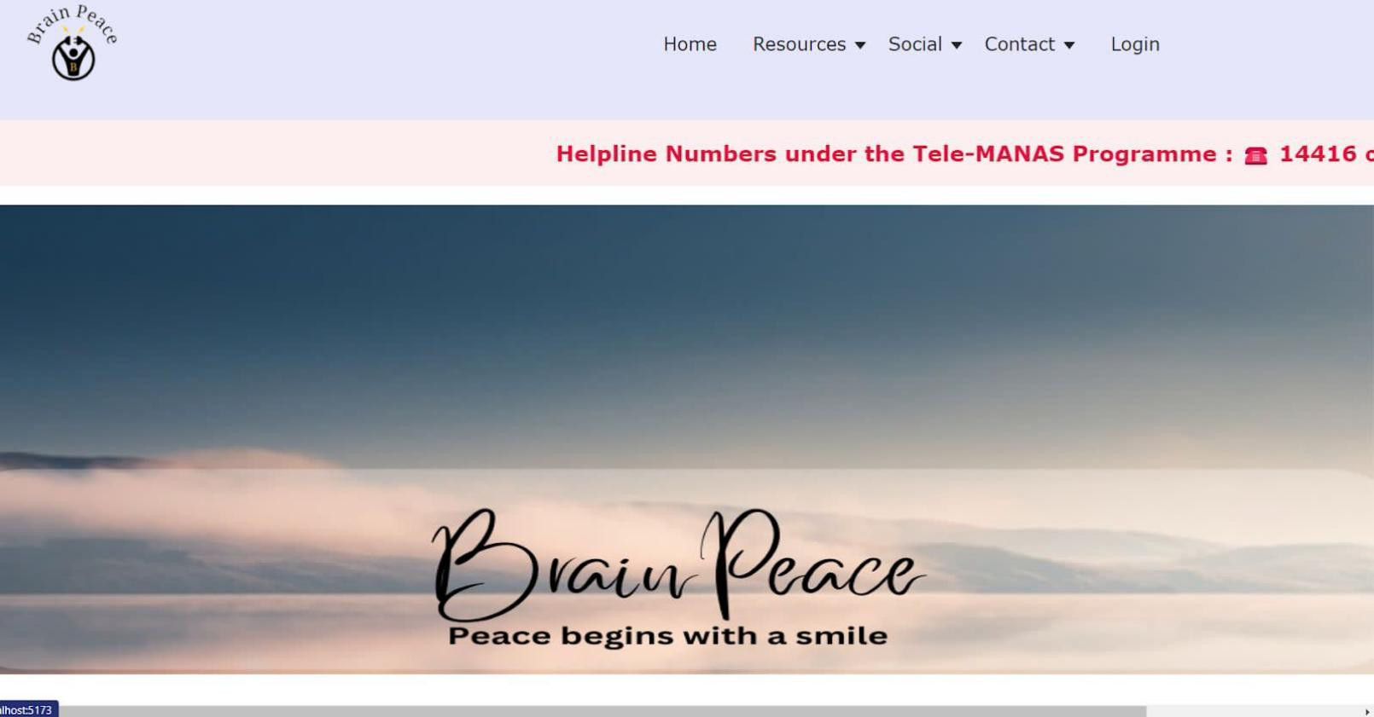

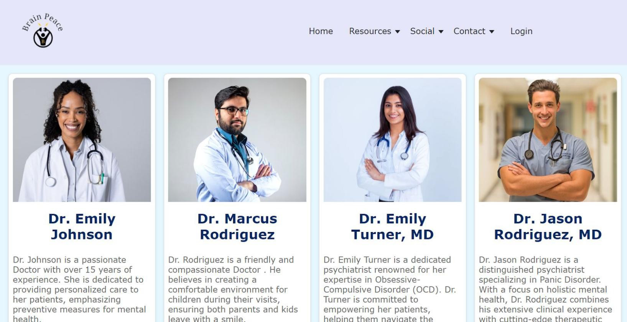

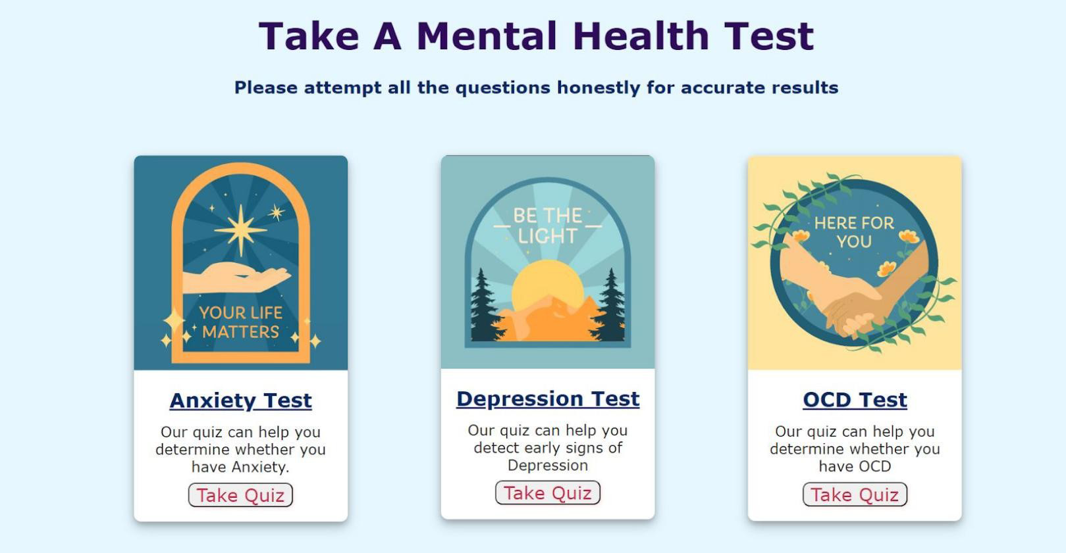

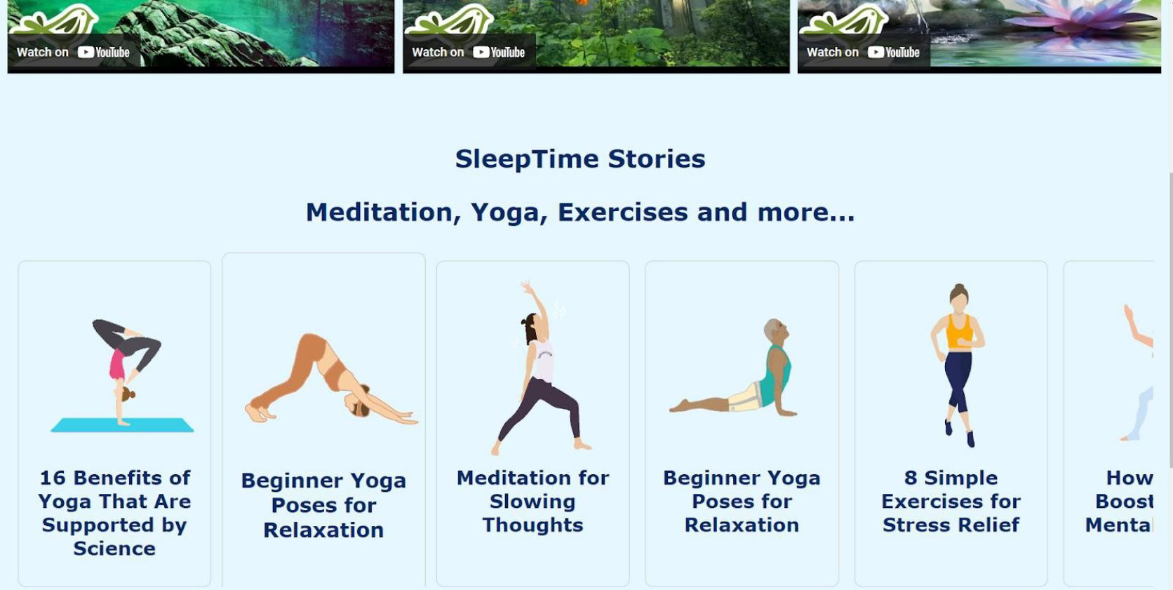

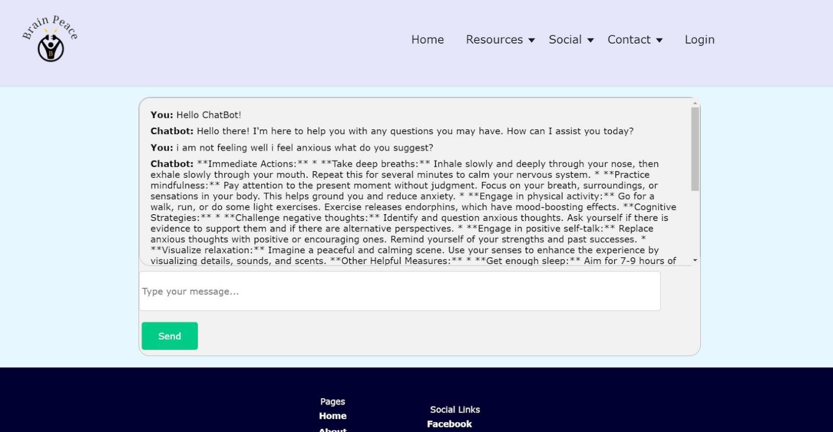

### 3.5 Conclusion and Future Work:

In this final segment, we weave together the threads of our proposed system. The concluding part reflects on the achievements of "Brain Peace" thus far and what they signify for the broader mission of mental health awareness. Looking ahead, we set our sights on continuous improvement and expansion. The roadmap for the future is brimming with exciting developments and innovations, all in the service of creating a more informed and compassionate world.