Lecture 1B.2

Dynamics and 1-D Linear Control

This lecture will talk a little bit about control. Again, we will focus on the vertical direction.

So let's think about controlling height. What we would like to do is to drive the robot to a desired vertical position - either up or down. In the previous lecture we derived the following equation:
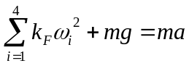
Let's use x to measure the vertical displacement. Clearly, the acceleration, a, is given by the second derivative of position.
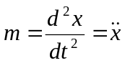
The left hand side, of our original equation is the sum of the forces. Let's define u as the sum of the forces divided by the mass. So we have now a very simple second order differential equation with an input u and a variable x, such that u is equal to the second derivative of x:
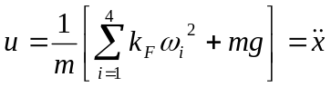

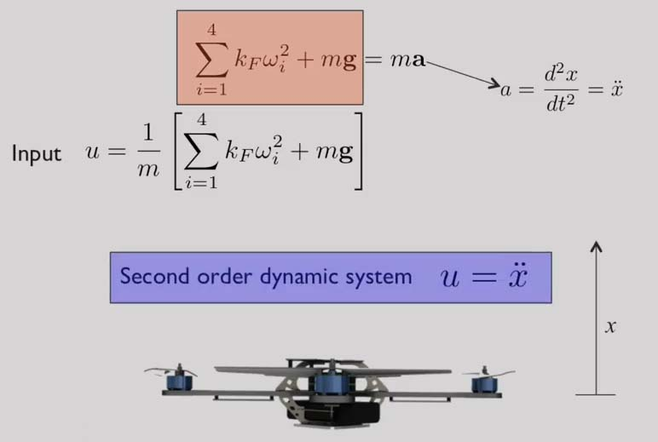

Our goal is to control this vehicle. So we need to determine the solution to the function u, such that the vehicle goes to the desired position x. So here is the control problem.

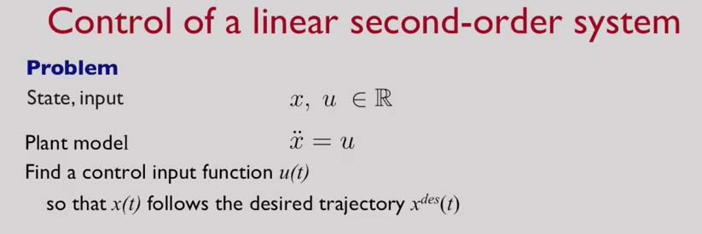

The system we have is a very simple system. It's a second order linear system. We're trying to figure out what value of u(t) drives x to the desired position x^{des}.

If you have a desired trajectory, in other words x desired is a function of time, x^{des}(t), we want to synthesize the control input u(t) that allows the vehicle to follow our desired trajectory.

In order to do that we define an error. The error function is essentially the difference between the desired trajectory, x^{des}(t), and the actual trajectory, x(t):

e(t) = x^{des}(t)-x(t)

The larger the error, obviously, the further the actual trajectory deviates from the desired trajectory. What we'd like to do is to take that error and decrease it to zero.

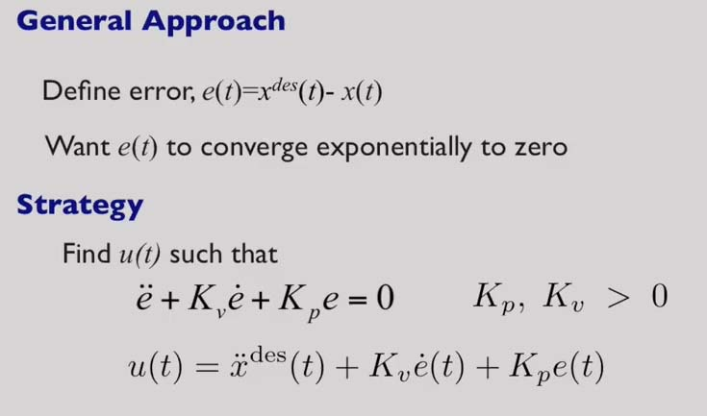
More specifically, we want this error to go exponentially to zero. In other words, we want to find u(t) such that the error function satisfies the second order differential equation:

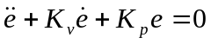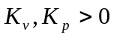

This differential equation has two unknowns, K_{p} & K_{v}. If we select appropriate values of K_{p} and K_{v} - more specifically, if we ensure that these values are positive - we can guarantee that this error will go exponentially to zero. The control input that achieves that is given by this very simple equation:

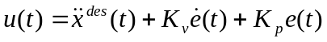

There are two variables in this equation. K_{p}, multiplies the error, and adds the product of the error and K_{p} to the control function. K_{v} multiplies the derivative of the error, and adds that to the control function. So K_{p} is called the proportional gain, and K_{v} is called the derivative gain.

In addition, we need some knowledge of how we want the trajectory to vary. So we're feeding forward the second derivative of the desired trajectory. This is often called the feedforward term.

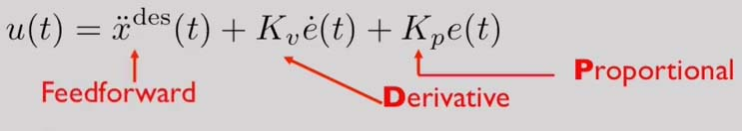

This completes your control law or the control equation that you can use to drive your motors

Here's a typical response of what the error might look like if we use such an approach to control:

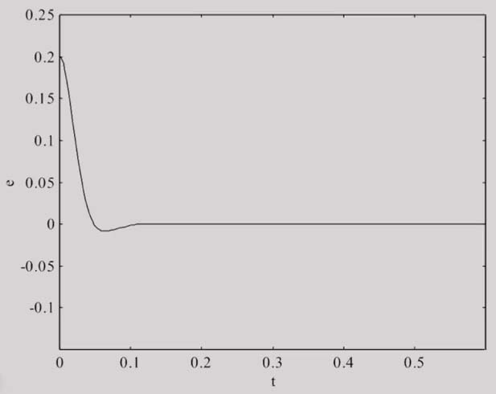

The error starts out being non-zero, but quickly settles down to the zero value. The error might undershoot but eventually its guaranteed to go to zero.

To summarize, we've derived a very simple control law. It's called the proportional plus derivative (PD) control law, which has a very simple form.

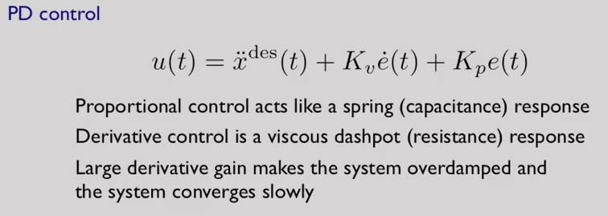

It has three terms: a feedforward term, a proportional term, and a derivative term. Each of these terms has a particular significance.

- The proportional term acts like a spring or a capacitance. The higher the proportional term is, the more springy the system becomes (and the more likely it is to overshoot).
- The higher the derivative term, the more dense it becomes. So this is like a viscous dashpot or a resistance in an electrical system.
- By increasing the derivative gain, the system essentially gets damped, and you can make it overdamped so that it never overshoots the desired value.

In exceptional cases, we might consider using a more sophisticated version of the proportional plus derivative controller. Here we have an extra term, which is proportional to the integral of the error.

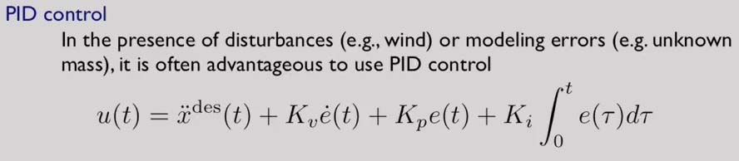

We often do this when we cannot specify the model exactly. For instance, we might not know the mass of the vehicle, or there might be variable wind resistance that we need to overcome, and we don't know a priori how much this wind resistance is. The last term essentially allows us to compensate for unknown effects caused by either unknown quantities, or unknown wind conditions, or disturbances.

The downside of adding this additional term is that our differential equation has now become a third-order differential equation. The reason for that is we've added an integral in the mix and if we want to eliminate the integral we have to differentiate the whole equation one more time which introduces a third derivative.

However, the benefit of this is that this integral term will make the error go to zero eventually.

So here are three examples of the system step response, based on what values that we pick for the proportional gain and the derivative gain:

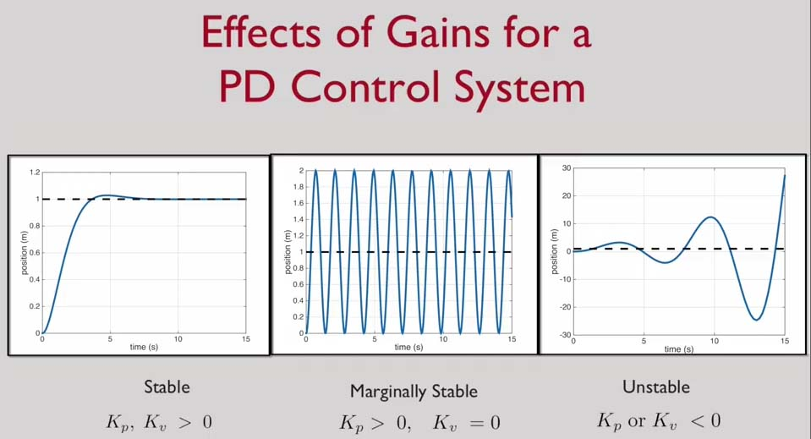

If both the gains are positive, we're guaranteed stability, as shown on the left. If K_{v}=0, then we obtain marginal stability. In this state, the system will not drift, but it will oscillate about the desired value.

Of course, if either gain is negative, then we essentially get an unstable system, as shown on the right.

Let’s now deal with a complete simulation of the quadrotor. Because we’re now dealing with three independent directions we're going to introduce x, y, and z coordinates. And this time the z coordinate points up.

Here's a simulation of the quadrotor and again, we're using a proportional derivative controller to control height.

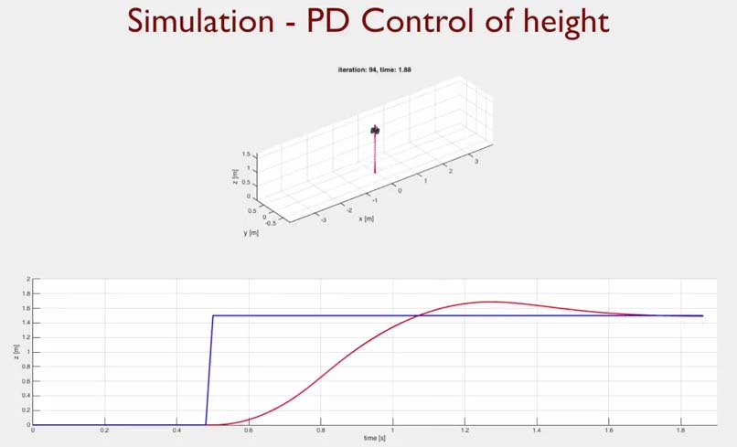

For the moment, we're ignoring the other variables. We'll be adding terms to make sure that the lateral displacement is zero, the roll and pitch stay zero, and the yaw stays zero. But the moment we're only construing the proportional derivative control of height.

You can see that the error starts out being non-zero and then eventually settles down. There is an overshoot - the red curve overshoots the desired blue curve - but eventually settles back down so that the red and the blue curves coincide.

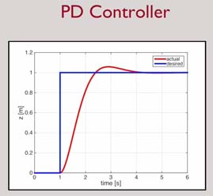

If we increase the value of K_{p} then, as we said earlier, the system gets more springy:

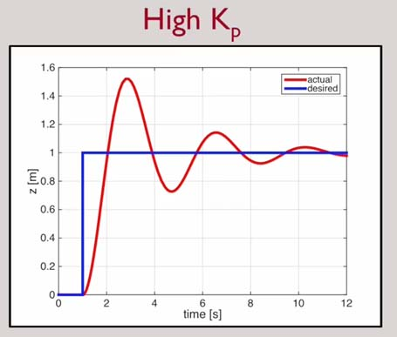

We can see that the system now overshoots. The red curve significantly overshoots the blue step but then settles down eventually. This happens because the proportional gain has been increased. If you turn down this proportional gain, you lose the overshoot but instead you get a very soft response:

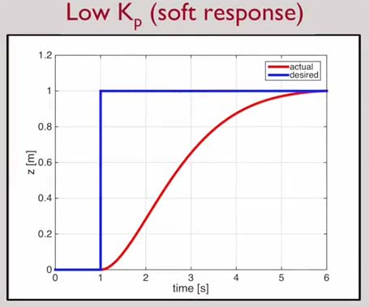
If we were to increase the derivative gain, the system becomes over-damped. In this case, the overshoot disappears but the system takes also a longer time to get to the desired position.

