Lecture 1B.3

Design Considerations

In the previous lecture, we looked at control using a very simple, idealized model. The main problem with that idealized model is that we assumed that the motors were capable of producing whatever thrust the controller requires.

In reality, motor thrust is limited, because all motors have a limited capacity. Recall the equation we derived for the forces acting on the quadrotor:

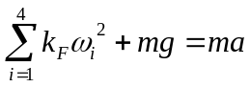

Considering forces acting in the vertical direction, clearly the thrusts from the rotors have to compensate for the weight of the quadcopter. If the thrust exceeds the weight it will produce a quadratic acceleration. But the thrust that the motor can produce is limited by the peak torque.

Let's assume that this peak torque is known. That determines the maximum thrust we can produce, T_{max}. This in turn determines the maximum acceleration, a_{max}.

In the model we developed, u, the control input, is determined by the vector sum of the motor thrust and the weight.

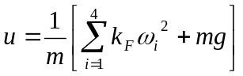

Remembering that the thrust points in the opposite direction to the weight

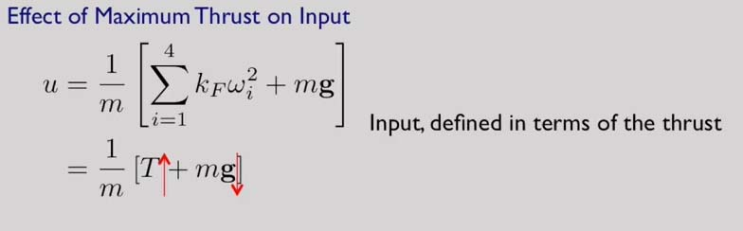

Assuming that we know what T_{max} is, we can calculate u_{max} by simply taking the maximum thrust and adding it to the weight, once again, remembering that the thrust acts in the vertical direction pointing up, while the weight acts in the vertical direction pointing down.

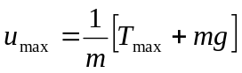

So when we design a PD controller, u(t) is determined not just by the proportional-plus-derivative control law, but also the maximum thrust that can be applied. If you take the minimum of these two functions, that'll give you the true value of the controlled input that can be applied.

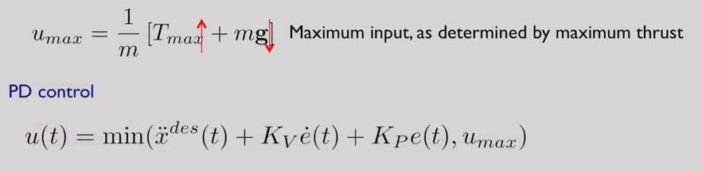

The same is also true for the PID controller.

The only difference between the two simulations shown below is the assumed value of maximum thrust:

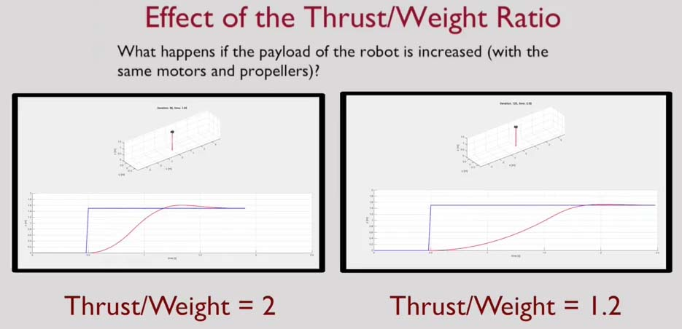

On the left side, the maximum thrust to weight ratio is 2. And on the right side the maximum thrust to weight ratio is 1.2.

These two simulations illustrate the differences between using two different motors, or of keeping the same motors, but changing the payload. In both cases,, it's only the thrust-to-weight ratio that changes. And this results in qualitatively different performances, as can be seen in these simulations.

