**Using Caffeine to Fight Against Fake News**

How to create maximum value in minimum time ? Attend a design-a-thon.

**1. And the wait is over…**

At 7:30 PM we finally see the problem. All the speculations about topics, structure, and the event

actually being a hack-a-thon which has been marketed as design-a-thon to pull the non- tech

crowd comes to an end.

[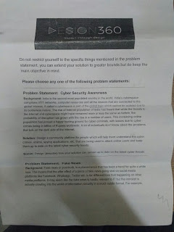](https://4.bp.blogspot.com/-W5gLECH1Di8/WNYHf0ZmJ6I/AAAAAAAAnZ4/Aj5ashNSBBY8jtFjgwGItdP9Cnf0v2fUgCLcB/s1600/19B118A6-2FAB-4D6B-8DB2-F1CB170E0757.jpg)[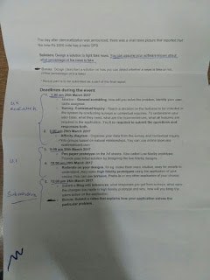](https://2.bp.blogspot.com/-FtRnF4Exsrs/WNYHf68c9ZI/AAAAAAAAnZ0/EqUHF1LjGswTEkXvz14_xEAzFT-uMlBAQCLcB/s1600/7EA144A0-9A70-4909-B606-0788417C820A.jpg)

 The best problem statements that we’ve encountered, not for what it asks but how it asks for it.

**2. Pick and split**

Which topic to choose was the only thing in the entire event on which we were at a split. Evaluating

the pros and cons of going down the product design road with very topic, we finally arrived at

building a solution to tackle fake news.

The two main influencers for our decision were:

1. Our lack of any in-depth knowledge for cyber security and it’s current state in the world.

2. Facebook released their ‘Fake News Checker’ just a day before, hence providing us a plenty of

resources on working of fact checkers by some major tech blogs. Thanks Mark for making

the timing so right :)

Next came splitting the responsibilities. We knew that it’s going to be a long night and hence if

something break downs or we miss a deadline, there needs to be someone held responsible but

who ? We decided on voting for a team leader but the condition put forward was that who ever

becomes the leader, voluntarily / involuntarily, must be entitled to one third the prize, if we win.

Since everyone was pretty confident on their skills and strengths we decided not to follow that

road. The structure was proposed. Looking reasonable, everyone get’s to

have their own team and be a leader.

So finally we came to this split:

[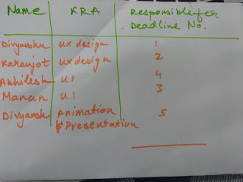](https://3.bp.blogspot.com/-6G0eImsbfjw/WNYIm5sVHzI/AAAAAAAAnaA/JLlLL6Y6R9Mbm4HLvApfhwV2JXRJdoFaQCLcB/s1600/296B7FDC-6141-4A35-9E6E-77B76AC5ABCA.jpg)

You’re my employee! So are You.

**3. Mujhe Idea aayega!**

[](https://1.bp.blogspot.com/-pcnN1t4pQ70/WNYJjEEO-kI/AAAAAAAAnaI/-4wdSp6mkcgSwB49GmdF9JqDmbceQSk9wCLcB/s1600/de1a26f4-1147-11e7-84f1-0794280c31a8.gif)

The real brain work starts now. What to and how to do it ? Here, we would like to thank Simon

Sinek to creating such an amazing framework for product designers. Having read at several places and gathering ideas from here and there, Karanjot figured out few ways to segregate fake news from the genuine one and also identified two broad principals of calculating the authenticity of a content piece.

[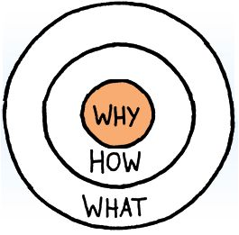](https://4.bp.blogspot.com/-c-yzoz3qH2U/WNYJ_EJ95vI/AAAAAAAAnaM/62R0Qz2LT8AOj_8yLPOGqe5O6aH8hlHVwCLcB/s1600/golden-circle.jpg)

Traversing these circles from the Why to the What made us empathise with those people who

facing the fake news problem for real. For here emerged our market assumptions, major user

groups, a partial marketing strategy and most importantly a confident product idea!

Now, it was time to go out in the field and get our assumptions validated.

**4. Making way through the green field of Users**

It was already 9:45 PM and we had just finalised our [questionnaire](https://docs.google.com/spreadsheets/d/1WgYBTBOxmU0CvOjbfosxL7p7-l9coLOlKSxzaiGyJbI/edit#gid=244643867). This speed was slow but

considering the fact that we had actually gone through brain storming to find the need and

inference drawn from every question we were complacent because even if we acquire a smaller

data set, we will know what exactly to draw from it. Nothing left hazy and unaccounted due to

variability in human nature.

[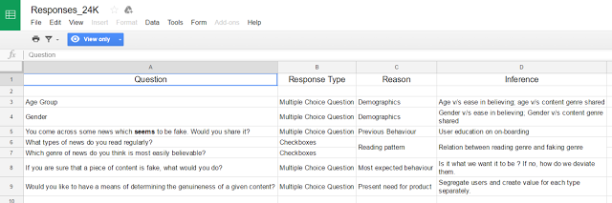](https://4.bp.blogspot.com/-6fLw0ojn98c/WNYW8g8P4fI/AAAAAAAAncE/PapmMfFdAg4Gj02Fzk7kI0JBXDS1Y8MXACLcB/s1600/Quest%2BAnalysis.png)

Questionnaire Reasoning

We distributed on this [questionnaire](https://goo.gl/forms/7GSymjSbB8sXRGJW2) to those people whom we knew won’t ask what are you doing

but simply fill the form and save our time. In two hours or so we received eight responses, two

more than we expected!

Finally we met our 1 am deadline with this

[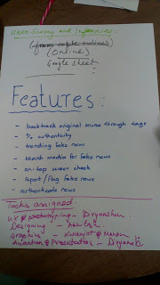](https://3.bp.blogspot.com/-D7jXfKrJw88/WNYKMw-WgZI/AAAAAAAAnaU/xDZRhCS75asF-ag6QXP1VkogW_SC0eoDwCLcB/s1600/18753F95-670B-42FB-A832-3B4F4BA68F3C.jpg)[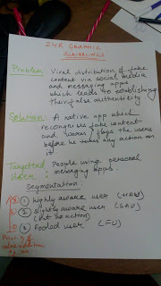](https://4.bp.blogspot.com/-aZvlq95KnBA/WNYKMq1VtXI/AAAAAAAAnaQ/tnhvfBZ9QOgrKMayiaqnEpEHFdnwJ3tFwCLcB/s1600/48C001C0-BE61-4FE4-AF85-25BA289F9F6B.jpg)

Our not so scribbled Scribbling

**5. Reaping the green field of Users**

We had what we wanted to know about users, a small set yet precise. It was time to formalise

everything we had learned about the user, his current behaviour, needs and possibly how we could

change this behaviour (if we wanted to).

All this learning, brainstorming and mess got formalised in an affinity map.

[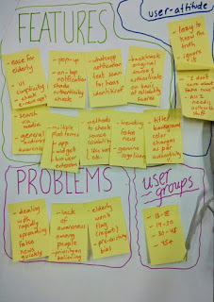](https://4.bp.blogspot.com/-jdBNDDIwFrU/WNYK2491BlI/AAAAAAAAnac/THoEtmfKdP423X-ruDVTyk2i1i_uW7tlQCLcB/s1600/9b4d8eaa-110c-11e7-8a3a-2e81325c5a94.jpeg)[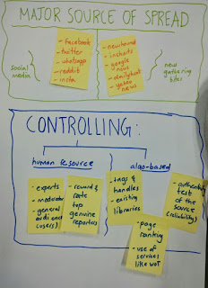](https://3.bp.blogspot.com/-8GpkpWWbfTE/WNYK3MRWjcI/AAAAAAAAnag/0qOs4VxpVfMR_tyF8yaNeXjE9-K6garkQCLcB/s1600/9b5134ec-110c-11e7-9c03-53e5347b8a59.jpeg)

 The affinity map for the world, the argument map for us

We finally met the 3 am deadline despite taking a lot of time for bullying Divyansh for coming in at

2nd place in the 2 am push up challenge.

**6. Alert! Graphics starts here**

We put our analytical caps asides and put on an artist’s beret. Tried to figure out the action triggers

on the app. We knew our app would be like the TrueCaller for content, so why not use their actions

and functions!?

The problem was accessing entire messages from the notification is quite complicated or maybe

even impossible in Android. But we found out something interesting, accessing individual

messages for scanning might not be possible but accessing an entire screen is! All we have to do

is take permission to overlay on any app from the user. Thus, we started working in this direction.

Unable to figure out any solution for parsing messages to scan for fake content, Karanjot out of his

usual habit started tapping the screen aggressively. It didn’t take time for his finger to land on the

home button and stick there for three seconds. Voila! Google On Tap opened and hence we knew

exactly what our action was going to be.

We drew a few wireframes

[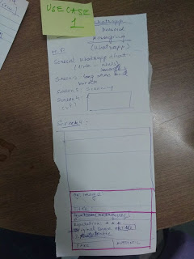](https://1.bp.blogspot.com/-tX8nDCLbe9A/WNYNVPvTFuI/AAAAAAAAnaw/dkW2mqiWFOIWnvh4UXmLB-uRdGdDLmMvACLcB/s1600/FC021248-7A38-43E0-BC0E-4D4440F3EB65%2B%25281%2529.jpg)[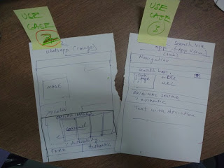](https://4.bp.blogspot.com/-hEfQ-jfTncs/WNYNXF-nzfI/AAAAAAAAna0/wUikyM-xueQzgzeDq06oFDj2EQzlHNbLwCLcB/s1600/56539E92-161C-47C0-9081-05990581B9EC%2B%25281%2529.jpg)

It takes genius designer or maybe just 4 other to decipher the wireframe Divyanshu had in mind.

But we did and came out the beauty out of Akhilesh’s hand.

[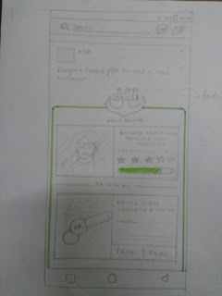](https://2.bp.blogspot.com/-X84XVSC5pl4/WNYPKoJypMI/AAAAAAAAnbI/dE97wnRtOI0TDL3XwVECHSSiZKIQIjEyQCLcB/s1600/0E30065A-3187-4013-8C44-D1349F75B99A.jpg)[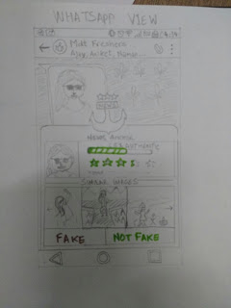](https://1.bp.blogspot.com/-IGDkCrKqgg8/WNYPKvOYpwI/AAAAAAAAnbE/br7IiHgg3hco3PNvuUmnYfYzJPqcig5SACEw/s1600/D38FCA86-AC1F-4D1D-9AC3-634D76CFDE26%2B%25281%2529.jpg)

**7. The final step**

Here it, all the brain, sweat and caffeine put together. Hope you like it.

**Bonus: Video that explains how the application solves the problem**

**Bonus: Behind the Scenes Sneak Peak**

**We identified two broad principals of calculating the authenticity of a content piece.**

**Principal 1: Tally with renowned news sources.**

Working: Viral extent of a news can be taken from trending tags on social media and other news

sharing apps like newshound, InShorts, etc. Viral extent maybe taken into account for

determining whether news is fake or not. Tags and key words from the headline and content of

the news can be used in a search algorithm that checks whether an article with same keywords

is present on the renowned news sources or not. Accordingly a news can be declared fake or

genuine. For determining a renowned source basic criteria such as year of establishment, user

reviews, etcetera are taken into account.

**Pros:** No human interaction.

**Cons:** Might show real news fake if no occurrences found on renowned sources. Can be overcome

by little human input.

**Principle 2: Human resource**

Can be implemented in two ways:

1. Dedicated experts

2. Crowdsourcing

**1. Dedicated experts:**Dedicated experts can review after an algorithm does basic filtration.

**Pros:** High accuracy

**Cons:** Slow process, expensive deal

**2. Crowdsourcing:** Volunteers who act as moderators can flag an article fake or genuine and according to the

reports fake news can be segregated from the genuine one. There could be a reward, rating, and

recognition system that motivates users to flag the fake news.

**Pros:** Can be accurate to a large extent

**Cons:** Cannot trust all volunteers but if sample size is huge, average reviews can result in

accurate flagging of the news.

**DETERMINATION OF PERCENTAGE OF AUTHENTICITY**

Over time the algorithm can learn which keywords are highly likely to be used in a fake article.

On this basis, it will increase the confidence of the percentage determined by the algorithm and

consequently decrease human intervention. The weighted mean of all percentages will give the

final percentage.

Confidence of P1 (by computer) = x

Confidence of P2 (by computer) = y

Confidence of P3 (by computer) = z

Where P(i) is the percentage

Final Percentage P = P1x + P2y + P3z

As the computer keeps learning to identify keywords, genres and trends of highly faked news, it

will ask for human intervention for fewer links.

P1 is a function of number of keywords that match patterns of highly faked news, difference

from original source, reliability of original source, genre and trend.

P2 = no. of moderators who marked authentic/ total no. of moderators asked

P3 = no. of people who marked authentic/ total no. of people asked

One such algorithm can be made that understands the context and accordingly matches latest

news from renowned sources and finally determines the percentage of authenticity. For

example, fake news is that a celebrity died in a car accident. The algorithm understands the

context as tragedy and car accident and look for similar occurrences. Say no such keyword was

found that suggests that the celebrity actually died in that. Therefore, taking all the information

into account a percentage of authenticity can be determined.