PRODUCT REQUIREMENTS DOCUMENT
TV Time 2.0
A private, social-free TV & movie tracker
Author | Karan Dalal
Status | Living document — v1.1
Last updated | August 2026
Live product | tv-time-2-0.vercel.app

1. Overview
TV Time 2.0 is a personal TV and movie tracker built as a direct replacement for TV Time, whose social features (feed, reactions, comments) had grown to overshadow its core utility: tracking what you watch. TV Time 2.0 strips that back to the essentials — mark episodes and movies watched, see what to watch next, and check upcoming releases — with no social layer at all.
It is a zero-cost, installable Progressive Web App (PWA): no App Store, no subscription, no ads, and no third party ever sees the data beyond the services strictly needed to fetch show metadata and, optionally, sync a user’s own watch history to their own Google Drive.

2. Problem Statement
- TV Time, the incumbent app, has drifted from a tracking tool into a social network — the features that matter (accurate episode tracking, a clean up-next queue) are buried under feed content nobody asked for.
- There is no lightweight, privacy-respecting alternative that does only the tracking job well.
- Friends and family with the same complaint have no easy way to get the same experience without standing up their own infrastructure.

3. Goals & Non-Goals

Goals
- Track TV shows and movies at the episode level with zero friction.
- Surface a clear, prioritized “what to watch next” queue that reflects real viewing behavior.
- Work fully offline for local tracking; sync across devices only when the user opts in.
- Cost nothing to run, for the author and for anyone else who uses it.
- Require no account creation beyond an optional, single Google sign-in for sync.

Non-goals
- No social feed, reactions, comments, or public activity of any kind.
- No ads, no paid tiers, no monetization — this shapes real technical decisions (see §7 and §11).
- No recommendation engine or algorithmic content surfacing.

4. Target Users
- Primary: the author, for daily personal tracking.
- Secondary: friends and family, invited to the same shared instance at zero marginal cost.

5. Guiding Principles
Recurring decisions across the build converged on a small set of principles that now guide every new feature:
- Local-first, privacy-first — data lives on-device by default; sync is opt-in and goes to the user’s own storage, never a shared database.
- Zero required setup — a new user should be productive within seconds, not minutes.
- Personal progress over broadcast status — the app describes your relationship to a show (caught up, not started), not the industry’s (renewed, cancelled), except where that fact is genuinely useful (see §6.1).
- No paid infrastructure — every dependency has a genuinely free tier sufficient for personal-to-small-group scale.
- Confirm before building anything with more than one reasonable interpretation — ambiguity gets resolved in conversation, not assumed in code.

6. Current Feature Set (Shipped)

6.1 TV Tracking
Shows are organized into five sections reflecting where they actually stand:
- Watch Next. Watch Next — shows with progress, most recently watched first; a show you were anticipating that just released gets a temporary 7-day priority slot above everything else.
- Yet to Start. Yet to Start — released, available, but untouched; ordered by when it became relevant to you (added, or aged out of its release window), not by raw air date.
- All Caught Up. All Caught Up — every aired episode watched, and the show is still airing more.
- Yet to Release. Yet to Release — nothing has aired yet; sorted soonest-first with a prominent day-countdown instead of a generic status label.
- Stopped. Stopped — a deliberate “set aside” state so the active queue doesn’t grow unbounded without losing watch history; only shown when non-empty.
Status pills reflect personal progress first: Ongoing, Caught Up, Yet to Release, Not Started, Stopped — except once a show is fully caught up and has actually finished (Ended/Cancelled, treated as one state), where the real-world fact is more useful than “Caught Up.”

6.2 Movie Tracking
Simpler binary state — To Watch or Watched — with release-date awareness: an unreleased movie is labeled Yet to Release rather than lumped in with your backlog.

6.3 Search
Unified search across TV and movies in one box, backed by TMDB.

6.4 Library & Stats
The library previews shows and movies most-recently-watched first, with a one-tap “See all” into the full list. Stats summarize episodes watched, time spent, and completion counts, split by TV and movies.

6.5 Sync & Backup
- Google Drive sync. Google Drive sync — sign in once; data syncs to a private app-only folder in the user’s own Drive. Built as a proper backend-for-frontend (a small serverless auth layer) specifically because the simpler client-only approach did not stay signed in reliably on mobile Firefox/Safari.
- CSV backup. CSV backup — export/import as a real, human-readable spreadsheet (opens in Excel/Numbers/Sheets), not an opaque JSON blob. Import re-fetches full show data by TMDB ID and restores original watch dates, not the import date.

6.6 Sharing the App Itself
A built-in, shared TMDB API key means anyone can use the app with zero setup — no signup required to start tracking. Multi-user support runs through Google’s standard OAuth test-user allowlisting.

6.7 Usage Insight (Admin)
A lightweight, password-gated roster shows who has connected and how much they’ve used the app — email, first/last seen, and aggregate show/movie counts only. Never titles, never watch history. Disclosed directly in-app.

6.8 Installability
A standards-based PWA: installable to a phone’s home screen, offline-capable app shell via a service worker, no App Store review process.

6.9 External Ratings (IMDb)
Every show and movie detail page shows its IMDb rating alongside the user’s own personal rating.
- Source. Source — the OMDb API (a free third-party aggregator), queried by the IMDb ID that TMDB already provides — directly for movies, via one added parameter for TV shows.
- Display. Display — a two-line block: IMDb rating on the first line, the user’s own 1–5 star rating on the second. The star control only appears once the user has actually watched something (at least one episode for a show, or the movie itself) — rating a title you haven’t watched isn’t meaningful.
- Caching. Caching — each title’s rating is fetched once and cached locally; never re-fetched on later views. A genuine “no rating exists” is cached as such, while a transient failure (e.g. rate limit) is retried on the next visit instead.
- Scope. Scope — IMDb rating only. No Rotten Tomatoes or Metacritic, to keep the detail view focused and because IMDb is the most consistently populated field in OMDb’s data.
- Limits. Limits — OMDb’s free tier allows 1,000 requests/day, shared across every user of the app’s built-in key. Fails silently if ever hit — the IMDb line is simply omitted for that visit, and retried later.
- License. License — OMDb data is non-commercial use only (CC BY-NC 4.0), which the app already satisfies (no ads, no paid tiers) and must continue to.

7. Planned Features (Not Yet Built)
The following are fully specified and locked, pending implementation.

7.1 Lists
A Spotify-playlist-style feature for grouping shows and movies into user-named collections.
- Placement. Placement — a new row in the You tab’s Library section, above the existing TV/Movies rows.
- Membership rule. Membership rule — a list is a curated view on top of tracking, not a replacement for it. Adding an item to a list auto-adds it to Watchlist only if it isn’t tracked yet; it never changes existing status or progress.
- Ordering. Ordering — descending by latest release (an ongoing show’s newest aired episode counts), not by when it was added to the list.
- Filtering. Filtering — four chips per list: All / Started / Watched / Not Started.
- Add-to-list flow. Add-to-list flow — from any show/movie, a Spotify-style sheet: existing lists as pre-checked multi-select checkboxes, plus “+ New list.”
- Sharing (deferred). Sharing — explicitly deferred to a later phase. Direction under consideration: a read-only live link backed by the Redis store already in place for usage insight, requiring no sign-in to view — not yet finalized.

8. Out of Scope (Investigated)
Features considered and explicitly ruled out, documented here so they aren’t re-investigated from scratch.

8.1 Episode-level release time gating
Requested: gate an episode’s appearance in Watch Next on its actual release time (e.g. 5pm local), not just its release date — so an episode wouldn’t show as available until the hour it actually drops.
- Investigation. Checked four categories of source — TMDB (episode data is date-only, no time field at all), TVmaze, Trakt/TheTVDB, and dedicated streaming-availability aggregators (Watchmode, movieofthenight) — for real per-episode release times.
- Finding. Real time-of-day data exists only for traditional broadcast/cable shows (TVmaze has a genuine, network-confirmed airtime for these). For streaming platforms — Netflix, Apple TV+, and the like, which make up most of what people track today — no source publishes an exact release time anywhere in structured, API-accessible form. This isn’t a “wrong API” problem: the platforms themselves don’t make that data available to aggregators at all.
- Decision. A partial implementation (real times for broadcast shows, date-only for streaming) was explicitly rejected in favor of one consistent behavior for every show. Since universal real time data doesn’t exist, the feature stays out of scope — Watch Next continues to gate on release date only, which is the accurate, honest representation of what’s actually knowable.

9. Technical Architecture
Deliberately minimal: no framework, no build step, no database beyond what each piece strictly needs.
- Client. Client — vanilla HTML/CSS/JavaScript, ES modules, IndexedDB for local-first storage, a service worker for offline capability.
- Hosting. Hosting — Vercel, serving the static app and a small set of serverless functions from the same deploy.
- Source control. Source control — GitHub; every push to main auto-deploys.
- Show/movie data. Show/movie data — TMDB API, built-in shared key.
- Sync. Sync — Google OAuth (server-side token exchange) + Google Drive API, refresh token held in an httpOnly cookie, never exposed to the client.
- Usage roster. Usage roster — Upstash Redis (free tier), written to by the serverless functions only.
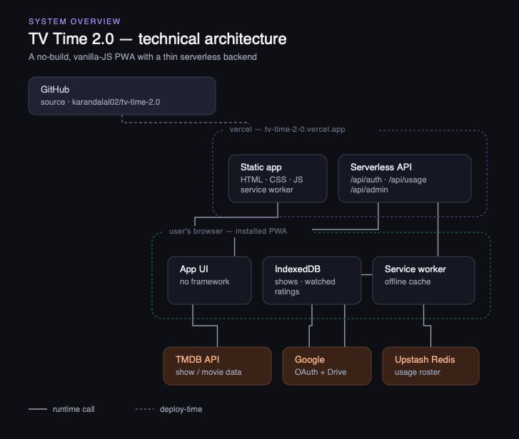
System architecture — see docs/architecture.svg in the repo for the full-detail version.

10. Success Metrics
Lightweight and personal-scale, not corporate KPIs — this is a personal tool first:
- Daily personal use replaces TV Time entirely.
- Watch history stays consistent across every device without manual intervention.
- At least a handful of friends/family actively using their own tracked library.
- Total infrastructure cost: $0/month, indefinitely, at current scale.

11. Risks & Open Questions
- OMDb rate limit. OMDb’s shared 1,000/day quota could be exhausted if usage grows meaningfully — mitigated by caching; a per-user key override is the fallback if it becomes a real problem.
- Lists sharing. The exact mechanism (live read-only link vs. export vs. collaborative) is decided in direction but not finalized.
- Free-tier dependency. Vercel, Upstash, TMDB, and OMDb all currently offer sufficient free tiers; a pricing change on any of them would require re-evaluation.
- Google OAuth verification. The app is in Google’s OAuth “testing” mode, which caps invited users and requires each person to click through an “unverified app” screen once — acceptable at friends-and-family scale, would need Google verification to grow further.

12. Release Notes
Versioning convention
Every net-new, independently-shippable feature gets its own version number and a short name (e.g. “V1.2 — Lists”), added as a new entry below the moment it ships. Bug fixes and refinements to an already-shipped feature update that same entry in place — they never spawn a new version number. An entry keeps evolving until that feature reaches a stable, final state.

V1.0 — Initial release
Aug 2026
- TV tracking — Watch Next / Yet to Start / All Caught Up / Yet to Release / Stopped, episode-level marking, release-aware queue ordering, personal-progress status pills.
- Movie tracking — To Watch / Watched, release-date-aware labeling.
- Unified TV + movie search.
- Library and Stats views.
- Google Drive sync (sign in once, own-account storage).
- CSV backup (human-readable export/import).
- Zero-setup sharing via a built-in TMDB key.
- Usage insight (admin roster — email + counts only).
- PWA installability with offline app shell.

V1.1 — External Ratings (IMDb)
Aug 2026
- IMDb rating shown on every show/movie detail page, sourced from OMDb via the IMDb ID TMDB already provides.
- Two-line ratings block: IMDb rating on line one, the user’s own 1–5 star rating on line two.
- Personal rating is only available once at least one episode (TV) or the movie itself has been watched.
- Ratings are fetched once per title and cached locally; failures fail silently and retry later rather than blocking the page.

Future entries (V1.2, …) get appended here as each planned feature in §7 actually ships.

