Personal Finance Expense Tracker
- Introduction : Managing personal finances is a critical aspect of modern life. Many individuals struggle to track their income and expenses, leading to overspending and poor financial planning. The proposed project aims to provide an easy-to-use web application that allows users to efficiently track, categorize, and analyze their financial transactions. This tool will help users make informed decisions about their spending, save money, and plan budgets effectively.
- System Design:
- Flow:
- User registers/login → token generated for session
- User adds transactions → data saved to database
- User views dashboard → backend calculates total income, expenses, and balance
- User filters transactions by category/date → backend queries and returns results
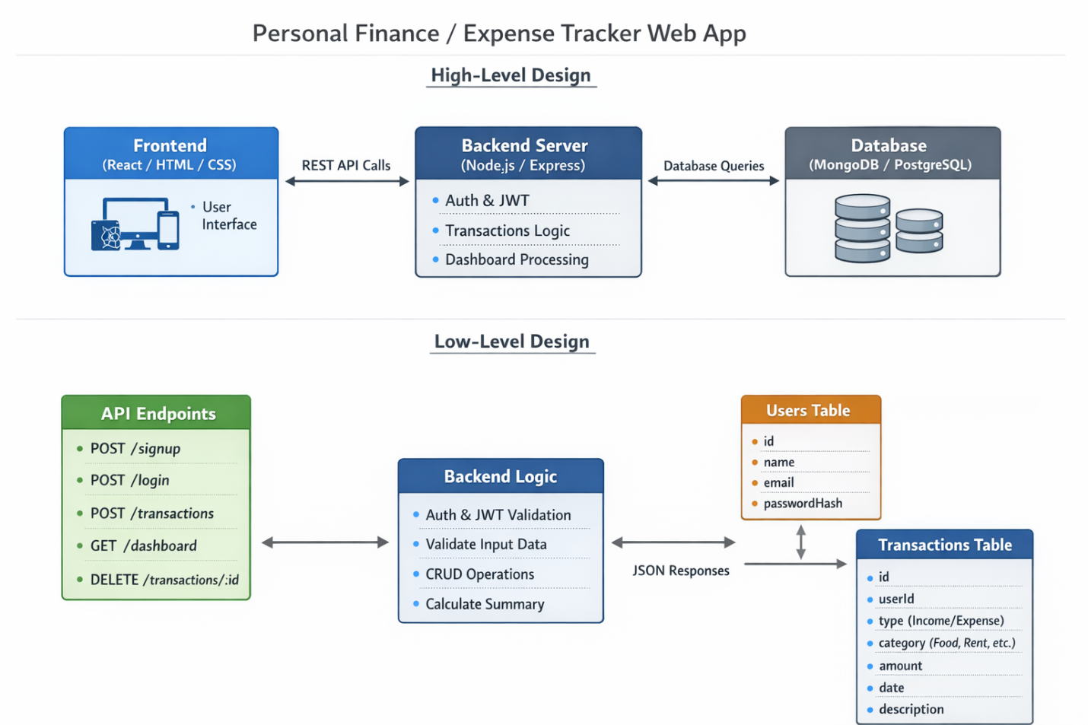

- High Level Design:
- Frontend(Client):
        - React
        - Pages : SignUp/Login/Dashboard/Transactions
        - Send request to backend via APIs
        - Display data in charts
- Backend (Server):
        - Spring Boot
        - Handles Authentication, transaction CRUD(Create ,Read ,Update , Delete),dashboard calculations
- Database :
        - MongoDB
        - Stores users and transactions
        - Handles queries for dashboard summary
- Low-Level Design (LLD):
1. Users Table: id, name, email, passwordHash
2. Transactions Table: id, userId, type, category, amount, date, description
3. API Endpoints : /signup, /login, /transactions (CRUD), /dashboard
- Tools and Technologies:
Component | Tool/Technology
Frontend | React
Backend | SpringBoot
Database | MongoDB
- Modules:
- User Authentication:
- Goal: Allow users to register and log in securely.
- Tasks: Frontend: Signup & Login form , Backend: /signup and /login APIs , Database , Users table/collection (id, name, email, passwordHash)
- Implement password hashing & JWT token authentication
- Outcome: Users can securely create accounts and log in.

- Database Setup:
- Goal: Create storage for all data.
- Tasks: Create Users and Transactions tables/collections , Test database connection and basic CRUD.
- Outcome: Database ready to store user info and transactions.
- Add Transactions:
- Goal: Users can record income and expenses.
- Tasks: Frontend: Form to add transaction (type, category, amount, date, description) ,
Backend API: POST /transactions , Validate input (amount > 0, type = income/expense)
- Outcome: Users can add new transactions to their account.
- View Transactions:
- Goal: Display all transactions for a user.
- Tasks: Backend API: GET /transactions → fetch all transactions of logged-in user
Frontend: Display transactions in a table/list
Show date, type, category, amount, description

- Outcome: Users can see their transaction history
- Dashboard & Summary
- Goal: Provide a summary of financial data.
Tasks: Backend API: GET /dashboard
Query transactions for the user
Calculate total income, total expenses, and balance
- Frontend: Display summary in cards or charts
Outcome: Users can quickly see financial health.
- Delete / Edit Transactions
- Goal: Allow users to modify their transaction history.
Tasks: Backend API: DELETE /transactions/:id & optional PUT /transactions/:id

Frontend: Add delete/edit buttons
- Ensure only the owner can modify their transactions
Outcome: Users can update or remove incorrect entries.
- Categories & Filtering
- Goal: Organize and filter transactions.
Tasks: Categorize transactions (Food, Rent, Salary, etc.)

Backend: Filter by category or date range (GET /transactions?category=Food)
- frontend: Add dropdowns or date pickers for filtering
Outcome: Users can focus on specific categories or time periods.
- Optional Enhancements
- Goal: Make your app more advanced and user-friendly.
Tasks: Add charts/graphs (Chart.js) for income vs expense trends

Notifications/alerts for budget limits
- Profile page for updating user info
Outcome: Users get a polished, feature-rich app.

