CICD – CODE INTEGRATION AND CODE DEPLOYMENT

INTEGRATION TOOLS :

1)CIRCLE CI

2)BAMBOO

3)CONTINOUS PIPELINE

4)TRAVIS CI

5)GITHUB ACTIONS

6)JENKINS

Jenkins integration tool released in 2005 , its is a open source free software ,jenkins is a supports tool

Scenario is install the jenkins tool features in ubuntu os

1)create a ubuntu server with all TCP open condition

2)then provide below mentioned command one by one

*sudo su

*apt-get update –y

*apt-get upgrade –y

*execute the Jenkins official webside (Jenkins.io)given commands .

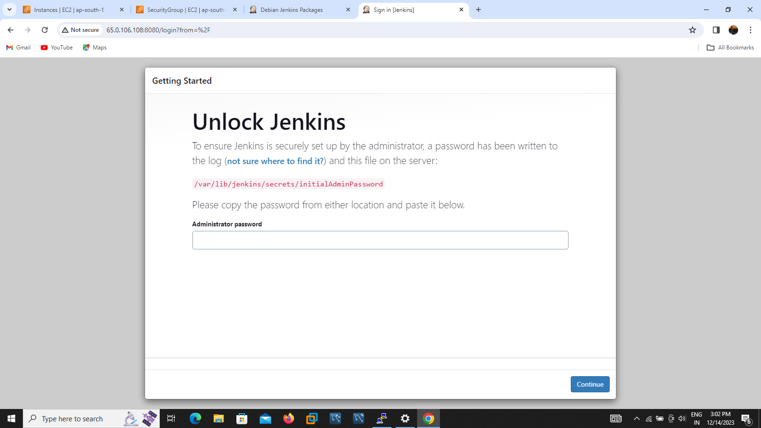

3)paste the public ip address in browser Jenkins page will be open and the page asking password ,we go for take password from putty and execute the command cat /var/lib/Jenkins/secrets/initial administrator password ,

4)And install the suggested pluggins

5)enter the user name and password and mail id to create a root account then ,URL will be open

6)click save & finish installation be completed

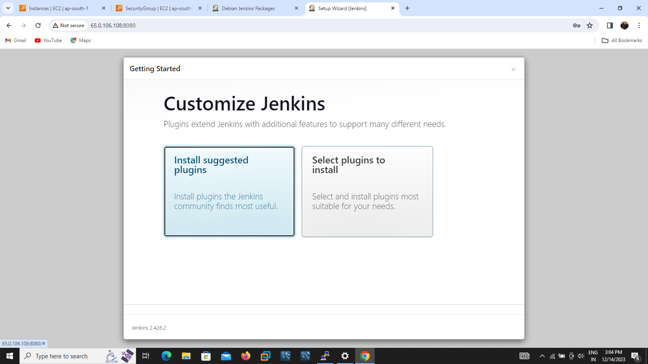

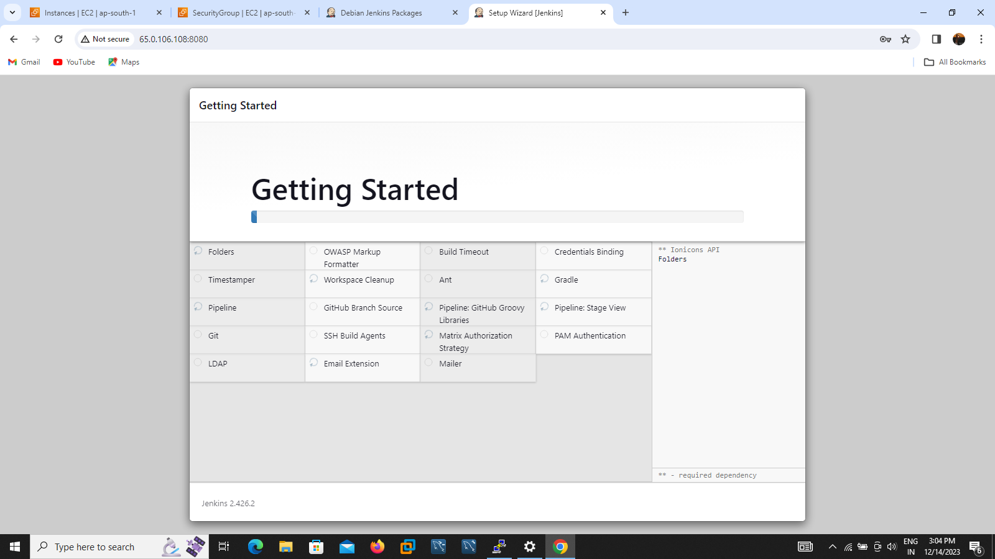

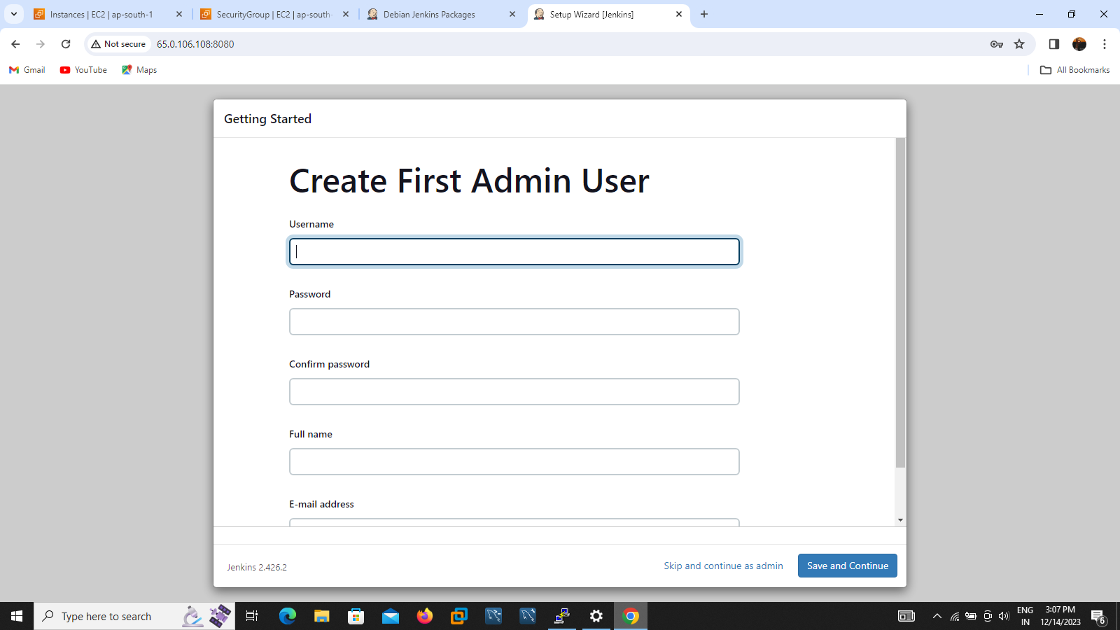

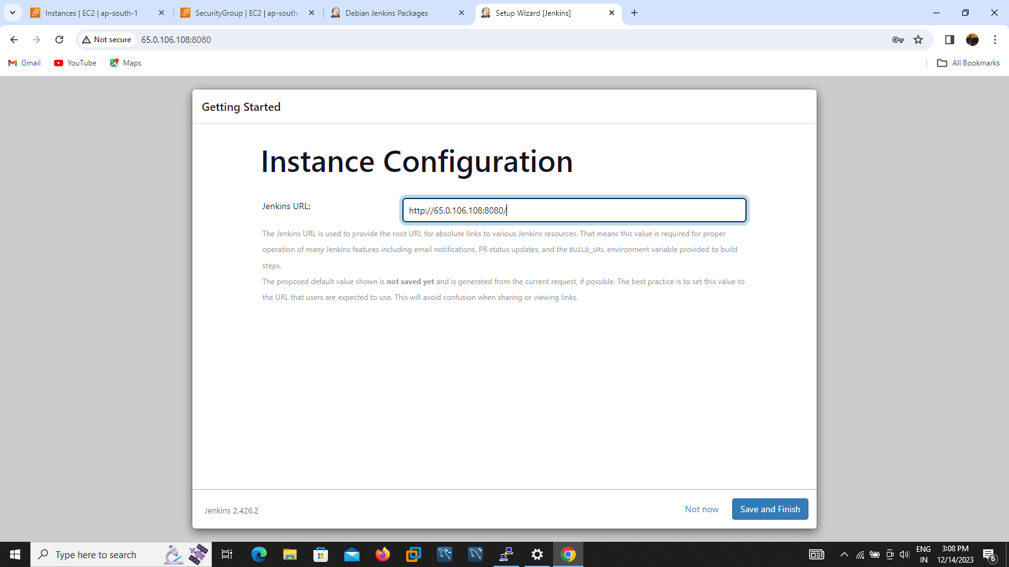

Now we want to to configure domain name with IP address so now go to ROUTE 53 map the DNS name server by using follow the steps :

1)create hosted name provide domain name then SOA and NS record will be created.

2)then want to create recode to map subdomain and ip address

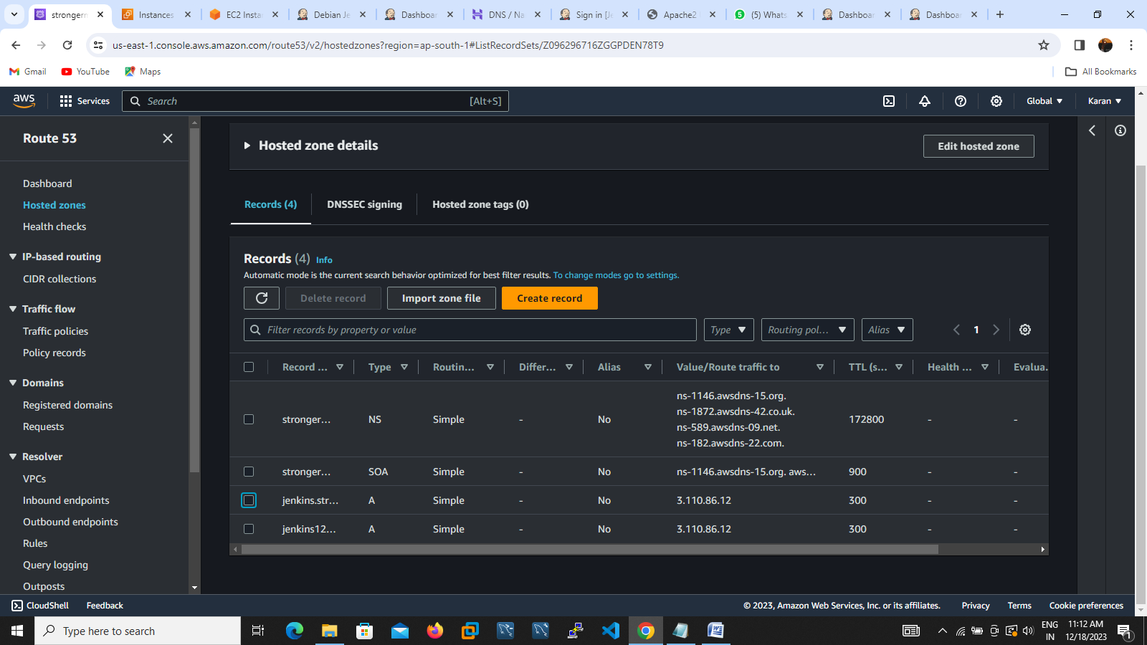

Then go to yout ubuntu server install apache 2 server and configutre apache 2 server and domain name follow by those steps:

1. Go to your putty
2. Execute below commands
3. sudo apt-get update
4. sudo apt-get install apache2 -y
5. sudo a2enmod proxy
6. sudo a2enmod proxy_http
7. sudo a2enmod headers
8. cd /etc/apache2/sites-available/
9. go to the directory then edit the file
10. sudo vim jenkins.conf
11. <Virtualhost *:80>
12. ServerName jenkins.strongermuch.shop
13. ProxyRequests Off
14. ProxyPreserveHost On
15. AllowEncodedSlashes NoDecode
17. <Proxy http://localhost:8080/*>
18. Order deny,allow
19. Allow from all
20. </Proxy>
22. ProxyPass / http://localhost:8080/ nocanon
23. ProxyPassReverse / http://localhost:8080/
24. ProxyPassReverse / http://jenkins.strongermuch.shop/
25. </Virtualhost>

Then go to save it and restart the apache 2 server and Jenkins ,domain name successfully configured with apache 2 server