
SHRI MOUNI VIDYAPITH’S
INSTITUTE OF CIVIL AND RURAL ENGINEERING.
A
Micro Project Report
Under the course
“Web Page Designing”(312004)
With title
“EDUCATIONAL INSTITUTE WEB PAGE”

ROLL NO
NAME

- APURVA RAJARAM DONGALE

- SHREYAS SURESH FARAKATE

- BHOOMI TANAJI GURAV

- NEHA TANAJI GURAV

- RADHIKA BHAGAVAN GURAV

Under the guidance of
Mr.S.G.Mane Sir

In Partial Fulfilment of Diploma in Computer Engineering

Department of Computer Engineering
(2022-23)



Department of Computer Engineering (2024 -25)
CERTIFICATE

This is certify that the micro project entitled" EDUCATIONAL INSTITUTE WEB PAGE "under the course of “WEB PAGE DESIGN ”summited to the institute of civil and Rural Engineerging , Gargoti in partial fulfilment of Diploma in Computer Engineering is a record of original work done by Apurva, Radhika, Bhoomi, Shreyas, Neha during the period from 2024 to 2025 . under my supervision and guidance and it has not copied or summited with other similar title by any candidates in any Diploma College.

Place: Gargoti Date:

Head Of Department Signature of the Guide



MAHARASHTRA STATEBOARD OF TECHNICAL EDUCATION
CERTIFICATE

This to certify that Mr.........................................................................
Roll No…... of Second semester of Diploma in Computer Engineering Form Institute Civil & Rural Engineering (code:0012) has completed the micro project work satisfactorily in course “WEB PAGE DESIGNING” (312004) For the academic year 2024-2025 as prescribed in the curriculum.

Place: Gargoti

Date: ………….

Subject Teacher Head of The Department



INDEX

Sr.No. | Contents | Page No.
1 | Introduction
2 | Aims of microproject
3 | Course outcome addressed
4 | Literature review
5 | Actual methodology used
6 | Actual Resources used
7 | Output of micro project
8 | Output window of the HTML code
9 | Application of this project
10 | Conclusion

MAHARASHTRA STATEBOARD OF TECHNICAL EDUCATION

Introduction:

At [Institute Name], we believe in empowering minds and shaping futures. Our institute is dedicated to providing quality education, innovative learning environments, and opportunities that prepare students for academic and professional success. With a team of experienced educators, modern facilities, and a commitment to excellence, we strive to nurture talent and inspire lifelong learning.

Aims of microproject:

1)Inform and Attract

2)EnhancFacilitate Information

3)Accesse Online Presence

4)Support StudentEngagement and Retention

5)Improve Marketing and Recruitment

Course outcome addressed :

CO1: Use various tags of HTML to design static web pages.

CO2: Design attractive web pages using HTML and CSS.

CO3: Create user-friendly and well-structured websites with proper navigation.

CO4: Apply the concept of external, internal, and inline CSS in website design.

CO5: Develop simple projects involving real-life problems using HTML

CO6: Build awareness about planning and executing web development projects.

Literature review:

Educational institute web pages play a crucial role in providing information and connecting with students, parents, and faculty. Studies emphasize that good web design should be user-friendly, responsive, and easy to navigate (Nielsen, 2012; Krug, 2014). Key factors for success include content quality, visual design, and technical performance (Aladwani & Palvia, 2002). A well-designed website helps improve the institution’s image and can attract more students (Bai & Lind, 2011). Current trends include mobile responsiveness, multimedia use, and accessibility, as recommended by W3C. These principles guide the development of this microproject.

---

Actual methodology used:

The project began with gathering requirements and planning the layout. HTML, CSS, and JavaScript were used to design and develop the website. A responsive layout was created to ensure compatibility across devices. The website was then tested for usability and functionality, followed by deployment and review for final improvements.

Actual Resources Used:

Sr.no. | Name of required resources | Specification | Quantity | Remarks
1. | Hardware (compute r) | Intel (i5 sixth generation), RAM 8 GB , Storage-256 GB(SSD) | 1 Each
2. | Software | DEV C++ | 1
3. | Online Reference | google.com https://www.tutorialspoint.com/cprogramming | -

HTML Code

<!DOCTYPE html>
<html lang="en">
<head>
<meta charset="UTF-8">
<title>ICRE Main Page</title>
<link rel="stylesheet" href="style.css">
<header>
<img src="C:\Users\farak\OneDrive\Desktop\HeaderImg.jpg" alt="Institute Logo" height="100" width="1000">
</header>
</head>
<body>
<nav style="background-color: #003366; padding: 15px; text-align: center;">
<a href="mp.html" style="color: white; margin: 0 15px; text-decoration: none; font-weight: bold;">Home</a>
<a href="aboutus.html" style="color: white; margin: 0 15px; text-decoration: none; font-weight: bold;">About Us</a>
<a href="admission.html" style="color: white; margin: 0 15px; text-decoration: none; font-weight: bold;">Admissions</a>
<a href="course.html" style="color: white; margin: 0 15px; text-decoration: none; font-weight: bold;">Courses</a>
<a href="contact.html" style="color: white; margin: 0 15px; text-decoration: none; font-weight: bold;">Contact</a>
</nav>
<style>
nav a:hover {
text-decoration: underline;
color: #ffcc00; /* golden yellow on hover */
}
</style>
<center>
<h1>Institute of Civil and Rural Engineering</h1>
<section>
<h2>Welcome to Our Institute</h2>
<img src="C:\Users\farak\OneDrive\Desktop\hr.jpg" alt="Campus Image" height="500" width="800">
</center>
</section>
</body>
</html>
HTML Code For Home Page

<!DOCTYPE html>
<html lang="en">
<head>
<meta charset="UTF-8">
<title>About Us</title>
<link rel="stylesheet" href="style.css">
<header>
<img src="C:\Users\farak\OneDrive\Desktop\HeaderImg.jpg" alt="Institute Logo" height="100" width="1000">
</header>
</head>
<body>
<nav style="background-color: #003366; padding: 15px; text-align: center;">
<a href="mp.html" style="color: white; margin: 0 15px; text-decoration: none; font-weight: bold;">Home</a>
<a href="aboutus.html" style="color: white; margin: 0 15px; text-decoration: none; font-weight: bold;">About Us</a>
<a href="admission.html" style="color: white; margin: 0 15px; text-decoration: none; font-weight: bold;">Admissions</a>
<a href="course.html" style="color: white; margin: 0 15px; text-decoration: none; font-weight: bold;">Courses</a>
<a href="contact.html" style="color: white; margin: 0 15px; text-decoration: none; font-weight: bold;">Contact</a>
</nav>
<style>
body {
margin: 0;
background-color: #e6f0ff; /* light blue shade for background */
font-family: Arial, sans-serif;
}

header {
text-align: center;
padding: 10px;
background-color: #cce0ff; /* lighter blue for header background */
}

nav {
background-color: #003366;
padding: 15px;
text-align: center;
}

nav a {
color: white;
margin: 0 15px;
text-decoration: none;
font-weight: bold;
}

nav a:hover {
text-decoration: underline;
color: #ffcc00; /* golden yellow on hover */
}

h1, h2 {
color: #003366;
}

section {
text-align: center;
padding: 20px;
}
</style>

<section>
<h2>About Us</h2>
<p>Institute Of Civil And Rural Engineering (ICRE) is located in Kolhapur, Maharashtra...</p>
<h3>Principal’s Message</h3>

<p>Welcome to our prestigious institution where we nurture future leaders...</p>
<h3>Faculty & Staff</h3>
<h3>Shri. J.S. Ghevade - Principal</h3>
<h3>Shri S.G. Mane - HOD</h3>
</section>
</body>
</html>
HTML Code For About Us
HTHHGhwhgf

<!DOCTYPE html>
<html lang="en">
<head>
<meta charset="UTF-8">
<title>Admissions</title>
<link rel="stylesheet" href="style.css">
<header>
<img src="C:\Users\farak\OneDrive\Desktop\HeaderImg.jpg" alt="Institute Logo" height="100" width="1000">
</header>
</head>
<body>
<nav style="background-color: #003366; padding: 15px; text-align: center;">
<a href="mp.html" style="color: white; margin: 0 15px; text-decoration: none; font-weight: bold;">Home</a>
<a href="aboutus.html" style="color: white; margin: 0 15px; text-decoration: none; font-weight: bold;">About Us</a>
<a href="admission.html" style="color: white; margin: 0 15px; text-decoration: none; font-weight: bold;">Admissions</a>
<a href="course.html" style="color: white; margin: 0 15px; text-decoration: none; font-weight: bold;">Courses</a>
<a href="contact.html" style="color: white; margin: 0 15px; text-decoration: none; font-weight: bold;">Contact</a>
</nav>
<style>
body {
margin: 0;
background-color: #e6f0ff; /* light blue shade for background */
font-family: Arial, sans-serif;
}

header {
text-align: center;
padding: 10px;
background-color: #cce0ff; /* lighter blue for header background */
}

nav {
background-color: #003366;
padding: 15px;
text-align: center;
}

nav a {
color: white;
margin: 0 15px;
text-decoration: none;
font-weight: bold;
}

nav a:hover {
text-decoration: underline;
color: #ffcc00; /* golden yellow on hover */
}

h1, h2 {
color: #003366;
}

section {
text-align: center;
padding: 20px;
}
</style>

<section>
<h2>Admissions</h2>
<img src="https://via.placeholder.com/600x200?text=Admissions+Open" alt="Admissions Banner">
<p><strong>Process:</strong> Fill the online form and attend the entrance exam.</p>
<form>
<label for="name">Name:</label>
<input type="text" id="name" name="name">
<label for="email">Email:</label>
<input type="email" id="email" name="email">
<button type="submit">Apply</button>
</form>
</section>
</body>
</html>
h
HTML Code For Admission Page

<!DOCTYPE html>
<html lang="en">
<head>
<meta charset="UTF-8">
<title>Courses</title>
<link rel="stylesheet" href="style.css">
<header>
<img src="C:\Users\farak\OneDrive\Desktop\HeaderImg.jpg" alt="Institute Logo" height="100" width="1000">
</header>
</head>
<body>
<nav style="background-color: #003366; padding: 15px; text-align: center;">
<a href="mp.html" style="color: white; margin: 0 15px; text-decoration: none; font-weight: bold;">Home</a>
<a href="aboutus.html" style="color: white; margin: 0 15px; text-decoration: none; font-weight: bold;">About Us</a>
<a href="admission.html" style="color: white; margin: 0 15px; text-decoration: none; font-weight: bold;">Admissions</a>
<a href="course.html" style="color: white; margin: 0 15px; text-decoration: none; font-weight: bold;">Courses</a>
<a href="contact.html" style="color: white; margin: 0 15px; text-decoration: none; font-weight: bold;">Contact</a>
</nav>
<style>
body {
margin: 0;
background-color: #e6f0ff; /* light blue shade for background */
font-family: Arial, sans-serif;
}

header {
text-align: center;
padding: 10px;
background-color: #cce0ff; /* lighter blue for header background */
}

nav {
background-color: #003366;
padding: 15px;
text-align: center;
}

nav a {
color: white;
margin: 0 15px;
text-decoration: none;
font-weight: bold;
}

nav a:hover {
text-decoration: underline;
color: #ffcc00; /* golden yellow on hover */
}

h1, h2 {
color: #003366;
}

section {
text-align: left;
padding: 20px;
}
</style>

<section>
<h2>Courses Offered</h2>
<ul>
<li>Computer Engineering</li>
<li>Electronics and Telecommunication</li>
<li>Electrical Engineering</li>
<li>Mechanical Engineering</li>
<li>Civil Engineering</li>
</ul>
</section>
</body>
</html>
HTML Code For Courses Page

<!DOCTYPE html>
<html lang="en">
<head>
<meta charset="UTF-8">
<title>Contact Us</title>
<link rel="stylesheet" href="style.css">
<header>
<img src="C:\Users\farak\OneDrive\Desktop\HeaderImg.jpg" alt="Institute Logo" height="100" width="1000">
</header>
</head>
<body>
<nav style="background-color: #003366; padding: 15px; text-align: center;">
<a href="mp.html" style="color: white; margin: 0 15px; text-decoration: none; font-weight: bold;">Home</a>
<a href="aboutus.html" style="color: white; margin: 0 15px; text-decoration: none; font-weight: bold;">About Us</a>
<a href="admission.html" style="color: white; margin: 0 15px; text-decoration: none; font-weight: bold;">Admissions</a>
<a href="course.html" style="color: white; margin: 0 15px; text-decoration: none; font-weight: bold;">Courses</a>
<a href="contact.html" style="color: white; margin: 0 15px; text-decoration: none; font-weight: bold;">Contact</a>
</nav>
<style>
body {
margin: 0;
background-color: #e6f0ff; /* light blue shade for background */
font-family: Arial, sans-serif;
}

header {
text-align: center;
padding: 10px;
background-color: #cce0ff; /* lighter blue for header background */
}

nav {
background-color: #003366;
padding: 15px;
text-align: center;
}

nav a {
color: white;
margin: 0 15px;
text-decoration: none;
font-weight: bold;
}

nav a:hover {
text-decoration: underline;
color: #ffcc00; /* golden yellow on hover */
}

h1, h2 {
color: #003366;
}

section {
text-align: center;
padding: 20px;
}
</style>

<section>
<h2>Contact Us</h2>
<img src="C:\Users\farak\OneDrive\Desktop\contact.png" alt="Contact Graphic" height="100" widhth="100">
<p>Address: Hutatma Murlidharnagar, Gargoti, Pin-416209</p>
<form>
<label for="message-name">Your Name:</label>
<input type="text" id="message-name" name="message-name">
<label for="message-email">Email:</label>
<input type="email" id="message-email" name="message-email">
<label for="message">Message:</label>
<textarea id="message" name="message"></textarea>
<button type="submit">Send</button>
</form>
</section>
</body>
</html>
HTML Code For Contact Page

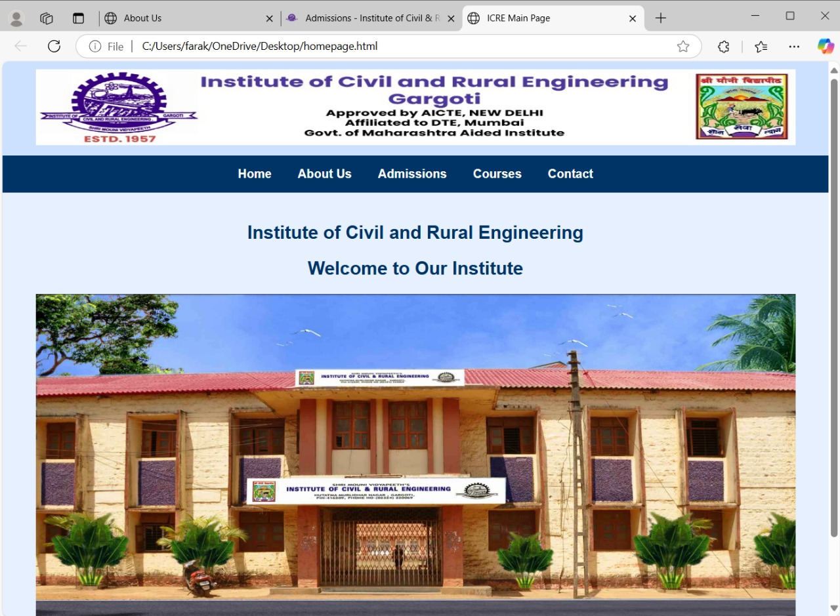
OUTPUT
Output Of HTML Code For Home Page

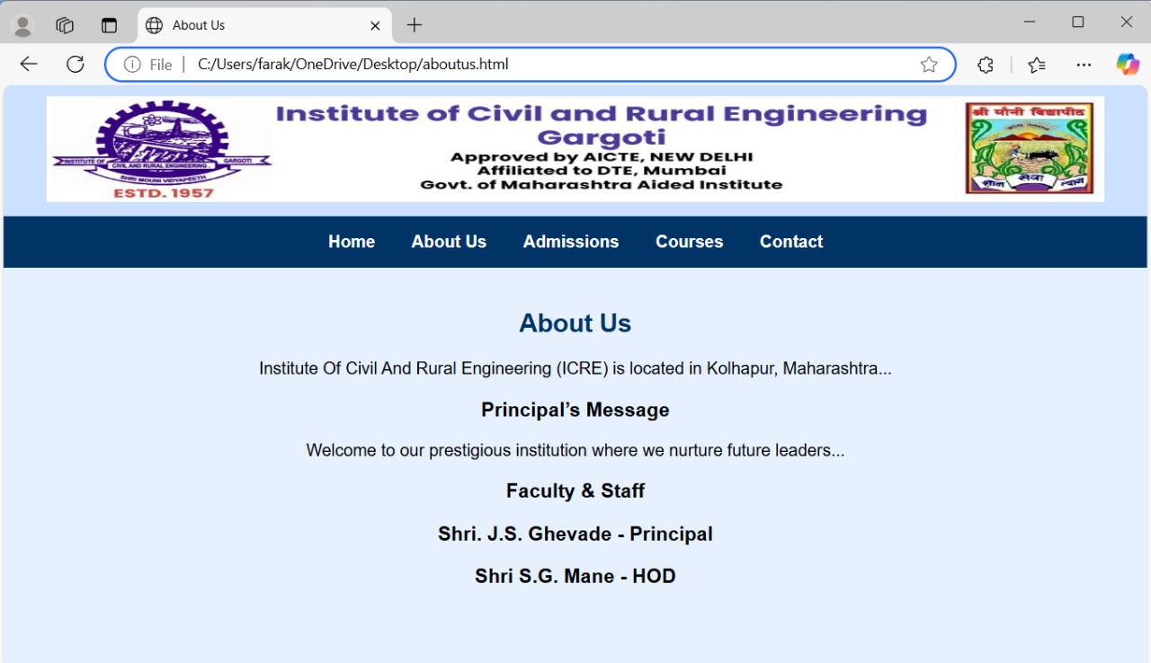
Output Of HTML Code For About Us Page

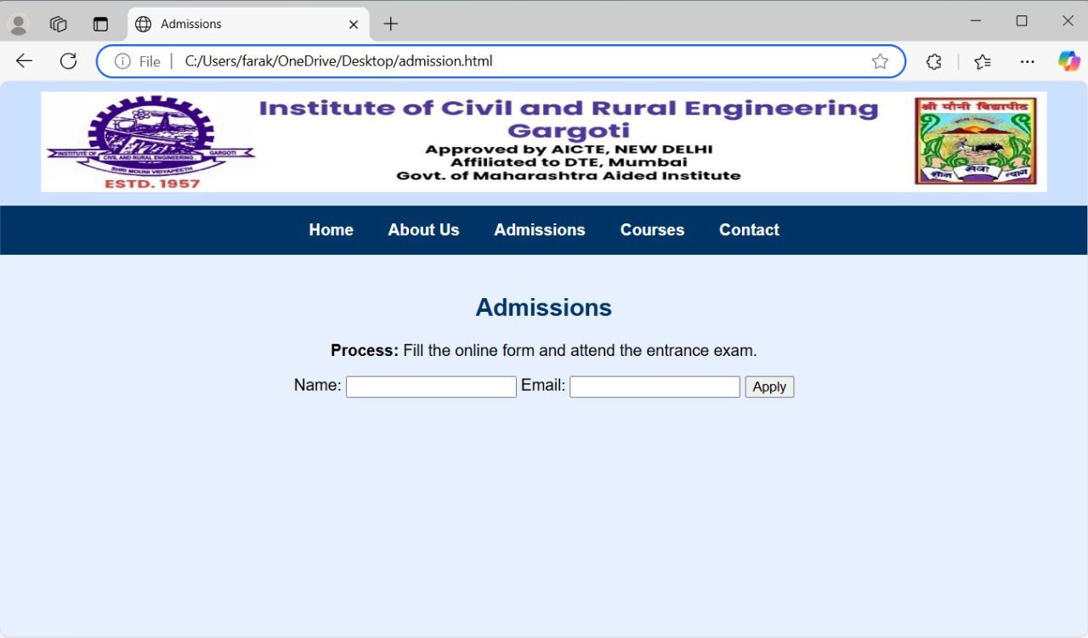
Output For HTML Code For Admission Page

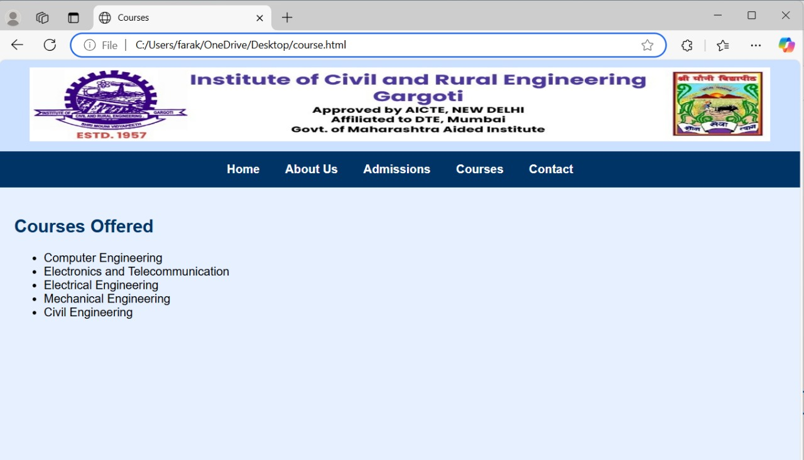
Output For HTML Code For Courses Page

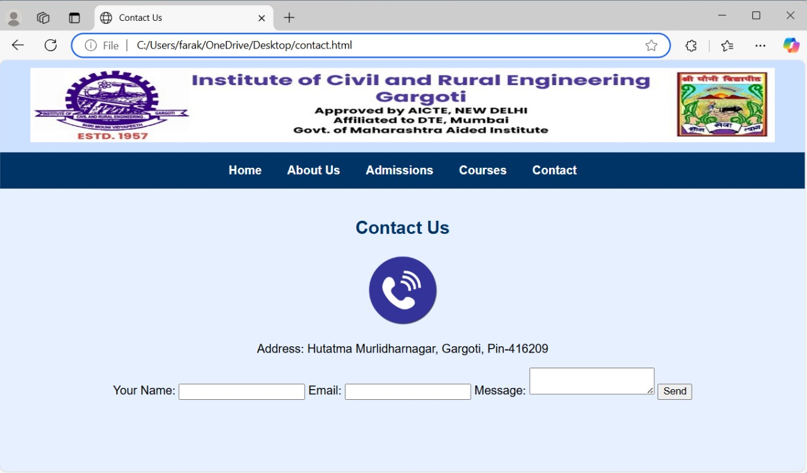
Output For HTML Code For Contact Page

- Application of This Microproject

This microproject provides a digital platform for an educational institute to share information, assist with admissions, display notices and events, and offer contact details. It improves communication between students, faculty, and the institution, and ensures easy access to important updates through a user-friendly, responsive web interface.

- Conclusion

This microproject successfully demonstrates the creation of a basic educational institute web page, showcasing key features like course details, faculty info, and contact options. It helped us apply web development skills practically and highlighted the importance of user-friendly design for effective communication .

