**INDUSTRIAL TRAINING REPORT**

**RESTAURANT & FOOD MANAGEMENT**

Submitted in partial fulfillment of the

Requirements for the award of

**Degree of Bachelor of Technology in CSE**

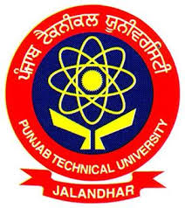

Submitted By

Karamjit Singh (1450910)

Karandeep Kaur (1450911)

**SUBMITTED TO:**

**Department of Computer Science & Engineering**

IK GUJRAL PUNJAB TECHNICAL UNIVERSITY CAMPUS, HOSHIARPUR

**DECLARATION**

I hereby declare that the Industrial Training Report entitled ("Restaurant & food Management") is an authentic record of my own work as requirements of 6-months Industrial Training during the period from 1 June to 30 November for the award of degree of B.Tech. (Computer Science & Engineering), IK Gujral Punjab Technical University Campus, Hoshiarpur, under the guidance of (Dr. Anshu Bhasin).

**(Signature of student)**

**Karamjit Singh (1450910)**

**Karandeep Kaur (1450911)**

**Date: ____________________**

Certified that the above statement made by the student is correct to the best of our knowledge and belief.

#### Signatures

#### Examined by:

#### 1. 2. 3. 4.

**Head of Department**

**(Signature and Seal)**