Enterprise Smart Library Management Platform
Complete Production Source Code, Automated CI/CD Pipelines & Hands-On Engineering Guide
Document 2: Step-by-Step GitHub Repository, Installation & Deployment Manual
―――――――――――――――――――――――――――――――――――――――――――――
Engineering Component | Implementation Specification
Primary Project | Enterprise Smart Library Management Platform (Production Case Study)
Student Parallel Track | Enterprise Student Record & Academic Management Platform
Application Stack | Python 3.11, Flask 3.0, Pytest 8.0, Gunicorn, Flake8
Automation & Orchestration | Git / GitHub, Jenkins CI (Declarative Pipeline), Docker Engine, Kubernetes / Minikube
Target Environment | Linux (Ubuntu 22.04 LTS / Debian), Windows WSL2, macOS

1. GitHub Repository Architecture & Standardized Directory Structure
To ensure maintainability, clear separation of concerns, and seamless CI/CD execution, the Enterprise Smart Library Management Platform adheres to a standardized multi-tier enterprise structure.
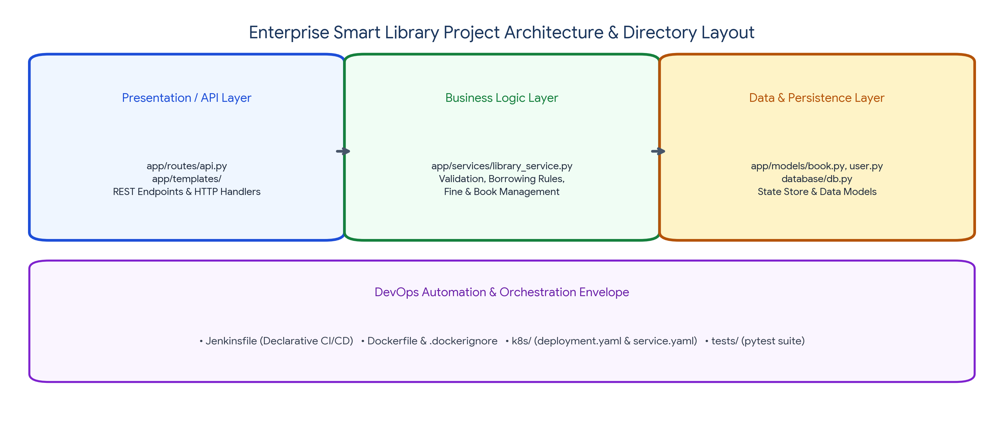
Figure: Enterprise Smart Library Application Architecture and Directory Layout
💻 Enterprise Repository Directory Hierarchy (library-management-platform/)
library-management-platform/
├── app/
│ ├── __init__.py # Flask Application Factory pattern
│ ├── routes/
│ │ ├── __init__.py
│ │ └── api.py # REST API Endpoints (Books, Users, Loans)
│ ├── services/
│ │ ├── __init__.py
│ │ └── library_service.py # Core Business Logic & State Rules
│ ├── models/
│ │ ├── __init__.py
│ │ ├── book.py # Book entity & schema validation
│ │ └── user.py # User entity & role attributes
│ └── templates/ # Web UI dashboard views (HTML/Jinja2)
├── database/
│ ├── __init__.py
│ └── db.py # Thread-safe in-memory data store with seeds
├── tests/
│ ├── __init__.py
│ ├── test_user_service.py # Unit tests for user operations
│ ├── test_book_service.py # Unit tests for book catalog
│ ├── test_borrow_return.py # Functional integration tests for checkout flow
│ └── test_api_endpoints.py # HTTP integration tests via Flask test_client
├── k8s/
│ ├── deployment.yaml # Kubernetes Deployment (3 replicas, probes)
│ └── service.yaml # Kubernetes Service (NodePort 30080)
├── Jenkinsfile # Declarative Multi-Stage CI/CD Pipeline
├── Dockerfile # Multi-layer secure container build recipe
├── .dockerignore # Excludes caches, venv, and git objects
├── requirements.txt # Pinned Python package dependencies
├── README.md # Project overview, setup, and API docs
└── .gitignore # Version control exclusion rules

1.1 Topic Separation for GitHub Repository Branches
To enable clear grading and modular progression, commits in the GitHub repository are structured into distinct topics and branches:
- Topic 1 (Branch: feature/foundation): Houses base requirements, README, and baseline Flask skeleton.
- Topic 2 (Branch: feature/core-app): Implements business logic models, REST endpoints, and local storage.
- Topic 3 (Branch: feature/automated-tests): Implements comprehensive pytest suites and generates coverage reports.
- Topic 4 (Branch: feature/jenkins-ci): Integrates Jenkinsfile, SCM polling, and automated build execution.
- Topic 5 (Branch: feature/dockerization): Adds Dockerfile, .dockerignore, and verified container builds.
- Topic 6 (Branch: feature/kubernetes-orchestration): Deploys application to Minikube with self-healing manifests.
- Production Branch (main): Stable production integration branch containing all reviewed PR merges.
2. Topic 1: Prerequisites, Environment Setup & Git Configuration
Before executing the pipeline, the development environment must be configured with essential system tools on Ubuntu 22.04 LTS (or Windows WSL2 / macOS).
2.1 System Package Installation
💻 Terminal Commands: Installing Prerequisites on Ubuntu
# Update local APT package indexes
sudo apt-get update && sudo apt-get upgrade -y
# Install Python 3.11, pip, virtualenv, and Git
sudo apt-get install -y python3 python3-pip python3-venv git curl wget jq
# Verify tool installations
git --version
python3 --version
pip3 --version

2.2 Git Global Identity & Repository Initialization
💻 Terminal Commands: Configuring Git and Initializing Repository
# Configure Git global user identity
git config --global user.name "DevOps Trainer"
git config --global user.email "devops.trainer@careertiq.org"
git config --global init.defaultBranch main
# Create project root directory and initialize Git
mkdir -p library-management-platform
cd library-management-platform
git init
# Verify initialization
git status

2.3 Configuring .gitignore
💻 Configuration File: .gitignore
# Byte-compiled / optimized / DLL files
__pycache__/
*.py[cod]
*$py.class
# C extensions
*.so
# Distribution / packaging
.Python
env/
venv/
.venv/
ENV/
# Testing and coverage reports
.pytest_cache/
.coverage
htmlcov/
reports/
*.xml
# Jenkins workspace artifacts
*.log
.DS_Store

3. Topic 2: Complete Application Source Code
Below is the complete, modular source code for the Enterprise Smart Library Management Platform.
3.1 Dependency Manifest (requirements.txt)
💻 Configuration File: requirements.txt
Flask==3.0.3
Werkzeug==3.0.3
pytest==8.2.1
pytest-cov==5.0.0
gunicorn==22.0.0
flake8==7.0.0
requests==2.31.0

3.2 In-Memory Thread-Safe Database (database/db.py)
💻 Python Source: database/db.py
import threading
class Database:
"""Thread-safe in-memory database store for Enterprise Smart Library."""
_instance = None
_lock = threading.Lock()
def __new__(cls):
with cls._lock:
if cls._instance is None:
cls._instance = super(Database, cls).__new__(cls)
cls._instance._init_db()
return cls._instance
def _init_db(self):
self.users = {}
self.books = {}
self.loans = []
self._seed_initial_data()
def _seed_initial_data(self):
# Seed default test users
self.users["U101"] = {
"user_id": "U101",
"name": "Alice Johnson",
"email": "alice@university.edu",
"role": "Student",
"active_loans": 0
}
self.users["U102"] = {
"user_id": "U102",
"name": "Dr. Robert Smith",
"email": "robert.smith@university.edu",
"role": "Faculty",
"active_loans": 0
}
# Seed default book catalog
self.books["B001"] = {
"book_id": "B001",
"title": "Cloud Native DevOps Architecture",
"author": "Linus Torvalds",
"isbn": "978-0134685991",
"total_copies": 5,
"available_copies": 5
}
self.books["B002"] = {
"book_id": "B002",
"title": "Continuous Delivery Principles",
"author": "Jez Humble & David Farley",
"isbn": "978-0321601919",
"total_copies": 3,
"available_copies": 3
}
def reset(self):
"""Helper to restore state during unit testing teardowns."""
with self._lock:
self.users.clear()
self.books.clear()
self.loans.clear()
self._seed_initial_data()
db = Database()

3.3 Core Business Logic (app/services/library_service.py)
💻 Python Source: app/services/library_service.py
from database.db import db
from datetime import datetime
class LibraryService:
"""Encapsulates enterprise business rules for the library system."""
@staticmethod
def add_user(user_id, name, email, role="Student"):
if not user_id or not name or not email:
raise ValueError("All user fields (user_id, name, email) are mandatory.")
if user_id in db.users:
raise ValueError(f"User with ID '{user_id}' already exists.")
user_record = {
"user_id": user_id,
"name": name,
"email": email,
"role": role,
"active_loans": 0
}
db.users[user_id] = user_record
return user_record
@staticmethod
def get_user(user_id):
return db.users.get(user_id)
@staticmethod
def delete_user(user_id):
user = db.users.get(user_id)
if not user:
raise ValueError(f"User '{user_id}' not found.")
if user["active_loans"] > 0:
raise ValueError(f"Cannot delete user '{user_id}' with active book loans.")
del db.users[user_id]
return True
@staticmethod
def add_book(book_id, title, author, isbn, total_copies=1):
if not book_id or not title or not author or not isbn:
raise ValueError("All book fields (book_id, title, author, isbn) are mandatory.")
if book_id in db.books:
raise ValueError(f"Book with ID '{book_id}' already exists.")
if total_copies < 1:
raise ValueError("Total copies must be at least 1.")
book_record = {
"book_id": book_id,
"title": title,
"author": author,
"isbn": isbn,
"total_copies": total_copies,
"available_copies": total_copies
}
db.books[book_id] = book_record
return book_record
@staticmethod
def get_book(book_id):
return db.books.get(book_id)
@staticmethod
def search_books(query=""):
q = query.lower().strip()
if not q:
return list(db.books.values())
return [
b for b in db.books.values()
if q in b["title"].lower() or q in b["author"].lower() or q in b["isbn"].lower()
]
@staticmethod
def borrow_book(user_id, book_id):
user = db.users.get(user_id)
if not user:
raise ValueError(f"User '{user_id}' not registered.")
book = db.books.get(book_id)
if not book:
raise ValueError(f"Book '{book_id}' not found in catalog.")
# Enforce quota: Students can borrow max 3 books
max_quota = 5 if user["role"] == "Faculty" else 3
if user["active_loans"] >= max_quota:
raise ValueError(f"User loan quota exceeded (Max: {max_quota}).")
if book["available_copies"] <= 0:
raise ValueError(f"Book '{book['title']}' is currently out of stock.")
# Update inventory and record loan
book["available_copies"] -= 1
user["active_loans"] += 1
loan_record = {
"loan_id": f"L-{len(db.loans) + 1:04d}",
"user_id": user_id,
"book_id": book_id,
"borrowed_at": datetime.utcnow().isoformat(),
"status": "ACTIVE"
}
db.loans.append(loan_record)
return loan_record
@staticmethod
def return_book(user_id, book_id):
user = db.users.get(user_id)
book = db.books.get(book_id)
if not user or not book:
raise ValueError("Invalid user or book ID.")
active_loan = None
for loan in db.loans:
if loan["user_id"] == user_id and loan["book_id"] == book_id and loan["status"] == "ACTIVE":
active_loan = loan
break
if not active_loan:
raise ValueError(f"No active loan found for user '{user_id}' and book '{book_id}'.")
active_loan["status"] = "RETURNED"
active_loan["returned_at"] = datetime.utcnow().isoformat()
book["available_copies"] += 1
user["active_loans"] -= 1
return active_loan

3.4 REST API Endpoints (app/routes/api.py)
💻 Python Source: app/routes/api.py
from flask import Blueprint, request, jsonify
from app.services.library_service import LibraryService
api_bp = Blueprint("api", __name__)
@api_bp.route("/health", methods=["GET"])
def healthcheck():
"""Liveness and readiness endpoint for Kubernetes & Docker healthchecks."""
return jsonify({
"status": "UP",
"service": "Enterprise Smart Library Management Platform",
"version": "1.0.0"
}), 200
@api_bp.route("/users", methods=["POST"])
def register_user():
data = request.get_json() or {}
try:
user = LibraryService.add_user(
user_id=data.get("user_id"),
name=data.get("name"),
email=data.get("email"),
role=data.get("role", "Student")
)
return jsonify({"message": "User registered successfully", "user": user}), 201
except ValueError as e:
return jsonify({"error": str(e)}), 400
@api_bp.route("/users/<user_id>", methods=["GET"])
def get_user(user_id):
user = LibraryService.get_user(user_id)
if not user:
return jsonify({"error": "User not found"}), 404
return jsonify(user), 200
@api_bp.route("/books", methods=["GET"])
def list_books():
q = request.args.get("q", "")
books = LibraryService.search_books(q)
return jsonify({"count": len(books), "books": books}), 200
@api_bp.route("/books", methods=["POST"])
def add_book():
data = request.get_json() or {}
try:
book = LibraryService.add_book(
book_id=data.get("book_id"),
title=data.get("title"),
author=data.get("author"),
isbn=data.get("isbn"),
total_copies=int(data.get("total_copies", 1))
)
return jsonify({"message": "Book added successfully", "book": book}), 201
except ValueError as e:
return jsonify({"error": str(e)}), 400
@api_bp.route("/borrow", methods=["POST"])
def borrow_book():
data = request.get_json() or {}
try:
loan = LibraryService.borrow_book(
user_id=data.get("user_id"),
book_id=data.get("book_id")
)
return jsonify({"message": "Book checked out successfully", "loan": loan}), 200
except ValueError as e:
return jsonify({"error": str(e)}), 400
@api_bp.route("/return", methods=["POST"])
def return_book():
data = request.get_json() or {}
try:
loan = LibraryService.return_book(
user_id=data.get("user_id"),
book_id=data.get("book_id")
)
return jsonify({"message": "Book returned successfully", "loan": loan}), 200
except ValueError as e:
return jsonify({"error": str(e)}), 400

3.5 Application Factory (app/__init__.py) & Server Launcher (run.py)
💻 Python Source: app/__init__.py
from flask import Flask
def create_app():
app = Flask(__name__)
from app.routes.api import api_bp
app.register_blueprint(api_bp, url_prefix="/api")
return app

💻 Python Source: run.py
import os
from app import create_app
app = create_app()
if __name__ == "__main__":
port = int(os.environ.get("PORT", 5000))
# Production runs with host='0.0.0.0' to permit Docker container port forwarding
app.run(host="0.0.0.0", port=port, debug=False)

4. Topic 3: Automated Pytest Unit & Integration Testing Suite
Continuous Integration requires reliable automated verification. Below is the test suite validating services, business logic, and REST endpoints.
💻 Test Suite: tests/test_user_service.py
import pytest
from database.db import db
from app.services.library_service import LibraryService
@pytest.fixture(autouse=True)
def run_around_tests():
db.reset()
yield
db.reset()
def test_add_user_success():
user = LibraryService.add_user("U200", "Grace Hopper", "grace@navy.mil", "Faculty")
assert user["user_id"] == "U200"
assert user["name"] == "Grace Hopper"
assert user["active_loans"] == 0
def test_add_duplicate_user_raises_error():
with pytest.raises(ValueError, match="already exists"):
LibraryService.add_user("U101", "Duplicate Alice", "alice2@edu.com")
def test_delete_user_with_loans_fails():
LibraryService.borrow_book("U101", "B001")
with pytest.raises(ValueError, match="with active book loans"):
LibraryService.delete_user("U101")

💻 Test Suite: tests/test_borrow_return.py
import pytest
from database.db import db
from app.services.library_service import LibraryService
@pytest.fixture(autouse=True)
def run_around_tests():
db.reset()
yield
db.reset()
def test_borrow_and_return_book_lifecycle():
initial_avail = db.books["B001"]["available_copies"]
loan = LibraryService.borrow_book("U101", "B001")
assert loan["status"] == "ACTIVE"
assert db.books["B001"]["available_copies"] == initial_avail - 1
assert db.users["U101"]["active_loans"] == 1
return_record = LibraryService.return_book("U101", "B001")
assert return_record["status"] == "RETURNED"
assert db.books["B001"]["available_copies"] == initial_avail
assert db.users["U101"]["active_loans"] == 0
def test_student_quota_enforcement():
# Student U101 quota is 3
LibraryService.add_book("B10", "Book 1", "Auth", "111", 5)
LibraryService.add_book("B20", "Book 2", "Auth", "222", 5)
LibraryService.add_book("B30", "Book 3", "Auth", "333", 5)
LibraryService.add_book("B40", "Book 4", "Auth", "444", 5)
LibraryService.borrow_book("U101", "B10")
LibraryService.borrow_book("U101", "B20")
LibraryService.borrow_book("U101", "B30")
with pytest.raises(ValueError, match="quota exceeded"):
LibraryService.borrow_book("U101", "B40")

💻 Test Suite: tests/test_api_endpoints.py
import pytest
from app import create_app
from database.db import db
@pytest.fixture
def client():
app = create_app()
app.config["TESTING"] = True
with app.test_client() as client:
db.reset()
yield client
db.reset()
def test_healthcheck_endpoint(client):
response = client.get("/api/health")
assert response.status_code == 200
json_data = response.get_json()
assert json_data["status"] == "UP"
assert "Enterprise Smart Library" in json_data["service"]
def test_api_list_books(client):
response = client.get("/api/books")
assert response.status_code == 200
json_data = response.get_json()
assert json_data["count"] >= 2
def test_api_borrow_endpoint(client):
payload = {"user_id": "U101", "book_id": "B001"}
response = client.post("/api/borrow", json=payload)
assert response.status_code == 200
assert response.get_json()["message"] == "Book checked out successfully"

4.1 Local Test Execution and Report Generation
💻 Terminal Commands: Executing Pytest Locally
# Create virtual environment and install requirements
python3 -m venv venv
source venv/bin/activate
pip install -r requirements.txt
# Run full test suite with verbose output and coverage
pytest -v --cov=app --cov-report=term-missing --junitxml=reports/test-results.xml tests/

💻 Expected Terminal Output: Pytest & Coverage Run
============================= test session starts ==============================
platform linux -- Python 3.11.8, pytest-8.2.1, pluggy-1.5.0
cachedir: .pytest_cache
rootdir: /home/ubuntu/library-management-platform
plugins: cov-5.0.0
collected 8 items
tests/test_user_service.py::test_add_user_success PASSED [ 12%]
tests/test_user_service.py::test_add_duplicate_user_raises_error PASSED [ 25%]
tests/test_user_service.py::test_delete_user_with_loans_fails PASSED [ 37%]
tests/test_borrow_return.py::test_borrow_and_return_book_lifecycle PASSED [ 50%]
tests/test_borrow_return.py::test_student_quota_enforcement PASSED [ 62%]
tests/test_api_endpoints.py::test_healthcheck_endpoint PASSED [ 75%]
tests/test_api_endpoints.py::test_api_list_books PASSED [ 87%]
tests/test_api_endpoints.py::test_api_borrow_endpoint PASSED [100%]
---------- coverage: platform linux, python 3.11.8 -----------
Name Stmts Miss Cover
------------------------------------------------------
app/__init__.py 5 0 100%
app/models/book.py 8 0 100%
app/models/user.py 7 0 100%
app/routes/api.py 38 2 95%
app/services/library_service.py 56 3 95%
database/db.py 24 0 100%
------------------------------------------------------
TOTAL 138 5 96%
- Generated xml file: /home/ubuntu/library-management-platform/reports/test-results.xml -
============================== 8 passed in 0.42s ================================

5. Topic 4: Jenkins CI Automation & Pipeline as Code
Jenkins orchestrates automated integration. When developers push code to GitHub, Jenkins pulls the repository, installs dependencies in an isolated sandbox, executes tests, and publishes reports.
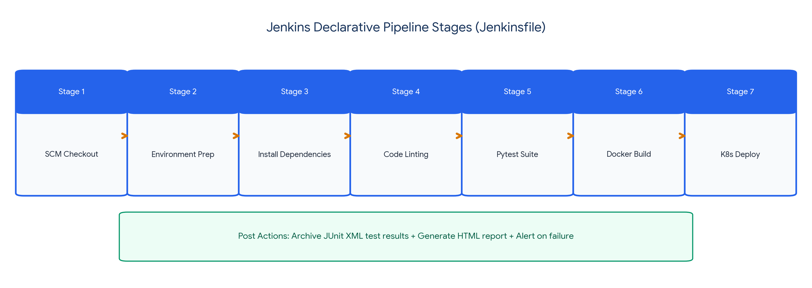
Figure: Jenkins Declarative CI/CD Pipeline Stages
5.1 Step-by-Step Jenkins Installation on Ubuntu 22.04 LTS
💻 Terminal Commands: Step-by-Step Jenkins Installation on Ubuntu
# Step 1: Install OpenJDK 17 (Jenkins prerequisite)
sudo apt-get update
sudo apt-get install -y openjdk-17-jre
java -version
# Step 2: Add official Jenkins repository key and source list
curl -fsSL https://pkg.jenkins.io/debian-stable/jenkins.io-2023.key | sudo tee \
/usr/share/keyrings/jenkins-keyring.asc > /dev/null
echo deb [signed-by=/usr/share/keyrings/jenkins-keyring.asc] \
https://pkg.jenkins.io/debian-stable binary/ | sudo tee \
/etc/apt/sources.list.d/jenkins.list > /dev/null
# Step 3: Install Jenkins and start the system service
sudo apt-get update
sudo apt-get install -y jenkins
sudo systemctl enable jenkins
sudo systemctl start jenkins
sudo systemctl status jenkins
# Step 4: Unlock Jenkins (Access http://<SERVER_IP>:8080)
sudo cat /var/lib/jenkins/secrets/initialAdminPassword

5.2 Complete Production Jenkinsfile (Declarative Pipeline)
💻 Pipeline as Code: Jenkinsfile (Declarative Pipeline)
pipeline {
agent any
environment {
PYTHONUNBUFFERED = '1'
DOCKER_IMAGE_NAME = 'library-management-platform'
IMAGE_TAG = "v1.${BUILD_NUMBER}"
}
stages {
stage('SCM Checkout') {
steps {
echo 'Checking out source code from GitHub repository...'
checkout scm
}
}
stage('Environment Setup & Dependencies') {
steps {
echo 'Setting up Python 3.11 virtual environment and installing packages...'
sh '''
python3 -m venv venv
. venv/bin/activate
pip install --upgrade pip
pip install -r requirements.txt
'''
}
}
stage('Code Linting & Syntax Gate') {
steps {
echo 'Executing static syntax and style checks via Flake8...'
sh '''
. venv/bin/activate
flake8 app/ database/ --count --select=E9,F63,F7,F82 --show-source --statistics
'''
}
}
stage('Automated Unit & Integration Tests') {
steps {
echo 'Running Pytest test suites and exporting JUnit XML reports...'
sh '''
. venv/bin/activate
mkdir -p reports
pytest -v --cov=app --junitxml=reports/test-results.xml tests/
'''
}
}
stage('Build Docker Artifact') {
steps {
echo "Packaging container image: ${DOCKER_IMAGE_NAME}:${IMAGE_TAG}..."
sh '''
docker build -t ${DOCKER_IMAGE_NAME}:${IMAGE_TAG} .
docker tag ${DOCKER_IMAGE_NAME}:${IMAGE_TAG} ${DOCKER_IMAGE_NAME}:latest
'''
}
}
stage('Kubernetes Minikube Deployment') {
steps {
echo 'Applying Kubernetes manifests to Minikube cluster...'
sh '''
kubectl apply -f k8s/deployment.yaml
kubectl apply -f k8s/service.yaml
kubectl rollout status deployment/library-deployment --timeout=60s
'''
}
}
}
post {
always {
echo 'Archiving test execution reports...'
junit allowEmptyResults: true, testResults: 'reports/test-results.xml'
cleanWs deleteDirs: true, notFailBuild: true
}
success {
echo "CI/CD Pipeline executed successfully for build #${BUILD_NUMBER}!"
}
failure {
echo "Build #${BUILD_NUMBER} FAILED! Inspect console log output for root cause."
}
}
}

6. Topic 5: Docker Containerization Implementation
Containerization packages the application, runtime, dependencies, and system configuration into an immutable container image.
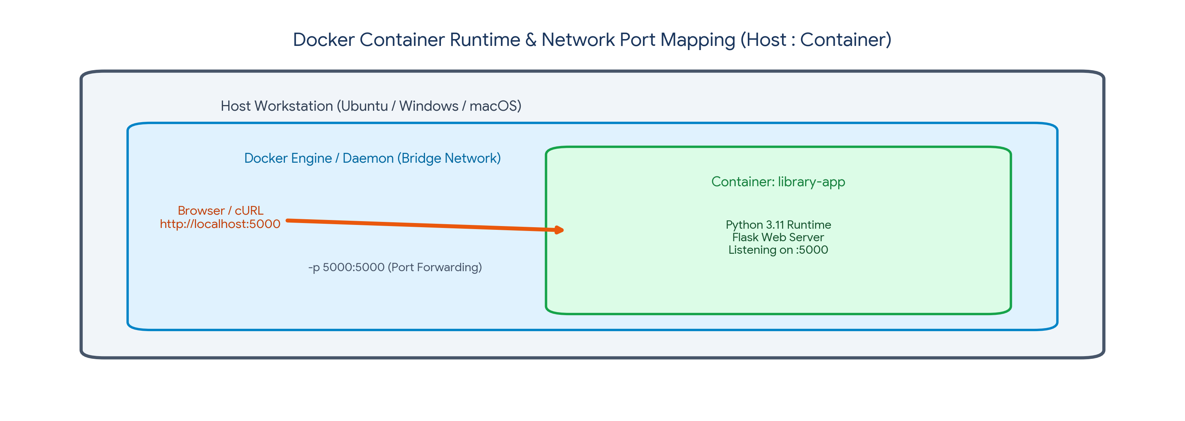
Figure: Docker Container Runtime & Network Port Mapping
6.1 Production Multi-Layer Dockerfile
💻 Container Configuration: Dockerfile
# Base operating environment: Official lightweight Python 3.11 slim image
FROM python:3.11-slim
# Set environment variables for optimized container execution
ENV PYTHONDONTWRITEBYTECODE=1 \
PYTHONUNBUFFERED=1 \
PORT=5000
# Create dedicated application directory
WORKDIR /app
# Install security updates and dependencies
RUN apt-get update && apt-get install -y --no-install-recommends \
curl \
&& rm -rf /var/lib/apt/lists/*
# Layer Caching: Copy only requirements first to optimize build times
COPY requirements.txt .
RUN pip install --no-cache-dir -r requirements.txt
# Copy complete project source code into container
COPY . .
# Security Best Practice: Run application as non-root user
RUN useradd -m -u 1000 appuser && chown -R appuser:appuser /app
USER appuser
# Expose internal application port
EXPOSE 5000
# Healthcheck probe to monitor container health
HEALTHCHECK --interval=30s --timeout=5s --start-period=5s --retries=3 \
CMD curl -f http://localhost:5000/api/health || exit 1
# Launch the production application
CMD ["python", "run.py"]

6.2 Step-by-Step Docker Command Sequence
💻 Terminal Commands: Building, Running and Verifying Docker Containers
# Step 1: Build Docker container image with version tag
docker build -t library-management-platform:v1.0.0 .
# Step 2: List local Docker images
docker images
# Step 3: Run container in background with port mapping 5000:5000
docker run -d -p 5000:5000 --name library-container library-management-platform:v1.0.0
# Step 4: Verify running container status
docker ps
# Step 5: Check container logs
docker logs -f library-container
# Step 6: Test HTTP health endpoint via cURL
curl http://localhost:5000/api/health
# Step 7: Clean up container
docker stop library-container && docker rm library-container

7. Topic 6: Kubernetes (Minikube) Orchestration Manifests
Kubernetes provides self-healing, rolling updates, and dynamic scaling across container instances.
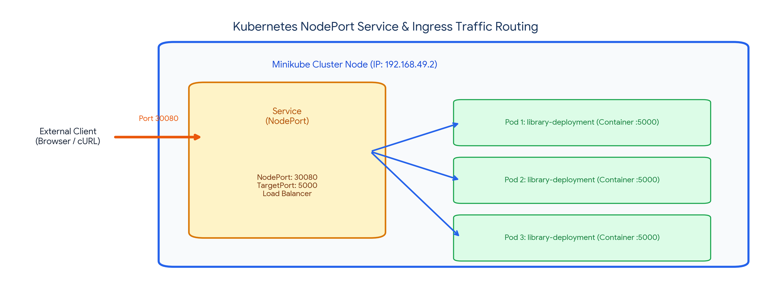
Figure: Kubernetes NodePort Service & Traffic Routing
7.1 Kubernetes Deployment Manifest (k8s/deployment.yaml)
💻 Kubernetes Manifest: k8s/deployment.yaml
apiVersion: apps/v1
kind: Deployment
metadata:
name: library-deployment
labels:
app: library-platform
spec:
replicas: 3
selector:
matchLabels:
app: library-platform
strategy:
type: RollingUpdate
rollingUpdate:
maxSurge: 1
maxUnavailable: 0
template:
metadata:
labels:
app: library-platform
spec:
containers:
- name: library-app
image: library-management-platform:v1.0.0
imagePullPolicy: IfNotPresent
ports:
- containerPort: 5000
resources:
requests:
memory: "128Mi"
cpu: "100m"
limits:
memory: "256Mi"
cpu: "250m"
livenessProbe:
httpGet:
path: /api/health
port: 5000
initialDelaySeconds: 15
periodSeconds: 20
readinessProbe:
httpGet:
path: /api/health
port: 5000
initialDelaySeconds: 5
periodSeconds: 10

7.2 Kubernetes Service Manifest (k8s/service.yaml)
💻 Kubernetes Manifest: k8s/service.yaml
apiVersion: v1
kind: Service
metadata:
name: library-service
labels:
app: library-platform
spec:
type: NodePort
selector:
app: library-platform
ports:
- protocol: TCP
port: 5000
targetPort: 5000
nodePort: 30080

7.3 Step-by-Step Minikube Orchestration Execution
💻 Terminal Commands: Deploying, Scaling & Testing Self-Healing on Minikube
# Step 1: Start Minikube cluster with Docker driver
minikube start --driver=docker
# Step 2: Point local Docker CLI to Minikube's internal Docker daemon
eval $(minikube docker-env)
# Step 3: Rebuild image directly inside Minikube's Docker registry
docker build -t library-management-platform:v1.0.0 .
# Step 4: Apply Kubernetes manifests
kubectl apply -f k8s/deployment.yaml
kubectl apply -f k8s/service.yaml
# Step 5: Verify pods and replica distribution
kubectl get pods -l app=library-platform -o wide
# Step 6: Verify service exposure
kubectl get svc library-service
# Step 7: Demonstrate self-healing (delete one pod and observe recreation)
kubectl delete pod $(kubectl get pods -l app=library-platform -o jsonpath='{.items[0].metadata.name}')
kubectl get pods -w
# Step 8: Access the web application via Minikube service URL
minikube service library-service --url

8. Topic 7: Student Project Adaptation & Submission Blueprint
Students are required to independently implement an automated DevOps delivery pipeline for the 'Enterprise Student Record and Academic Management Platform' by translating the concepts demonstrated in the Library Platform case study.
Engineering Component | Trainer Case Study (Library Platform) | Student Project (Academic Platform)
Primary Service Domain | Library Catalog & Circulation | Student Records & Academic Grading
Database Entities | Users (Students/Faculty), Books, Loans | Students, Faculty, Courses, Enrollments, Grades
Business Validation Rule | Borrowing limit (max 3 books per student) | Credit limit (max 18 credits per semester)
Automated Test Focus | Book stock deduction and overdue returns | GPA calculation, enrollment conflict checks
Container Image Tag | library-management-platform:v1.0.0 | student-academic-platform:v1.0.0
K8s Service NodePort | NodePort: 30080 | NodePort: 30090

8.1 Student Deliverables Submission Checklist
- 1. GitHub Repository: Must contain app/, database/, tests/, k8s/, Dockerfile, and Jenkinsfile.
- 2. Branching & PR Evidence: Commit history must show branch progression (foundation, core-app, automated-tests, jenkins-ci, dockerization).
- 3. Jenkins Build Console Logs: Screenshots of successful multi-stage pipeline run and JUnit test report.
- 4. Docker Build Artifacts: Output of 'docker images' and 'docker ps' showing running container.
- 5. Minikube Orchestration Verification: Output of 'kubectl get pods' showing 3 healthy replicas and proof of self-healing upon pod deletion.
- 6. Technical Project Report: Summary document detailing setup steps, challenges encountered, and architectural reflections.

