Enterprise Smart Library Management Platform
DevOps Foundation, Version Control, Continuous Integration & Container Orchestration
Document 1: Comprehensive Theoretical and Architectural Reference Manual
―――――――――――――――――――――――――――――――――――――――――――――
Document Attribute | Specification Details
Course & Unit | UNIT 3: DevOps, CI/CD, Containerization & Application Deployment
Target Platform | Enterprise Smart Library Management Platform (Python / Flask / Pytest / Jenkins / Docker / Minikube)
Student Parallel System | Enterprise Student Record & Academic Management Platform
Document Purpose | Comprehensive Academic & Professional DevOps Theoretical Framework, Architecture & Engineering Principles
Version & Status | v1.0.0 Production Release — Comprehensive Academic Manual

1. Executive Summary & Engineering Context
In enterprise software engineering, bridging the traditional chasm between application development and operational stability is paramount. Prior academic phases established requirements gathering, backlog grooming, and Agile sprint planning. Unit 3 marks the crucial transition from conceptual design to production-grade engineering practices.
DevOps is fundamentally not merely an assortment of automation utilities; it represents an institutional engineering culture and methodology designed to integrate developers, quality assurance engineers, and IT operations into an agile, highly automated continuum. Rather than treating software deployment as an afterthought, enterprise engineering treats the build, validation, packaging, and hosting pipeline as code.
This document provides an exhaustive theoretical foundation for the Enterprise Smart Library Management Platform. It articulates the business imperatives driving DevOps adoption, contrasts traditional waterfall IT with modern CI/CD, breaks down the complete eight-stage DevOps lifecycle, details distributed version control mechanics in Git/GitHub, explicates Continuous Integration (CI) with Jenkins, and analyzes containerization with Docker and orchestration via Kubernetes (Minikube).
📌 CORE ARCHITECTURAL OBJECTIVE: DevOps bridges development and operations through Culture, Automation, Measurement, and Sharing (CAMS).
The primary engineering objective is reducing Cycle Time (from commit to customer) while increasing Deployment Frequency, Stability, and Mean Time to Recovery (MTTR).

2. The Business Need for DevOps: Cultural Paradigm Shift
2.1 The Traditional Software Delivery Dilemma
Historically, software engineering organizations operated in rigid organizational silos. The development team was incentivized by business stakeholders to rapidly write new features, while the IT operations team was incentivized to maintain infrastructure stability, uptime, and strict change control.
This misalignment generated what industry pioneers describe as the 'Wall of Confusion'. The traditional sequential delivery model (Waterfall) proceeded through protracted phases:
- Requirements Silo: Requirements were locked down months in advance, leaving no room for market agility.
- Development Silo: Software engineers worked in isolation, without visibility into production server configurations.
- Testing Silo: Large, infrequent batches of code were thrown over the wall to QA for manual verification.
- Operations Silo: Sysadmins received release packages with extensive, error-prone manual runbooks.
- Maintenance Silo: Unmonitored bugs and performance degradations escalated into midnight outages and stressful blame games.
Key systemic pathologies of traditional IT include:
- Environment Drift: The notorious 'Works on My Machine' syndrome, where applications operate on developer workstations but crash on staging or production servers due to subtle environment discrepancies.
- Integration Hell: Merging months of unintegrated work resulted in weeks of merge conflicts and regressions.
- Error-Prone Manual Releases: Manual SSH scripts, FTP uploads, and manual configuration tweaks yielded high change failure rates.
- Protracted Downtime & Rollback Risks: When a production defect emerged, rolling back required recreating complex database states and restoring monolithic servers.
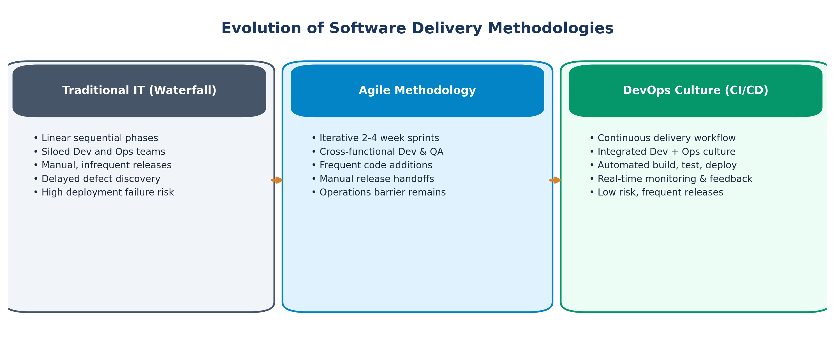
Figure: Evolution of Software Delivery Methodologies from Traditional IT to Agile and DevOps
2.2 Comparative Evolution: Traditional IT vs. Agile vs. DevOps
While Agile principles significantly improved project management and developer responsiveness by breaking monolithic requirements into 2-to-4 week sprints, Agile alone stopped at the boundary of working software on a developer's workstation. It failed to address the downstream friction of deployment, configuration management, and runtime reliability. DevOps completes the transformation.
Engineering Dimension | Traditional IT (Waterfall) | Agile Methodology | DevOps Framework (CI/CD)
Delivery Rhythm | Sequential, monolithic (Months / Quarters) | Iterative sprints (2 to 4 weeks) | Continuous, on-demand (Multiple daily releases)
Organizational Structure | Strictly siloed Dev, QA, and Ops teams | Cross-functional Dev & QA teams | Integrated cross-functional Product & DevOps teams
Deployment Method | Manual checklist, fragile shell scripts | Manual or partially automated at sprint end | Fully automated, immutable CI/CD pipelines
Environment Parity | Frequent drift between Dev, QA, & Prod | Staging environments diverge from Prod | Guaranteed parity via Docker containers & IaC
Quality Verification | Post-development manual regression testing | Sprint-based manual & automated testing | Continuous shift-left automated tests on every commit
Feedback & Telemetry | Periodic customer surveys, post-mortems | Sprint review and retrospective meetings | Real-time automated metrics, logs, and APM alerting
Change Failure & Risk | High blast radius; catastrophic rollbacks | Moderate risk localized to sprint drops | Low blast radius; instant rollback via blue/green or canary

3. The End-to-End DevOps Lifecycle Architecture
The DevOps lifecycle is modeled as an infinite loop rather than a linear sequence, underscoring that modern software engineering is an iterative, continuous feedback mechanism. Every production observation immediately informs future architecture and backlog planning.
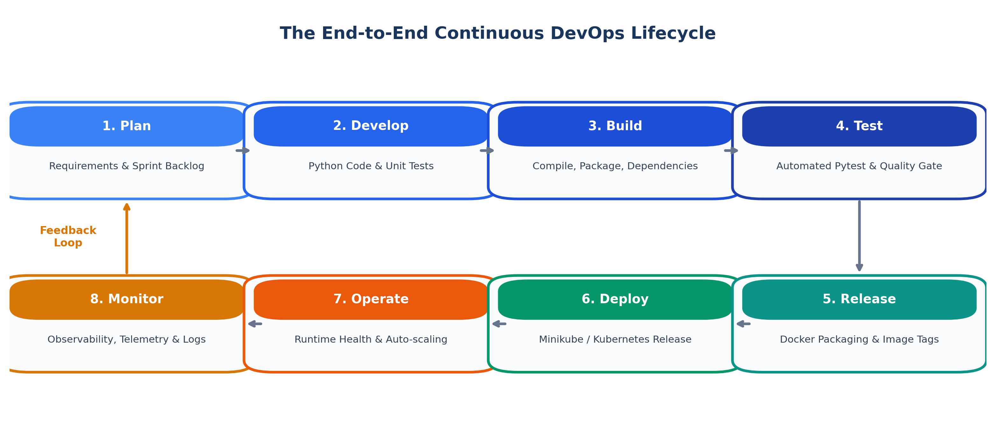
Figure: The Infinite Continuous DevOps Engineering Lifecycle
3.1 Comprehensive Lifecycle Phase Breakdown
- Phase 1 - Plan: Engineers and product owners analyze business requirements, user stories, and acceptance criteria. Tasks are broken into small increments and tracked via backlogs (Jira, GitHub Issues, Kanban boards). Architectural standards and non-functional requirements (security, scalability) are defined.
- Phase 2 - Develop (Code): Engineers write modular, clean Python application code within integrated development environments (IDEs). Code is version-controlled in short-lived Git feature branches. Pair programming, automated local linting (flake8, black), and pre-commit hooks ensure baseline quality.
- Phase 3 - Build: Automated builds compile code, isolate runtime dependencies, and assemble immutable build artifacts. In Python, this involves creating clean virtual environments, resolving requirements.txt, and validating syntax across all packages.
- Phase 4 - Test: Continuous Integration servers execute rigorous automated unit tests, integration tests, and static code quality analysis (pytest, coverage, SonarQube). Builds fail immediately if any test fails ('Shift-Left Testing').
- Phase 5 - Release: Validated artifacts are bundled into versioned Docker container images, tagged with semantic version numbers (e.g., v1.0.0, commit SHA), and pushed to an enterprise container registry (Docker Hub, Amazon ECR, Harbor).
- Phase 6 - Deploy: The containerized application is deployed to target staging or production runtime infrastructure (Kubernetes clusters, Minikube). Deployments utilize rolling updates to ensure zero downtime for end users.
- Phase 7 - Operate: Infrastructure and application health are managed actively. Auto-scalers dynamically adjust replica counts based on CPU/memory pressure. Database connection pools, caching layers, and load balancers maintain optimal throughput.
- Phase 8 - Monitor: Distributed tracing, metrics collection, and centralized log aggregation (Prometheus, Grafana, ELK Stack, Datadog) monitor runtime performance. Automated synthetic health checks and alert thresholds trigger instant root-cause analysis.
📌 SHIFT-LEFT TESTING PARADIGM: Shift-Left Principle: The financial and operational cost of defect remediation increases by 10x with each lifecycle stage.
Catching bugs during local development or automated CI testing costs fractions of cents compared to diagnosing a high-severity incident in live production.

4. Enterprise Version Control & Collaborative Git Workflows
4.1 Distributed Version Control Principles
Version Control Systems (VCS) record changes to files over time, enabling software engineers to recall specific versions, audit changes, and collaborate concurrently without destructive overwrites. Git, engineered by Linus Torvalds, is a Distributed Version Control System (DVCS). Unlike centralized systems (such as SVN or Perforce), every developer's local machine hosts a complete clone of the repository history.
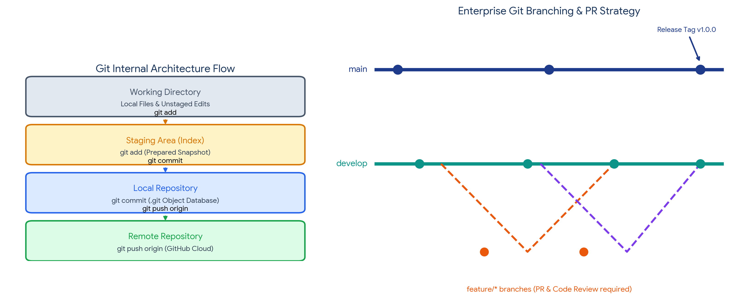
Figure: Git Internal Architectural Flow and Enterprise Feature-Branching Strategy
4.2 Git Three-Tier Architecture
Git manages files across three logical areas on a developer's workstation before synchronizing with remote repositories:
- 1. Working Directory: The physical file directory containing project code, configs, and assets where active editing occurs.
- 2. Staging Area (Index): A staging index (the .git/index file) that acts as a draft snapshot where selected modifications are prepared using 'git add' prior to committing.
- 3. Local Repository (.git): The hidden .git directory containing the object database (blobs, trees, commits, tags). Running 'git commit' permanently records an immutable SHA-1 hashed snapshot.
- 4. Remote Repository: A centralized hosting platform (GitHub, GitLab, Bitbucket) that acts as the single source of truth for the entire distributed team, updated via 'git push'.
4.3 Comparative Matrix: Git vs. GitHub
Criterion | Git (Core Engine) | GitHub (Collaboration Platform)
Classification | Open-source distributed version control CLI tool | Cloud-based hosting, collaboration, and DevOps platform
Execution Location | Runs entirely locally on the developer's computer | Hosted on cloud infrastructure (web GUI, REST APIs)
Network Dependency | Completely offline; commits, logs, branches need no internet | Requires internet access to push, pull, review, or trigger webhooks
Primary Capabilities | Branching, merging, commit tracking, diff inspection | Pull requests, code review, issue tracking, project boards, actions
Enterprise CI/CD Role | Version records source files and pipeline definitions | Houses source code and triggers Jenkins CI/CD via webhooks

4.4 Enterprise Branching Strategies
A structured branching strategy prevents unstable experimental code from polluting production systems. For enterprise platforms, a controlled Feature Branch Workflow is industry standard:
- main (Production Branch): Strictly protected branch reflecting production-ready, thoroughly validated code. Direct pushes are barred; merges require approved Pull Requests.
- develop (Development Branch): Integration branch where completed feature branches converge for end-to-end integration and staging validation.
- feature/* (Feature Branches): Short-lived branches branched off develop (e.g., feature/user-auth, feature/book-catalog). Developers commit frequently in isolation, then open a Pull Request.
- hotfix/* (Urgent Fixes): Emergency branches branched directly from main to patch critical production defects, followed by immediate merge-back into both main and develop.
5. Continuous Integration (CI) and Jenkins Build Automation
5.1 Theoretical Foundation of Continuous Integration
Continuous Integration is the software engineering discipline where team members integrate their work into the main codebase frequently (typically multiple times a day). Each integration is automatically verified by an automated build and test sequence.
Without CI, teams suffer from 'Integration Hell'—a crippling condition where developers work in isolation for weeks, leading to massive merge conflicts, incompatible interface assumptions, and widespread breakage that halts progress.
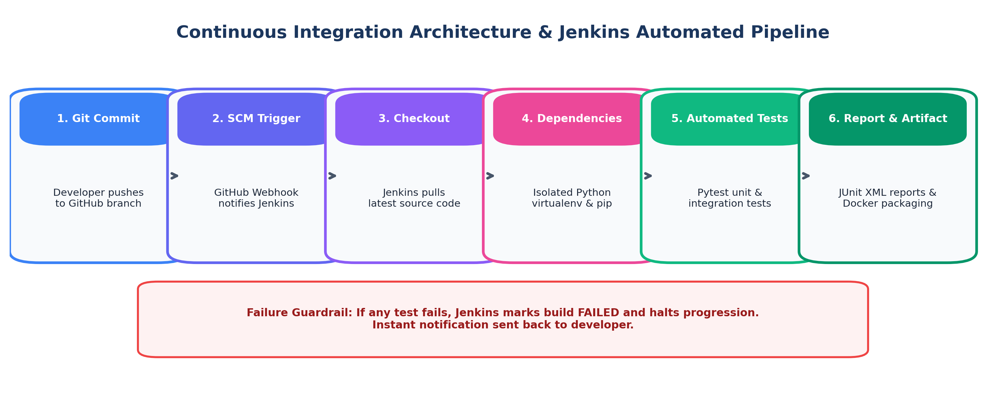
Figure: Continuous Integration Architecture & Jenkins Automated Pipeline Workflow
5.2 Anatomy of the CI Pipeline Stages
- Stage 1 - Source Checkout: Jenkins receives an automated webhook trigger from GitHub indicating a new push or pull request, and securely clones the exact commit SHA.
- Stage 2 - Dependency Isolation: An isolated Python virtual environment is instantiated. The package manager (pip) installs exact library versions declared in requirements.txt.
- Stage 3 - Linting & Static Code Analysis: Static analysis tools (flake8, pylint) verify syntax, check code standards (PEP 8), and catch syntax regressions without running the code.
- Stage 4 - Automated Test Execution: The automated test framework (pytest) executes unit and integration tests. Assertions check data models, service business logic, and API endpoints.
- Stage 5 - Quality Gate & Coverage Analysis: Test reports are generated in standardized JUnit XML and HTML formats. Code coverage must exceed threshold percentages (e.g., 85%).
- Stage 6 - Artifact Packaging & Failure Guard: If all tests and gates succeed, the pipeline packages the deployable artifact (Docker image) or notifies the deployment manager. If any stage fails, the pipeline halts immediately, alerting the committer.
5.3 Jenkins Architecture: Controller and Agent Model
Jenkins is the industry-standard, open-source automation engine. Its enterprise architecture operates on a distributed Controller-Agent pattern:
- Jenkins Controller (Master): Hosts the web user interface, manages user authentication, schedules build jobs, monitors agents, and receives webhook notifications from GitHub.
- Jenkins Build Agents (Workers): Lightweight worker instances (virtual machines, containers, or bare-metal servers) that execute the actual resource-intensive build, test, and container packaging commands as directed by the controller.
6. Containerization, Docker Architecture & Runtime Packaging
6.1 Resolving Environment Inconsistency: Virtual Machines vs. Containers
Traditional IT deployed applications directly onto bare-metal operating systems or full Virtual Machines (VMs). Virtual machines require a Hypervisor (e.g., VMware, Hyper-V, KVM) that runs an entire Guest Operating System (including kernel, system drivers, and background daemons) for every application, consuming gigabytes of RAM and taking minutes to boot.
Docker revolutionizes software delivery through OS-level virtualization. Containers share the host operating system kernel while isolating execution processes through two fundamental Linux kernel primitives:
- Linux Namespaces: Provide strict process isolation by creating distinct virtual views of process IDs (PID), network interfaces (NET), mount points (MNT), and user IDs (USER).
- Control Groups (cgroups): Provide resource governance by strictly metering and capping memory, CPU utilization, disk I/O, and network bandwidth allocated to each container.
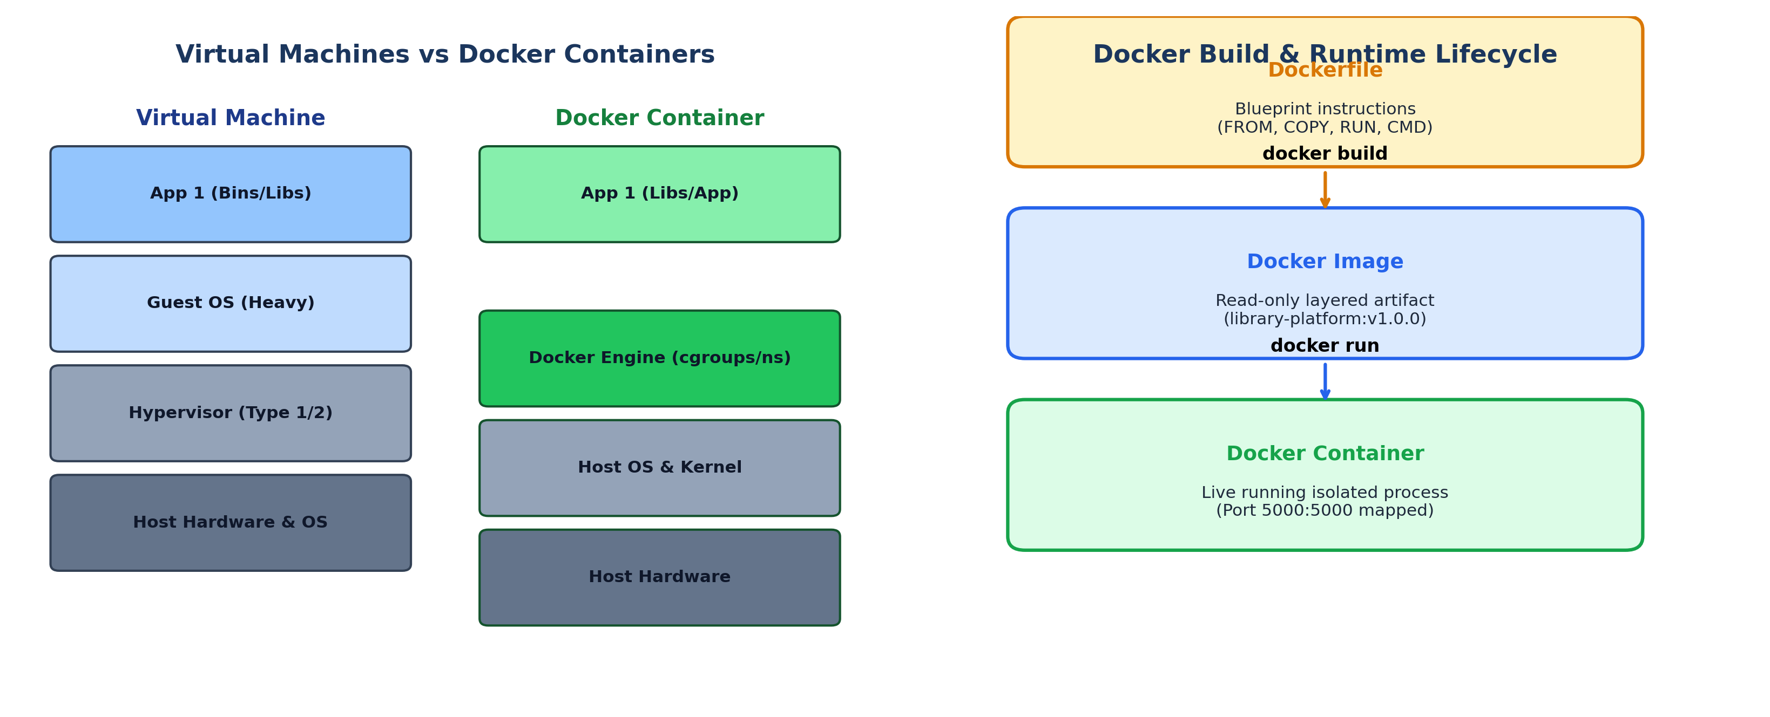
Figure: Architectural Comparison between Virtual Machines and Docker Containers alongside Build Lifecycle
6.2 Comparative Architecture: Virtual Machines vs. Containers
Architectural Attribute | Virtual Machines (VMware / KVM) | Docker Containers
Virtualization Level | Hardware-level virtualization (via Hypervisor) | Operating System-level virtualization (via Docker Engine)
Operating System Kernel | Each VM runs a complete, independent Guest OS kernel | Containers share the host operating system kernel
Startup Latency | Minutes (full OS initialization & bootloader) | Milliseconds to seconds (instant process execution)
Resource Footprint | Heavyweight (several gigabytes per VM image) | Lightweight (tens to hundreds of megabytes per image)
Density & Scalability | Low density (tens of VMs per high-end server) | High density (hundreds of containers per server)
Portability Guarantee | Subject to hypervisor formats and VM templates | Strict write-once, run-anywhere container standards (OCI)

6.3 Docker Image Layering and Immutability
A Docker Image is an immutable, read-only template built from a sequence of instructions defined in a Dockerfile. Each instruction (FROM, COPY, RUN) creates an independent, content-addressable layer. Docker employs an Overlay File System (OverlayFS) with Copy-on-Write (CoW) mechanics:
- Layer Caching: Identical base layers (such as python:3.11-slim) are shared across multiple images on the host machine, saving disk space.
- Build Optimization: During 'docker build', Docker skips re-executing unchanged instructions, completing subsequent builds in fractions of a second.
- Container Layer: When a container runs, Docker places a thin, ephemeral read-write container layer on top of the immutable read-only image layers.
7. Container Orchestration with Kubernetes & Minikube
7.1 Why Orchestration is Essential in Production
While Docker provides an exceptional format for packaging and running individual containers, enterprise production demands managing hundreds of interacting containers across distributed server fleets. Standalone Docker cannot natively handle:
- Self-Healing & Auto-Restart: Containers terminate abruptly upon process crashes; production requires automatic detection and recreation.
- Dynamic Horizontal Scaling: Traffic surges require instantly scaling from 2 to 20 container replicas and distributing incoming requests evenly.
- Zero-Downtime Rolling Releases: Deploying new application versions without dropping active client connections requires rolling updates and instant rollback if errors occur.
- Service Discovery & Load Balancing: Containers receive dynamic IP addresses upon recreation; client requests require a permanent, DNS-addressable virtual entry point.
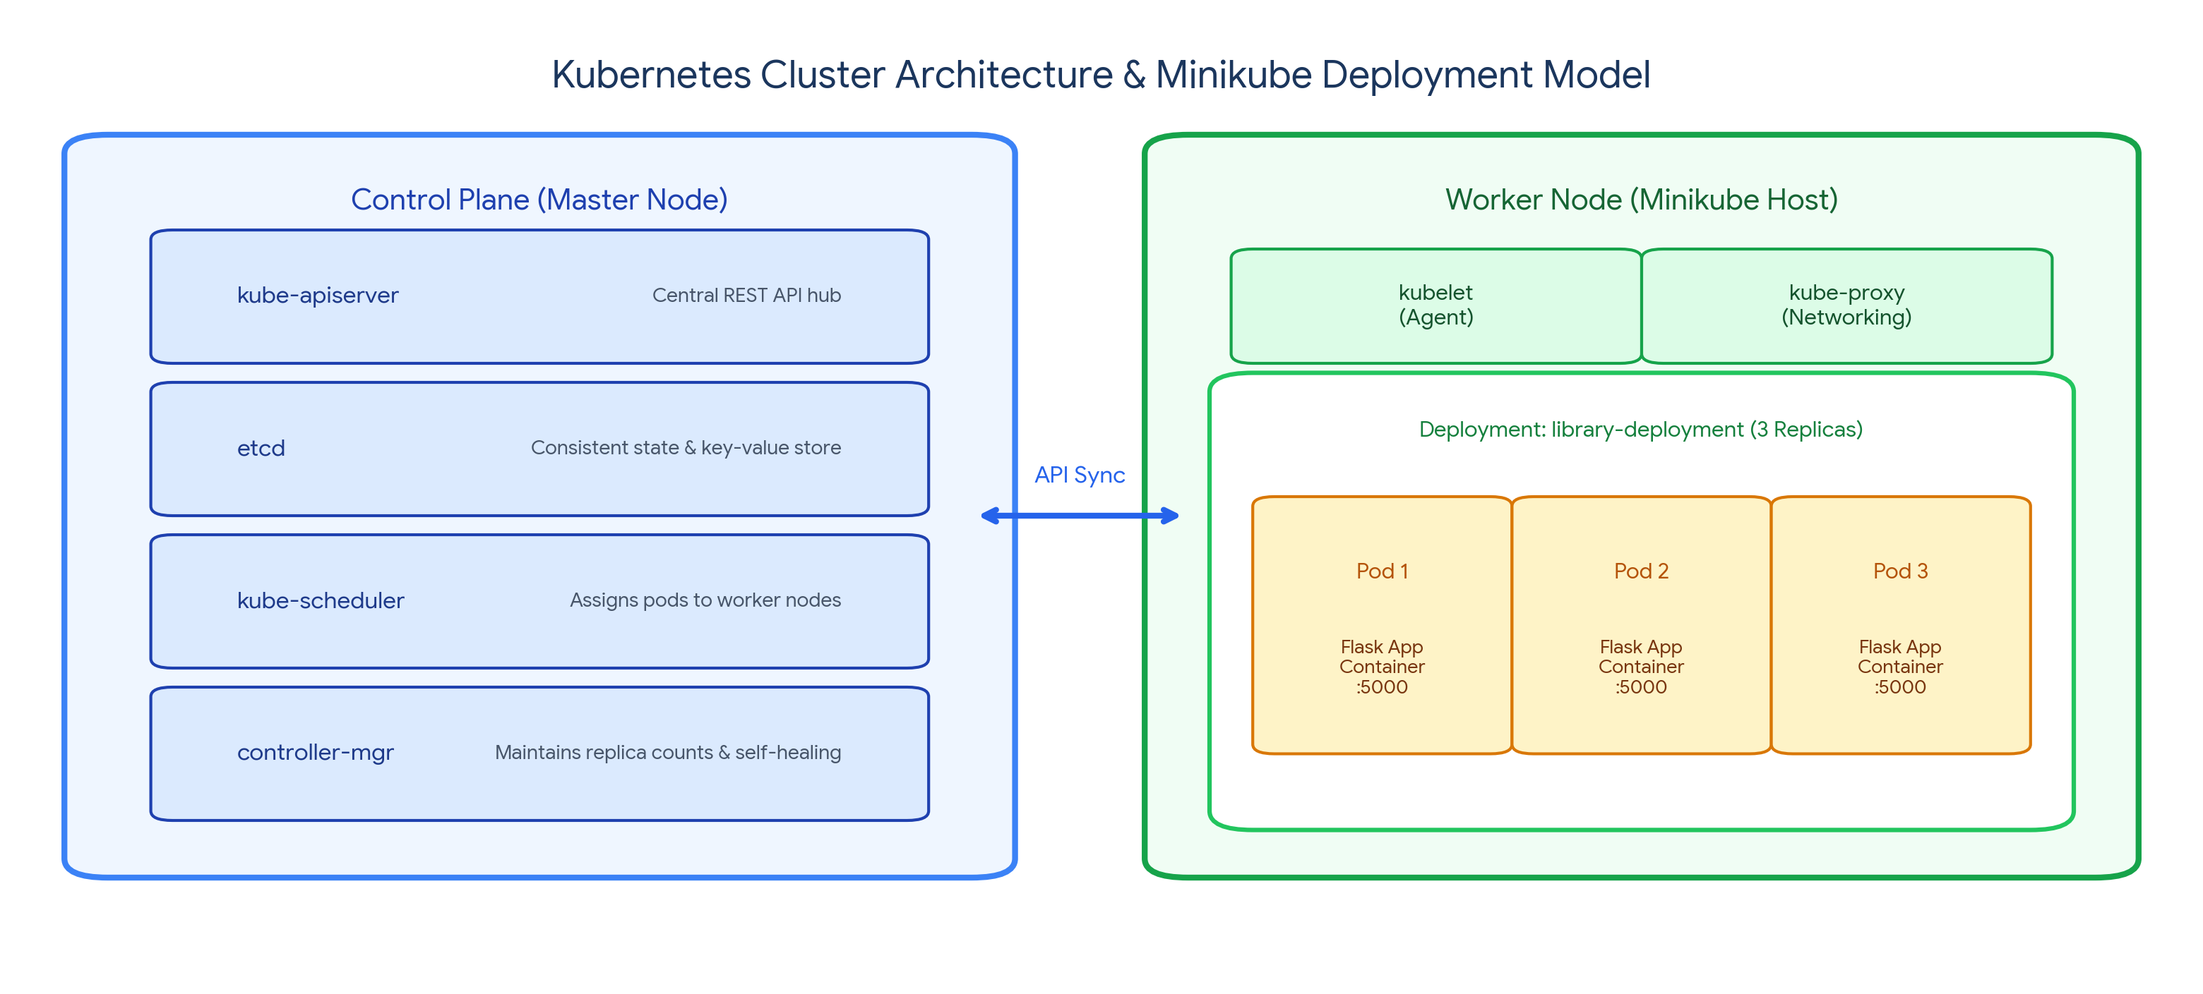
Figure: Kubernetes Cluster Architecture & Minikube Deployment Model
7.2 Kubernetes Architecture & Core API Primitives
Kubernetes orchestrates applications via a distributed Control Plane and Worker Nodes:
- kube-apiserver: The REST API gateway exposing cluster administration endpoints for kubectl CLI and internal controllers.
- etcd: High-availability distributed key-value store maintaining cluster state, configurations, and secrets.
- kube-scheduler: Watches for unassigned Pods and schedules them onto appropriate Worker Nodes based on resource availability.
- kube-controller-manager: Enforces the cluster's declared state (e.g., maintaining replica counts, handling node failures).
- kubelet: Node agent that communicates with the API Server and manages containers via the container runtime (containerd).
- kube-proxy: Network proxy that maintains network rules and load-balances traffic across pods.
The fundamental API objects used in our project include:
- Pod: The smallest deployable unit in Kubernetes, encapsulating one or more tightly coupled containers sharing storage and network namespaces.
- Deployment: A declarative controller that manages ReplicaSets to guarantee the specified number of Pod replicas remain healthy and handles zero-downtime rolling updates.
- Service: A stable networking abstraction providing a single IP, DNS name, and load balancer in front of dynamic Pod replicas (ClusterIP, NodePort, LoadBalancer).
8. The End-to-End Integrated DevOps Ecosystem
The entire automated software lifecycle converges when Git, Jenkins, Docker, and Kubernetes operate as a cohesive continuous delivery system.
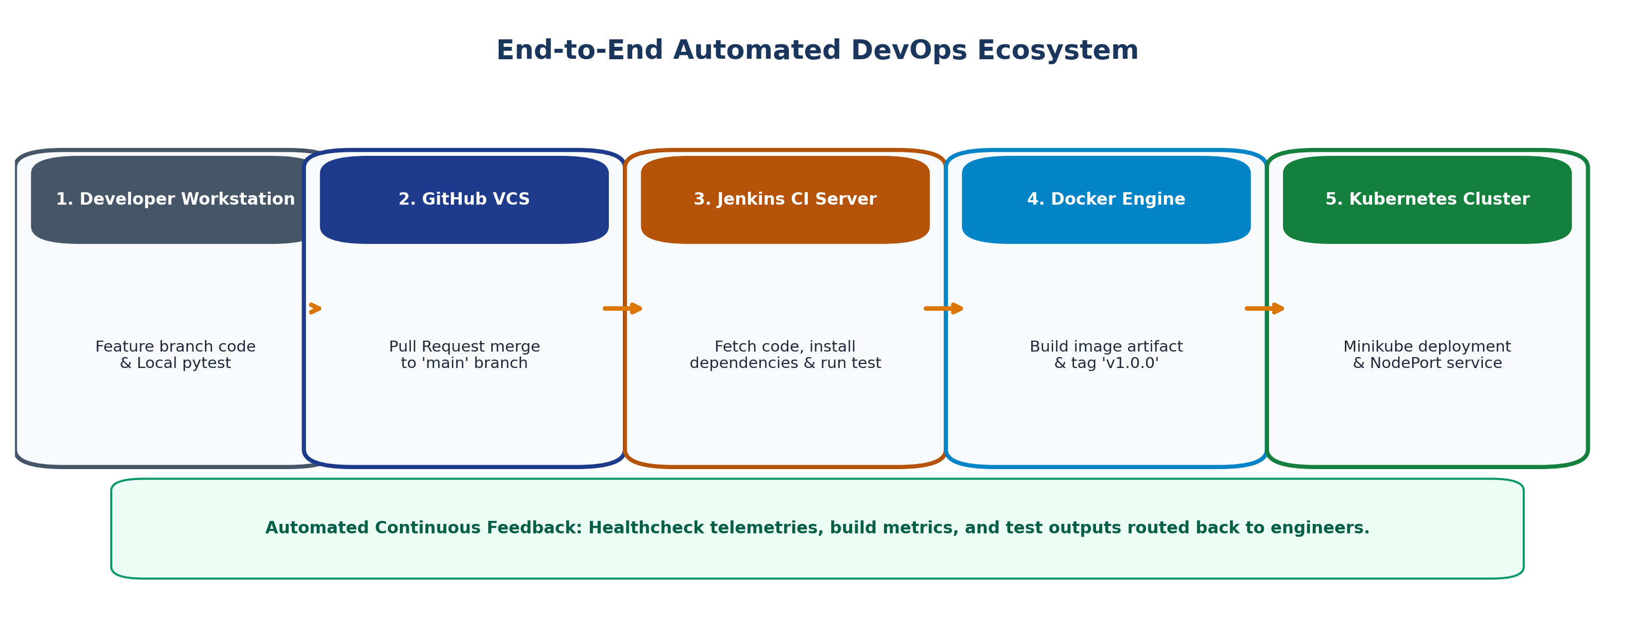
Figure: End-to-End Automated DevOps Ecosystem Architecture
8.1 The Complete Automated Path to Production
- Step 1: Developer pushes code to a feature branch on GitHub, opening a Pull Request.
- Step 2: GitHub Webhook triggers Jenkins CI server; Jenkins pulls code, runs static linting, and executes pytest suites.
- Step 3: Upon Pull Request approval and merge into main, Jenkins executes the deployment pipeline.
- Step 4: Jenkins triggers Docker to build a production container image with a unique version tag (v1.0.0).
- Step 5: The image is pushed to the container registry, making the release artifact globally accessible.
- Step 6: Jenkins applies Kubernetes manifests (kubectl apply -f k8s/), triggering a rolling update on Minikube.
- Step 7: Kubernetes provisions new Pods, conducts readiness healthchecks, routes user traffic through the NodePort service, and gracefully terminates old containers.
- Step 8: Application metrics, logs, and health status flow into monitoring dashboards, completing the continuous feedback loop.
8.2 Academic Project Alignment: Trainer vs. Student Implementations
Lifecycle Phase | Trainer Implementation (Case Study) | Student Project (Independent Implementation)
Domain Application | Enterprise Smart Library Management Platform | Enterprise Student Record & Academic Management Platform
Core Business Entities | Books, Borrowers, Inventory, Loans, Overdue Fines | Students, Courses, Faculty, Enrollments, Academic Marks
Validation Modules | Book checkouts, duplicate ISBNs, membership rules | Course registrations, student lookups, grade GPAs
CI Test Coverage | tests/test_book_service.py, tests/test_borrow_return.py | tests/test_student_service.py, tests/test_marks_mgmt.py
Packaging & Deployment | Docker image: library-platform:v1.0.0 on Minikube | Docker image: student-platform:v1.0.0 on Minikube

