Karan Garg

I017

MBA(Tech).IT

# Parking Booking Application for the University

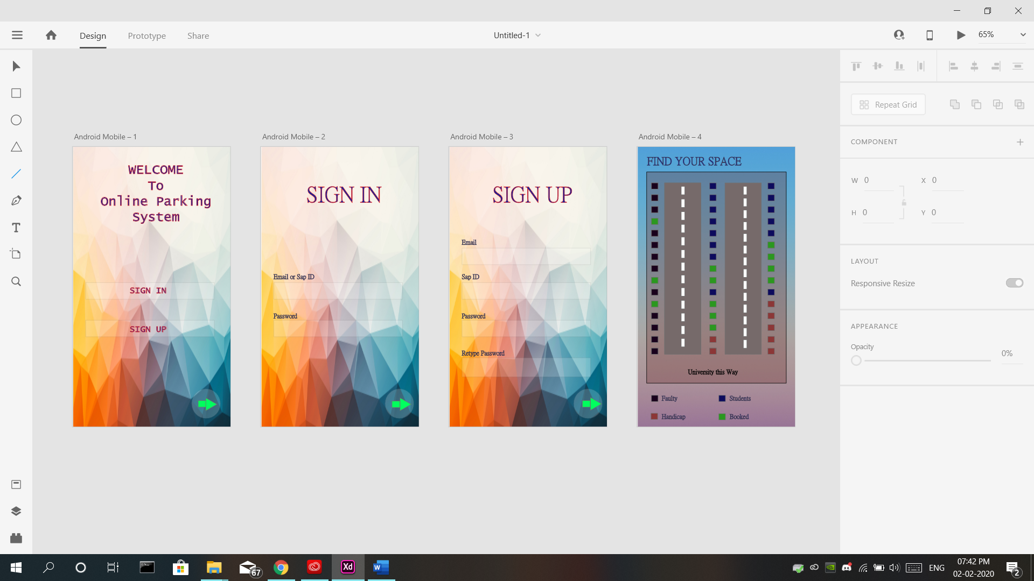

* This Application allows user to view the parking in advance. To see if parking space is available or not
* User needs to be registered on this application by using Email, SAP ID and password.
* Database of this application is managed by University Admin department