**Lab 2.2a & 2.2b: Stack-based Recursive Graphics [30 points]**

**Last name:**

**First name:**

**ID#:**

1. Before designing your recursive graphics using Processing review the following topics/examples ([link 1](https://processing.org/examples/tree.html), [link](https://processing.org/examples/recursion.html) 2, [link 3](http://learningprocessing.com/examples/chp13/example-13-08-recursion), [link 4](https://natureofcode.com/book/chapter-8-fractals/)). To design two different works of recursive shapes, consider incorporating [pushMatrix()](https://www.processing.org/reference/pushMatrix_.html) , [popMatrix(),](https://www.processing.org/reference/popMatrix_.html) or [ArrayList](https://processing.org/reference/ArrayList.html) along with both mouse and key interactivities (e.g., mouse movement to change shape, color change through pressing different keys ) for your recursive graphics. To get a full mark, your work should show uniqueness in addition to technical excellency different from web examples in addition to incorporating mouse/key interaction. Do not directly copy other’s work or sample code. Your code implementation should be different (minimum 80% by adding algorithm, conditional statements, loops, randomization, new variables etc.) from original sample code. You must add reference showing your research efforts by including any sample code link as well as image link relate to your creation. Just changing variable names also counted as [plagiarism](https://libguides.kpu.ca/academicintegrity/plagiarism). Without your significant implementation of original source code, you will receive ‘0’; [plagiarism](http://libguides.kpu.ca/academicintegrity/plagiarism).

* Recursion examples: [Tree](https://processing.org/examples/tree.html), [circles](https://processing.org/examples/recursion.html)
* [pushMatrix()](https://www.processing.org/reference/pushMatrix_.html)
* [popMatrix().](https://www.processing.org/reference/popMatrix_.html)
* [ArrayList](https://processing.org/reference/ArrayList.html)
* [Fractals](http://natureofcode.com/book/chapter-8-fractals/)

2. Find some reference images showing recursive patterns in nature. Try some keywords; pattern, flower, skin, tree, wave, people etc. Must explain the reason why you choose those images for your two examples. You must add your reference image with web link below with a short description about the reason why you choose specific pattern.

|  |  |  |
| --- | --- | --- |
| #1 |  |  |
|  | [Image result for pattern tree](https://www.etsy.com/au/listing/101766880/tree-cross-stitch-pattern-pdf) | Briefly explain the reason why you choose this image |
| Link | <https://www.etsy.com/au/listing/101766880/tree-cross-stitch-pattern-pdf> |  |

|  |  |  |
| --- | --- | --- |
| #2 |  |  |
|  | [Image result for pattern crowd stick figure](https://www.dreamstime.com/stock-illustration-unique-stick-figure-crowd-illustration-image68466276) | Briefly explain the reason why you choose this image |
| Link | <https://www.dreamstime.com/stock-illustration-unique-stick-figure-crowd-illustration-image68466276> |  |

1. **Create two new Processing file and name your Processing files as recursiveGraphics02aFall23_yourLastname_firstnameInitial.pde and recursiveGraphics02bFall23_yourLastname_firstnameInitial.pde.** Not following the file naming convention will result in a penalty. Each file should contain a different recursive pattern based on recursive method/function design.
2. **Based on your research from step 2, describe your recursive design rules with images (or sketches) showing the breakdown of each recursive process (an example shown below) for your first work.**

[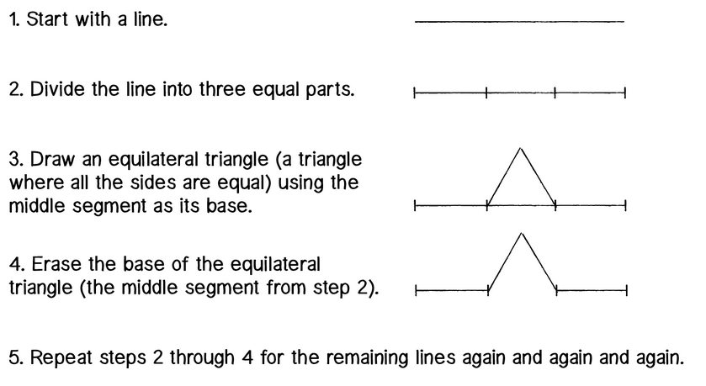](http://natureofcode.com/book/chapter-8-fractals/)

* Attach minimum two screen shots of your Processing work showing an interactive change.

1. **Based on your research from step 2, describe your recursive design rules with images (or sketches) showing the breakdown of each recursive process for your second work.**

](http://natureofcode.com/book/chapter-8-fractals/)

* Attach minimum two screen shots of your Processing work showing an interactive change.