**ABSTRACT**:- Today technology is growing to a bigger extent, but there's no price effective device for visually impaired folks. For a visually impaired person it becomes not possible to try to to his/her day to day activities, so sensible Blind stick will facilitate visually impaired folks in moving and permitting them to perform their work simply. The sensible stick can have sensors embedded with it, thereby it senses the objects/intruder, once associatey objects or obstacles are available in vary of an supersonicdevice then the person is alerted with a fast reaction time employing a vibrator. The general system conjointly encompasses a GPS module, so the person with incapacity will recognize this location with the assistance of a electro-acoustic transducerand a speaker. this technique conjointly has a feature wherever within which the person with incapacity will contact to a particular person whose range is keep in an exceedingly microcontroller just in case of any emergency. this techniqueconjointly encompasses a water device at very cheap of the stick and Infrared device for effective obstacle detection. coming up with a price effective and economical blind stick is that the main aim of the project.

**I. INTRODUCTION**

There area unit regarding 253 million folks digest vision impairment, thirty six million area unit blind and 217 million have moderate to severe vision impairment. eighty one of individuals World Health Organization area unit blind area unit aged fifty years and on top of (WHO estimation). the quantity of visually impaired folks area unit expected to grow within the future because of numerous reasons. As a result, there's a necessity for a value effective system which will be employed by blind folks so as to steer simply and well. it's necessary that a sensible resolution is planned for the blind folks in order that they will use this in their way of life

**II. PROPOSED WORK**

**A. Existing System**: Google Glass may be a wearable laptop with Associate in Nursing

optical head-mounted show that's being developed by Google within the Project Glass analysis and development project. Google's mission is to supply a mass-market pervasive laptop [i.e., computing that may seem everyplace and anywhere. Google Glass displays info in an exceedingly good phone-like hands-free format that may interact with the net via tongue voice commands. it isn't a combine of "Google Glasses," but one Google Glass telephone receiver. Glass contains a terribly easy, clean style that, in some regards, is beautiful and elegant; in others, crude and clumsy. We'll begin with the elegant bits, most compelling being the plasticbacked metallic element band that sweeps around and forms the frame. Glass will perform

With a Wi-Fi or Bluetooth knowledge association – it's a completely freelance device. This suggests you'll leave your phone behind and walk around anyplace with Wi-Fi while not losing association. But this costs around 14000$(around 900000 rupees) that isn't attainable to use by most of the blind folks in a developing country like India.

**B. Methodology**

The stick is embedded with Raspberry Pi, GSM module, GPS module, vibrator, switches and sensors. If any device is invoked, the vibrator that is placed over the handle vibrates. If the visually impaired person needs to grasp their current location they'll press the switch allotted for that purpose, associate degree audio relating to this location is detected by the blind man with the assistance of Bluetooth audio device. totally different types of devices like

water sensor, supersonic device and Infrared sensor ar placed at numerous elements of the stick creating it strong. If the visually impaired person conjointly wants some facilitate throughout some emergency, a decision or a message is shipped to a group of mobile numbers stored during a small controller. Developing the merchandise at bottom value becomes the key agenda of the project. If the person needs to grasp the directions to induce to the proper location, he/she will really press a button associated for the aim, the direction primarily based audio message is detected by them victimization the Bluetooth primarily based audio device. Infrared device that is gift at rock bottom of the stick will detect presence of holes and stairs. Google Assistant is deployed here for swish interface for voice and audio I/O.

**C. Obstacle Detection**

To observe obstacles whereas walking, we tend to use unhearable sensors. These sensors are embedded within the stick and area unit organized in several orientation. Output from these sensors are processed in an exceedingly microcontroller and appropriate undulation feedback are provided. relying upon the output of unhearable devices/IR sensor, necessary vibration modules are activated to tell the person concerning the obstacle.

**D. Navigation**

The basic plan here is to integrate Google Assistant in our good stick that is a powerful tool for pursuit and navigating within the very best means. User can have a Bluetooth enabled speaker from that he are ready to hear the

stereo sound directions facultative him to navigate to a location.

**E. Emergency alert**

This system additionally includes a feature wherever within which the person with incapacity will contact to a specific person whose range is keep in an exceedingly microcontroller just in case of any emergency. He/she can press the switch appointed for it.

**IV. REQUIREMENT SPECIFICATION**

System Requirement

1. Hardware Requirements

• Raspberry Pi 3 B module.

**•**  Ultrasonic sensors.

• IR sensor

• Vibrator

• Bluetooth module.

• Push Buttons

• Stick body(plastic)

B. Software Requirements

• Raspberry pi programming with Python

• Google Assistant SDK.

**V. ABSTRACT SPECIFICATION OF SUB-SYSTEMS**

**A. Obstacle Detection System:**

The fundamental principle is to sight presence of obstacles victimisation multiple inaudible sensors and provides feedback in undulation kind. associate degree inaudible detector could be a device which will live the space to an object by victimisation sound waves. It measures distance by causing out a wave at a selected frequency

and listening for that wave to convalesce. These sensors are going to be embedded within the stick and are organized in numerous orientation. Output from these sensors are going to be processed in Raspberry Pi 3b microcontroller and appropriate undulation feedback are going to be provided. So, whenever the person confronts any obstacle ahead of him, the inaudible detector detects it and informs the user about it through a undulation feedback.

1. **Communication System:**

An fundamental a part of our verbal exchange machine is the GPS and GSM module that is embedded inside the Raspberry pi 3b module. In GPS, the GPS satellites circle the Earth two times a day in a specific orbit. each satellite tv for pc transmits a unique signal and orbital parameters that allow our clever stick device to decode and compute the perfect location of the satellite. GPS receiver in our clever stick use this statistics and trilateration to calculate a user's precise place. basically, the GPS receiver measures the distance to each satellite by using the amount of time it takes to receive a transmitted sign. With distance measurements from some more satellites, the receiver can determine a user's function and display it electronically to measure our going for walks route, or find a way home from everywhere.

**VI. IMPLEMENTATION**

The given model has supersonic device and water sensor hooked up thereto. If any of the device is triggered then the there'll be vibration. The blind man just in case if he's any

emergency will endure the emergency button, a message is distributed concerning his current location to a pair of individuals whose mobile range is saved within the small controller. The model takes voice input and offers out the voice output concerning a way to navigate from a specific purpose. If the blind man needs to grasp this location he is in he will press the situation button and can receive a voice output concerning his location.. For our model we have a tendency to 1st listed out all the sensors/microcontrollers needed and so analyzing the compatibility and price we have a tendency to selected the acceptable sensors/microcontroller that are:

1. Renesas Microcontroller(RL78)

2. Ultrasonic Sensor (HC-SR04) x 2

3. Moisture Sensor (SEN-13634)

4. Relay Switches

5. Bluetooth (HC-05)

**Coding**

First, we analyzed the nation and collection diagrams and then we wrote a pseudo code for each module. Then we used Renesas dice Suite software to application the pseudo code in embedded c program languageperiod. any other a part of the coding required us to increase an android app which interfaced with the Bluetooth module. We wrote the code thus while both of the switches had been pressed. set of rules Used for object identification the usage of system mastering: Convolution Neural Networks.

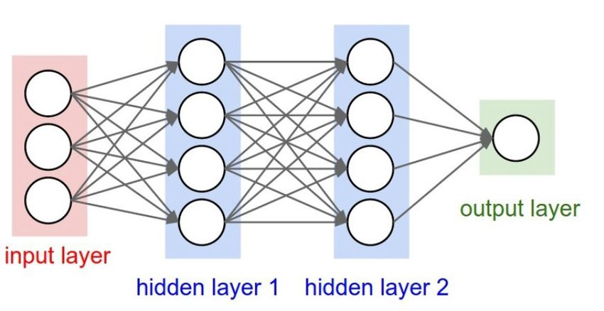

**VII. EXPERIMENTAL RESULTS**

Developed a model that may verify barriers and conjointly give knowledge on a navigation system based mostly inaudible device for barrier detection .Developed a model for visually impaired to maneuver before alright ,as well as safely navigate. created it obtainable at less expensive costs while not compromising with the functionalities. decreased its maintenance and expense. Build a model that gives blind and visually impaired communities a wise device that provides them freelance personal quality outside the house. created a wise blind stick that is innovative high-tech stick that may facilitate visually impaired individuals to discover obstacles close to them and navigate their manner

1. **Result Screenshots**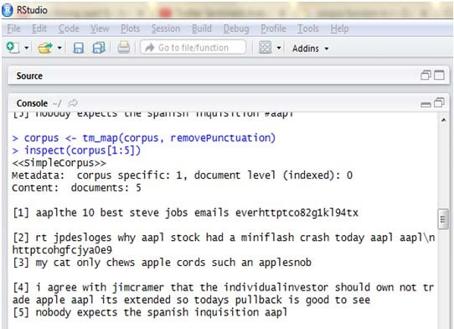

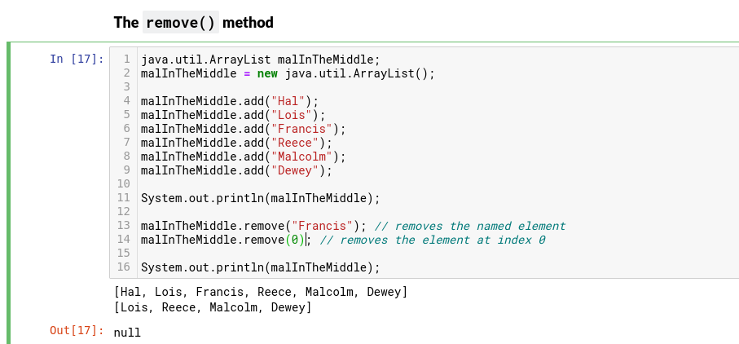

**VIII. CONCLUSION**

It is necessary that visually impaired folks get access to AN economical and comfortable object so as to measure their way of life well. in an exceedingly developing country like India, there's a desire for a value effective resolution so most of the folks will have an effective product in hand. thus exploitation such good technology we tend to aim to assist visually impaired folks for his or her profit. The project analyzed the present electronic aids for blind folks and supported the constraints in existing aids, this project proposes AN enhanced helping electronic aid exploitation latest technology like supersonic waves, GPS, GSM .Hence our project aims to form lives higher for the visually impaired human kind Future Enhancements

**Source code for the project**

f=None

y=None

import speak as

f=None

y=None

# Import packages

import os

import cv2

import numpy as np

from picamera.array import PiRGBArray

from picamera import PiCamera

import tensorflow as tf

import argparse

import sys

window_name = 'Image'

import RPi.GPIO as GPIO

import time

# font

font = cv2.FONT_HERSHEY_SIMPLEX

# org

org = (50, 50)

# fontScale

fontScale = 1

# Blue color in BGR

color = (255, 0, 0)

thickness = 2

t="none"

# Set up camera constants

IM_WIDTH = 1280

IM_HEIGHT = 720

#IM_WIDTH = 640 Use smaller resolution for

#IM_HEIGHT = 480 slightly faster framerate

# Select camera type (if user enters --usbcam when calling this script,

# a USB webcam will be used)

camera_type = 'picamera'

parser = argparse.ArgumentParser()

parser.add_argument('--usbcam', help='Use a USB webcam instead of picamera',

action='store_true')

args = parser.parse_args()

if args.usbcam:

camera_type = 'usb'

# This is needed since the working directory is the object_detection folder.

sys.path.append('..')

i=7.5

# Import utilites

from utils import label_map_util

from utils import visualization_utils as vis_util

# Name of the directory containing the object detection module we're using

MODEL_NAME = 'ssdlite_mobilenet_v2_coco_2018_05_09'

# Grab path to current working directory

CWD_PATH = os.getcwd()

# Path to frozen detection graph .pb file, which contains the model that is used

# for object detection.

PATH_TO_CKPT = os.path.join(CWD_PATH,MODEL_NAME,'frozen_inference_graph.pb')

# Path to label map file

PATH_TO_LABELS = os.path.join(CWD_PATH,'data','mscoco_label_map.pbtxt')

# Number of classes the object detector can identify

NUM_CLASSES = 90

## Load the label map.

# Label maps map indices to category names, so that when the convolution

# network predicts `5`, we know that this corresponds to `airplane`.

# Here we use internal utility functions, but anything that returns a

# dictionary mapping integers to appropriate string labels would be fine

label_map = label_map_util.load_labelmap(PATH_TO_LABE)categories = label_map_util.convert_label_map_to_categories(label_map,

max_num_classes=NUM_CLASSES, use_display_name=True)

category_index = label_map_util.create_category_index(categories)

# Load the Tensorflow model into memory.

detection_graph = tf.Graph()

with detection_graph.as_default():

od_graph_def = tf.GraphDef()

with tf.gfile.GFile(PATH_TO_CKPT, 'rb') as fid:

serialized_graph = fid.read()

od_graph_def.ParseFromString(serialized_graph)

tf.import_graph_def(od_graph_def, name='')

sess = tf.Session(graph=detection_graph)

# Define input and output tensors (i.e. data) for the object detection classifier

# Input tensor is the image

image_tensor = detection_graph.get_tensor_by_name('image_tensor:0')

# Output tensors are the detection boxes, scores, and classes

# Each box represents a part of the image where a particular object was detected

detection_boxes = detection_graph.get_tensor_by_name('detection_boxes:0')

# Each score represents level of confidence for each of the objects.

# The score is shown on the result image, together with the class label.

detection_scores = detection_graph.get_tensor_by_name('detection_scores:0')

detection_classes = detection_graph.get_tensor_by_name('detection_classes:0')

# Number of objects detected

num_detections = detection_graph.get_tensor_by_name('num_detections:0')

# Initialize frame rate calculation

frame_rate_calc = 1

freq = cv2.getTickFrequency()

freq=100000

font = cv2.FONT_HERSHEY_SIMPLEX

def blinds():

i=0

y=None

### Picamera ###

k=None

if camera_type == 'picamera':

# Initialize Picamera and grab reference to the raw capture

camera = PiCamera()

camera.resolution = (IM_WIDTH,IM_HEIGHT)

camera.framerate = 90

rawCapture = PiRGBArray(camera, size=(IM_WIDTH,IM_HEIGHT))

rawCapture.truncate(0)

for frame1 in camera.capture_continuous(rawCapture, format="bgr",use_video_port=True):

t1 = cv2.getTickCount()

# Acquire frame and expand frame dimensions to have shape: [1, None, None, 3]

# i.e. a single-column array, where each item in the column has the pixel RGB value

frame = np.copy(frame1.array)

frame.setflags(write=1)

frame_rgb = cv2.cvtColor(frame, cv2.COLOR_BGR2RGB)

frame_expanded = np.expand_dims(frame_rgb, axis=0)

# Perform the actual detection by running the model with the image as input

(boxes, scores, classes, num) = sess.run(

[detection_boxes, detection_scores, detection_classes, num_detections],

feed_dict={image_tensor: frame_expanded})

# Draw the results of the detection (aka 'visulaize the results')

k,p,o=vis_util.visualize_boxes_and_labels_on_image_array(

frame,

np.squeeze(boxes),

np.squeeze(classes).astype(np.int32),

np.squeeze(scores),

category_index,

use_normalized_coordinates=True,

line_thickness=8,

min_score_thresh=0.40)

print(p)

if p=="none":

p=None

i=1+i

#if o is not None:

# z.ChangeDutyCycle(o)

cv2.putText(frame,"FPS: {0:.2f}".format(frame_rate_calc),(30,50),font,1,(255,255,0),2,cv2.LINE_AA)

image_np=frame

# Using cv2.putText() method

cv2.imshow('object detection',image_np)

# Press 'q' to quit

if cv2.waitKey(1) == ord('q') or i==5:

cv2.destroyAllWindows()

break

if p is not None:

s.speaker(p+"detected")

rawCapture.truncate(0)

camera.close()

**simple simulation circuit:**

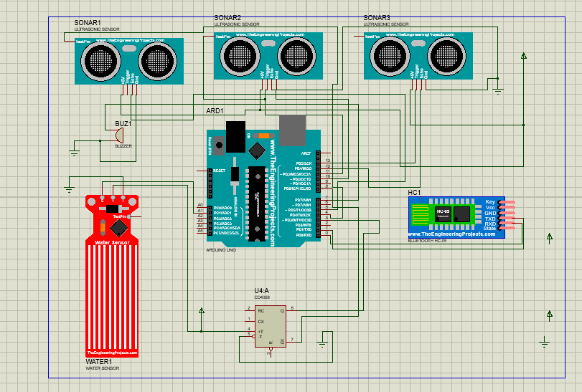

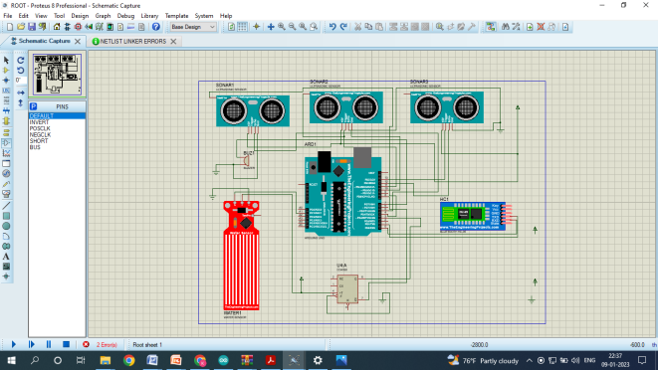

**NOTE :**

This is the only IOT based simulation. In this simulation using raspberry PI we can modify the IOT project into a MACHINE LEARNING.Using the above coding feed the input to the raspberry pi and using ESP camera we can find the object and deduct the object .It is use full for the blind people for their navigation.

**IT IS A FIRST STEP OF OUR PROJECT…**

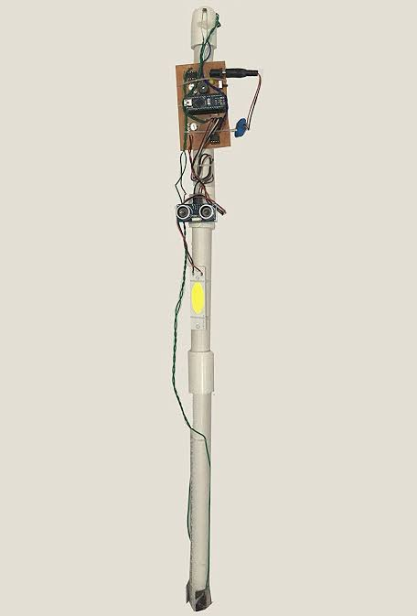

**ALGORITHM FOR THE CODING:**

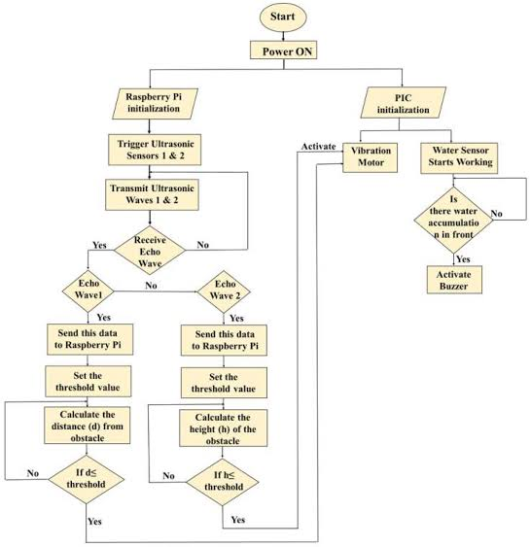

**Resources person**

A.Karankumar

V.Gokul

II ND YEAR ECE DEPARTMENT

P.A.COLLEGE OF ENGNEERING AND TECNOLOGY(POLLACHI)