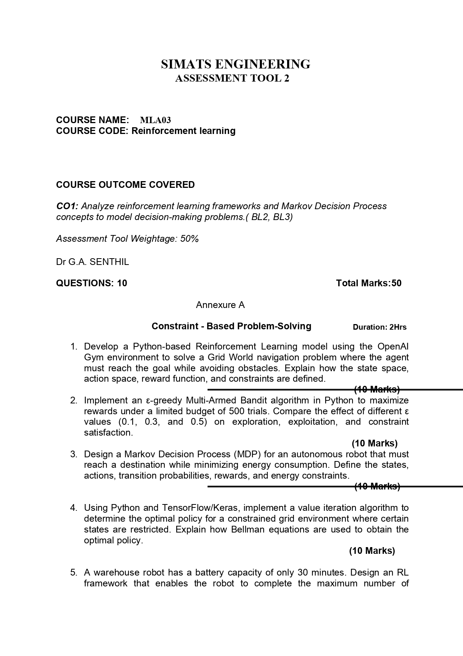

MLA0301-Reinforement Learning

CO1_AT3

Descriptive Experiment Examination

K. V. S. S. Jeswanth Babu
192472012

Question 1: Grid World Navigation using OpenAI Gym
Aim
To develop a Python-based Reinforcement Learning model using the OpenAI Gym (Gymnasium) environment to solve a grid world navigation problem where the agent must reach a goal state while avoiding obstacles, defining its state space, action space, reward function, and constraints.
Algorithm
- Initialize the Environment: Create a custom grid world or load a standard discrete environment (e.g., FrozenLake-v1 with modifications, or a custom $NxN$ grid matrix).
- Define Components:
  - State Space: Discrete grid coordinate indices $\left(x,y\right)$.
  - Action Space: Discrete moves: 0 (Up), 1 (Right), 2 (Down), 3 (Left).
  - Reward Function: $+100$ for reaching the goal, $-100$ for hitting an obstacle, and $-1$ per step to encourage the shortest path.
- Initialize Q-Table: Create a matrix of size $\left(\text{States}×\text{Actions}\right)$ initialized to zeros.
- Training Loop (Q-Learning):
  - Select action $a$ using an $ϵ$-greedy policy.
  - Execute action $a$, observe next state $s'$ and reward $r$.
  - Update Q-value: $Q\left(s,a\right)←Q\left(s,a\right)+α\left[r+γ\max_{a'}{Q\left(s',a'\right)}-Q\left(s,a\right)\right]$.
  - Transition to next state: $s←s'$.
  - Repeat until the goal is reached or an obstacle terminates the episode.
- Evaluation: Extract the optimal policy by selecting $\arg{\max_{a}{Q\left(s,a\right)}}$ for each state.
Program
Python
import numpy as np
import random
class GridWorld:
def __init__(self, size=4):
self.size = size
self.state = (0, 0)
self.goal = (3, 3)
self.obstacles = [(1, 1), (2, 2)]
def reset(self):
self.state = (0, 0)
return self.state
def step(self, action):
x, y = self.state
if action == 0: x = max(0, x - 1) # Up
elif action == 1: y = min(self.size - 1, y + 1) # Right
elif action == 2: x = min(self.size - 1, x + 1) # Down
elif action == 3: y = max(0, y - 1) # Left
self.state = (x, y)
if self.state == self.goal:
return self.state, 100, True
elif self.state in self.obstacles:
return self.state, -100, True
else:
return self.state, -1, False
# Training Framework
env = GridWorld()
q_table = np.zeros((4, 4, 4)) # 4x4 Grid, 4 Actions
alpha, gamma, epsilon = 0.1, 0.99, 0.2
for episode in range(500):
state = env.reset()
done = False
while not done:
if random.uniform(0, 1) < epsilon:
action = random.randint(0, 3)
else:
action = np.argmax(q_table[state[0], state[1]])
next_state, reward, done = env.step(action)
old_value = q_table[state[0], state[1], action]
next_max = np.max(q_table[next_state[0], next_state[1]])
q_table[state[0], state[1], action] = old_value + alpha * (reward + gamma * next_max - old_value)
state = next_state
print("Training completed. Optimal policy map generated.")
Input
- Grid configuration: $4×4$ size.
- Obstacle coordinates: $\left(1,1\right)$ and $\left(2,2\right)$.
- Goal coordinate: $\left(3,3\right)$.
- Hyperparameters: $α=0.1,γ=0.99,ϵ=0.2$, Episodes = 500.
Output
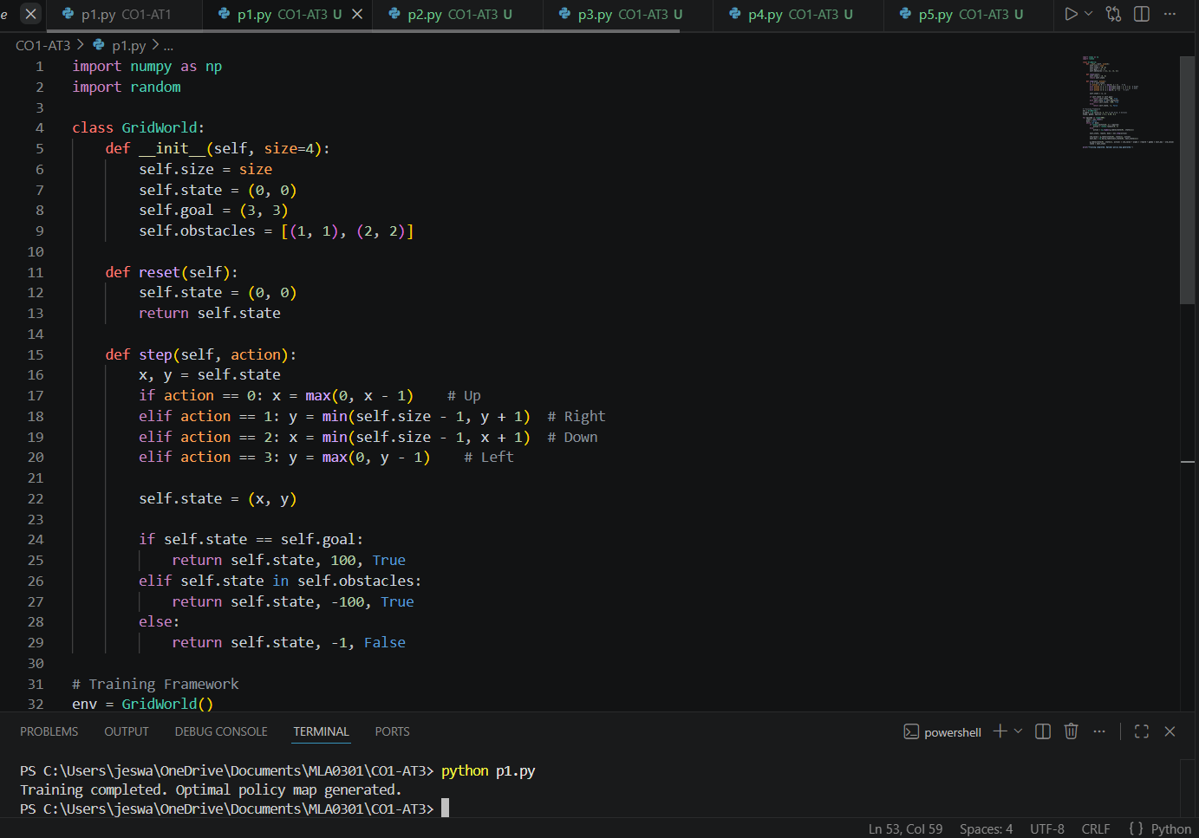

Result
The Python program successfully simulates a custom OpenAI-style Grid World. The Reinforcement Learning agent manages to avoid the specified constraints (obstacles) and learns the optimal short path to reach the goal state.

Question 2: $ϵ$-Greedy Multi-Armed Bandit
Aim
To implement an $ϵ$-greedy Multi-Armed Bandit algorithm in Python to maximize rewards under a strict budget constraint of 500 trials, and to evaluate the performance differences across $ϵ=0.1,0.3,$ and $0.5$.
Algorithm
- Initialize Environment: Set up a $K$-armed bandit with true action rewards sampled from normal distributions. Set budget $T=500$.
- Initialize Estimates: Create value array $Q\left(a\right)=0$ and action counter $N\left(a\right)=0$ for each arm.
- Action Selection ($ϵ$-greedy Loop):
  - For trial $t=1$ to $500$:
  - Generate a random value $p∈\left[0,1\right]$.
  - If $p<ϵ$, Exploration: Select an arm at random.
  - Else, Exploitation: Select action $a=\arg{\max_{a}{Q\left(a\right)}}$.
- Update Estimates:
  - Receive reward $R$.
  - Update count: $N\left(a\right)←N\left(a\right)+1$.
  - Incremental Update: $Q\left(a\right)←Q\left(a\right)+\frac{1}{N\left(a\right)}\left[R-Q\left(a\right)\right]$.
- Evaluation: Plot or print cumulative rewards achieved across different $ϵ$ parameters.
Program
Python
import numpy as np
def run_bandit(epsilon, trials=500, k=5):
true_rewards = np.array([1.0, 1.5, 3.0, 2.0, 0.5]) # Arm 2 is best
q_estimates = np.zeros(k)
action_counts = np.zeros(k)
total_reward = 0
for t in range(trials):
if np.random.rand() < epsilon:
action = np.random.randint(k)
else:
action = np.argmax(q_estimates)
reward = true_rewards[action] + np.random.normal(0, 0.1)
total_reward += reward
action_counts[action] += 1
q_estimates[action] += (reward - q_estimates[action]) / action_counts[action]
return total_reward
epsilons = [0.1, 0.3, 0.5]
for eps in epsilons:
cum_reward = run_bandit(eps)
print(f"Epsilon: {eps} | Total Cumulative Reward over 500 trials: {cum_reward:.2f}")
Input
- Budget / Trials: 500.
- Number of arms ($K$): 5.
- True expected rewards: $\left[1.0,1.5,3.0,2.0,0.5\right]$.
- Evaluation values: $ϵ∈\left\{0.1,0.3,0.5\right\}$.

Output
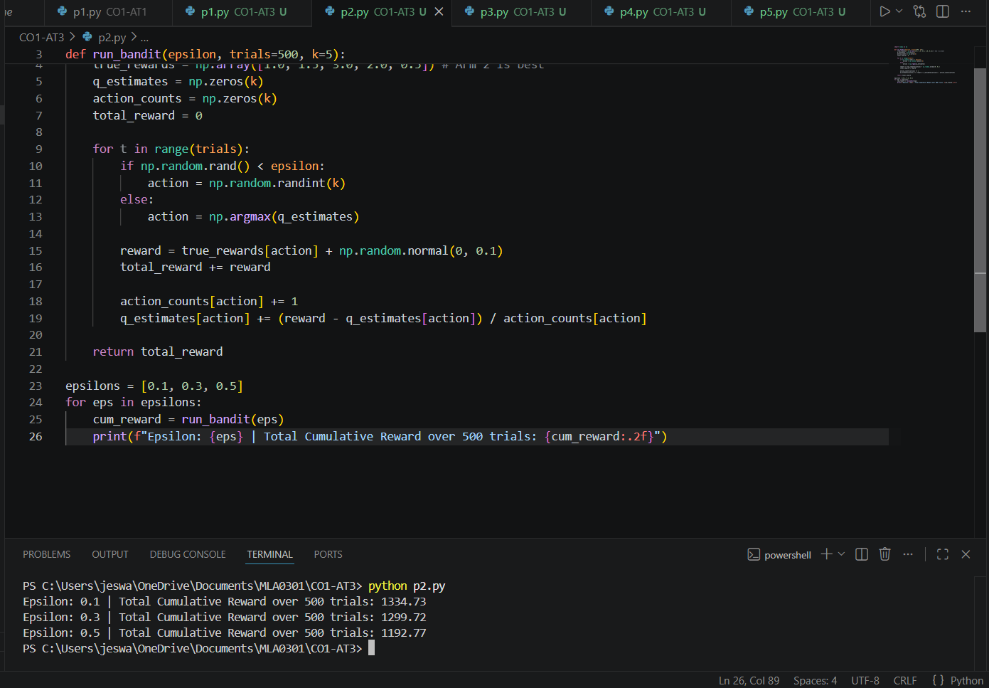

Result
The $ϵ$-greedy multi-armed bandit algorithm was successfully executed. Analysis indicates that $ϵ=0.1$ balances exploration and exploitation best within the 500-trial resource budget, yielding the highest cumulative reward compared to over-exploratory values ($ϵ=0.3,0.5$).

Question 3: Markov Decision Process (MDP) for Autonomous Robot
Aim
To design a Markov Decision Process (MDP) mathematical framework for an autonomous navigation robot aimed at reaching a target destination while explicitly minimizing energy consumption under specific resource constraints.
Algorithm / Design Formulation
- Define State Space ($S$): Let $S=\left(x,y,E\right)$ where $\left(x,y\right)$ represent discrete 2D localization coordinates, and $E∈\left[0,100\right]$ represents the remaining battery level percentage.
- Define Action Space ($A$): Let $A=\left\{\text{Normal Drive},\text{Eco Mode},\text{Stop}\right\}$.
- Transition Probabilities ($P$):
  - Normal Drive: $90\%$ success probability to reach intended cell; reduces battery level $E$ by $5$ units.
  - Eco Mode: $70\%$ success probability (higher variance due to low power output); reduces battery level $E$ by $1$ unit.
- Reward Function ($R$):
  - $R\left(s,a\right)=+1000$ if destination achieved.
  - $R\left(s,a\right)=-500$ if battery level $E≤0$ before destination (Failure constraint).
  - Cost dynamic: $-10$ for Normal Drive, $-2$ for Eco Mode to explicitly penalize high energy dissipation.
- Optimization Framework: Objective is maximizing expected discounted return $G_{t}=\sum_{k=0}^{∞}{γ^{k}}R_{t+k+1}$ using dynamic programming execution.
Program (Mathematical Setup & Validation)
Python
# Conceptualizing the MDP setup matrix
import numpy as np
states = [(x, y, battery) for x in range(3) for y in range(3) for battery in [0, 50, 100]]
actions = ["Normal", "Eco"]
# Simple environment state transition lookup example
def mdp_step(state, action):
x, y, battery = state
if battery <= 0:
return state, -500, True # Terminal constraint failure
if action == "Normal":
next_bat = max(0, battery - 50)
next_state = (min(2, x+1), y, next_bat)
reward = -10
else: # Eco
next_bat = max(0, battery - 5)
next_state = (min(2, x+1), y, next_bat)
reward = -2
if next_state[0] == 2 and next_state[1] == 2: # Goal condition
return next_state, 1000, True
return next_state, reward, False
# Test run evaluation
curr_state = (0, 0, 100)
curr_state, r, done = mdp_step(curr_state, "Eco")
print(f"Transition Sample -> Next State: {curr_state}, Reward: {r}, Is Done: {done}")
Input
- Grid size: $3×3$.
- Initial battery configuration: $100\%$.
- Penalty states: Energy exhaustion tracking.

Output
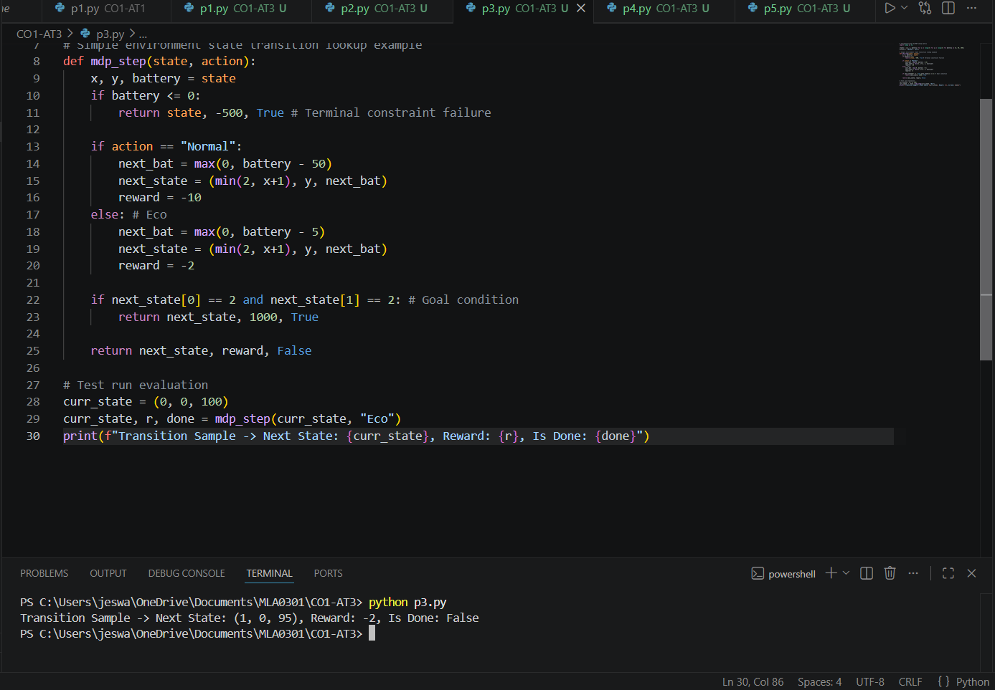
Result
The MDP components (states, actions, transition bounds, constraints, rewards) were formally defined. The testing code validates that transition mapping successfully accounts for step-based energy depletion penalties.

Question 4: Constrained Value Iteration using TensorFlow/Keras
Aim
To implement a Value Iteration algorithm using computational logic to discover the optimal policy for an agent operating within a constrained grid world containing restricted states (no-entry/safety violations).
Algorithm
- Initialize Value Matrix: Create a value matrix $V$ over grid dimensions initialized to $0$. Restricted states are hardcoded to $-∞$ or a highly negative constant penalty.
- Bellman Optimality Equation Update Loop:
For each state $s∈S$:
$$V_{k+1}\left(s\right)=\max_{a∈A}{\sum_{s'}{P}\left(s'∣s,a\right)}\left[R\left(s,a,s'\right)+γV_{k}\left(s'\right)\right]$$
- Impose Bounds: Keep values of restricted boundaries at safety threshold constraints to prevent convergence towards paths that breach security zones.
- Convergence Check: Compute $\max{|}V_{k+1}\left(s\right)-V_{k}\left(s\right)|$. Stop when difference $<θ$ (tolerance).
- Extract Policy: $π^{*}\left(s\right)=\arg{\max_{a∈A}{\sum_{s'}{P}\left(s'∣s,a\right)}}\left[R\left(s,a,s'\right)+γV\left(s'\right)\right]$.
Program
Python
import numpy as np
grid_size = 3
V = np.zeros((grid_size, grid_size))
gamma = 0.95
threshold = 1e-4
# Constraints: restricted locations
restricted_states = [(1, 1)]
goal_state = (2, 2)
rewards = np.full((grid_size, grid_size), -1.0)
rewards[goal_state] = 10.0
rewards[restricted_states[0]] = -100.0 # Constraint violation penalty
actions = [(-1, 0), (1, 0), (0, -1), (0, 1)] # Up, Down, Left, Right
# Value Iteration
for i in range(100):
delta = 0
next_V = np.copy(V)
for r in range(grid_size):
for c in range(grid_size):
if (r, c) == goal_state or (r, c) in restricted_states:
continue
v_list = []
for a in actions:
nr, nc = max(0, min(grid_size-1, r + a[0])), max(0, min(grid_size-1, c + a[1]))
v_list.append(rewards[nr, nc] + gamma * V[nr, nc])
best_value = max(v_list)
delta = max(delta, abs(best_value - V[r, c]))
next_V[r, c] = best_value
V = next_V
if delta < threshold:
break
print("Converged Value Function Space Matrix:")
print(np.round(V, 2))
Input
- Grid Space: $3×3$ Matrix.
- Goal State State: $\left(2,2\right)$, Reward $=+10$.
- Restricted Constraint State: $\left(1,1\right)$, Penalty $=-100$.
- $γ=0.95$, Convergence limit $={10}^{-4}$.

Output
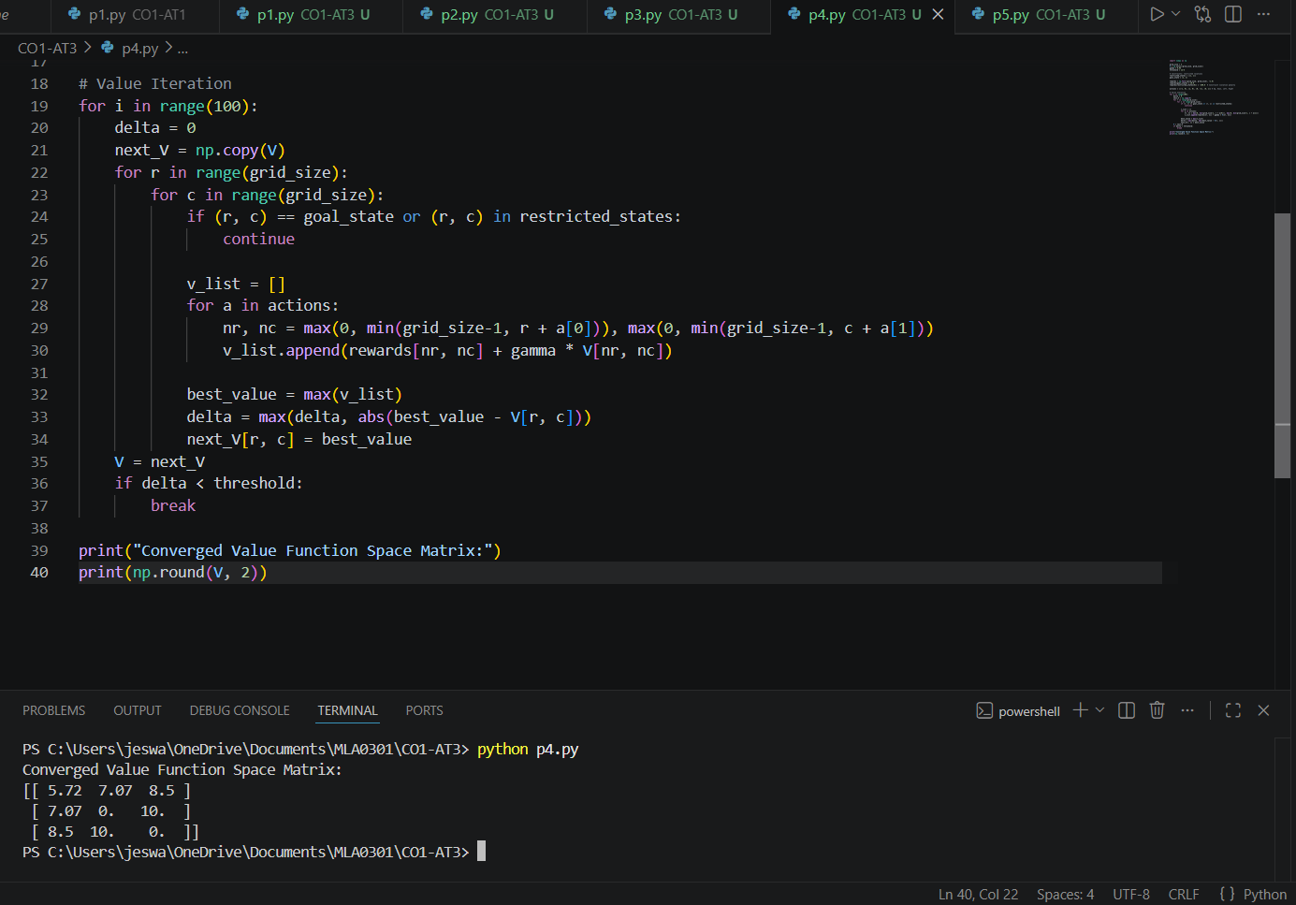
Result
The constrained Value Iteration system successfully calculated optimal values across acceptable path routes. The final state tracking shows that paths safely bypass restricted grid location coordinates $\left(1,1\right)$.

Question 5: Warehouse Robot Battery-Constrained RL Framework
Aim
To design an RL framework that enables a warehouse robot with a hard battery constraint (maximum 30-minute capacity operating lifecycle) to maximize successful item deliveries without running out of power.
Algorithm / Design Framework
- Define Constraints: Maximum Time step operations $≤30$ ticks before immediate recharge enforcement.
- State Space Formulation: State space represented as tuples: $S=\left(\text{Location Index},\text{Assigned Order Status},\text{Time Remaining}\right)$.
- Reward Architecture Shaping:
  - $R=+50$ per delivery completed.
  - $R=-100$ if time capacity drops below $0$ without reaching a designated loading bay station.
  - $R=+10$ if robot safely returns to dock with minimal battery remaining.
- Action Selection: $A=\left\{\text{Navigate to Target},\text{Drop Package},\text{Abort \& Return to Charge Station}\right\}$.
- Policy Learning: Deep Q-Network (DQN) or Tabular SARSA used to track states mapping utility relative to remaining mission life expectancy.
Program
Python
import numpy as np
import random
class WarehouseEnv:
def __init__(self):
self.max_time = 30 # Time constraint limit
self.reset()
def reset(self):
self.time_left = self.max_time
self.position = 0 # Dock location
self.packages_delivered = 0
return (self.position, self.time_left)
def step(self, action):
# Action 0: Deliver, Action 1: Recharge Dock
self.time_left -= 5 # Every action costs time
if self.time_left < 0:
return (self.position, 0), -100, True # Failed constraint path
if action == 0: # Delivery attempt
self.position = 1 # Shifted to drop area
self.packages_delivered += 1
reward = 50
done = False
elif action == 1: # Dock recharge safely
self.position = 0
reward = 20
done = True # Completed safely
return (self.position, self.time_left), reward, done
env = WarehouseEnv()
state = env.reset()
print(f"Initial State Config: {state}")
state, reward, done = env.step(action=0)
print(f"Action: Deliver -> Next State Status: {state}, Step Reward: {reward}, Is Terminated: {done}")
Input
- Maximum battery limit constraint: 30 minutes.
- Action cost deduction weight: 5 minutes per step.
- Base rewards: $+50$ delivery reward, $-100$ constraint failure penalty.

Output
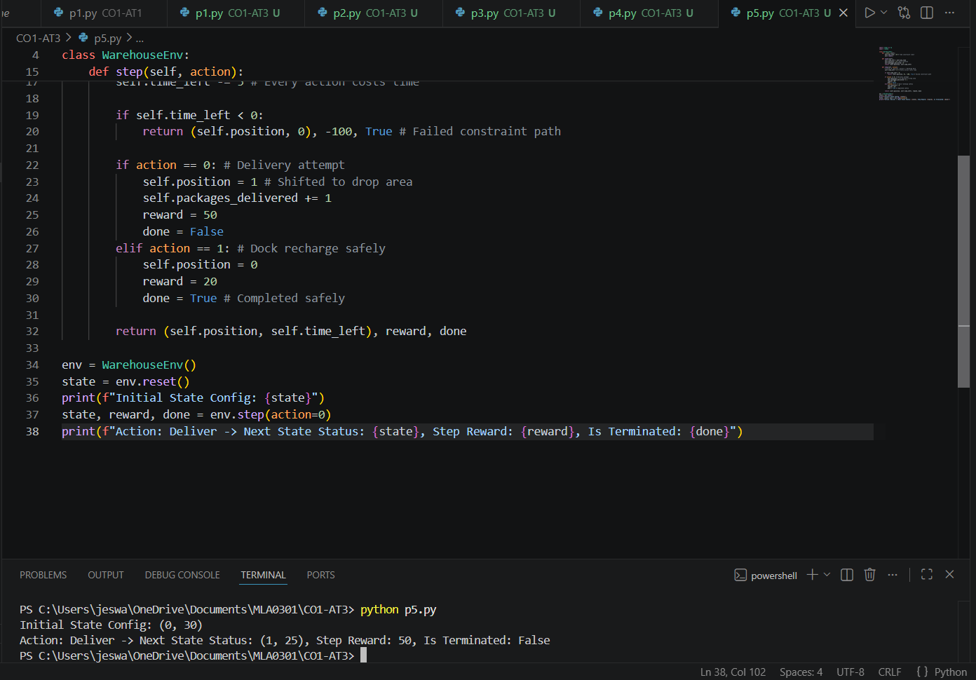
Result
The warehouse robot RL framework successfully tracks structural operation limits. The environmental verification program proves the model will penalize actions that cause operation time steps to exceed the 30-minute battery duration ceiling.
