MOBILE APPLICATIONS

Designed by

Anand kumar
Anil kumar
Srilatha
Sailaja

ABSTRACT

The aim of the project is to create a mobile application which will give security for mobile phones and call recognition.

Now a days many of us look towards mobile gadgets. In our lives mobile plays a key role. In the mobile market there are plenty of mobile models are there. There are different different operating systems are there like Android,Symbion etc.. But the users don't know exactly which applications are more useful or more effective for a particular OS. Mobile apps provide more interface to the user. With using mobile apps user can easily operate a particular OS. So mobile apps plays a key role in the mobile.

This application performs the security operation based on SIM numbers. When user changes SIM this app will ask password if he enter correct password normal function is going on.If he enter wrong password this app will ask again ,that time also he enter wrong normal function is going on but the text message will sent to 5 number those are registered during the registration.

And second part of this app is about the call recognition and spells the caller name if it is present in contacts . Otherwise it spells unknown is calling.

Software Requirement and Specifications

for

MOBILE APPLICATOINS

Prepared by
N09
Roll No:

from RGUKT IIIT

On 21-12-12

Table of contents:

1.Introduction......................................................................4
1.1 Purpose 4
1.2 Scope 4
1.3 Overview..............................................................................................4
1.4 References 4

2.Overall Description............................................................5
2.1 Product perspective...................................................................5
2.2 Product function........................................................................5

3.Requirements.................................................................5-6
3.1 Functional Requirements 5
3.2 Software Requirements 5
3.3 Non-functional Requirements 5
3.4 Hardware Requirements 6
4.Module Description...........................................................7
4.1 Administrative module................................................................7
4.2 User module...............................................................................7
5. Block diagram..................................................................8
6. UML diagrams..............................................................9-16
6.1.Use case diagram.......................................................................9
6.2.Activity diagram........................................................................10
6.3.Start chart diagram...................................................................11
6.4.Sequence diagram.....................................................................12
6.5.Data flow diagram.....................................................................13
6.6.Context level diagram................................................................14
6.7.Communication diagram............................................................15
6.8.Entity Relationship diagram.......................................................16

1.Introduction:
Mobile applications create a interface between user and mobile. This particular application provide more security to mobile device and also this app recognizes the caller without looking at the call.

1.1.Purpose:
Now a days many of us look towards mobile gadgets. In our lives mobile plays a key role. In the mobile market there are plenty of mobile models are there. There are different different operating systems are there like Android. But the users don't know exactly which applications are more useful or more effective for a particular OS. Mobile apps provide more interface to the user. With using mobile apps user can easily operate a particular OS. So mobile apps plays a key role in the mobile.

1.2.Scope:
This application provides security for mobile phones and call recognition for blind people.

1.3.Overview:
In this particular application we have mainly two things.
Mobile security,
call recognition.
When user install this application, this asks the user to store
the password, 5 mobile numbers and a text message which is sent to the
5 mobile numbers which are stored in the app database. When the user change
the SIM card immediately this application automatically read the SIM number
and compares with previous number which was stored in app database. If any
conflict arises it ask user to type password,if user fails to enter correct possword
it will send given text message to the given 5 numbers. So we can find the
mobile location with the help of service providers. Second one is call
recognition with out looking at the call. This feature will spells out the
incoming caller name if caller name present in the contact list .

1.4 References:

IEEE SRS Format,

Roseindia.net,

Java2s.com.

Definitions, Acronyms and Abbreviations:

J2ME: Java 2 Micro Edition.

SIM : Subscriber identity module
App: Application

Java ME is a programming platform— part of the Java
Platform-for developing and running distributed mobile based architecture Java
applications.

2.Overall description:

2.1.Product perspective:
This mobile application will provide more security to your mobile and recognize the call without looking at the call.

2.2.Product function:
suppose somewhere you forgot your mobile, you forgot where the mobile actually is. When you send a message to your mobile number which contain a keyword like 'where are you' then this will sense the mobile location and give you the information in the form of message. And this application spell the caller name if it contain otherwise spells as unknown.

3.Requirements:

3.1.Functional requirements:

- 5 mobile numbers for security purpose,
- User details for Identification,
- Text message.

3.2.Software requirement:
- Netbeans 7.2.1,
- java supported mobile phone.

3.3.Non functional requirements:
- 24x7 availability,
- It supports many users to use this application,
- Secure access of confidential data

3.3.Hardware requirement:
To Run Netbeans:
Processor : Intel core 2 dual, Pentium

Ram : 260 MB

Hard disk : 2 GB

.
4.Module Description:

The list of modules incorporated with the “Mobile Apps” are

1. Administrative module,

2. User module.

4.1.Administrative module:

This module is provided for the sake of the
administrators to maintain and update the features to the application.

1. Administrators rectify the problems in the present version if any and add the new features to the particular version and released into the market.

4.2.User module:

This module is particularly for users to protect their device from thefts. And it will more useful to blind people to recognize the caller.

5. BLOCK DIAGRAM:

Application
Mobile security
Call
recognizatoin
Incoming
call
Contact list

User

Installation
database
Updating
DB
sounds

We will we
give a ask
not present
Unknown
calling
Spell contact
name
password
5 numbers

present
working

switch on
Normal login
Sim number
checking

same change

Ask password
Right

Wrong
Right

Ask password
Txt msg to 5
numbers

wrong

5. UML DIAGRAMS:

Design is the only way that we can accurately translate a user’s requirements into a finished software product or system. Taking software requirements specification document of analysis phase as input to the design phase we have drawn Unified Modeling Language (UML) diagrams. UML depends on the visual modeling of the system. Visual modeling is the process of taking the information from the model and displaying graphically using some sort of standards set of graphical elements.

5.1.TYPES OF UML DIAGRAMS:

5.1.1.USE CASE DIAGRAM:
The purpose of use case diagram is to capture the dynamic aspect of a system. But this definition is too generic to describe the purpose.
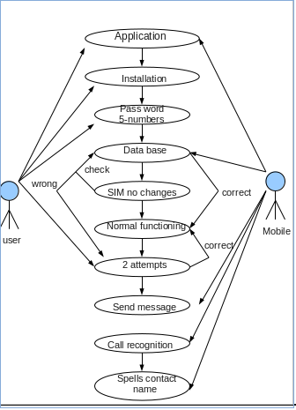
Use case diagrams are considered for high level requirement analysis of a system. So when the requirements of a system are analyzed the functionalities are captured in use cases.

5.1.2.ACTIVITY DIAGRAM:
Activity diagram is basically a flow chart to represent the flow form one activity to another activity. The activity can be described as an operation of the system.
Activity is a particular operation of the system. Activity diagrams are not only used for visualizing dynamic nature of a system but they are also used to construct the executable system by using forward and reverse engineering techniques.

5.1.3.1.Activity Diagram 5.1.3.2.activity Diagram
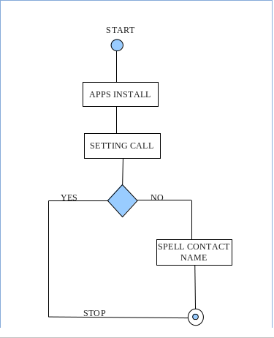
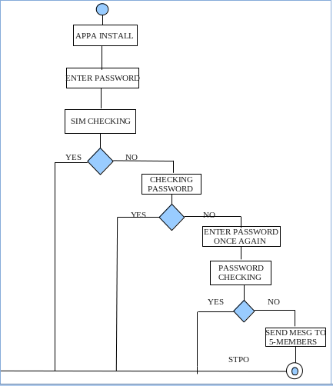

5.1.3.STATE CHART DIAGRAM:

A State chart diagram describes a state machine. Now to clarify it state machine can be defined as a machine which defines different states of an object and these states are controlled by external or internal events.

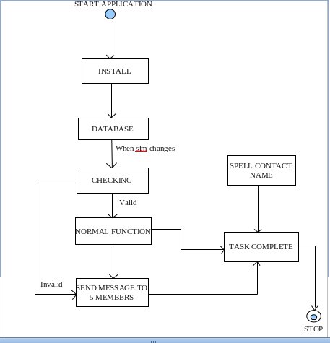

5.1.4.SEQUENTIAL DIAGRAM:

A sequence diagram shows, as parallel vertical lines (lifelines), different processes or objects that live simultaneously, and, as horizontal arrows, the messages exchanged between them, in the order in which they occur. This allows the specification of simple run time scenarios in a graphical manner.

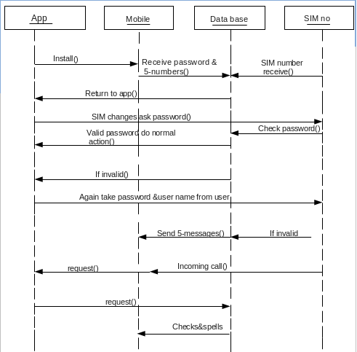

5.1.5.DATA FLOW DIAGRAM:

A data flow diagram (DFD) is a graphical representation of the "flow" of data through an information system, modeling its process aspects. Often they are a preliminary step used to create an overview of the system which can later be elaborated. DFDs can also be used for the visualization of data processing

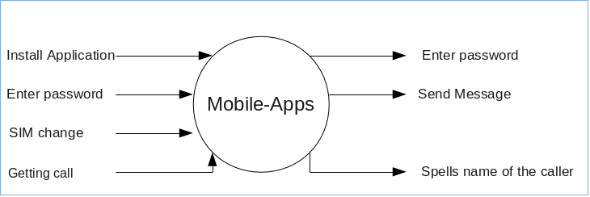
Data flow diagram(level-0):

Data flow diagram(level-1):

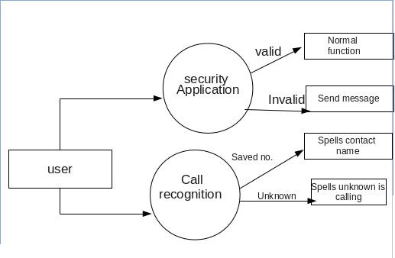

5.1.6.CONTEXT DIAGRAM:

Context diagrams are used early in a project to get agreement on the scope under investigation. Context diagrams are typically included in a requirements document. These diagrams must be read by all project stakeholders and thus should be written in plain language, so the stakeholders can understand items within the document.

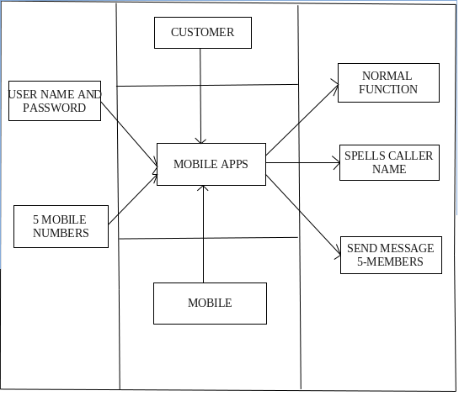

5.1.7.COMMUNICATION DIAGRAM:

A Communication diagram models the interactions between objects or parts in terms of sequenced messages. Communication diagrams show a lot of the same information as sequence diagrams, but because of how the information is presented, some of it is easier to find in one diagram than the other.

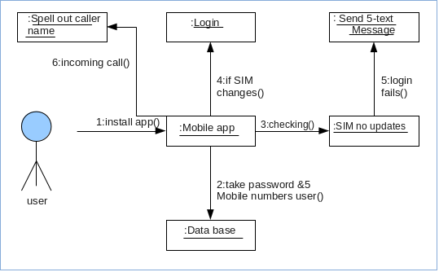

5.1.8.ER-DIAGRAM:

An ER model is an abstract way to describe a database. Describing a database usually starts with a relational database, which stores data in tables. Some of the data in these tables point to data in other tables - for instance, your entry in the database could point to several entries for each of the phone numbers that are yours.
Diagrams created to design these entities and relationships are called entity–relationship diagrams or ER diagrams.

