Submission 3: Second Progress Report

EEE3097S: ECE Design

ABRKAR004 KGKOMO001

Karan Abraham Omolemo Kegakilwe

# Admin Documents

## Contribution Table

|  |  |
| --- | --- |
| Karan | Omolemo |
|  |  |

## Project Management Tool

@Omo

## Link to GitHub page

<https://github.com/karanimaan/Compress_Encrypt_Program.git>

## Timeline and if your progress is on time

@Omo

# IMU Module

## Different features to required IMU

|  |  |
| --- | --- |
| ICM-20948 (Our sensor) | ICM-20649 (Required sensor) |
| * **512 B** FIFO buffer * Has **compass** * **Lowest Power** 9-Axis Device at 2.5 mW * Has gyroscope with programmable FSR of ±**4000** dps * Has accelerometer with programmable FSR of ±**30** g | * **4 kB** FIFO buffer |

## Extrapolation between two IMUs

* As both IMUs have gyroscopes with programmable Full-Scale Ranges (FSR), same range will be used for both. Make sure not to use FSR of ±4000 dps
* As both IMUs have accelerometers with programmable Full-Scale Ranges, same range will be used for both.
* Gyroscope + accelerometer mode on ICM20948 to be used as ICM2069 is only a 6-axis module.
* FIFO register will be used to send the data we need as both IMUs have this functionality. ICM2069 has larger FIFO so this doesn’t limit our extrapolation.

These steps will ensure that whatever testing is done on the ICM20948 is within the scope of the ICM20969 (to be used on actual buoy) functionalities.

List the steps you plan to take to make sure that your testing with this IMU can be extrapolated easily to the IMU to be used in the actual buoy.

* + List a set of validation tests to make sure that the IMU is working and is working as expected.
    - For example, check the switch on sequence.
    - Take some data from it and try to show that this is what you expect. For example,  you can create a shaking motion and see what kind of data it creates. Also, you can bring a strong magnet near to it and note its behaviours.

## Validation tests

* Check if moving the sensor changes the acceleration values at all.
* Check if rotating the sensor changes the gyroscope values at all.
* Move IMU module in one direction to see if correct ACCEL axis value responds to movement.
* Rotate IMU module along one specific axis and see if correct GYRO axis value responds to rotation.
  + Try to be innovative in thinking of test cases to validate the IMU.

# Experiment Setup

## Overall

* + - * The IMU sensor module will be I2C interfaced with STM to send the sensor data to it. FIFO will have data sent in bursts as opposed to a continuous stream to save power consumption.
      * Sampling rate will determine frequency of bursts which can be adjusted to control how much data is sent from sensor for processing.
      * To assess if IMU module has been correctly interfaced with STM, the unprocessed sensor data will be viewed using the STMCubeIDE debugger.
      * Sensor data being sent to PC via UART will be viewed using Putty and integrity checked by comparing to how it was before being sent.
      * Compression and encryption functions will be used to process the data, experimentation of each block is described below.

## Compression

## Encryption

* Synchronous key will be used for encryption and decryption. A developer/user generated key will be used in STM and built into it when compiling for encryption.
* Same key will be used in decryption program on PC to decrypt data once it has been transmitted.
* Sensor data will be passed into encryption function on STM to be encrypted. Encrypted data will be viewed using the STMCubeIDE debugger to see if it has been encrypted.
* Data will be sent over to the PC via UART and saved into a text file.
* Data will be decrypted using decryption program on PC which takes a file (independent of filetype, txt in this case) as input and outputs a file of the decrypted data.
* Process is repeated with compressed data being passed into encryption function on STM as opposed to sensor data.
  + In this section, you should describe the experiments/simulations you would run. There does not have to be simulations??. It should have three subsections:
    - The first one discussing the simulations/experiments to check the overall functionality of the system. Note that now, your system is IMU+STM.
    - The next two subsections should discuss the experiments for individual blocks (compression and encryption). One of these should clearly be owned by one of the team members.

## Data each block is expected to get in and give out

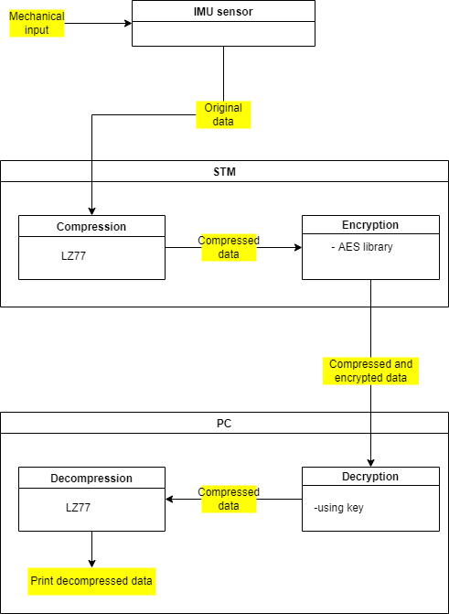

# Results

* + In this section, you should describe the results of the experiments you have run. It should have three subsections.
    - The first one discussing the results of the experiments to check the overall functionality of the system.
    - The next two subsections should discuss the results from the individual blocs (compression and encryption). One of these should clearly be owned by one of the team members.
  + Try to check the change in the performance when you change the data (e.g. making it faster or under-sampling it or adding different levels of white-Gaussian noise)

# ATPs

* + Recreate the ATPs from your previous document
  + In a table mention each ATP and mention if this has been met in your design
    - If an ATP has not been met then comment why and either change the design or change the specifications
  + If you change the specifications (due to unmet ATPs) then tabulate the specifications again showing the previous version and the new version