Software Requirements Specification

for

Q-Taskers

**Version 1.0**

**Prepared by Karan Inder Singh**

**Q-Taskers**

**30/08/2018**

**Table of Contents**

**Table of Contents ii**

**Revision History ii**

**1. Introduction 1**

1.1 Purpose 1

1.2 Document Conventions 1

1.3 Intended Audience and Reading Suggestions 1

1.4 Product Scope 1

1.5 References 1

**2. Overall Description 2**

2.1 Product Perspective 2

2.2 Product Functions 2

2.3 User Classes and Characteristics 2

2.4 Operating Environment 2

2.5 Design and Implementation Constraints 2

2.6 User Documentation 2

2.7 Assumptions and Dependencies 3

**3. External Interface Requirements 3**

3.1 User Interfaces 3

3.2 Hardware Interfaces 3

3.3 Software Interfaces 3

3.4 Communications Interfaces 3

**4. System Features 4**

4.1 System Feature 1 4

4.2 System Feature 2 (and so on) 4

**5. Other Nonfunctional Requirements 4**

5.1 Performance Requirements 4

5.2 Safety Requirements 5

5.3 Security Requirements 5

5.4 Software Quality Attributes 5

5.5 Business Rules 5

**6. Other Requirements 5**

**Appendix A: Glossary 5**

**Appendix B: Analysis Models 5**

**Appendix C: To Be Determined List 6**

**Revision History**

|  |  |  |  |
| --- | --- | --- | --- |
| **Name** | **Date** | **Reason For Changes** | **Version** |
| Revision 1.0 | 30/8/18 | None | 1.0 |
|  |  |  |  |

# Introduction

## Purpose

The purpose of the document is to represent an online system for offering services like Electronics and Electrical servicing, Tutors, Photography, Planning, etc. (logistics for households) on a single platform and hence removing the middlemen who are involved.

## Document Conventions

1. *Default sentences/ Body of Document (Arial 11 Italic).*
2. *Underlined words are important keywords/ crux (Arial 11 Italic Underline).*
3. *Bold words are headings and subheadings (Times 14 Bold).*

## Intended Audience and Reading Suggestions

This project is a prototype of an online service-offering platform which targets every section of the society who are willing to enjoy a single platform for any paid-service they are supposed to get. This is also intended for the shops and individuals providing the services.

## Product Scope

The purpose of this all-inclusive platform is to offer a plethora of ultra-fast services. The customers don’t have to contact and search for each of them at different places and still wait to get them. This also would help the shops to get a regular customer base regardless of weather, time of the year and therefore biased-brokerage is eliminated.

## References

1. <http://qtaskers.herokuapp.com/>
2. <https://web.cs.dal.ca/~hawkey/3130/srs_template-ieee.doc>
3. <http://searchsoftwarequality.techtarget.com/answer/Software-requirements-specification-and-the-IEEE-standard>

# Overall Description

## Product Perspective

This is an online platform offering services and is an improvement over previously present sites like UrbanClap and TaskRabbit with a different business model altogether and also a different market penetration level and target.

## Product Functions

The product functions have been explained using the following ER diagram

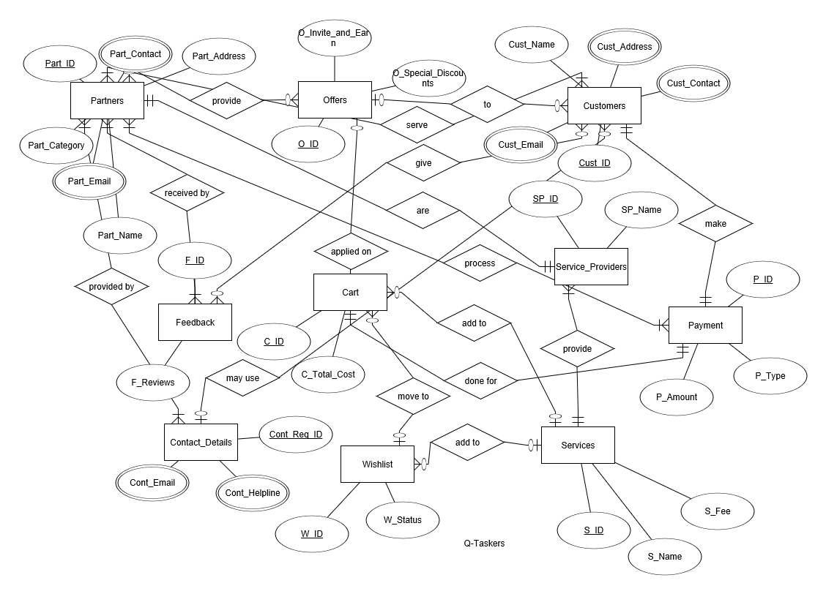

## User Classes and Characteristics

1. Business Partners: Information about those shops who register with the app.
2. Service Providers: Details about the people who are to actually offer the services at the doorstep.
3. Customers: The individuals who are to register with us and enjoy the doorstep services offered.
4. Guests: The individuals who are not registered but still want to enjoy the doorstep services offered.

Registration is done using name, mobile no. , address, email (optional).

Login will be done on a standard login portal which uses email/phone no. and password for authentication. Login portal will have a sign up as Guest option for Guest users.

The app acts as a bridge between all these people to have a win-win situation for everyone.

## Operating Environment

Operating environment for the services-offering system is as listed below.

1. OS: Windows 7 sp1 and later(amd64), Android(4.0 and later versions) (arm64)
2. Database(Distributed Database): SQLite/MongoDB/NoSQL
3. Platforms: Java-JavaFX/PHP/HTML

## Design and Implementation Constraints

1. *The global schema and the allocation schema*
2. *SQL commands for the queries*
3. *A category-based interface to access the services*
4. *Verification of the customers using OTP-authentication and services can be offered or enjoyed by verified personnel only.*

## User Documentation

User manual for Q-Taskers windows app

Help and video tutorials in the android app

SRS IEEE document for Q-taskers

## Assumptions and Dependencies

The closest verified service provider will be allocated to the user using Google Maps API and it is assumed that once a user requests a second service, the same provider will be allocated to him to increase the loyalty benefits for him.

# External Interface Requirements

## User & Software Interfaces

*Simple UI/UX using Studio by UXPin*

*Multilingual*

*Buttons- Settings, Help, About*

*Help will be interactive which will be based on text messages which will be displayed along with a tutorial.*

*Additional tutorials for usage and settings change will be added on the website and within the app as well.*

*App will have a link to the product documentation in the ‘About’ section.*

*The About section will include additional details like built using, version, build no., which will be helpful to the developers.*

## Hardware Interfaces

*Since neither the mobile application nor the web portal have any designated hardware, it does not have any direct hardware interfaces. The physical GPS is managed by the GPS application in the mobile phone and the hardware connection to the database server is managed by the underlying operating system on the mobile phone and the web server.*

## Communications Interfaces

## *The mobile application communicates with the GPS application in order to get geographical information about where the user is located and the visual representation of it, and with the database in order to get the information about the service providers. The communication between the database and the web portal consists of operation concerning both reading and modifying the data, while the communication between the database and the mobile application consists of only reading operations. Email of customer may be used to get review/satisfaction of service most recently used. SHA hashing mechanism will be used for password hashing. 1 Mb/s is the minimum data rate for efficient usage & functioning of the app. HTTP/HTTPS will be used between client and server.*

# System Features/ Functional Requirements

## System Feature 1

## 3.2 Functional requirements

This section includes the requirements that specify all the fundamental actions of the software system.

# 4. Prioritization and Release Plan

In order to get a view of how to divide the requirements into different releases and what requirements should be included in which release, a prioritization of the requirements is needed. This section discusses the choice of prioritization methods and gives a suggestion of how the release plan for these requirements could look like.

4.1.1 Description and Priority

*Use of maps (Google Maps) for location based suggestions and implementation of the app.*

*Integration of Rating based services and suggestions for implementation of app.*

4.1.2 Stimulus/Response Sequences

*Not Applicable*

4.1.3 Functional Requirements

*TBD*

## System Feature 2 (and so on)

# Other Nonfunctional Requirements

## Performance Requirements

*arm64 and amd64 based systems with a 100kBps internet (minimum 2G)*

*1 GB RAM for arm64*

*2 Gb RAM for amd64*

## Safety Requirements

*Deleting of the data folder and/ or AppData of the app may result in loss of user data.*

## Security Requirements

*No other personnel to authorised to tamper with the source code and database of the app.*

## Software Quality Attributes

## Business Rules

*Only verified and qualified technicians would be hired to incorporate with us.*

# Other Requirements

TBD

**Appendix A: Glossary**

*TBD*

**Appendix B: Analysis Models**

*TBD*

**Appendix C: To Be Determined List**

*TBD*