ADR 2/01 Side-Door Latch and Hinge Similarity Supplement
2017 Dodge Challenger variants versus 2017 Dodge Charger variants
2026-07-31
FUNCTIONAL-ARCHITECTURE PASS under broad variant/trim criterion; exact core latch/hinge part-number equivalence not established

Executive determination
- **PASS — functional similarity:** all 12 screened Challenger/Charger variant-pair combinations contain corresponding left/right front-door latch architecture; lower left/right hinge pairs were also identified by OEM part listings.
- **VERIFIED:** 613 front-door catalog rows, 52 direct latch/attaching-hardware rows, 21 exploded-diagram records and zero scraper errors.
- **VERIFIED:** 26 exact shared exterior-handle part numbers support common door-control architecture.
- **LIMIT:** no exact common OEM service part number was established for the core Challenger-versus-Charger latch or lower-hinge assemblies. The coupes and sedans use different core service numbers.
- **ADR LIMIT:** this supports an ADR 2/01 component-architecture similarity argument only. It does not prove latch/hinge strength, longitudinal/transverse load performance, installed configuration, or ADR compliance.

Comparison rule used
At the user’s direction, variants and trims may be mixed. A pair passes if a Challenger variant and a Charger variant expose corresponding component classes and functions, even where the OEM service part numbers differ. Exact matches are reported separately and are not fabricated.

Functional latch and hinge crosswalk
Component | Challenger PN | Charger PN | Match basis | Result
Front door latch — right | 68174640AH | 04589916AH | same OEM component class, side and function; different service part number | FUNCTIONAL-SIMILARITY PASS
Front door latch — left | 68174641AH | 04589913AI | same OEM component class, side and function; different service part number | FUNCTIONAL-SIMILARITY PASS
Front lower door hinge — right | 68026642AC | 68148514AB | same OEM component class, side and lower-hinge function; different service part number | FUNCTIONAL-SIMILARITY PASS
Front lower door hinge — left | 68026643AC | 68148515AB | same OEM component class, side and lower-hinge function; different service part number | FUNCTIONAL-SIMILARITY PASS

Variant-pair results
Challenger | Charger | Exact core | Functional match | Status
SXT 3.6L | R/T 5.7L | 0 | front door latch left; front door latch right; lower door hinge left; lower door hinge right | FUNCTIONAL-ARCHITECTURE PASS — core service part numbers differ
SXT 3.6L | R/T Scat Pack 6.4L | 0 | front door latch left; front door latch right; lower door hinge left; lower door hinge right | FUNCTIONAL-ARCHITECTURE PASS — core service part numbers differ
SXT 3.6L | SRT 392 6.4L | 0 | front door latch left; front door latch right; lower door hinge left; lower door hinge right | FUNCTIONAL-ARCHITECTURE PASS — core service part numbers differ
R/T 5.7L | R/T 5.7L | 0 | front door latch left; front door latch right; lower door hinge left; lower door hinge right | FUNCTIONAL-ARCHITECTURE PASS — core service part numbers differ
R/T 5.7L | R/T Scat Pack 6.4L | 0 | front door latch left; front door latch right; lower door hinge left; lower door hinge right | FUNCTIONAL-ARCHITECTURE PASS — core service part numbers differ
R/T 5.7L | SRT 392 6.4L | 0 | front door latch left; front door latch right; lower door hinge left; lower door hinge right | FUNCTIONAL-ARCHITECTURE PASS — core service part numbers differ
R/T Scat Pack 6.4L | R/T 5.7L | 0 | front door latch left; front door latch right; lower door hinge left; lower door hinge right | FUNCTIONAL-ARCHITECTURE PASS — core service part numbers differ
R/T Scat Pack 6.4L | R/T Scat Pack 6.4L | 0 | front door latch left; front door latch right; lower door hinge left; lower door hinge right | FUNCTIONAL-ARCHITECTURE PASS — core service part numbers differ
R/T Scat Pack 6.4L | SRT 392 6.4L | 0 | front door latch left; front door latch right; lower door hinge left; lower door hinge right | FUNCTIONAL-ARCHITECTURE PASS — core service part numbers differ
SRT 392 6.4L | R/T 5.7L | 0 | front door latch left; front door latch right; lower door hinge left; lower door hinge right | FUNCTIONAL-ARCHITECTURE PASS — core service part numbers differ
SRT 392 6.4L | R/T Scat Pack 6.4L | 0 | front door latch left; front door latch right; lower door hinge left; lower door hinge right | FUNCTIONAL-ARCHITECTURE PASS — core service part numbers differ
SRT 392 6.4L | SRT 392 6.4L | 0 | front door latch left; front door latch right; lower door hinge left; lower door hinge right | FUNCTIONAL-ARCHITECTURE PASS — core service part numbers differ

Exact shared related front-door parts
Exterior-handle/door-control parts; not latch/hinge retention components.
Part no. | Description | Challenger variants | Charger variants
1MZ84DX8AM | 2013-2021 Mopar Front Door Exterior Handle Right | Right | R/T 5.7L | R/T Scat Pack 6.4L | SRT 392 6.4L | SXT 3.6L | R/T 5.7L | R/T Scat Pack 6.4L | SRT 392 6.4L
1MZ84GW7AM | 2020 2021 Dodge Challenger - Front Door Exterior Handle Right | R/T 5.7L | R/T Scat Pack 6.4L | SRT 392 6.4L | SXT 3.6L | R/T 5.7L | R/T Scat Pack 6.4L | SRT 392 6.4L
1MZ84JRYAJ | Front Door Exterior Handle, Right | Right | R/T 5.7L | R/T Scat Pack 6.4L | SRT 392 6.4L | SXT 3.6L | R/T 5.7L | R/T Scat Pack 6.4L | SRT 392 6.4L
1MZ84JSCAJ | Front Door Exterior Handle, Right | Right | R/T 5.7L | R/T Scat Pack 6.4L | SRT 392 6.4L | SXT 3.6L | R/T 5.7L | R/T Scat Pack 6.4L | SRT 392 6.4L
1MZ84KARAM | 2011-2021 Mopar Front Door Exterior Handle Right | Right | R/T 5.7L | R/T Scat Pack 6.4L | SRT 392 6.4L | SXT 3.6L | R/T 5.7L | R/T Scat Pack 6.4L | SRT 392 6.4L
1MZ84KBXAM | Front Door Exterior Handle, Right | Right | R/T 5.7L | R/T Scat Pack 6.4L | SRT 392 6.4L | SXT 3.6L | R/T 5.7L | R/T Scat Pack 6.4L | SRT 392 6.4L
1MZ84LAUAM | 2013-2021 Mopar Front Door Exterior Handle Right | Right | R/T 5.7L | R/T Scat Pack 6.4L | SRT 392 6.4L | SXT 3.6L | R/T 5.7L | R/T Scat Pack 6.4L | SRT 392 6.4L
1MZ84MGMAM | Front Door Exterior Handle, Right | Right | R/T 5.7L | R/T Scat Pack 6.4L | SRT 392 6.4L | SXT 3.6L | R/T 5.7L | R/T Scat Pack 6.4L | SRT 392 6.4L
1MZ84NRVAM | 2014-2021 Mopar Front Door Exterior Handle Right | R/T 5.7L | R/T Scat Pack 6.4L | SRT 392 6.4L | SXT 3.6L | R/T 5.7L | R/T Scat Pack 6.4L | SRT 392 6.4L
1MZ84NVPAM | 2020 2021 Dodge Challenger - Front Door Exterior Handle Right | Right | R/T 5.7L | R/T Scat Pack 6.4L | SRT 392 6.4L | SXT 3.6L | R/T 5.7L | R/T Scat Pack 6.4L | SRT 392 6.4L
1MZ84PDNAM | 2014-2021 Mopar Front Door Exterior Handle Right | R/T 5.7L | R/T Scat Pack 6.4L | SRT 392 6.4L | SXT 3.6L | R/T 5.7L | R/T Scat Pack 6.4L | SRT 392 6.4L
1MZ84RY4AM | Front Door Exterior Handle, Right | Right | R/T 5.7L | R/T Scat Pack 6.4L | SRT 392 6.4L | SXT 3.6L | R/T 5.7L | R/T Scat Pack 6.4L | SRT 392 6.4L
1MZ84ZR3AM | 2013-2021 Mopar Front Door Exterior Handle Right | R/T 5.7L | R/T Scat Pack 6.4L | SRT 392 6.4L | SXT 3.6L | R/T 5.7L | R/T Scat Pack 6.4L | SRT 392 6.4L
1MZ85DX8AM | 2013-2021 Mopar Front Door Exterior Handle Left | Left | R/T 5.7L | R/T Scat Pack 6.4L | SRT 392 6.4L | SXT 3.6L | R/T 5.7L | R/T Scat Pack 6.4L | SRT 392 6.4L
1MZ85GW7AM | 2020 2021 Dodge Challenger - Front Door Exterior Handle Left | Left | R/T 5.7L | R/T Scat Pack 6.4L | SRT 392 6.4L | SXT 3.6L | R/T 5.7L | R/T Scat Pack 6.4L | SRT 392 6.4L
1MZ85JRYAM | Front Door Exterior Handle, Left | Left | R/T 5.7L | R/T Scat Pack 6.4L | SRT 392 6.4L | SXT 3.6L | R/T 5.7L | R/T Scat Pack 6.4L | SRT 392 6.4L
1MZ85JSCAM | 2011-2021 Mopar Front Door Exterior Handle Left | Left | R/T 5.7L | R/T Scat Pack 6.4L | SRT 392 6.4L | SXT 3.6L | R/T 5.7L | R/T Scat Pack 6.4L | SRT 392 6.4L
1MZ85KARAM | 2011-2021 Mopar Front Door Exterior Handle Left | Left | R/T 5.7L | R/T Scat Pack 6.4L | SRT 392 6.4L | SXT 3.6L | R/T 5.7L | R/T Scat Pack 6.4L | SRT 392 6.4L
1MZ85KBXAM | 2013-2018 Mopar Front Door Exterior Handle Left | R/T 5.7L | R/T Scat Pack 6.4L | SRT 392 6.4L | SXT 3.6L | R/T 5.7L | R/T Scat Pack 6.4L | SRT 392 6.4L
1MZ85LAUAM | 2013-2021 Mopar Front Door Exterior Handle Left | Left | R/T 5.7L | R/T Scat Pack 6.4L | SRT 392 6.4L | SXT 3.6L | R/T 5.7L | R/T Scat Pack 6.4L | SRT 392 6.4L
1MZ85MGMAJ | Front Door Exterior Handle, Left | Left | R/T 5.7L | R/T Scat Pack 6.4L | SRT 392 6.4L | SXT 3.6L | R/T 5.7L | R/T Scat Pack 6.4L | SRT 392 6.4L
1MZ85NRVAM | 2020 2021 Dodge Challenger - Front Door Exterior Handle Left | Left | R/T 5.7L | R/T Scat Pack 6.4L | SRT 392 6.4L | SXT 3.6L | R/T 5.7L | R/T Scat Pack 6.4L | SRT 392 6.4L
1MZ85NVPAM | 2015-2021 Mopar Front Door Exterior Handle Left | Left | R/T 5.7L | R/T Scat Pack 6.4L | SRT 392 6.4L | SXT 3.6L | R/T 5.7L | R/T Scat Pack 6.4L | SRT 392 6.4L
1MZ85PDNAM | 2014-2021 Mopar Front Door Exterior Handle Left | Left | R/T 5.7L | R/T Scat Pack 6.4L | SRT 392 6.4L | SXT 3.6L | R/T 5.7L | R/T Scat Pack 6.4L | SRT 392 6.4L
1MZ85RY4AM | Front Door Exterior Handle, Left | Left | R/T 5.7L | R/T Scat Pack 6.4L | SRT 392 6.4L | SXT 3.6L | R/T 5.7L | R/T Scat Pack 6.4L | SRT 392 6.4L
1MZ85ZR3AM | 2013-2021 Mopar Front Door Exterior Handle Left | Left | R/T 5.7L | R/T Scat Pack 6.4L | SRT 392 6.4L | SXT 3.6L | R/T 5.7L | R/T Scat Pack 6.4L | SRT 392 6.4L

Representative MoparAmerica diagrams

Challenger R/T Scat Pack 6.4L — diagram 1: Door Handle Bracket, Right
https://www.moparamerica.com/v-2017-dodge-challenger--r-t-scat-pack--6-4l-v8-gas/doors-door-mirrors-and-related-parts--front-door?assembly=1
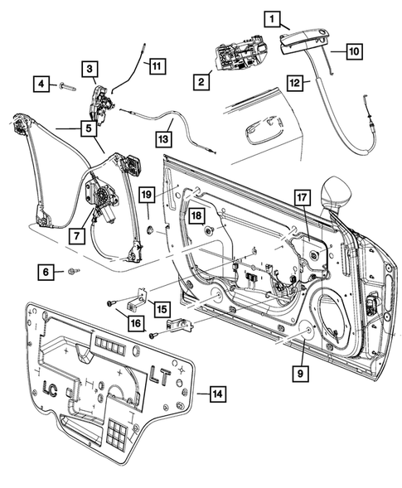

Challenger R/T Scat Pack 6.4L — diagram 2: Tapping Plate
https://www.moparamerica.com/v-2017-dodge-challenger--r-t-scat-pack--6-4l-v8-gas/doors-door-mirrors-and-related-parts--front-door?assembly=2
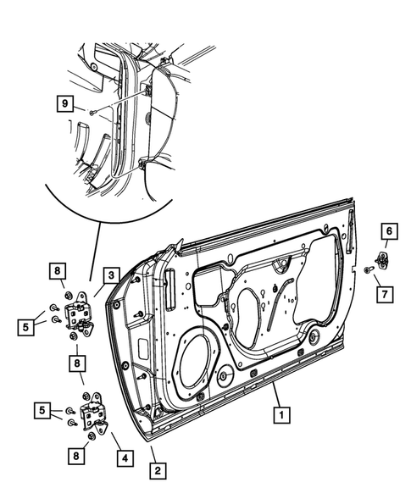

Challenger R/T Scat Pack 6.4L — diagram 3: Door Lock Cylinder
https://www.moparamerica.com/v-2017-dodge-challenger--r-t-scat-pack--6-4l-v8-gas/doors-door-mirrors-and-related-parts--front-door?assembly=3
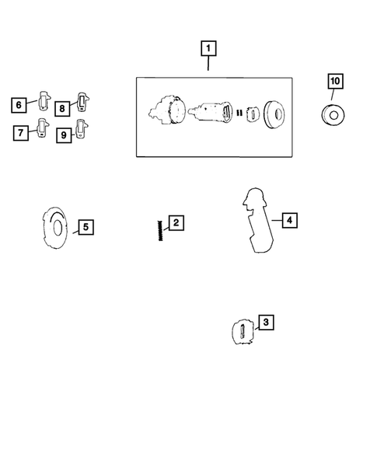

Charger R/T Scat Pack 6.4L — diagram 1: Round Black Tape
https://www.moparamerica.com/v-2017-dodge-charger--r-t-scat-pack--6-4l-v8-gas/doors-door-mirrors-and-related-parts--front-door?assembly=1
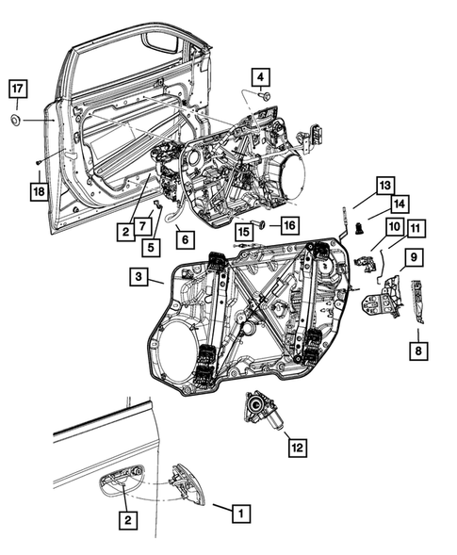

Charger R/T Scat Pack 6.4L — diagram 2: Door Latch Striker Spacer
https://www.moparamerica.com/v-2017-dodge-charger--r-t-scat-pack--6-4l-v8-gas/doors-door-mirrors-and-related-parts--front-door?assembly=2
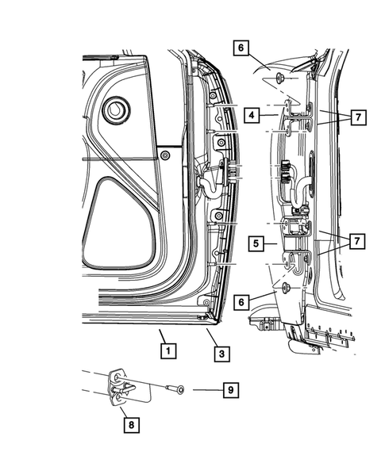

Charger R/T Scat Pack 6.4L — diagram 3: Door Lock Cylinder
https://www.moparamerica.com/v-2017-dodge-charger--r-t-scat-pack--6-4l-v8-gas/doors-door-mirrors-and-related-parts--front-door?assembly=3
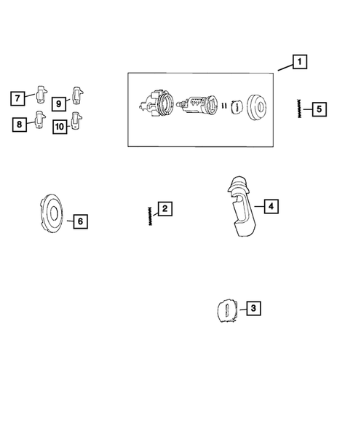

Controlled conclusion
**Broad-criterion result: PASS.** Challenger and Charger variants demonstrate corresponding front-door latch and lower-hinge architecture, and 26 exact common exterior-handle service numbers support shared door-control design. The core latch and lower-hinge service numbers differ, so the evidence must be described as functional/component-class similarity—not exact latch/hinge identity and not ADR 2/01 compliance.

Evidence needed for a compliance-grade conclusion
- VIN-specific build records and fitted part labels.
- OEM engineering drawings/specifications for latch, striker, hinge and attachments.
- ADR 2/01 or accepted-alternative test evidence with variant coverage.
- Clause-level assessment of longitudinal/transverse latch loads and hinge requirements.

