2017 Dodge Charger / Chrysler 300 — ADR-Critical Interior Hardware Catalog Commonality
VINs 2C3CDXGJ2HH530684 and 2C3CCAEG4HH586472
2026-07-31
CONDITIONAL — strong catalog-level commonality; installed configuration and ADR compliance are not proven

Executive determination
- **VERIFIED:** 45 MoparAmerica exploded-diagram records were collected with local images and source URLs.
- **VERIFIED:** 1435 raw catalog-part rows were parsed and reduced to 606 deduplicated VIN/category candidates.
- **VERIFIED:** 86 candidate part numbers occur in both vehicle catalog routes; 63 are selected as ADR-critical by component keyword/scope.
- **VERIFIED:** The supplied 2023 LD STARPARTS sample contains 15 callout items and 19 unique part numbers. 14 of the 19 occur in both selected 2017 catalog routes; 2 occur only in the Charger route; 3 occur in neither 2017 route.
- **CONDITIONAL:** This is meaningful catalog commonality evidence, especially for seat tracks/adjusters, seat frames/brackets/fasteners, belt hardware, airbag-related hardware and steering components.
- **GAP:** Catalog presence does not establish which option-dependent part is actually installed on either VIN. The Chrysler VIN did not resolve in MoparAmerica and was routed by decoded model/trim.
- **GAP:** The forwarding email text says “this is a challenger” while the STARPARTS title identifies platform LD; this provenance inconsistency prevents vehicle-specific reliance.
- **GAP:** Parts-catalog commonality cannot by itself prove ADR performance, crashworthiness, calibration or legal compliance.

Vehicle identity and catalog routing
VIN | Vehicle | Catalog status
2C3CDXGJ2HH530684 | 2017 Dodge Charger R/T 392 / R/T Scat Pack 6.4L V8 Gas | VIN search accepted
2C3CCAEG4HH586472 | 2017 Chrysler 300C 3.6L V6 RWD / C 3.6L V6 Flex | VIN search failed; route inferred

Supplied STARPARTS sample
2023 LD passenger power-seat adjuster/recliner/shield/riser extract. Later-model contextual evidence only; not VIN-specific 2017 proof.
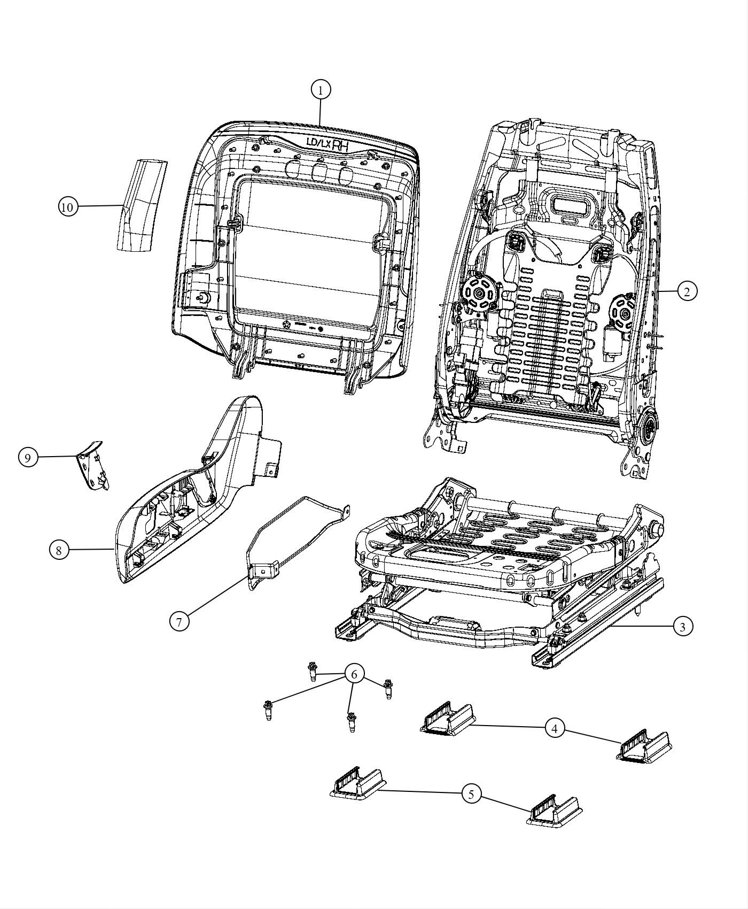
Callout | Description | Part numbers
1 | PANEL, Front Seat Back | 1UY02DX9AC
2 | FRAME, Front Seat Back | 68159139AA | 68593541AA | 68593544AA
3 | ADJUSTER, Power Seat | 68193460AC | 68193462AC
4 | COVER, Track, Rear | 1UV50DX9AA
5 | COVER, Track, Front | 1UV51DX9AA
6 | SCREW, Hex Head, M14x1.5x109.0, Adjuster To Floor | 06507594AA
7 | BRACKET, Seat, Side Shield Attaching | 68157098AA
8 | SHIELD, Seat Adjuster | 1UZ62DX9AC
9 | COVER, Front Seat Anchor Bolt | 1UV75DX9AA | 1UV75DX9AB
10 | CHUTE, Airbag | 68102980AA | 68103691AA
-11 | BLOWER, Seat Back | 55057389AD
-12 | BLOWER, Seat Cushion | 68306763AA
-13 | BRACKET, Module, Heated Seat Module, (NOT SERVICED) | [not serviced]
-14 | BOLT, Seat, Seat Back to Cushion | 68104960AA
-15 | NUT, M6x1.00, Air Bag Attaching | 68104961AA

2023 sample cross-check against 2017 catalog routes
2023 part | Description | Charger | Chrysler 300
1UY02DX9AC | PANEL, Front Seat Back | YES | YES
68159139AA | FRAME, Front Seat Back | YES | YES
68593541AA | FRAME, Front Seat Back | NO | NO
68593544AA | FRAME, Front Seat Back | NO | NO
68193460AC | ADJUSTER, Power Seat | YES | YES
68193462AC | ADJUSTER, Power Seat | YES | YES
1UV50DX9AA | COVER, Track, Rear | YES | YES
1UV51DX9AA | COVER, Track, Front | YES | YES
06507594AA | SCREW, Hex Head, M14x1.5x109.0, Adjuster To Floor | YES | YES
68157098AA | BRACKET, Seat, Side Shield Attaching | YES | YES
1UZ62DX9AC | SHIELD, Seat Adjuster | YES | YES
1UV75DX9AA | COVER, Front Seat Anchor Bolt | NO | NO
1UV75DX9AB | COVER, Front Seat Anchor Bolt | YES | YES
68102980AA | CHUTE, Airbag | YES | YES
68103691AA | CHUTE, Airbag | YES | YES
55057389AD | BLOWER, Seat Back | YES | YES
68306763AA | BLOWER, Seat Cushion | YES | YES
68104960AA | BOLT, Seat, Seat Back to Cushion | YES | NO
68104961AA | NUT, M6x1.00, Air Bag Attaching | YES | NO

Category overlap
Category | Charger | Chrysler 300 | Common | Jaccard
air-bags | 12 | 27 | 9 | 0.3
front-seat-adjusters | 36 | 37 | 28 | 0.6222
front-seats-first-row | 0 | 86 | 0 | 0.0
instrument-panel | 54 | 71 | 14 | 0.1261
rear-seat-adjusters | 21 | 0 | 0 | 0.0
rear-seats-second-row | 85 | 88 | 15 | 0.0949
seat-belts | 17 | 21 | 10 | 0.3571
steering-column | 10 | 12 | 7 | 0.4667
steering-wheel | 13 | 16 | 3 | 0.1154

ADR scope matrix
Exact legal applicability remains conditional on first-manufacture/new-model date and approval pathway. Catalog evidence is commonality evidence only.
ADR | Title | Tier | Critical hardware | Applicability status
2/01 | Side Door Latches and Hinges | ancillary interior/body closure | Door latches, hinges and retention hardware | LIKELY; confirm approval-pathway applicability.
3/03 | Seats and Seat Anchorages | core | Seat frames, tracks/adjusters, recliners, attachment bolts, anchor points | LIKELY BUILD-APPLICABLE; exact model/first-manufacture basis TBC.
4/05 | Seatbelts | core | Retractors, buckles, pretensioners, webbing assemblies | LIKELY BUILD-APPLICABLE.
5/05 | Anchorages for Seatbelts | core | Belt anchorage bolts, brackets, anchor points and related seat/floor interfaces | LIKELY BUILD-APPLICABLE.
8/01 | Safety Glazing Material | ancillary interior | Windscreen/side/rear glazing and markings | LIKELY; outside present hardware comparison.
10/02 | Steering Column | conditional core | Steering column, intermediate shaft, wheel and driver airbag interface | CONDITIONAL: ADR 10/02 clause 6.2 exemption may apply if ADR 69 compliance using a steering-column airbag is established.
11/00 | Internal Sun Visors | ancillary interior | Sun visors and attachments | LIKELY; outside present core packet.
14/02 | Rear Vision Mirrors | ancillary interior | Interior mirror and mounts; exterior mirror system | LIKELY; outside present core packet.
18/03 | Instrumentation | ancillary interior | Instrument cluster, tell-tales and controls | LIKELY BUILD-APPLICABLE.
21/00 | Instrument Panel | core interior | Instrument panel, interior impact surfaces, seat-back zones and power closure controls | LIKELY BUILD-APPLICABLE.
22/00 | Head Restraints | core | Front and rear head restraints, guides, seat-back frames and locks | LIKELY BUILD-APPLICABLE.
34/02 | Child Restraint Anchorages and Child Restraint Anchor Fittings | core | Top-tether and lower anchorage hardware, rear seat interfaces | LIKELY 2017 BUILD-APPLICABLE EDITION; ADR 34/03 was made later in 2017.
69/00 | Full Frontal Impact Occupant Protection | system-level | Airbags, belts/pretensioners, seats, steering column and sensors as a restraint system | LIKELY BUILD-APPLICABLE.
72/00 | Dynamic Side Impact Occupant Protection | system-level | Side-curtain and seat-mounted airbags, seats, belts, door/side structure and sensors | LIKELY BUILD-APPLICABLE.
73/00 | Offset Frontal Impact Occupant Protection | system-level | Frontal restraint hardware and occupant compartment as a system | POTENTIALLY BUILD-APPLICABLE; exact category/date/approval-pathway applicability requires confirmation.

Common ADR-critical catalog candidates
Category | Part no. | Charger description | Chrysler 300 description
air-bags | 5LB70DX9AH | Module | Steering Column Module | Module | Steering Column Module
air-bags | 5LB71DX9AI | Module | Steering Column Module | Module | Steering Column Module
air-bags | 5LB72DX9AH | Module | Steering Column Module | Module | Steering Column Module
air-bags | 6102132AA | Hex Head Screw | Screw | Hex Head Screw | Screw
air-bags | 6104725AA | Hex Nut | Washer | Hex Nut | Washer
air-bags | 6510026AA | Screw | Screw
front-seat-adjusters | 1UV50DX9AA | Cover | Track Cover | Rear | Track Cover
front-seat-adjusters | 1UV51DX9AA | Cover | Track Cover | Front | Track Cover
front-seat-adjusters | 1UV72DX9AA | Handle | Recliner Handle | Handle | Recliner Handle
front-seat-adjusters | 1UV75DX9AB | Cover | Front Seat Anchor Bolt Cover | Cover | Front Seat Anchor Bolt Cover
front-seat-adjusters | 1UW25DX9AB | Cover | Front Seat Anchor Bolt Cover, Left | Cover | Front Seat Anchor Bolt Cover, Left
front-seat-adjusters | 1UY02DX9AC | 2011-2021 Mopar Front Seat Back Panel | Panel | 2011-2021 Mopar Front Seat Back Panel | Panel
front-seat-adjusters | 1UY08DX9AB | Seat Shield | Shield | Seat Shield | Shield
front-seat-adjusters | 1UY33DX9AC | 2011-2020 Mopar Seat Adjuster Shield | Shield | 2011-2020 Mopar Seat Adjuster Shield | Shield
front-seat-adjusters | 1UZ62DX9AC | 2011-2021 Mopar Seat Adjuster Shield | Shield | 2011-2021 Mopar Seat Adjuster Shield | Shield
front-seat-adjusters | 55057389AD | Blower | Seat Back Blower | Blower | Seat Back Blower
front-seat-adjusters | 6507594AA | Hex Head Screw | Screw | Hex Head Screw
front-seat-adjusters | 68102980AA | Airbag Chute | Chute | Airbag Chute
front-seat-adjusters | 68103691AA | Airbag Chute | Chute | Airbag Chute
front-seat-adjusters | 68103696AA | Frame | Front Seat Back Frame | Frame | Front Seat Back Frame
front-seat-adjusters | 68104427AA | Frame | Front Seat Back Frame | Frame | Front Seat Back Frame
front-seat-adjusters | 68104489AA | Frame | Front Seat Back Frame | Frame | Front Seat Back Frame
front-seat-adjusters | 68157098AA | Bracket | Seat Bracket | Bracket | Seat Bracket
front-seat-adjusters | 68157292AA | Front | Seat Bracket | Bracket | Seat Bracket
front-seat-adjusters | 68157294AA | Rear | Seat Bracket | Bracket | Seat Bracket
front-seat-adjusters | 68159137AA | Frame | Front Seat Back Frame | Frame | Front Seat Back Frame
front-seat-adjusters | 68159139AA | Frame | Front Seat Back Frame | Frame | Front Seat Back Frame
front-seat-adjusters | 68159141AA | Bracket | Seat Bracket | Bracket | Seat Bracket
front-seat-adjusters | 68193458AC | 2013-2021 Mopar Manual Seat Adjuster | Adjuster | 2013-2021 Mopar Manual Seat Adjuster | Adjuster
front-seat-adjusters | 68193460AC | Adjuster | Power Seat Adjuster | Adjuster | Power Seat Adjuster
front-seat-adjusters | 68193462AC | 2013-2020 Mopar Power Seat Adjuster | Adjuster | 2013-2020 Mopar Power Seat Adjuster | Adjuster
front-seat-adjusters | 68264615AB | Adjuster | Power Seat Adjuster | Adjuster | Power Seat Adjuster
front-seat-adjusters | 68264619AB | 2015-2021 Mopar Power Seat Adjuster | Adjuster | 2015-2021 Mopar Power Seat Adjuster | Adjuster
front-seat-adjusters | 68306763AA | Blower | Seat Cushion Blower | Blower | Seat Cushion Blower
instrument-panel | 1JN63DX9AF | 2011-2021 Mopar Steering Column Opening Kneeblocker | Kneeblocker | 2011-2021 Mopar Steering Column Opening Kneeblocker | Kneeblocker
rear-seats-second-row | 1DL16DX9AA | Headrest Sleeve, Locking | Locking | Headrest Sleeve, Locking | Locking
rear-seats-second-row | 1UY04DX9AB | Headrest Sleeve, Non-Locking | Non-locking | Headrest Sleeve, Non-Locking | Non-locking
rear-seats-second-row | 5SB021V5AB | Seat Bolster, Right | Right | Seat Bolster, Right
rear-seats-second-row | 5SB031V5AB | Seat Bolster, Left | Left | Seat Bolster, Left
rear-seats-second-row | 5SB041X9AB | Seat Bolster, Right | Right | Seat Bolster, Right
rear-seats-second-row | 5SB051X9AB | Seat Bolster, Left | Left | Seat Bolster, Left
rear-seats-second-row | 5YA39DX9AA | Headrest | Rear Headrest | Headrest | Rear Headrest
rear-seats-second-row | 68102973AA | Foam | Seat Back Foam | Foam | Seat Back Foam
rear-seats-second-row | 68104310AA | Foam | Seat Back Foam | Foam | Seat Back Foam
rear-seats-second-row | 68159129AA | Frame | Rear Seat Cushion Frame | Frame | Rear Seat Cushion Frame
rear-seats-second-row | 68159140AA | Foam | Seat Cushion Foam | Foam | Seat Cushion Foam
seat-belts | 1HZ06DX9AI | Front Outer Seat Belt, Right | Right | Front Outer Seat Belt, Right | Right
seat-belts | 5135197AA | Seat Belt Extender | Seat Belt Extender
seat-belts | 6105124AA | Pan Head Screw | Pan Head Screw
seat-belts | 6502724 | Hex Flange Nut | Nut | Hex Flange Nut | Nut
seat-belts | 6504537 | Flange Locking Nut | Nut | Flange Locking Nut | Nut
seat-belts | 6509460AA | Hex Nut | Nut | Hex Nut | Nut
seat-belts | 68080745AD | Adjuster | Seat Belt Turning Loop Adjuster | Adjuster | Seat Belt Turning Loop Adjuster
seat-belts | 68770846AA | Buckle Assembly-S/Belt Buckle Assembly | Right | Assy | Buckle Assembly-S/Belt Buckle Assembly
seat-belts | 6ET091X9AB | Front Inner Seat Belt, Left | Left | Front Inner Seat Belt, Left | Left
steering-column | 6104406AA | Hex Head Screw And Washer | Washer | Hex Head Screw And Washer | Washer
steering-column | 6104709AA | Hex Flange Nut | Nut | Hex Flange Nut | Nut
steering-column | 6104716AA | Hex Flange Nut | Nut | Hex Flange Nut | Nut
steering-column | 6506950AA | Bolt | Hex Flange Head Locking Bolt | Bolt | Hex Flange Head Locking Bolt
steering-column | 6510755AA | Hex Head Screw And Washer | Washer | Hex Head Screw And Washer | Washer
steering-column | 68140569AG | 2014-2021 Mopar Steering Column | Column | 2014-2021 Mopar Steering Column | Column
steering-column | 68259474AD | 2014-2021 Mopar Steering Column | Column | 2014-2021 Mopar Steering Column | Column
steering-wheel | 6511907AA | Oval Head Screw | Screw | Oval Head Screw | Screw

MoparAmerica exploded-diagram register

1. 2C3CDXGJ2HH530684 — front-seat-adjusters — 1: Seat Bolt
https://www.moparamerica.com/v-2017-dodge-charger--r-t-scat-pack--6-4l-v8-gas/interior-trim--front-seats-adjusters-recliners-shields-and-risers?assembly=1
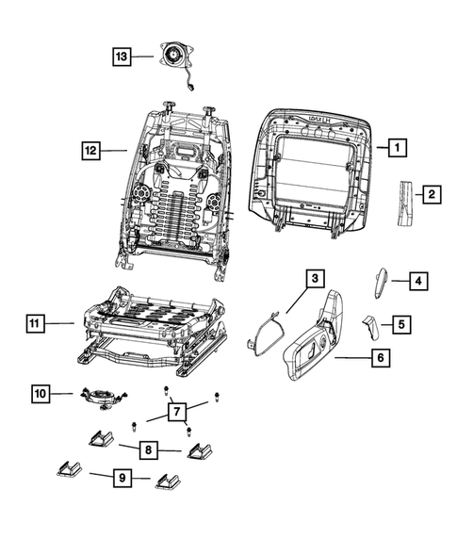
Catalog part rows on diagram page: 44. SHA-256: 770401fd0145125ea93a7856ad37254ffaa0c7921ea99e44aa8e6cfb3b9886fd

2. 2C3CDXGJ2HH530684 — front-seat-adjusters — 2: Seat Back Blower
https://www.moparamerica.com/v-2017-dodge-charger--r-t-scat-pack--6-4l-v8-gas/interior-trim--front-seats-adjusters-recliners-shields-and-risers?assembly=2
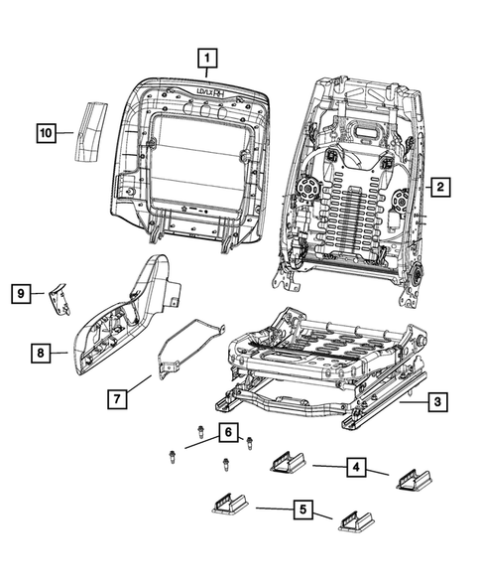
Catalog part rows on diagram page: 30. SHA-256: d59a9d20079d1c738e9336fb6b61d3aa883cf566e367eac4c4899ba1d03ec3f4

3. 2C3CDXGJ2HH530684 — front-seat-adjusters — 3: Seat Bolt
https://www.moparamerica.com/v-2017-dodge-charger--r-t-scat-pack--6-4l-v8-gas/interior-trim--front-seats-adjusters-recliners-shields-and-risers?assembly=3
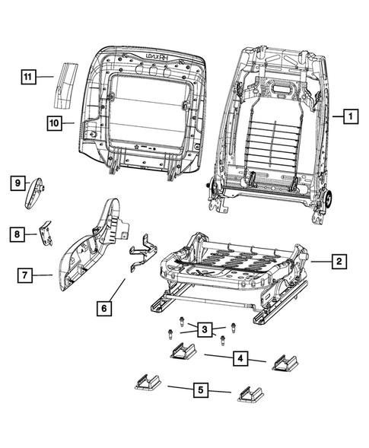
Catalog part rows on diagram page: 32. SHA-256: db07cd2b60382aa44332db42e3c791adea0f1eb00628256ba1a0242c576c1ee9

4. 2C3CDXGJ2HH530684 — rear-seats-second-row — 1: Assist Strap
https://www.moparamerica.com/v-2017-dodge-charger--r-t-scat-pack--6-4l-v8-gas/interior-trim--rear-seats-second-row?assembly=1
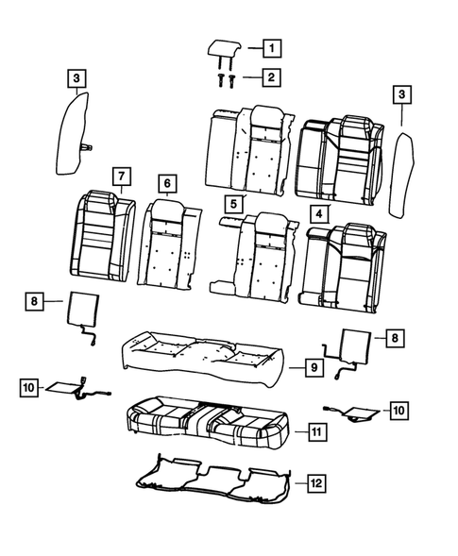
Catalog part rows on diagram page: 121. SHA-256: 0abd519d6262caca74f249940354edeaaf14c5e66bdef042edf98d6443f6e154

5. 2C3CDXGJ2HH530684 — rear-seats-second-row — 2: Armrest Lid Hinge Pin
https://www.moparamerica.com/v-2017-dodge-charger--r-t-scat-pack--6-4l-v8-gas/interior-trim--rear-seats-second-row?assembly=2
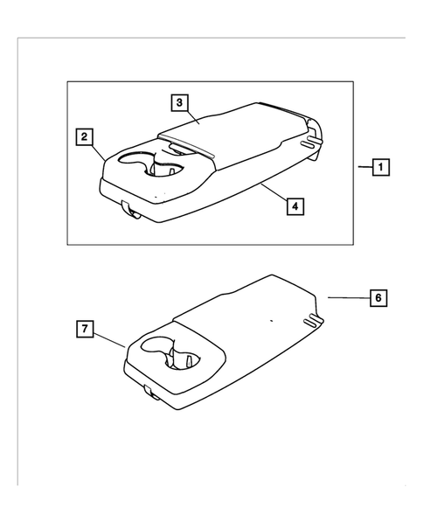
Catalog part rows on diagram page: 0. SHA-256: d7d4ea90f8fae41ea596e147477dae1424f3f3e49fccf0d88a193f32482f8399

6. 2C3CDXGJ2HH530684 — rear-seats-second-row — 3: Rear Seat Back Frame
https://www.moparamerica.com/v-2017-dodge-charger--r-t-scat-pack--6-4l-v8-gas/interior-trim--rear-seats-second-row?assembly=3
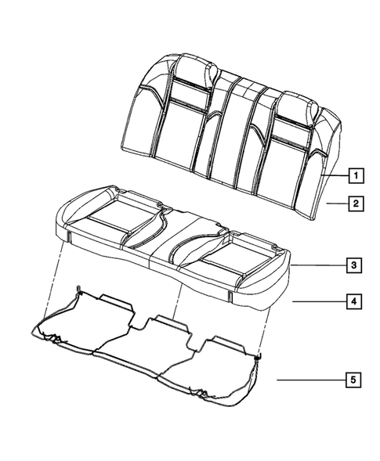
Catalog part rows on diagram page: 0. SHA-256: 78ecfa91fe7c9e70c4db7072629d3aa5c907f3658b5c4f0158544c70a0c34e6d

7. 2C3CDXGJ2HH530684 — rear-seat-adjusters — 1: Bushing 21
https://www.moparamerica.com/v-2017-dodge-charger--r-t-scat-pack--6-4l-v8-gas/interior-trim--rear-seats-second-row-adjusters-recliners-shields-and-risers
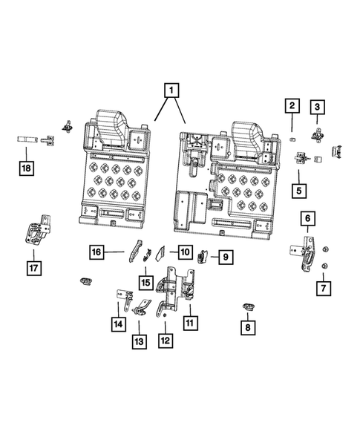
Catalog part rows on diagram page: 37. SHA-256: 817a4021764c4ec492422383b62fc908d471170f7d4a2c686e765fdff3068e26

8. 2C3CDXGJ2HH530684 — seat-belts — 1: Seat Belt Extender
https://www.moparamerica.com/v-2017-dodge-charger--r-t-scat-pack--6-4l-v8-gas/restraints--seat-belts?assembly=1
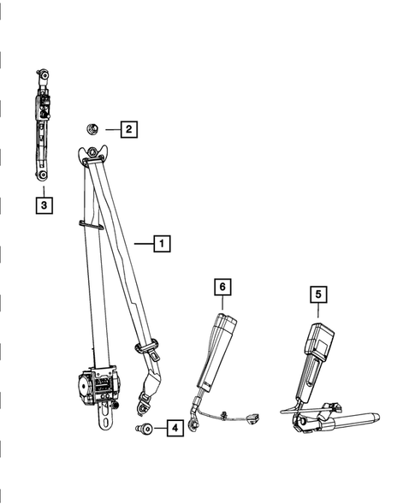
Catalog part rows on diagram page: 16. SHA-256: bd8b72d2d1393896debafc4fe431419093a929ecc2a6645d3c00d6b92e286d0b

9. 2C3CDXGJ2HH530684 — seat-belts — 2: Retractor Seat Belt, Left
https://www.moparamerica.com/v-2017-dodge-charger--r-t-scat-pack--6-4l-v8-gas/restraints--seat-belts?assembly=2
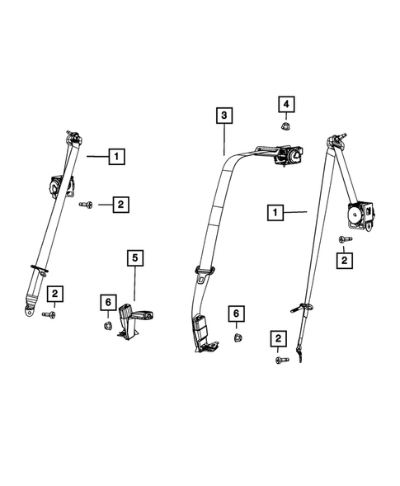
Catalog part rows on diagram page: 13. SHA-256: 82bb1ff401db3b79d040da88f25623a6ff2fe84e79cdd86749e204669ae15d04

10. 2C3CDXGJ2HH530684 — air-bags — 1: Screw
https://www.moparamerica.com/v-2017-dodge-charger--r-t-scat-pack--6-4l-v8-gas/restraints--air-bags?assembly=1
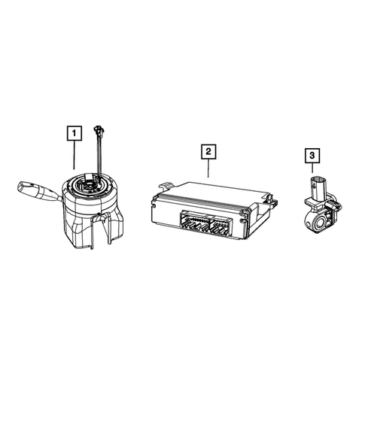
Catalog part rows on diagram page: 13. SHA-256: f2a075c131aecca44808efa7a543f5e8cfc68805ed4d0e2c42ffbc28b69bc8ef

11. 2C3CDXGJ2HH530684 — air-bags — 2: Side Curtain Air Bag, Right
https://www.moparamerica.com/v-2017-dodge-charger--r-t-scat-pack--6-4l-v8-gas/restraints--air-bags?assembly=2
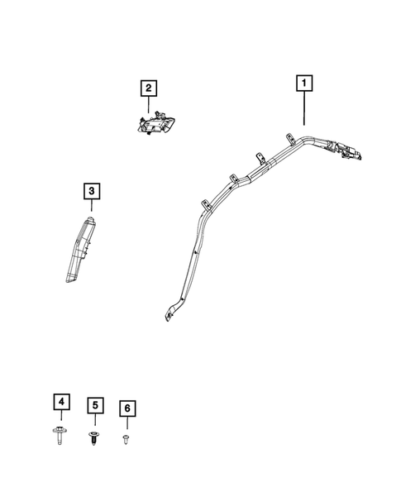
Catalog part rows on diagram page: 0. SHA-256: 0219ed86ade847975b4f5b50c615ef6590be022ccd496f2d518c3a5ea87f7225

12. 2C3CDXGJ2HH530684 — air-bags — 3: Passenger Air Bag
https://www.moparamerica.com/v-2017-dodge-charger--r-t-scat-pack--6-4l-v8-gas/restraints--air-bags?assembly=3
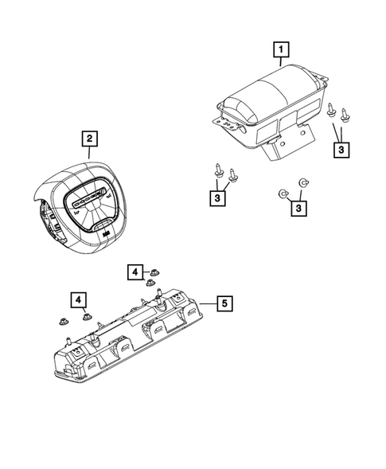
Catalog part rows on diagram page: 7. SHA-256: 1eb0bb6ccc32747f38f981e0ba63ca468dbb95a6d26ee48d6aa1f3143918ee4f

13. 2C3CDXGJ2HH530684 — steering-column — 1: Steering Column 14
https://www.moparamerica.com/v-2017-dodge-charger--r-t-scat-pack--6-4l-v8-gas/steering--steering-column-and-intermediate-shaft
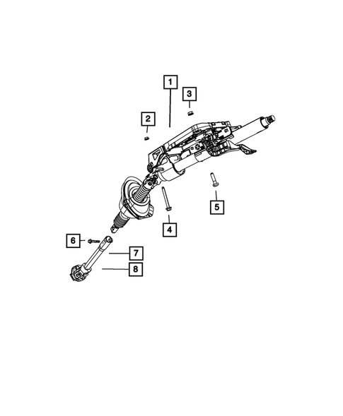
Catalog part rows on diagram page: 20. SHA-256: f0a10455e686141cf8c918c830661f89d41a4a7dcb4b4d722b3abc142019b4cf

14. 2C3CDXGJ2HH530684 — steering-wheel — 1: Steering Wheel
https://www.moparamerica.com/v-2017-dodge-charger--r-t-scat-pack--6-4l-v8-gas/steering--steering-wheel?assembly=1
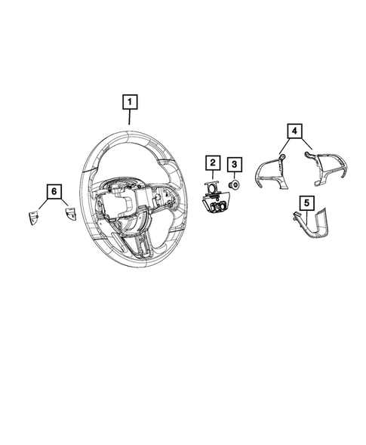
Catalog part rows on diagram page: 26. SHA-256: eb31c5d39307edd8e98c082b7830cec7996885cd8bea6c9ff05e377feec5f871

15. 2C3CDXGJ2HH530684 — steering-wheel — 2: Steering Wheel
https://www.moparamerica.com/v-2017-dodge-charger--r-t-scat-pack--6-4l-v8-gas/steering--steering-wheel?assembly=2
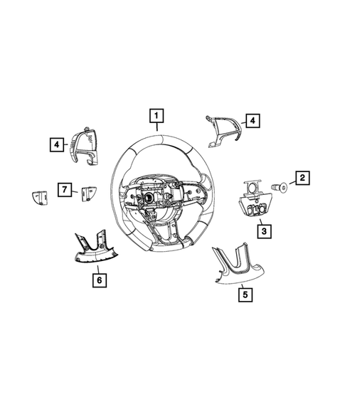
Catalog part rows on diagram page: 0. SHA-256: 18875f0c2cbfbb7403c860f2ac6f1e22096e94d77c3ed5dab818f46c62e1a66c

16. 2C3CDXGJ2HH530684 — instrument-panel — 1: Screw 76
https://www.moparamerica.com/v-2017-dodge-charger--r-t-scat-pack--6-4l-v8-gas/interior-trim--instrument-panel
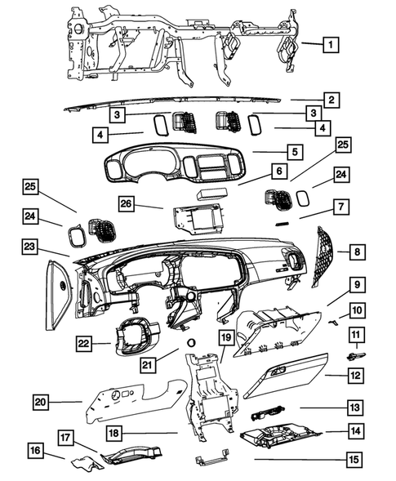
Catalog part rows on diagram page: 89. SHA-256: e3653daa1939e03b84b25d2de305b6c238e070667ad9fff33f0078ac576ba7ca

17. 2C3CCAEG4HH586472 — front-seat-adjusters — 1: Hex Head Screw
https://www.moparamerica.com/v-2017-chrysler-300--c--3-6l-v6-flex/interior-trim--front-seats-adjusters-recliners-shields-and-risers?assembly=1
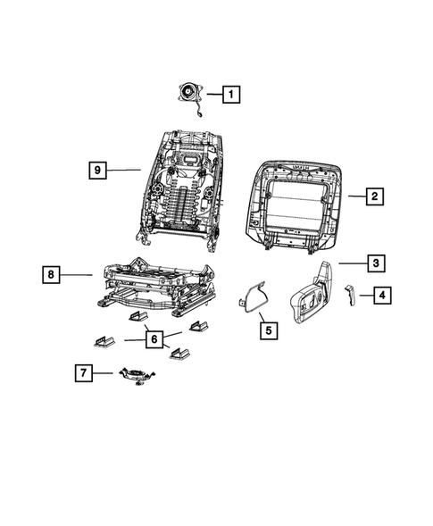
Catalog part rows on diagram page: 52. SHA-256: e63f1c0d060a250d8be7bbd7a0de284b304bf70e217accdcaf3f5830d6241c35

18. 2C3CCAEG4HH586472 — front-seat-adjusters — 2: Hex Head Screw
https://www.moparamerica.com/v-2017-chrysler-300--c--3-6l-v6-flex/interior-trim--front-seats-adjusters-recliners-shields-and-risers?assembly=2
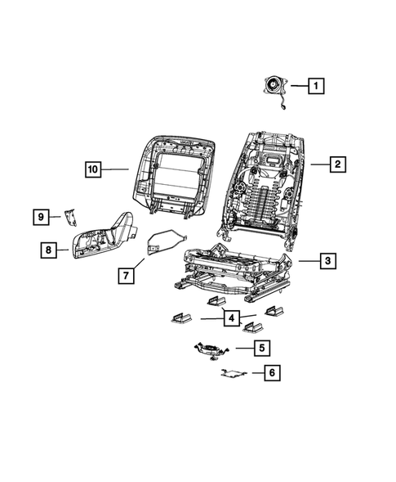
Catalog part rows on diagram page: 48. SHA-256: fc52644bd23505e0f63a72f98b0b5c45a31f4cc779687dbc7ac8c0809cdf9b7c

19. 2C3CCAEG4HH586472 — front-seat-adjusters — 3: Hex Head Screw
https://www.moparamerica.com/v-2017-chrysler-300--c--3-6l-v6-flex/interior-trim--front-seats-adjusters-recliners-shields-and-risers?assembly=3
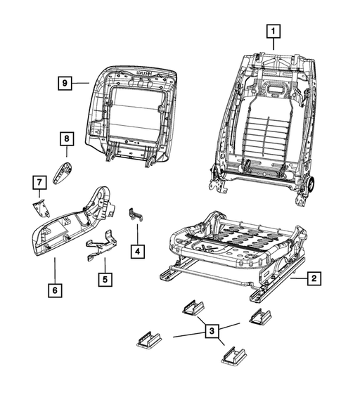
Catalog part rows on diagram page: 21. SHA-256: 57cfc8f841f8bc6fc96ee0c99cfa276fe08931f44b05b928e33cb39c98be3b25

20. 2C3CCAEG4HH586472 — front-seats-first-row — 1: Front Headrest, Right Or Left
https://www.moparamerica.com/v-2017-chrysler-300--c--3-6l-v6-flex/interior-trim--front-seats-first-row?assembly=1
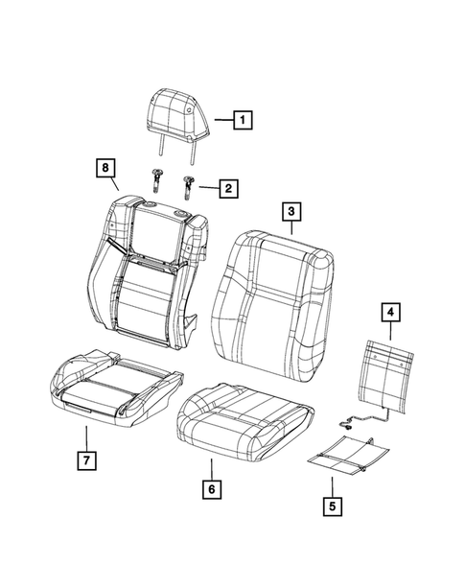
Catalog part rows on diagram page: 20. SHA-256: a991c64180eb65dcff7d381daf3707b003ae339af65e2157e85895454069b882

21. 2C3CCAEG4HH586472 — front-seats-first-row — 2: Front Headrest, Right Or Left
https://www.moparamerica.com/v-2017-chrysler-300--c--3-6l-v6-flex/interior-trim--front-seats-first-row?assembly=2
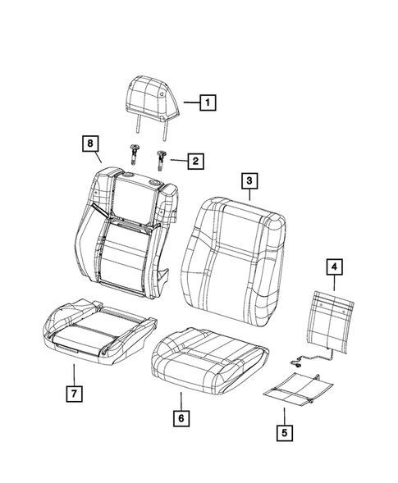
Catalog part rows on diagram page: 42. SHA-256: d471352dd249c3538c89e0862751f00c2f43d67f39ea3bd7bae2169add63a241

22. 2C3CCAEG4HH586472 — front-seats-first-row — 3: Front Headrest, Right Or Left
https://www.moparamerica.com/v-2017-chrysler-300--c--3-6l-v6-flex/interior-trim--front-seats-first-row?assembly=3
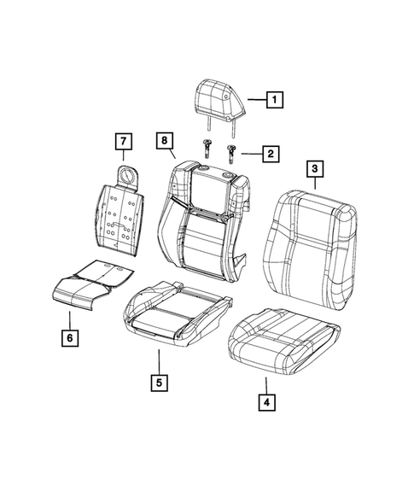
Catalog part rows on diagram page: 24. SHA-256: 039350fb0af956258a39b4956a5f8fe434bada8823e5fe7727a3c031f76f6d16

23. 2C3CCAEG4HH586472 — front-seats-first-row — 4: Front Headrest, Right Or Left
https://www.moparamerica.com/v-2017-chrysler-300--c--3-6l-v6-flex/interior-trim--front-seats-first-row?assembly=4
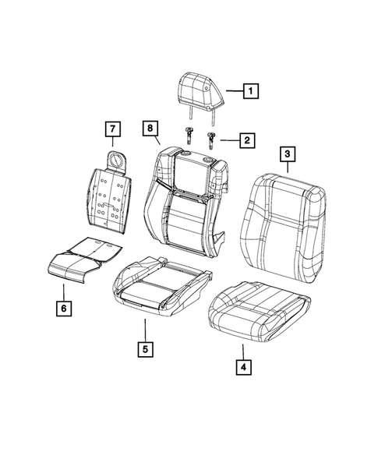
Catalog part rows on diagram page: 42. SHA-256: 1c40686ea815243f73ecb2770cbfedcac0790d65970a54d77c05b86eee2fbaaf

24. 2C3CCAEG4HH586472 — front-seats-first-row — 5: Front Headrest, Right Or Left
https://www.moparamerica.com/v-2017-chrysler-300--c--3-6l-v6-flex/interior-trim--front-seats-first-row?assembly=5
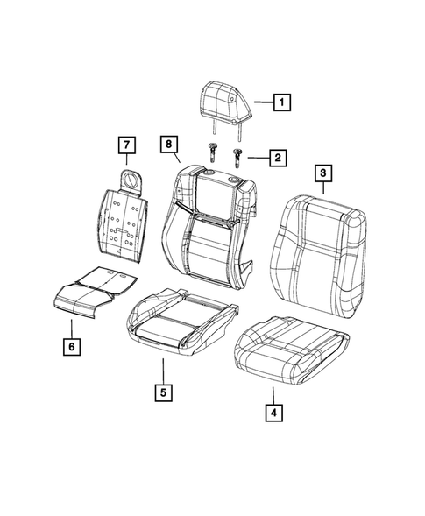
Catalog part rows on diagram page: 30. SHA-256: 16465cbaf1e495bb0263d7c08833341e70e4675dbdcdbf0a1cbf6555855b9298

25. 2C3CCAEG4HH586472 — front-seats-first-row — 6: Front Headrest, Right Or Left
https://www.moparamerica.com/v-2017-chrysler-300--c--3-6l-v6-flex/interior-trim--front-seats-first-row?assembly=6
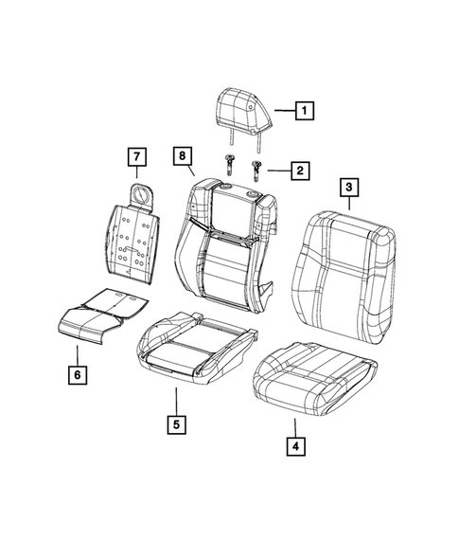
Catalog part rows on diagram page: 40. SHA-256: 6cc7a82da5a18f5efa59e6accc8cb7bb1a67bc7e1b444e15636554aeb3dbcb35

26. 2C3CCAEG4HH586472 — front-seats-first-row — 7: Front Headrest, Right Or Left
https://www.moparamerica.com/v-2017-chrysler-300--c--3-6l-v6-flex/interior-trim--front-seats-first-row?assembly=7
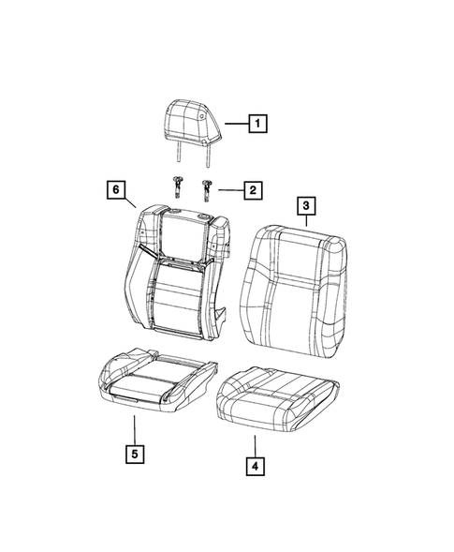
Catalog part rows on diagram page: 38. SHA-256: 590ea15bf065bcaafd9a46e9fe04a4ea0c45e9bc9d4e25f5cec129bb6524b74e

27. 2C3CCAEG4HH586472 — rear-seats-second-row — 1: Armrest Lid Hinge Pin
https://www.moparamerica.com/v-2017-chrysler-300--c--3-6l-v6-flex/interior-trim--rear-seats-second-row?assembly=1
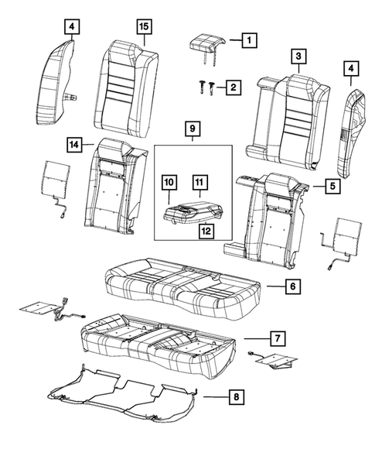
Catalog part rows on diagram page: 48. SHA-256: 873e5422475f94d68681b897d8ef747f31c89d34fa4582109fb810553342e571

28. 2C3CCAEG4HH586472 — rear-seats-second-row — 2: Armrest Lid Hinge Pin
https://www.moparamerica.com/v-2017-chrysler-300--c--3-6l-v6-flex/interior-trim--rear-seats-second-row?assembly=2
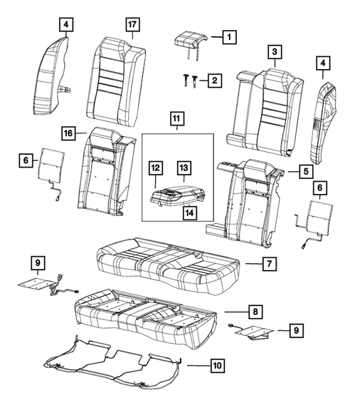
Catalog part rows on diagram page: 74. SHA-256: 7d10cd6de394fa73222d7442a53949c9d64a0fb883f1262608a097b489cacb14

29. 2C3CCAEG4HH586472 — rear-seats-second-row — 3: Armrest Lid Hinge Pin
https://www.moparamerica.com/v-2017-chrysler-300--c--3-6l-v6-flex/interior-trim--rear-seats-second-row?assembly=3
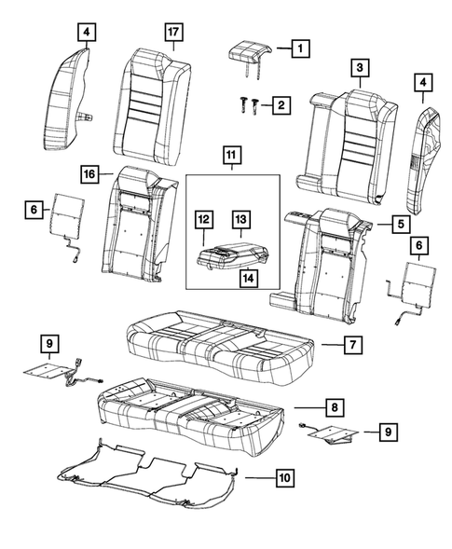
Catalog part rows on diagram page: 59. SHA-256: 4b6d8ea7d919be6cdb20e5b678c3bb8b7d0951815d9abdc15530149f8279c9c2

30. 2C3CCAEG4HH586472 — rear-seats-second-row — 4: Armrest Lid Hinge Pin
https://www.moparamerica.com/v-2017-chrysler-300--c--3-6l-v6-flex/interior-trim--rear-seats-second-row?assembly=4
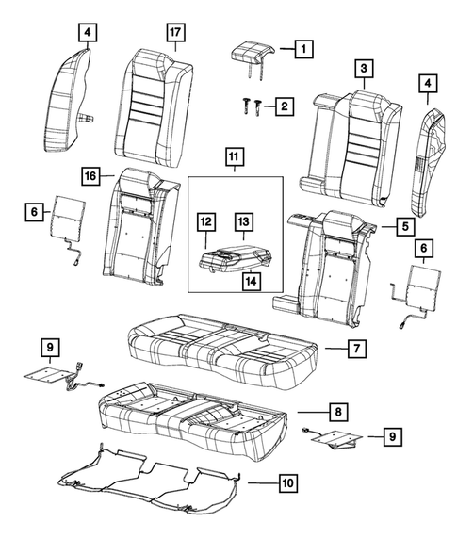
Catalog part rows on diagram page: 57. SHA-256: f8a2d3fca87fa893fe0c3deb63efaf7fafcd8711385f4451a9ef9c323876b49d

31. 2C3CCAEG4HH586472 — rear-seats-second-row — 5: Armrest Lid Hinge Pin
https://www.moparamerica.com/v-2017-chrysler-300--c--3-6l-v6-flex/interior-trim--rear-seats-second-row?assembly=5
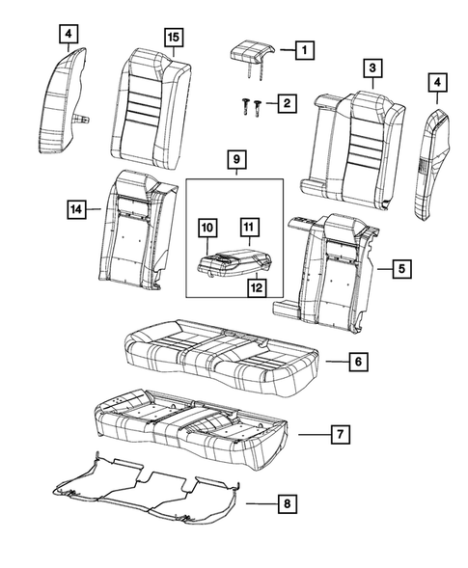
Catalog part rows on diagram page: 37. SHA-256: b21d787b9cc4f99e226160f6252a423a3dfa18ea0f4c67d4d17fd620f9f044ce

32. 2C3CCAEG4HH586472 — rear-seats-second-row — 6: Armrest Lid Hinge Pin
https://www.moparamerica.com/v-2017-chrysler-300--c--3-6l-v6-flex/interior-trim--rear-seats-second-row?assembly=6
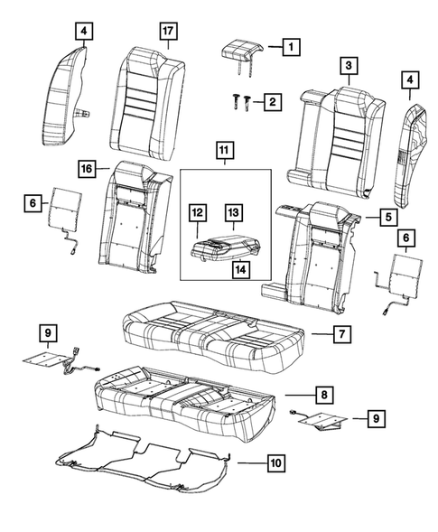
Catalog part rows on diagram page: 49. SHA-256: e8430285352d95e0c8ce9ec9bdf86d9dc5a145c87705922e0ca3afab39a7f40b

33. 2C3CCAEG4HH586472 — rear-seats-second-row — 7: Rear Headrest
https://www.moparamerica.com/v-2017-chrysler-300--c--3-6l-v6-flex/interior-trim--rear-seats-second-row?assembly=7
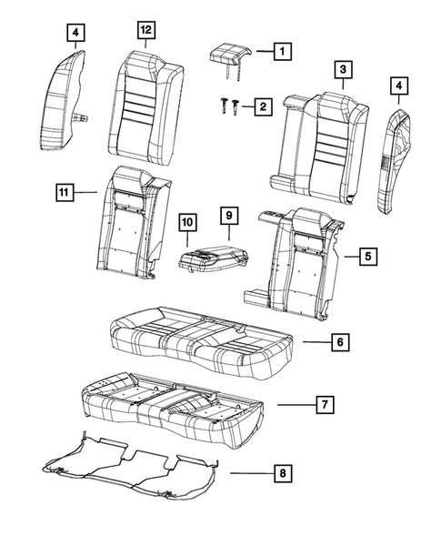
Catalog part rows on diagram page: 40. SHA-256: deef1e3215c32989704b966dd90437c0ccbf084495851d74cd50f3ee1306c7f6

34. 2C3CCAEG4HH586472 — rear-seats-second-row — 8: Seat Bolster, Left
https://www.moparamerica.com/v-2017-chrysler-300--c--3-6l-v6-flex/interior-trim--rear-seats-second-row?assembly=8
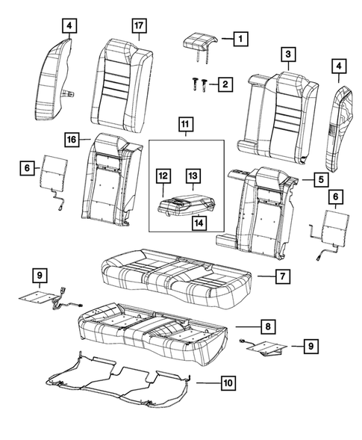
Catalog part rows on diagram page: 4. SHA-256: 13b5f52a7d34748e591ce9575e3a1196dedda596932deab3b4de649e6552408f

35. 2C3CCAEG4HH586472 — rear-seats-second-row — 9: Seat Bolster, Right
https://www.moparamerica.com/v-2017-chrysler-300--c--3-6l-v6-flex/interior-trim--rear-seats-second-row?assembly=9
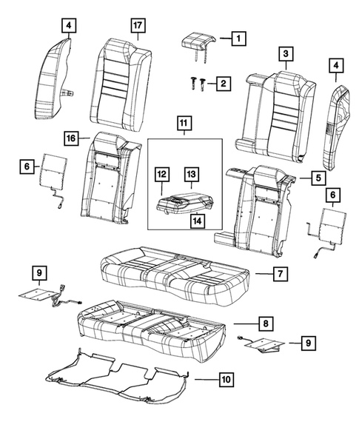
Catalog part rows on diagram page: 4. SHA-256: 482f2629633f8dfaa143f6730dbd692c68074b2bb8dcca419c5583b0dc5f98ad

36. 2C3CCAEG4HH586472 — rear-seats-second-row — 10: Seat Bolster, Right
https://www.moparamerica.com/v-2017-chrysler-300--c--3-6l-v6-flex/interior-trim--rear-seats-second-row?assembly=10
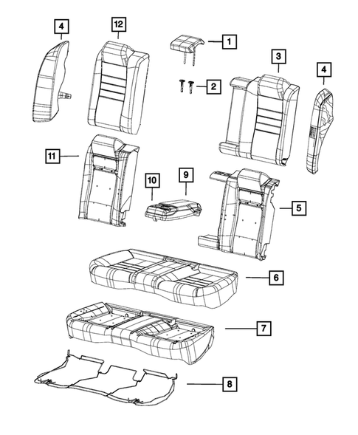
Catalog part rows on diagram page: 4. SHA-256: 1593f03d12ac711af31db584e9cdcea0805a6c248e38ef21661fcaf52d084f80

37. 2C3CCAEG4HH586472 — seat-belts — 1: Seat Belt Extender
https://www.moparamerica.com/v-2017-chrysler-300--c--3-6l-v6-flex/restraints--seat-belts?assembly=1
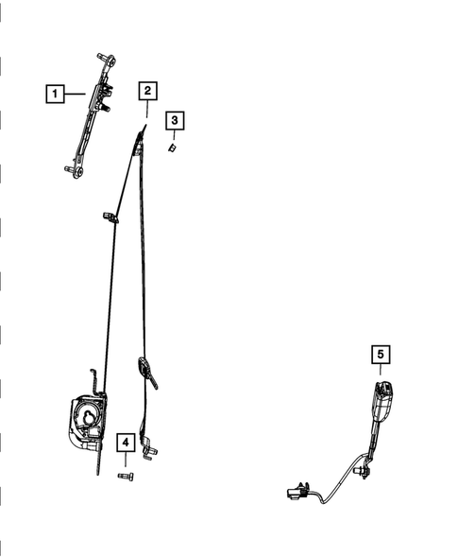
Catalog part rows on diagram page: 17. SHA-256: 442a58dcf7f089219c54f5b0f4be00d34487bd46f04ba42380eaafa71d0499df

38. 2C3CCAEG4HH586472 — seat-belts — 2: Retractor Seat Belt
https://www.moparamerica.com/v-2017-chrysler-300--c--3-6l-v6-flex/restraints--seat-belts?assembly=2
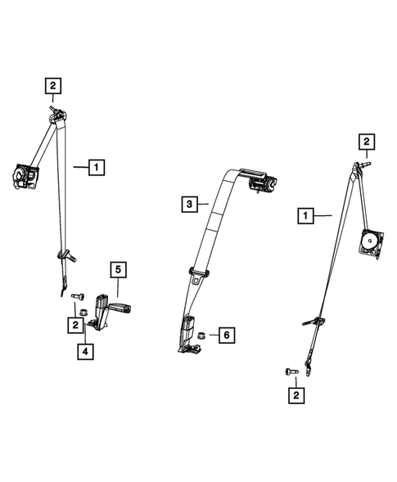
Catalog part rows on diagram page: 17. SHA-256: b41752c0206ee09dbcf03ee9da0c89f4796d954e978acaceadbf978f7e20b598

39. 2C3CCAEG4HH586472 — air-bags — 1: Screw
https://www.moparamerica.com/v-2017-chrysler-300--c--3-6l-v6-flex/restraints--air-bags?assembly=1
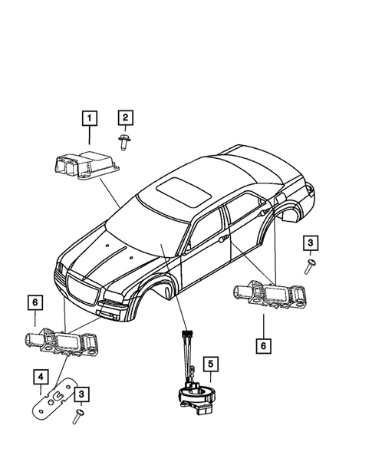
Catalog part rows on diagram page: 18. SHA-256: 979485852b6e79bca48448b84f256b68956781e0aa4bd4b86fe02a039d014c5c

40. 2C3CCAEG4HH586472 — air-bags — 2: Side Curtain Air Bag, Right
https://www.moparamerica.com/v-2017-chrysler-300--c--3-6l-v6-flex/restraints--air-bags?assembly=2
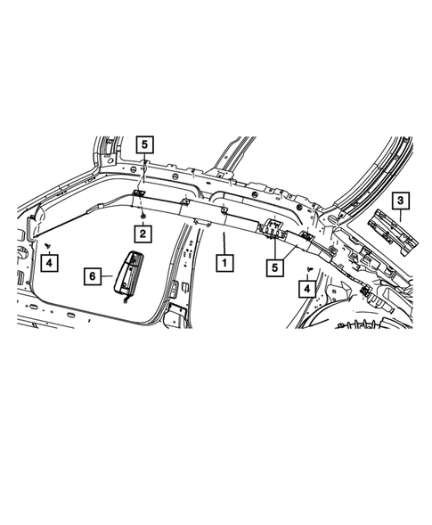
Catalog part rows on diagram page: 14. SHA-256: 4261430c99e5f967ae6982130c0628450f053f4c7f2eaa04ecc82d9912222502

41. 2C3CCAEG4HH586472 — air-bags — 3: Passenger Air Bag
https://www.moparamerica.com/v-2017-chrysler-300--c--3-6l-v6-flex/restraints--air-bags?assembly=3
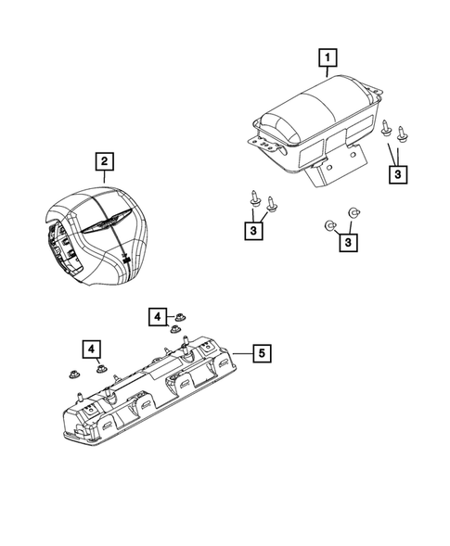
Catalog part rows on diagram page: 9. SHA-256: 15ccc80b2f8b292cf0ddf9874a93ec15f7f70a26f7eec3cf47e7ef081e074de1

42. 2C3CCAEG4HH586472 — steering-column — 1: Steering Column 19
https://www.moparamerica.com/v-2017-chrysler-300--c--3-6l-v6-flex/steering--steering-column-and-intermediate-shaft
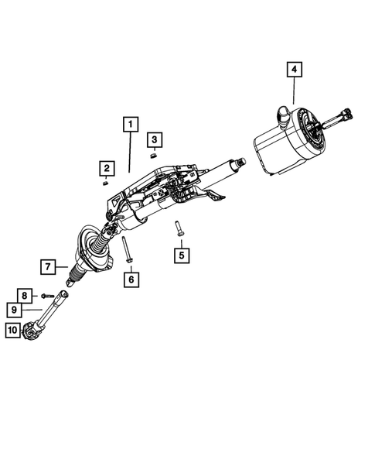
Catalog part rows on diagram page: 24. SHA-256: ee52568ce7894570f8907540c1317dee376a0c23fa626062706b6cb28b25729c

43. 2C3CCAEG4HH586472 — steering-wheel — 1: Steering Wheel
https://www.moparamerica.com/v-2017-chrysler-300--c--3-6l-v6-flex/steering--steering-wheel?assembly=1
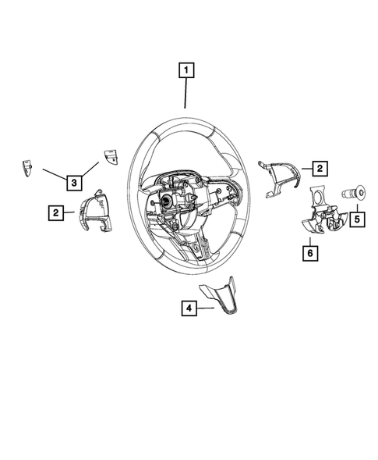
Catalog part rows on diagram page: 23. SHA-256: 6e6f454a15cd174448533c05c6866ae0750485a615f39951693f806dc7309e2d

44. 2C3CCAEG4HH586472 — steering-wheel — 2: Steering Wheel
https://www.moparamerica.com/v-2017-chrysler-300--c--3-6l-v6-flex/steering--steering-wheel?assembly=2
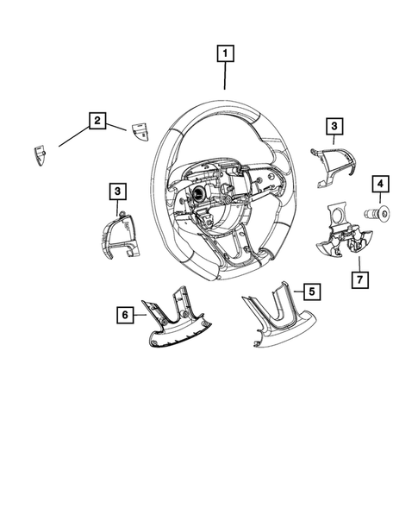
Catalog part rows on diagram page: 15. SHA-256: acc65af7b4ec98e0f85e25692bd8bf16b83a1be2f24e2a9afba8a78badf2c43c

45. 2C3CCAEG4HH586472 — instrument-panel — 1: Instrument Panel Closeout Panel, Left, Inboard 122
https://www.moparamerica.com/v-2017-chrysler-300--c--3-6l-v6-flex/interior-trim--instrument-panel
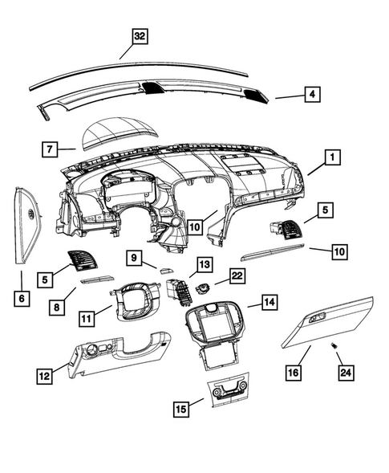
Catalog part rows on diagram page: 117. SHA-256: a016a297c7c29d537e79df51d1c92b80efc951ef5cacd8c2772723e9efefc8d8

Limitations and next evidence needed
- Obtain OEM build sheets/sales-code lists for both VINs.
- Run a dealer/OEM VIN-specific part query for the exact left/right, colour, trim, seat-option and restraint sales codes.
- Verify physical labels/part numbers and installation photographs for seats, belts, airbags, steering column and child-restraint anchorages.
- Use test reports/approval evidence for ADR performance; do not substitute this catalog comparison for crash, anchorage or dynamic-test evidence.
- Resolve the two scraper gaps recorded in `extracted/mopar/errors.json` if an additional catalog route becomes available.

