Expanded Challenger–Charger Similarity Supplement for Previously Unresolved ADR Areas
2017 cross-variant/trim Mopar catalog screening
2026-07-31

Executive determination
All 13 previously unresolved ADR areas pass the broad cross-variant/trim similarity screen. Seven are exact-direct, one exact-supporting and five functional-architecture passes. This is not an ADR compliance determination.
Screened 7 variants across 16 categories and 112 route/category jobs; 2253 rows, 93 exact category-level common part numbers, 22 drawings, 0 errors.

ADR result matrix
ADR | Subject | Challenger | Charger | Exact direct | Exact supporting | Assessment
8/01 | Safety Glazing Material | 9 | 9 | 0 | 28 | FUNCTIONAL-ARCHITECTURE PASS
11/00 | Internal Sun Visors | 9 | 15 | 0 | 1 | FUNCTIONAL-ARCHITECTURE PASS
14/02 | Rear Vision Mirrors | 13 | 66 | 0 | 2 | FUNCTIONAL-ARCHITECTURE PASS
18/03 | Instrumentation | 22 | 27 | 0 | 13 | FUNCTIONAL-ARCHITECTURE PASS
21/00 | Instrument Panel | 22 | 31 | 3 | 13 | EXACT-DIRECT PART MATCH PASS
25/02 | Anti-Theft Lock | 1 | 1 | 1 | 22 | EXACT-DIRECT PART MATCH PASS
29/00 | Side Door Strength | 20 | 21 | 0 | 33 | FUNCTIONAL-ARCHITECTURE PASS
34/02 | Child Restraint Anchorages and Fittings | 0 | 0 | 0 | 12 | EXACT-SUPPORTING PART MATCH PASS
42/04 | General Safety Requirements | 85 | 164 | 40 | 55 | EXACT-DIRECT PART MATCH PASS
69/00 | Full Frontal Impact Occupant Protection | 37 | 41 | 20 | 45 | EXACT-DIRECT PART MATCH PASS
72/00 | Dynamic Side Impact Occupant Protection | 17 | 17 | 4 | 43 | EXACT-DIRECT PART MATCH PASS
73/00 | Offset Frontal Impact Occupant Protection | 37 | 41 | 20 | 45 | EXACT-DIRECT PART MATCH PASS
85/00 | Pole Side Impact Performance | 9 | 5 | 1 | 39 | EXACT-DIRECT PART MATCH PASS

Controlled evidence statements
ADR | Selected exact parts | Controlled statement | Regulatory limit
8/01 | [none — functional comparison] | Both models expose windscreen/door/quarter-glass catalog architecture; no exact glazing service number was established. | Similarity/catalog evidence only; does not prove ADR compliance, installed VIN configuration or test performance.
11/00 | [none — functional comparison] | Both models expose visor assemblies and attachments; the sole exact category overlap is an audio microphone, not a visor. | Similarity/catalog evidence only; does not prove ADR compliance, installed VIN configuration or test performance.
14/02 | [none — functional comparison] | Both models expose interior/exterior mirror systems; no exact mirror assembly or glass number was established. | Similarity/catalog evidence only; does not prove ADR compliance, installed VIN configuration or test performance.
18/03 | [none — functional comparison] | Both models expose instrument-cluster and display architecture; no exact cluster service number was established. | Similarity/catalog evidence only; does not prove ADR compliance, installed VIN configuration or test performance.
21/00 | 1QF13DX9AP | 68110649AA | 68110650AA | Exact common glove-box, dampener and latch-striker components support shared instrument-panel architecture. | Similarity/catalog evidence only; does not prove ADR compliance, installed VIN configuration or test performance.
25/02 | 68404422AA | Exact common ignition-switch trim ring supports a shared ignition-control interface; it does not establish steering-lock or immobilizer identity. | Similarity/catalog evidence only; does not prove ADR compliance, installed VIN configuration or test performance.
29/00 | 1MZ84DX8AM | 1MZ85KBXAM | Shared front-door handles plus corresponding door/aperture categories support functional body-side architecture; no exact intrusion beam or door-strength structure was established. | Similarity/catalog evidence only; does not prove ADR compliance, installed VIN configuration or test performance.
34/02 | 4628848AB | 68110232AA | 68110212AA | 68110213AA | 68110214AA | Exact common rear-seat latch/striker and seat-bracket parts support rear-seat architecture; no exact child-tether anchorage service number was identified. | Similarity/catalog evidence only; does not prove ADR compliance, installed VIN configuration or test performance.
42/04 | 1MZ84DX8AM | 1MZ85KBXAM | 6AD80DX9AA | 6AD81DX9AA | Exact door-handle and steering-wheel components support common general-safety control architecture. | Similarity/catalog evidence only; does not prove ADR compliance, installed VIN configuration or test performance.
69/00 | 56054085AA | 6ET081X9AB | 6ET091X9AB | 68140569AG | 68259474AD | 6AD80DX9AA | Exact acceleration sensor, front inner belts, steering columns and steering-wheel components support common frontal-restraint architecture. | Similarity/catalog evidence only; does not prove ADR compliance, installed VIN configuration or test performance.
72/00 | 56054085AA | 6ET081X9AB | 6ET091X9AB | Exact acceleration sensor and front inner belt components support common side-impact restraint architecture. | Similarity/catalog evidence only; does not prove ADR compliance, installed VIN configuration or test performance.
73/00 | 56054085AA | 6ET081X9AB | 6ET091X9AB | 68140569AG | 68259474AD | Exact sensor, belt and steering-column components support common offset-frontal restraint architecture. | Similarity/catalog evidence only; does not prove ADR compliance, installed VIN configuration or test performance.
85/00 | 56054085AA | Exact acceleration-sensor commonality supports side-impact sensing architecture; applicability is probably not mandatory for these 2017 vehicles and remains conditional. | Similarity/catalog evidence only; does not prove ADR compliance, installed VIN configuration or test performance.

ADR 8/01 — Safety Glazing Material
Assessment: FUNCTIONAL-ARCHITECTURE PASS
Selected evidence: [none]
Official ADR: https://www.legislation.gov.au/F2005L03908/latest/text

ADR 11/00 — Internal Sun Visors
Assessment: FUNCTIONAL-ARCHITECTURE PASS
Selected evidence: [none]
Official ADR: https://www.legislation.gov.au/F2006L01785/latest/text

ADR 14/02 — Rear Vision Mirrors
Assessment: FUNCTIONAL-ARCHITECTURE PASS
Selected evidence: [none]
Official ADR: https://www.legislation.gov.au/F2006L02663/latest/text

ADR 18/03 — Instrumentation
Assessment: FUNCTIONAL-ARCHITECTURE PASS
Selected evidence: [none]
Official ADR: https://www.legislation.gov.au/F2006L01392/latest/text

ADR 21/00 — Instrument Panel
Assessment: EXACT-DIRECT PART MATCH PASS
Selected evidence: 1QF13DX9AP — 2011 2021 Mopar Instrument Panel Glove Box | 68110649AA — Glove Box Door Dampener | 68110650AA — Glove Box Door Latch Striker
Official ADR: https://www.legislation.gov.au/F2006L01786/latest/text

ADR 25/02 — Anti-Theft Lock
Assessment: EXACT-DIRECT PART MATCH PASS
Selected evidence: 68404422AA — Ignition Switch Trim Ring
Official ADR: https://www.legislation.gov.au/F2006L02664/latest/text

ADR 29/00 — Side Door Strength
Assessment: FUNCTIONAL-ARCHITECTURE PASS
Selected evidence: 1MZ84DX8AM — 2013 2021 Mopar Front Door Exterior Handle Right | 1MZ85KBXAM — 2013 2018 Mopar Front Door Exterior Handle Left
Official ADR: https://www.legislation.gov.au/F2006L01429/latest/text

ADR 34/02 — Child Restraint Anchorages and Fittings
Assessment: EXACT-SUPPORTING PART MATCH PASS
Selected evidence: 4628848AB — Seat Back Latch Striker | 68110232AA — Seat Latch | 68110212AA — Seat Bracket | 68110213AA — Seat Bracket | 68110214AA — Seat Bracket
Official ADR: https://www.legislation.gov.au/F2012L00703/latest/text

ADR 42/04 — General Safety Requirements
Assessment: EXACT-DIRECT PART MATCH PASS
Selected evidence: 1MZ84DX8AM — 2013 2021 Mopar Front Door Exterior Handle Right | 1MZ85KBXAM — 2013 2018 Mopar Front Door Exterior Handle Left | 6AD80DX9AA — Steering Wheel | 6AD81DX9AA — Steering Wheel
Official ADR: https://www.legislation.gov.au/F2005L03996/latest/text

ADR 69/00 — Full Frontal Impact Occupant Protection
Assessment: EXACT-DIRECT PART MATCH PASS
Selected evidence: 56054085AA — Acceleration Sensor | 6ET081X9AB — Front Inner Seat Belt Right | 6ET091X9AB — Front Inner Seat Belt Left | 68140569AG — 2014 2021 Mopar Steering Column | 68259474AD — 2014 2021 Mopar Steering Column | 6AD80DX9AA — Steering Wheel
Official ADR: https://www.legislation.gov.au/F2006L01455/latest/text

ADR 72/00 — Dynamic Side Impact Occupant Protection
Assessment: EXACT-DIRECT PART MATCH PASS
Selected evidence: 56054085AA — Acceleration Sensor | 6ET081X9AB — Front Inner Seat Belt Right | 6ET091X9AB — Front Inner Seat Belt Left
Official ADR: https://www.legislation.gov.au/F2005L03992/latest/text

ADR 73/00 — Offset Frontal Impact Occupant Protection
Assessment: EXACT-DIRECT PART MATCH PASS
Selected evidence: 56054085AA — Acceleration Sensor | 6ET081X9AB — Front Inner Seat Belt Right | 6ET091X9AB — Front Inner Seat Belt Left | 68140569AG — 2014 2021 Mopar Steering Column | 68259474AD — 2014 2021 Mopar Steering Column
Official ADR: https://www.legislation.gov.au/F2005L03990/latest/text

ADR 85/00 — Pole Side Impact Performance
Assessment: EXACT-DIRECT PART MATCH PASS
Selected evidence: 56054085AA — Acceleration Sensor
Official ADR: https://www.legislation.gov.au/F2015L02109/latest/text

Representative exploded drawings

Challenger — headliners-visors catalog assembly 1: Headliner, Export
https://www.moparamerica.com/v-2017-dodge-challenger--r-t-scat-pack--6-4l-v8-gas/interior-trim--headliners-visors-assist-straps?assembly=1
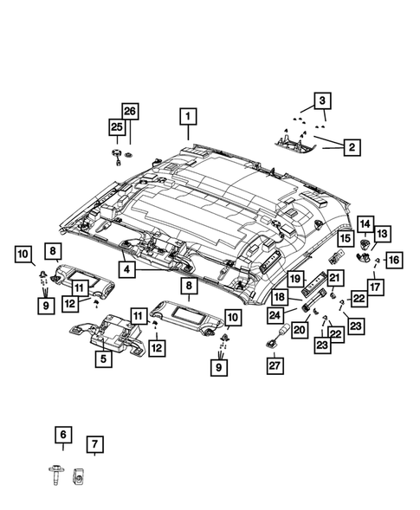

Charger — headliners-visors catalog assembly 1: Headliner
https://www.moparamerica.com/v-2017-dodge-charger--r-t-scat-pack--6-4l-v8-gas/interior-trim--headliners-visors-assist-straps?assembly=1
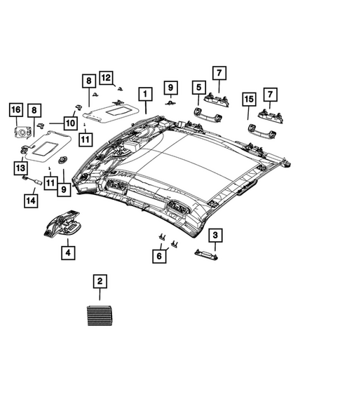

Challenger — front-door catalog assembly 1: Door Handle Bracket, Right
https://www.moparamerica.com/v-2017-dodge-challenger--r-t-scat-pack--6-4l-v8-gas/doors-door-mirrors-and-related-parts--front-door?assembly=1
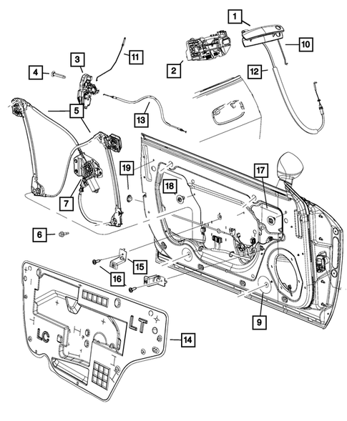

Charger — front-door catalog assembly 1: Round Black Tape
https://www.moparamerica.com/v-2017-dodge-charger--r-t-scat-pack--6-4l-v8-gas/doors-door-mirrors-and-related-parts--front-door?assembly=1
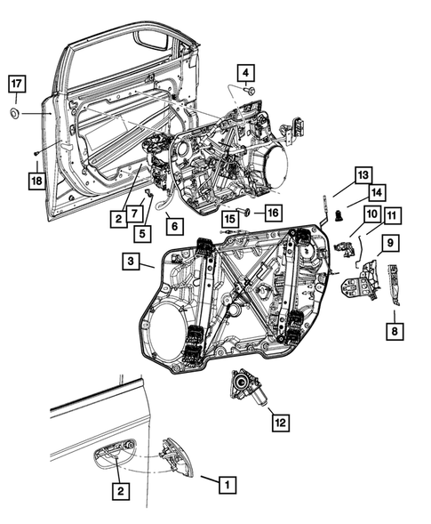

Challenger — air-bags catalog assembly 1: Steering Column Module
https://www.moparamerica.com/v-2017-dodge-challenger--r-t-scat-pack--6-4l-v8-gas/restraints--air-bags?assembly=1
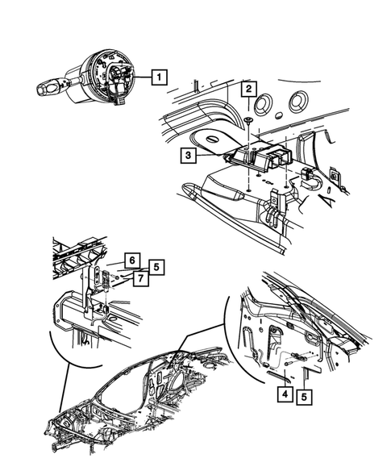

Challenger — seat-belts catalog assembly 1: Seat Belt Extender
https://www.moparamerica.com/v-2017-dodge-challenger--r-t-scat-pack--6-4l-v8-gas/restraints--seat-belts?assembly=1
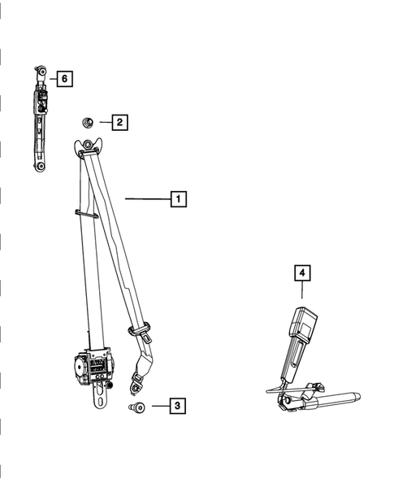

Challenger — steering-wheel catalog assembly 1: Oval Head Screw
https://www.moparamerica.com/v-2017-dodge-challenger--r-t-scat-pack--6-4l-v8-gas/steering--steering-wheel?assembly=1
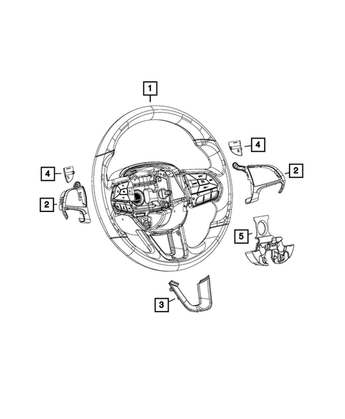

Challenger — aperture-pillars catalog assembly 1: Body Side Aperture Rear Panel, Right
https://www.moparamerica.com/v-2017-dodge-challenger--r-t-scat-pack--6-4l-v8-gas/body-sheet-metal-except-doors--aperture-panel-and-pillar-supports?assembly=1
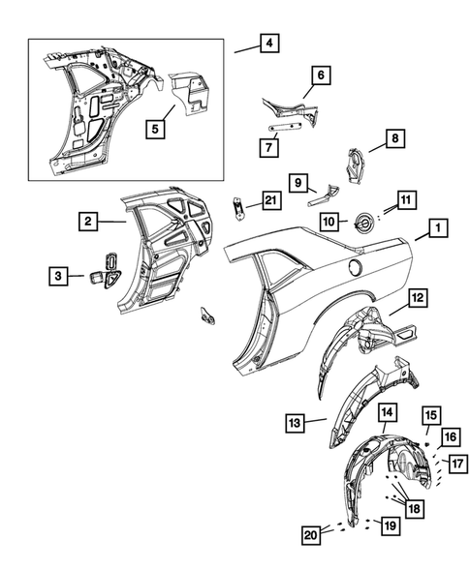

Charger — aperture-pillars catalog assembly 1: Body Side Aperture Outer Panel, Left
https://www.moparamerica.com/v-2017-dodge-charger--r-t-scat-pack--6-4l-v8-gas/body-sheet-metal-except-doors--aperture-panel-and-pillar-supports?assembly=1
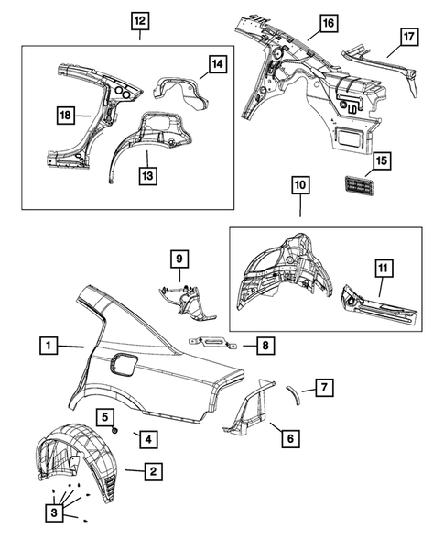

Challenger — floor-pans catalog assembly 1: Seat Belt Anchor Reinforcement
https://www.moparamerica.com/v-2017-dodge-challenger--r-t-scat-pack--6-4l-v8-gas/body-sheet-metal-except-doors--floor-pans?assembly=1
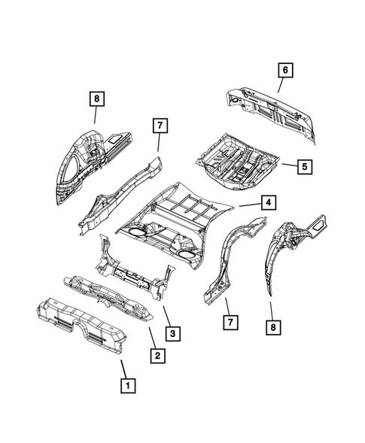

Charger — floor-pans catalog assembly 1: Hex Head Screw And Washer
https://www.moparamerica.com/v-2017-dodge-charger--r-t-scat-pack--6-4l-v8-gas/body-sheet-metal-except-doors--floor-pans?assembly=1
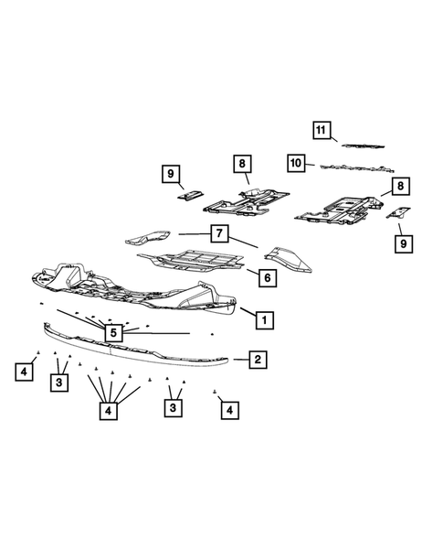

Evidence needed for compliance-grade conclusions
- VIN/variant-specific build and fitted-component records.
- Manufacturer drawings, specifications and controlled declarations.
- Applicable ADR/UN/FMVSS test reports with demonstrated variant coverage.
- Physical labels, markings, dimensions and inspection evidence where the ADR requires them.
- Clause-level comparison for each accepted alternative-standard route and confirmation that the route is legally available.

