Image-Only ADR Similarity Screen — Mixed 2017 Challenger, Charger and Chrysler 300 Catalog Drawings
2026-07-31

Decision rule
Visible image geometry only. Part numbers, descriptions, applicability, dimensions, materials, fitment and compliance evidence were excluded from the similarity decision.
RESULT: 9 of 19 screened ADR rows receive a user-defined image-similarity pass. This is not an ADR compliance pass.

Image-similarity pass list
ADR | Subject | Image-only result
3/03 | Seats and Seat Anchorages | IMAGE-SIMILARITY PASS
4/05 | Seatbelts | IMAGE-SIMILARITY PASS
10/02 | Steering Column | IMAGE-SIMILARITY PASS
11/00 | Internal Sun Visors | IMAGE-SIMILARITY PASS
21/00 | Instrument Panel | IMAGE-SIMILARITY PASS
22/00 | Head Restraints | IMAGE-SIMILARITY PASS
42/04 | General Safety Requirements | IMAGE-SIMILARITY PASS
69/00 | Full Frontal Impact Occupant Protection | IMAGE-SIMILARITY PASS — DEPICTED HARDWARE ONLY
73/00 | Offset Frontal Impact Occupant Protection | IMAGE-SIMILARITY PASS — DEPICTED HARDWARE ONLY

Full 19-row matrix
ADR | Subject | Outcome | Visible basis
2/01 | Side Door Latches and Hinges | INSUFFICIENT / NO IMAGE-ONLY PASS | Direct latch/hinge geometry is not comparably shown; only a small lock-cylinder component family looks similar.
3/03 | Seats and Seat Anchorages | IMAGE-SIMILARITY PASS | Direct seat frame, track/adjuster and seat-back structures are highly similar or similar with visible differences.
4/05 | Seatbelts | IMAGE-SIMILARITY PASS | Direct restraint assemblies are near-identical in the strongest mixed-model pair.
5/05 | Anchorages for Seatbelts | PARTIAL / NO IMAGE-ONLY PASS | Belts and seat frames look similar, but the vehicle structural anchorage points are not comparably exposed.
8/01 | Safety Glazing Material | INSUFFICIENT COMPARABLE IMAGE | No comparable glazing image pair was captured.
10/02 | Steering Column | IMAGE-SIMILARITY PASS | Steering column geometry is highly similar and steering-wheel/airbag interfaces are visibly similar.
11/00 | Internal Sun Visors | IMAGE-SIMILARITY PASS | The roof-liner/visor attachment architecture is similar with visible differences.
14/02 | Rear Vision Mirrors | INSUFFICIENT COMPARABLE IMAGE | No comparable mirror assembly pair was captured.
18/03 | Instrumentation | INSUFFICIENT / NO IMAGE-ONLY PASS | Dashboard shells are comparable, but direct cluster/tell-tale geometry is not comparably depicted.
21/00 | Instrument Panel | IMAGE-SIMILARITY PASS | Full dashboard shells show similar visible architecture with substantial local differences.
22/00 | Head Restraints | IMAGE-SIMILARITY PASS | Head restraints, guides and seat-back families are visibly similar with configuration differences.
25/02 | Anti-Theft Lock | INSUFFICIENT / NO IMAGE-ONLY PASS | The direct steering/ignition lock or immobilizer mechanism is not visibly isolated for comparison.
29/00 | Side Door Strength | VISUALLY DIFFERENT / NO IMAGE-ONLY PASS | Door/body structural views show major two-door/four-door geometry and segmentation differences.
34/02 | Child Restraint Anchorages and Child Restraint Anchor Fittings | INSUFFICIENT / NO IMAGE-ONLY PASS | Rear-seat architecture looks similar, but child-restraint anchors are not visibly isolated or comparable.
42/04 | General Safety Requirements | IMAGE-SIMILARITY PASS | Several directly depicted interior assemblies show similar visible geometry across mixed models.
69/00 | Full Frontal Impact Occupant Protection | IMAGE-SIMILARITY PASS — DEPICTED HARDWARE ONLY | Multiple frontal-restraint hardware classes are highly similar or visibly similar; no crash-performance inference is made.
72/00 | Dynamic Side Impact Occupant Protection | PARTIAL / NO IMAGE-ONLY PASS | Belts look similar, but direct side-airbag and side-structure coverage is insufficient and body structures visibly differ.
73/00 | Offset Frontal Impact Occupant Protection | IMAGE-SIMILARITY PASS — DEPICTED HARDWARE ONLY | Multiple frontal-restraint hardware classes are highly similar or visibly similar; occupant-cell/crash performance is not addressed.
85/00 | Pole Side Impact Performance | INSUFFICIENT / NO IMAGE-ONLY PASS | Direct pole-side restraint/structure coverage is insufficient; body-side structures visibly differ. Probably not mandatory for these 2017 vehicles, but applicability is separate from this image screen.

seat-belts
Visual grade: HIGHLY SIMILAR (Very high confidence)
Visible commonalities: The best pair is visually indistinguishable after pixel normalization; webbing paths, retractors, buckles and callout placement coincide.
Visible differences/limits: Image identity does not prove fitted identity, webbing specification, pretensioner behaviour or anchorage strength.
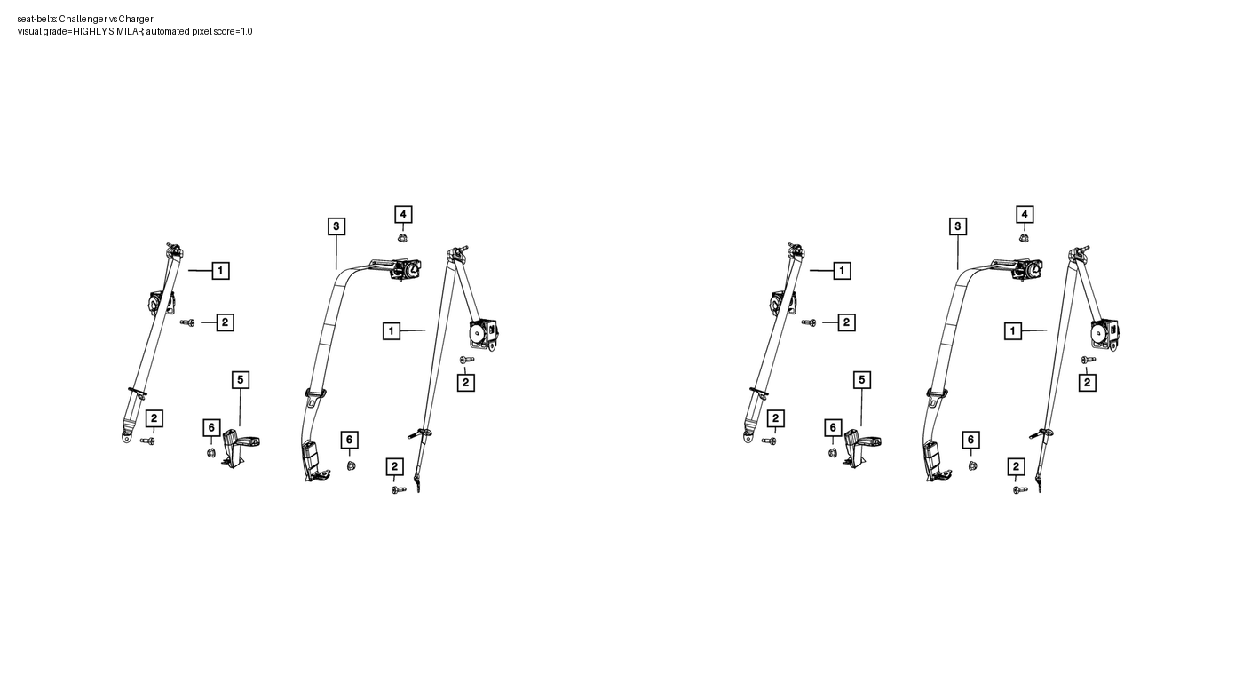

front-seat-adjusters
Visual grade: SIMILAR WITH VISIBLE DIFFERENCES (High confidence)
Visible commonalities: Both drawings show matching seat-back frame, cushion/track frame, side shield and floor-foot arrangement.
Visible differences/limits: Spring field, side hardware and small attachment layout differ.
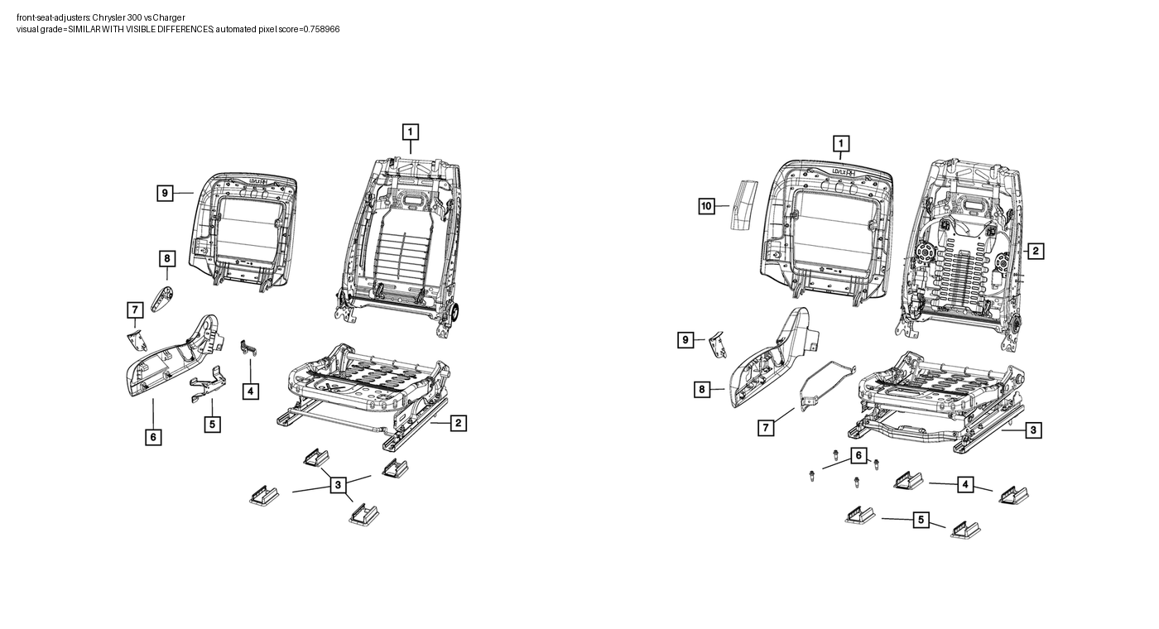

rear-seat-adjusters
Visual grade: HIGHLY SIMILAR (High confidence)
Visible commonalities: Twin seat-back frames, perforated panels, central latch/bracket cluster and peripheral hardware have closely corresponding geometry.
Visible differences/limits: Callout numbering and several small peripheral pieces differ.
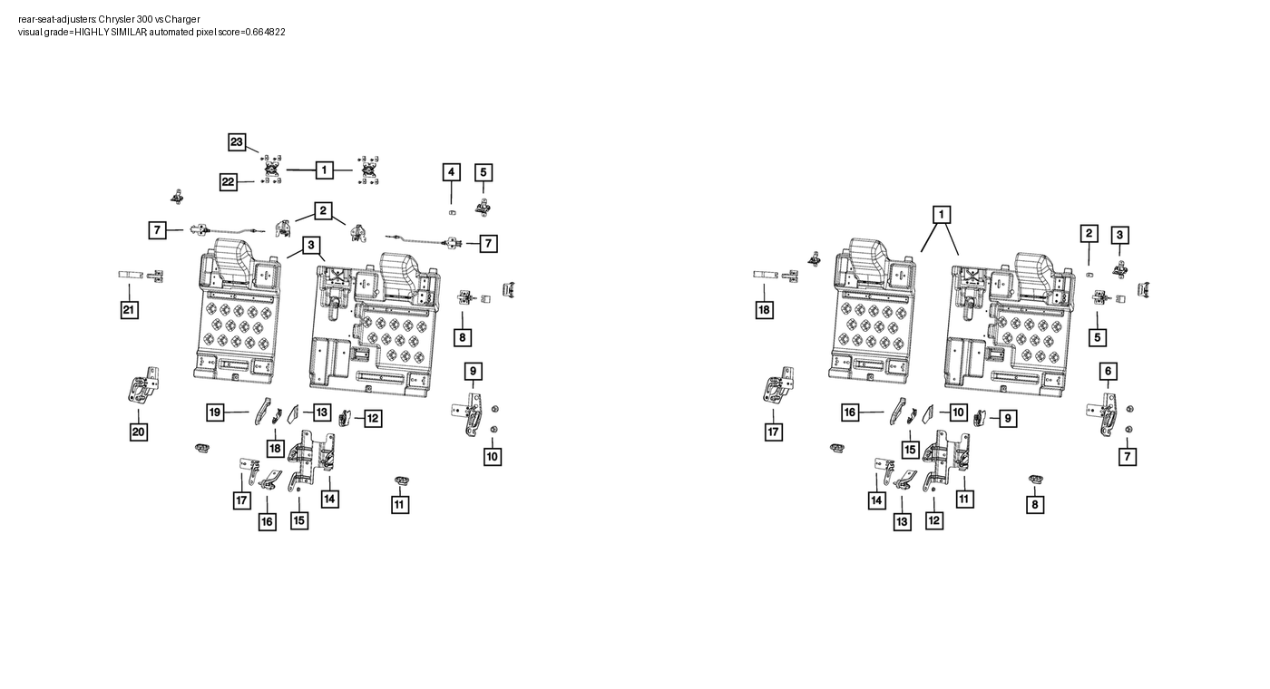

steering-column
Visual grade: HIGHLY SIMILAR (High confidence)
Visible commonalities: Angled column shaft, upper housing, mounting bracket, coupling and fastener locations closely correspond.
Visible differences/limits: One drawing includes an additional large shroud/module and callout layout differs.
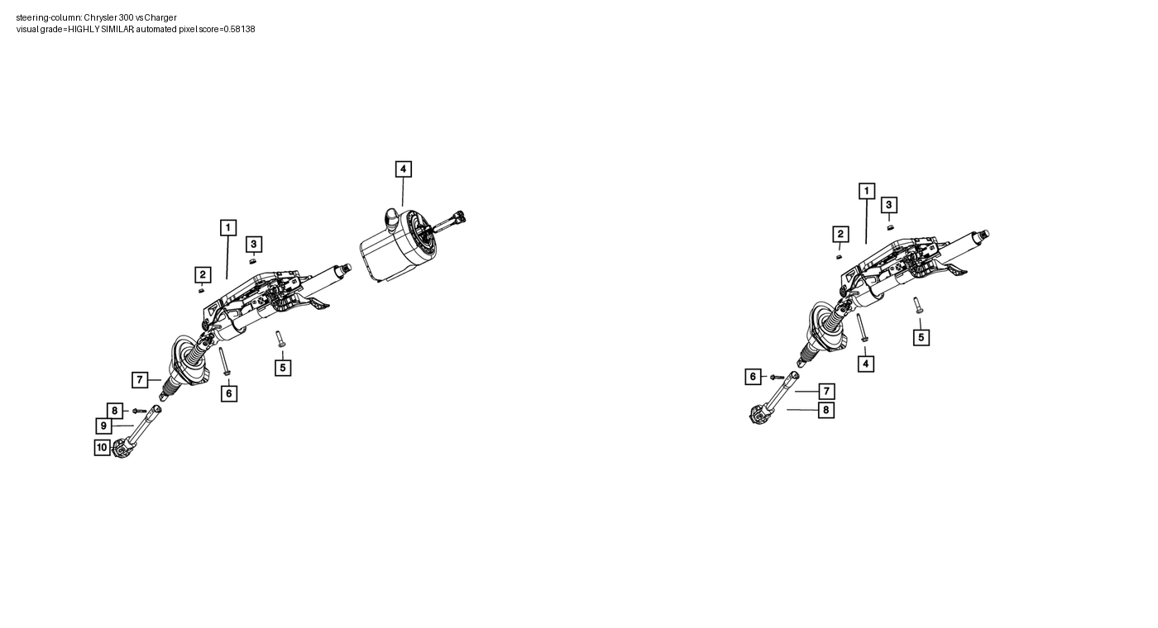

steering-wheel
Visual grade: SIMILAR WITH VISIBLE DIFFERENCES (High confidence)
Visible commonalities: Both show a round three-spoke wheel, central airbag/hub interface, side switch/trim modules and lower spoke trim.
Visible differences/limits: Spoke trim, hub detail and peripheral module shapes differ.
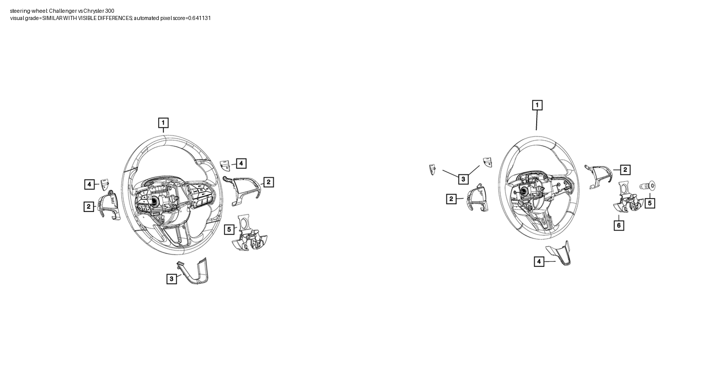

air-bags
Visual grade: HIGHLY SIMILAR (High confidence)
Visible commonalities: Passenger-airbag module, steering-wheel airbag family and lower bolster occupy the same three-part exploded layout.
Visible differences/limits: Steering-wheel hub/spoke detail differs; the drawing does not show calibration, sensors or deployment behaviour.
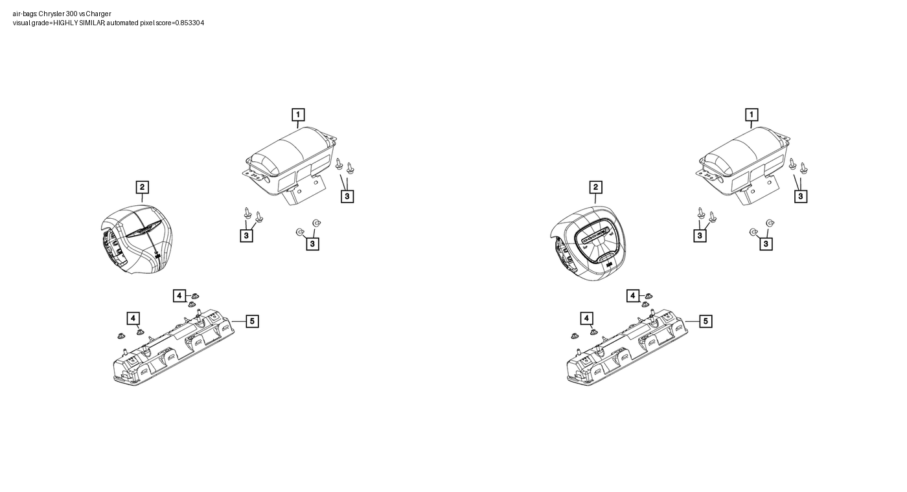

headliners-visors
Visual grade: SIMILAR WITH VISIBLE DIFFERENCES (Medium confidence)
Visible commonalities: Both show a large roof-liner panel with front visor/console attachment groups and perimeter fasteners.
Visible differences/limits: Roof openings, panel contour and quantity/location of smaller attachments differ; visor geometry is small in the source view.
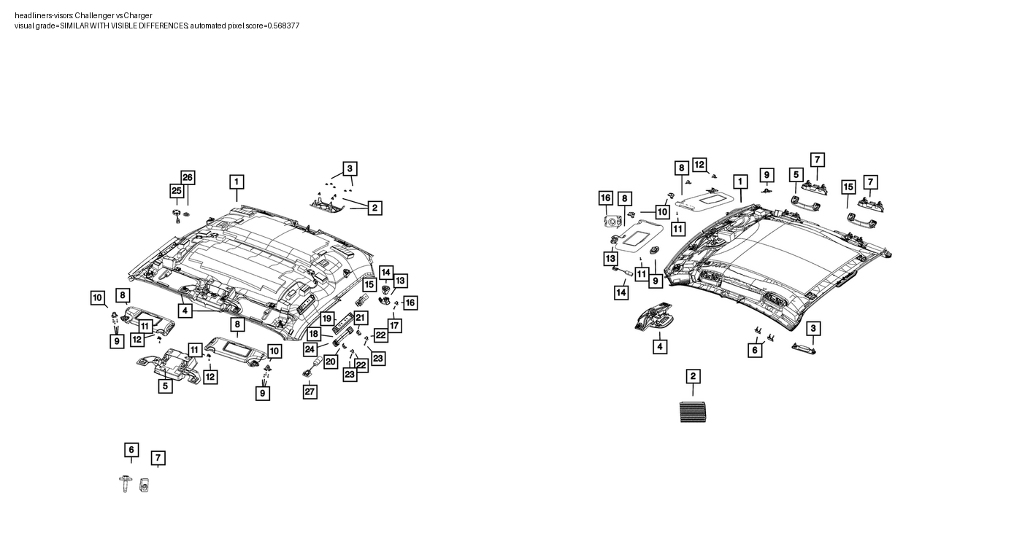

instrument-panel
Visual grade: SIMILAR WITH VISIBLE DIFFERENCES (Medium confidence)
Visible commonalities: Both show a full-width dashboard shell with instrument binnacle, centre stack, vent groups, glove-box region and lower trim.
Visible differences/limits: Main shell contour, centre-stack shape, component count and callout arrangement visibly differ.
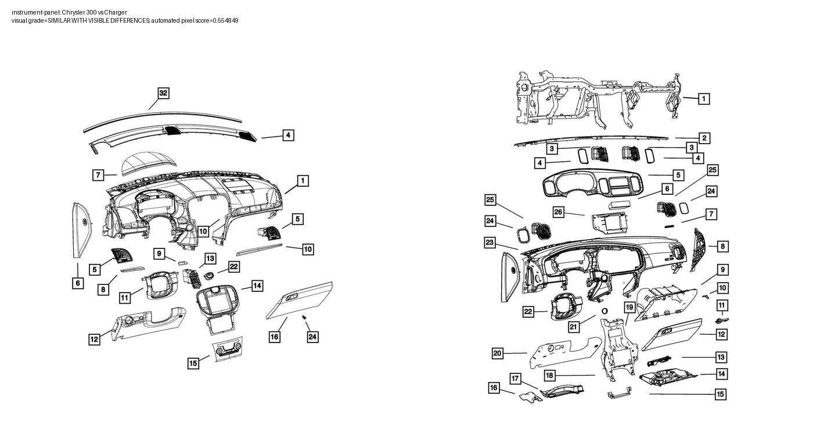

rear-seats-second-row
Visual grade: SIMILAR WITH VISIBLE DIFFERENCES (Medium confidence)
Visible commonalities: Both show split rear seat-backs, head restraints, side bolsters, cushions and lower trim in a comparable exploded arrangement.
Visible differences/limits: Backrest split/configuration, cushion segmentation and accessory layout differ; child anchors are not visibly isolated.
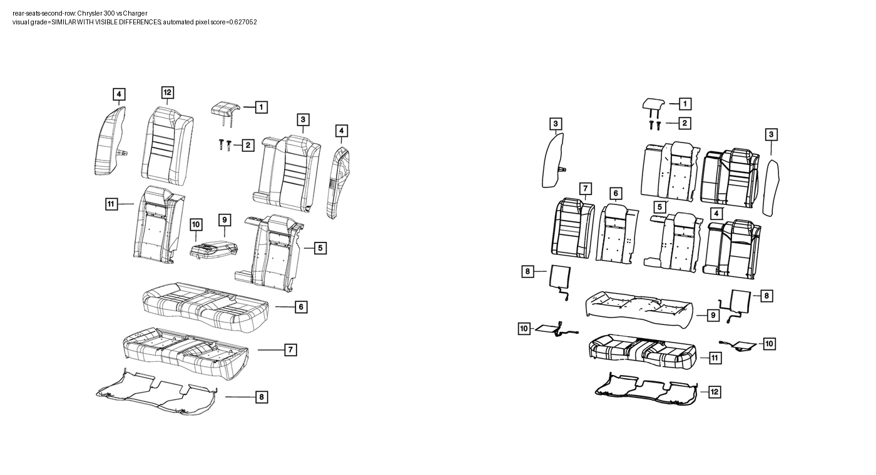

Limitations
Image similarity does not prove part identity, dimensions, materials, attachment strength, fitment, interchangeability, calibration, dynamic performance or ADR compliance. Crash ADR outcomes are depicted-hardware screens only.

