Task-1 : Draw a simple diagram showing the main components of a food delivery app like Zomato or Swiggy (such as user, restaurant, order, delivery partner, payment) and label how they interact in the software architecture.

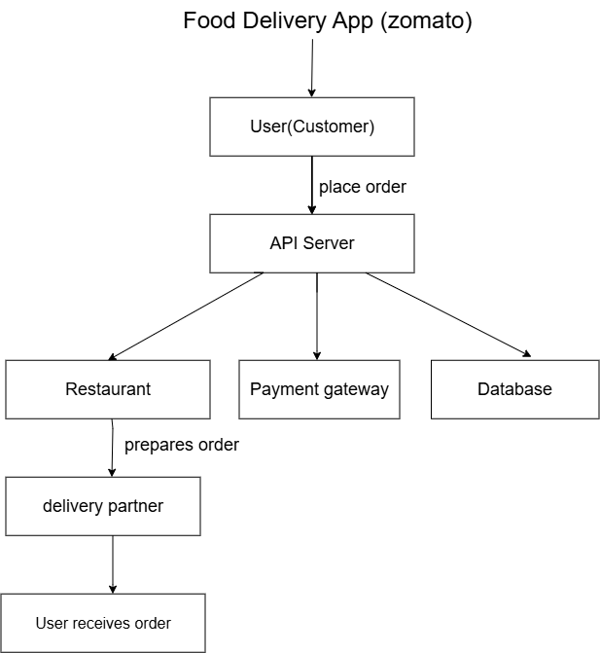

TASK-2 : Pick any app you use daily (Instagram, Paytm, Flipkart, etc.) and list 5 different testing activities that must be performed before the app is released to users.<br><br><em><strong>Hint:</strong> Think about things like login, payment, notifications, speed, and security.</em>

Testing Activities – Paytm App

Before releasing the Paytm app to users, different testing activities should be performed to make sure the app works properly and safely.

1. Planning and Control

First, we decide what needs to be tested, how it will be tested, and what resources are required.

Example: We plan to test Paytm's login, payment, notification, performance and security features.

2. Choosing Test Conditions

In this step, we decide the different conditions or situations that need to be tested.

Example: For login, we test correct OTP, incorrect OTP, invalid mobile number and empty fields.

3. Designing Test Cases

After choosing the conditions, we create test cases with input, steps and expected results.

Example: Enter a valid mobile number and correct OTP → Expected result: User should be logged in successfully.

4. Checking Results

We execute the test cases and compare the actual result with the expected result.

Example: If ₹500 is sent, we check whether exactly ₹500 is deducted and the transaction is completed correctly.

5. Evaluating Completion Criteria

We check whether enough testing has been completed and whether the important features are working properly.

Example: We check that major features like login, payment and notifications have passed the required tests before release.

6. Reporting on Testing Process and System Under Test

We prepare a report about the testing done, passed/failed test cases and defects found.

Example: If payment fails during testing, we record the problem and report it to the development team.

7. Finalizing / Closure

After the testing phase is completed, we close the testing activity and prepare the final testing report.

Example: Once important defects are fixed and required testing is completed, the Paytm release can move forward.

8. Reviewing Documents and Static Analysis

Testing also includes reviewing documents and source code without actually running the application.

Example: We review Paytm's requirements and source code to find mistakes before the app is released.

Task-3 : Explain in your own words why testing is important at each stage of the Software Development Life Cycle (SDLC), using an example from an app like BookMyShow or IRCTC.

D
Testing is important at every stage of SDLC because it helps us find mistakes early and make sure the final application works as expected.

1. Requirement Gathering

In this stage, the team collects the user and business requirements. Testing helps to check whether the requirements are clear, complete and correct.

Example: For BookMyShow, we check requirements such as movie search, seat selection, ticket booking and online payment.

2. Analysis

In this stage, the requirements are studied in detail and the problem to be solved is defined. It explains what the system should do, without deciding how it will be developed. Testing helps to find unclear or missing requirements at this stage.

Example: For BookMyShow, we decide what should happen when a user selects a seat that has already been booked by another user.

3. Design

In this stage, the requirements are converted into system architecture, components and interfaces. Testing helps to make sure the design covers all the required features and can be tested properly.

Example: The design should include separate parts for movie details, seat booking, payment and ticket confirmation.

4. Implementation

In this stage, developers write the actual code and build the application. Testing helps to find coding errors and check whether each component works correctly.

Example: We test whether the selected seat is correctly booked and the correct ticket details are generated.

5. Testing

After implementation, the application is tested in detail. Different types of testing such as unit testing, application testing, regression testing and stress testing can be performed.

Example: We test the complete BookMyShow flow:
Select movie → Select seat → Make payment → Get ticket confirmation.

6. Maintenance

After the application is released, changes, new features and bug fixes may be required. Testing is important here to make sure these changes do not create problems in existing features.

Example: If BookMyShow adds a new payment option, we test the new option and also check that the existing payment options and ticket booking still work..

Task-4 : Write down the main objectives and purpose of testing by imagining you are part of a team launching a new music streaming feature in Spotify. List at least 3 objectives and explain each in one line.

Imagine our team is launching a new music streaming feature in Spotify. Before releasing it to users, we need to test it properly.
- Find Defects
To find bugs in the new feature before users start using it.
- Check Functionality
To make sure songs play correctly and features like play, pause, next, and volume work properly.
- Check Performance
To make sure the feature works smoothly without taking too much time to load or causing the app to slow down.
- Check User Experience
To make sure the new feature is easy to understand and simple for users to use.

